**Supporting Information**

Fig S1: Raman spectra of prepared composite

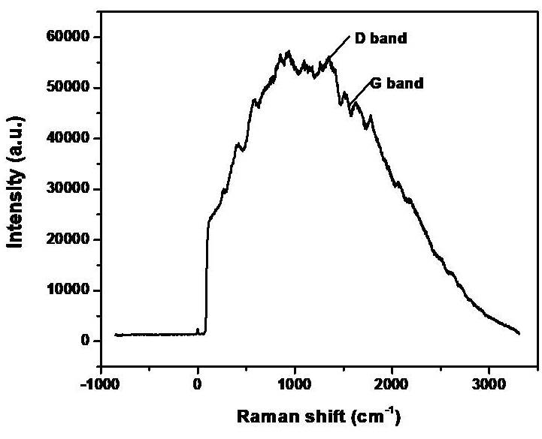

Table S1: A comparison on F- removal using different adsorbents

|  |  |  |  |
| --- | --- | --- | --- |
| **Adsorbent Name** | **Adsorption capacity** | **F- concentration** | **pH** |
| Activated-Al2O3 | 0.86 | 15-100 | 5-6 |
| MnO-coated Al | 2.85 | 2.5-30 | 7 |
| Hydrous MnO-coated Al | 7.09 | 10-70 | 5.2 |
| CuO-coated Al | 7.8 | 10 | - |
| Iron(III)-tin(IV) mixed oxide | 10.47 | 10-50 | 6.4 |
| Al2O3/CNTs | 28.7 | 50 | 6 |
| PPy/Fe3O4 | 17.6-22.3 | 5-100 | 6.5 |
| KMnO4 modified carbon | 7.8 | 20 | 2 |
| Cu2O-RGO (current study) | 34.4 | 10 | 9 |

Fig S2a: Freundlich adsorption isotherms of 30 mg sorbent at (a) pH=4, (b) pH=7 and (c) pH=9.

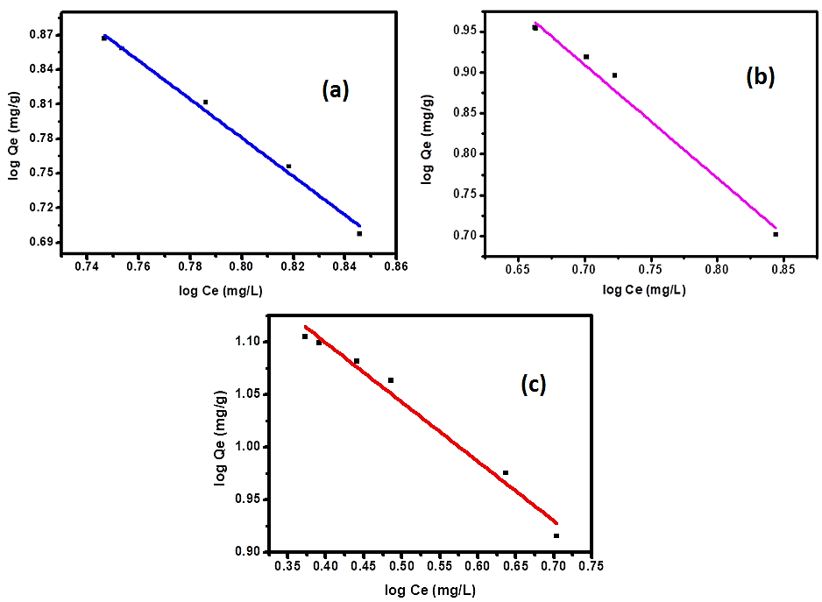

Fig S2b: Freundlich adsorption isotherms of 10 mg sorbent at (a) pH=4, (b) pH=7 and (c) pH=9.

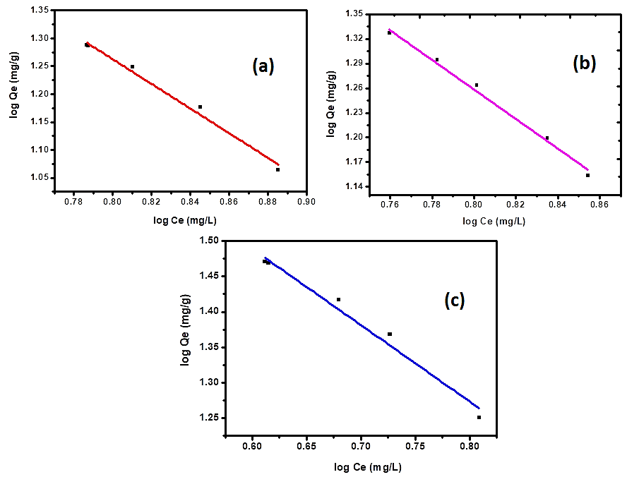

Fig S3a: Langmuir adsorption isotherms of 30 mg sorbent at (a) pH=4, (b) pH=7 and (c) pH=9.

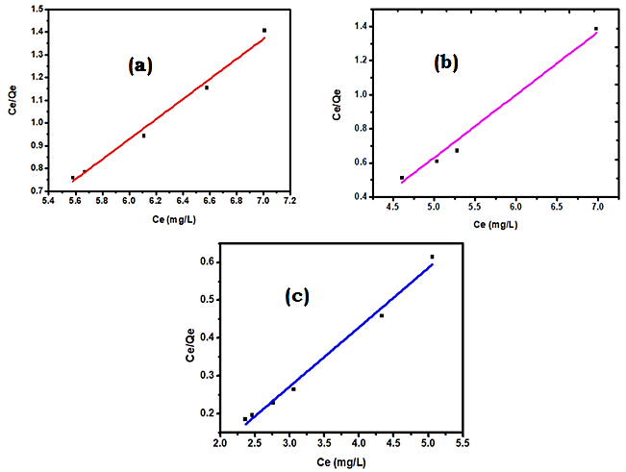

Table S2: The regression coefficient (R2), slope and intercept for Langmuir model

|  |  |  |  |  |
| --- | --- | --- | --- | --- |
| Catalyst dose | pH | R2 | Slope | Intercept |
| 30 mg | 4 | 0.99897 | 6.2178 | -5.11912 |
| 7 | 0.99656 | 5.69854 | -4.12728 |
| 9 | 0.99621 | 3.52167 | -0.75819 |
| 10 mg | 4 | 0.9989 | 6.81948 | -6.24299 |
| 7 | 0.99896 | 6.39264 | -5.44412 |
| 9 | 0.99477 | 5.0866 | -3.10409 |

Fig S3b: Langmuir adsorption isotherms of 10 mg sorbent at (a) pH=4, (b) pH=7 and (c) pH=9.

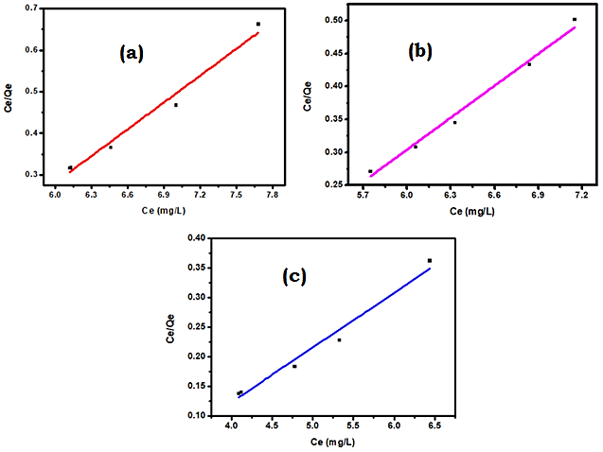

Fig S4a: Temkin adsorption isotherms of 30 mg sorbent at (a) pH=4, (b) pH=7 and (c) pH=9.

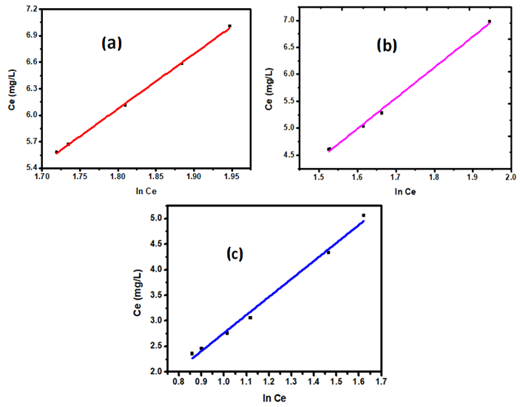

Table S3: The regression coefficient (R2), slope and intercept for Temkin model

|  |  |  |  |  |
| --- | --- | --- | --- | --- |
| Catalyst dose | pH | R2 | Slope | Intercept |
| 30 mg | 4 | 0.99897 | 6.2178 | -5.11912 |
| 7 | 0.99656 | 5.69854 | -4.12728 |
| 9 | 0.99621 | 3.52167 | -0.75819 |
| 10 mg | 4 | 0.9989 | 6.81948 | -6.24299 |
| 7 | 0.99896 | 6.39264 | -5.44412 |
| 9 | 0.99477 | 5.0866 | -3.10409 |

Fig S4b: Temkin adsorption isotherms of 10 mg sorbent at (a) pH=4, (b) pH=7 and (c) pH=9.

