**Supplementary 1: Schematic diagram of preparation of modified starch based composites with bentonite/organobentonite**

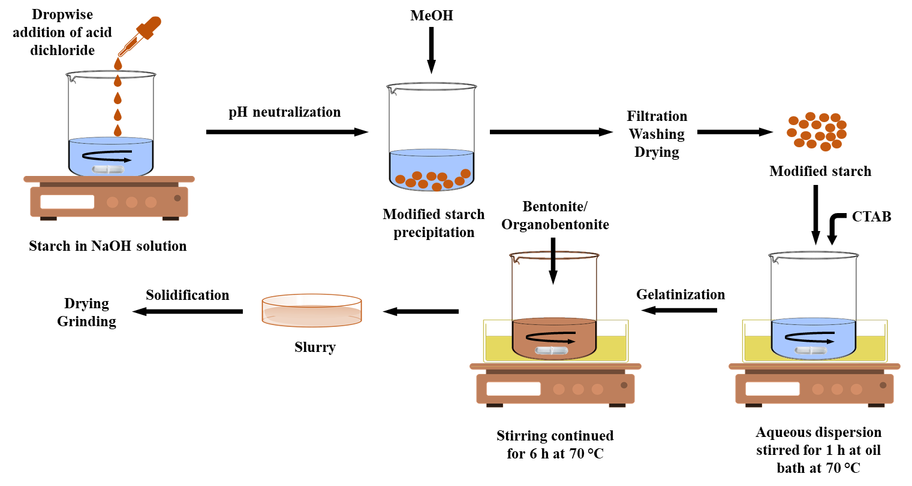

**Supplementary 2: Assignment of bands of FT-IR spectra**

|  |  |  |
| --- | --- | --- |
| **Band (cm-1)** | **Assignment** | **Material(s)** |
| 3350-3450 | O–H stretching | Starch |
| 2922 | –CH2– asymmetric stretching |
| 2855 | –CH2– symmetric stretching |
| 1650 | O–H bending |
| 1462 | –CH2– symmetric bending |
| 1369 | –CH2– asymmetric bending |
| 1161 | C–O–H stretching |
| 992 | C–O–C stretching |
| 767 | C–O–C ring vibration |
| 3350-3450 | O–H stretching | Modified starch |
| 3100 | C=H of benzene ring bending |
| 2920-2925 | –CH2– asymmetric stretching |
| 2850-2855 | –CH2– symmetric stretching |
| 1738-1760 | C=O stretching |
| 1550 | C=H of benzene ring stretching |
| 3350-3450 | O–H stretching | Composites |
| 2925 | –CH2– asymmetric stretching |
| 2850 | –CH2– symmetric stretching |
| 1743 | C=O stretching |
| 1460 | –CH2– symmetric bending |
| 1337 | –CH2– asymmetric bending |
| 1149 | C–O–H stretching |
| 1012 | Si–O stretching |