Supplementary data Fig. S1

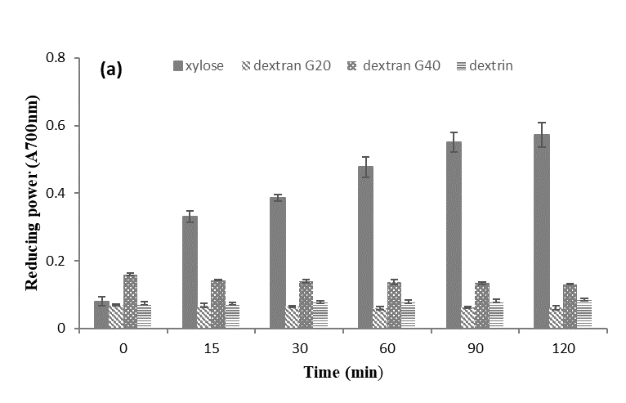

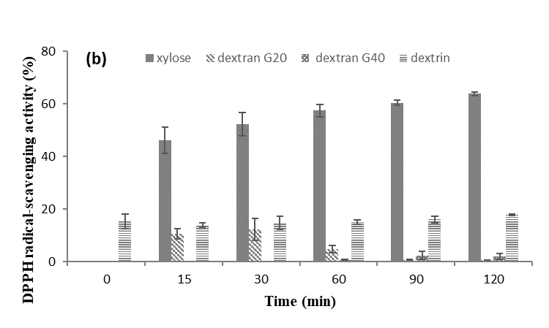

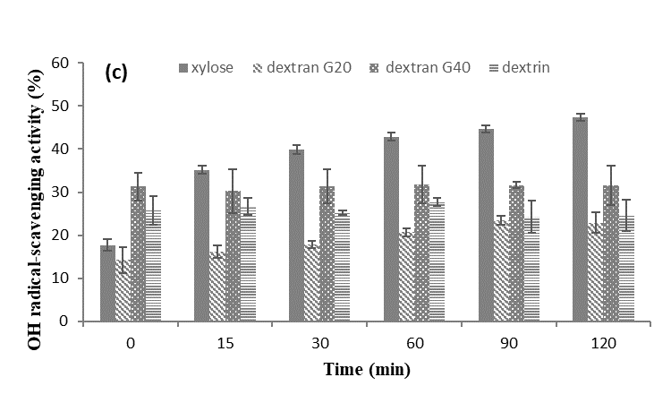

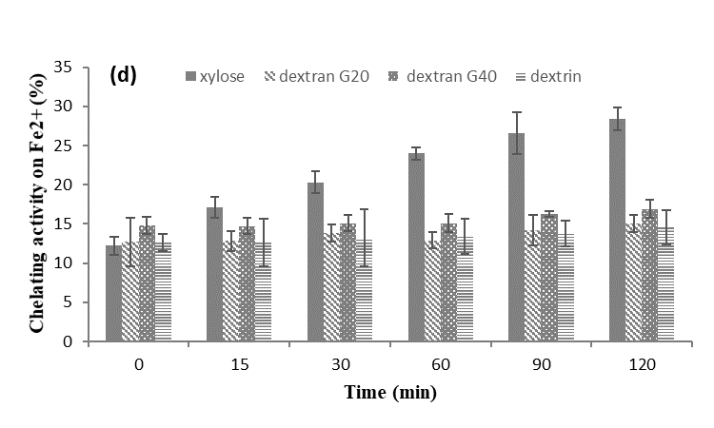

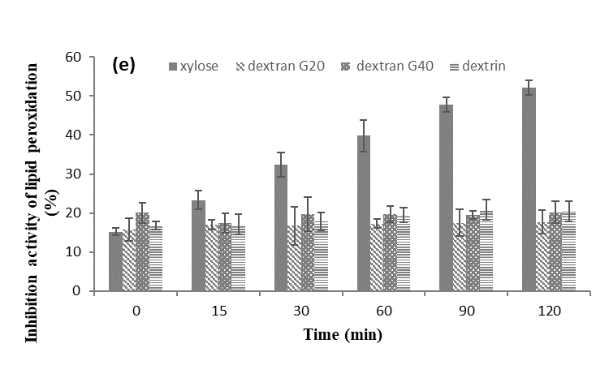

Fig. S1 Effect of reducing sugar types on Reducing power (a), DPPH radical-scavenging activity (b), OH radical-scavenging activity (c), Chelating activity on Fe2+ (d), and Inhibition activity of lipid peroxidation (e) of glycosylated WPI conjugates

In Maillard reaction, the type of reducing sugar is an important factor affecting the functional properties of the MRPs. The properties of the MRPs are closely related to the type, structure and activity of sugar molecules. The MRP were prepared through MR between WPI and xylose, dextran G20, dextran G40, or dextrin. As shown in Fig. S1, the antioxidant activities of WPI-X were much higher than the MRP from the other carbohydrates (P < 0.05). The degree of Maillard reaction of WPI-X gradually increased with the prolongation of reaction time, and its antioxidant capacity increased significantly.

Under the same wet-heating reaction conditions, the MRP from WPI and xylose Maillard had the strongest antioxidant capacity. Xylose has high reactivity because of its low molecular weight, short carbon chain and small steric hindrance, which can penetrate into protein folding structure. Therefore, xylose could react with protein under mild reaction conditions, which could better protect the efficacy and nutritional value of raw protein. The results showed that the functional protein products with emulsifying and high antioxidant activity could be obtained by grafting xylose onto whey protein isolate under appropriate reaction conditions.