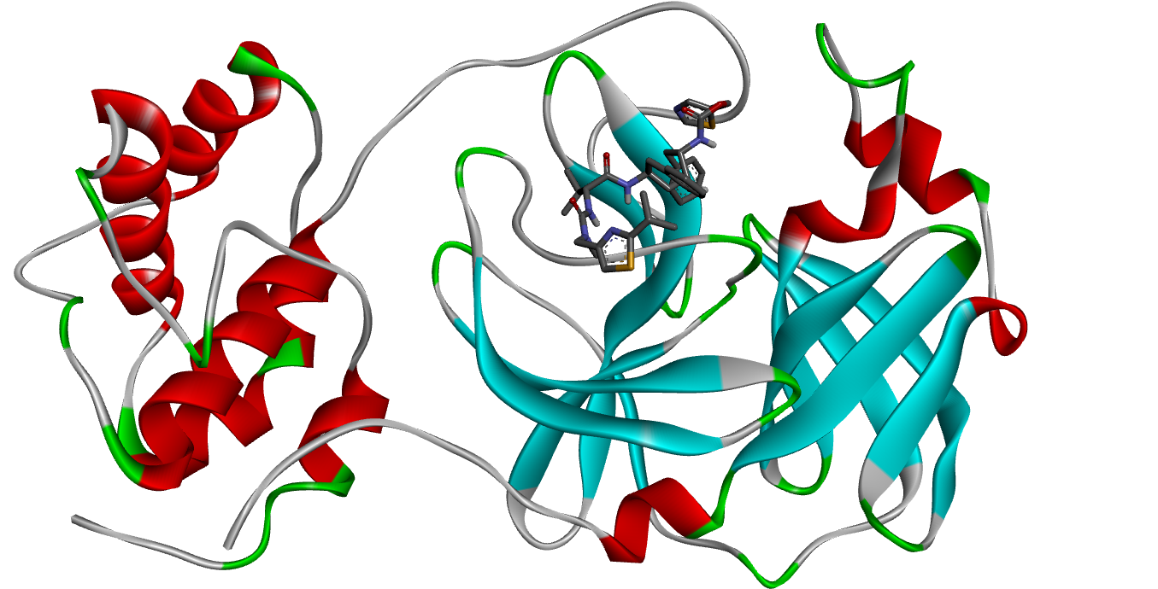

**Figure S1:** 3D visualization of protein (Protease) docked with Ritonavir

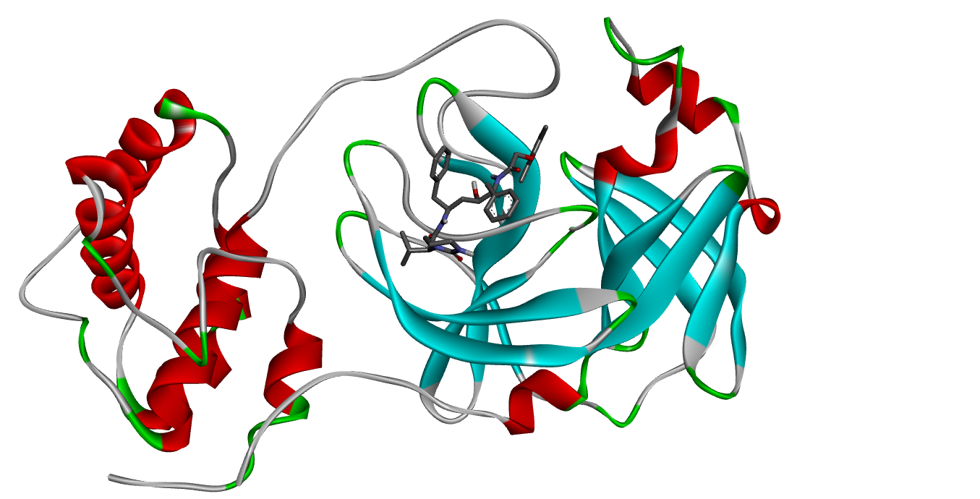

**Figure S2:** 3D visualization of protein (Protease) docked with Lopinavir

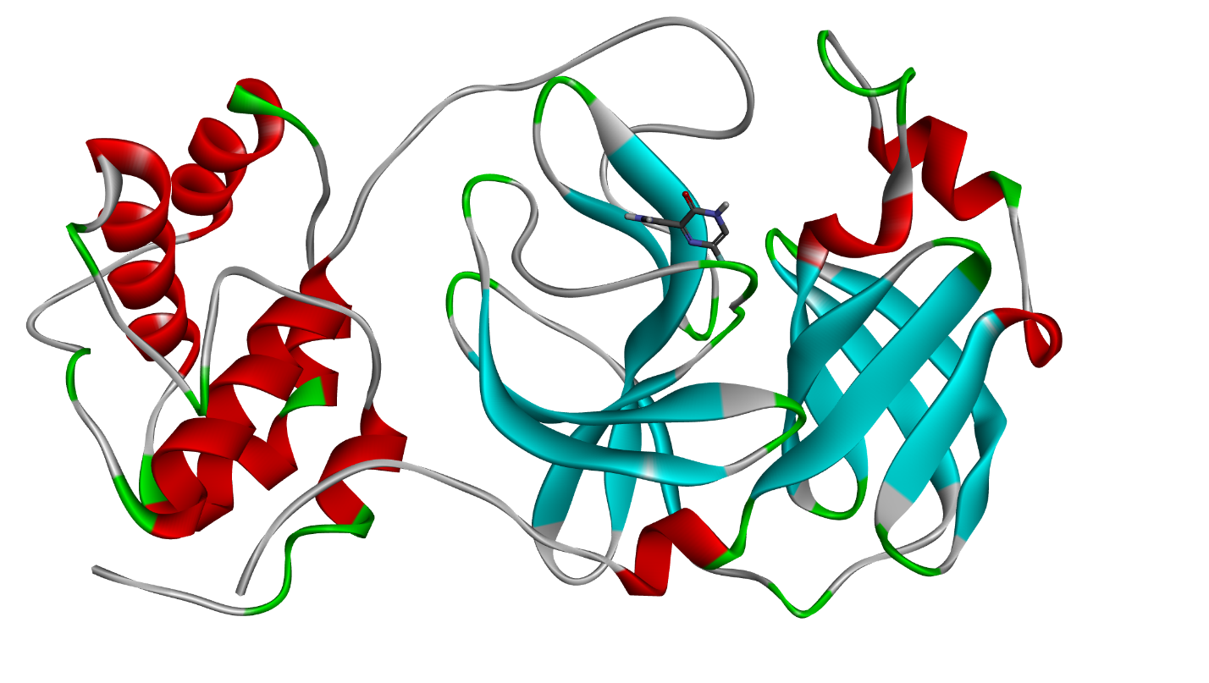

**Figure S3:** 3D visualization of protein (Protease) docked with Favipiravir

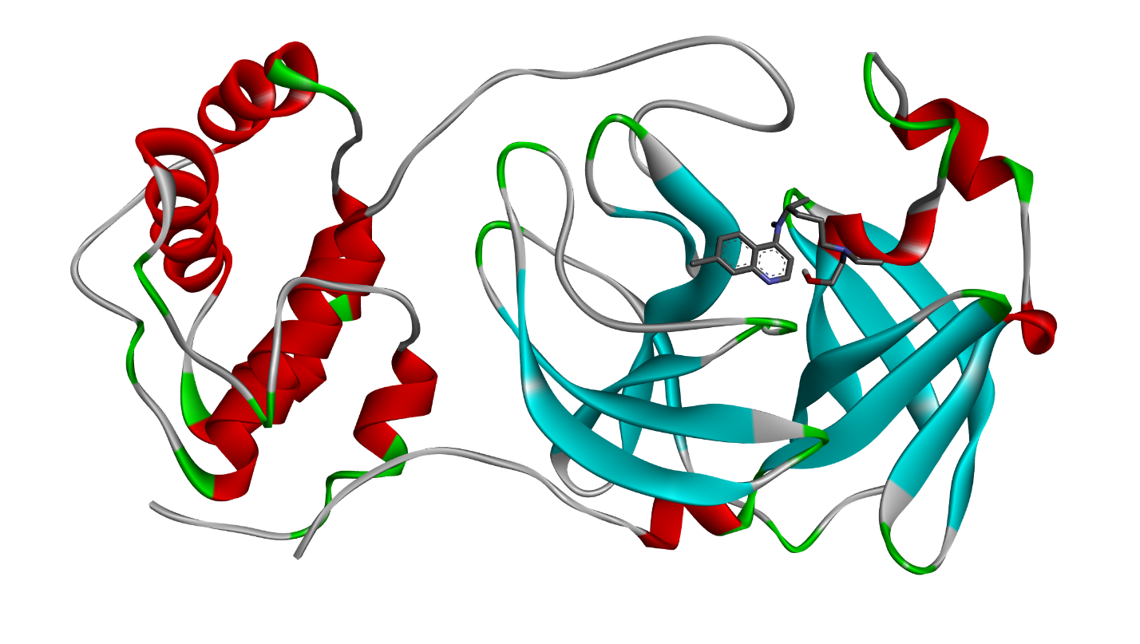

**Figure S4:** 3D visualization of protein (Protease) docked with Hydroxychloroquine

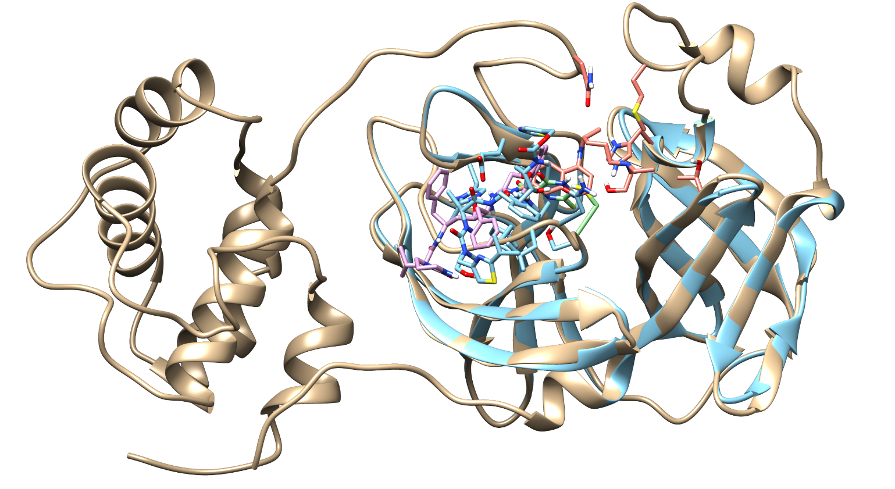

**Figure S5:** Native Protease (PDB: 6LU7) shown with Golden Color and superimposed complex (in ribbon pattern shown by turquoise color) with selected drugs Ritonavir (turquoise), Lopinavir (pink), Favipiravir (green) and hydroxychloroquine (orange).