**Supplemental material**

**Preparation of N-acetyl-para-aminophenol via a flow route of a clean amination and acylation of p-nitrophenol catalyzing by core-shell Cu2O@CeO2**

Yue Li1,2#, Yuxuan Ma1#, Yuanyuan Zhang1, Xiaojing Wang1,*, Fenghua Bai1,3,*

1.Inner Mongolia Key Laboratory of Chemistry and Physics of Rare Earth Materials, School of Chemistry and Chemical Engineering, Inner Mongolia University, Hohhot, Inner Mongolia, 010021, P. R. China

2. Key Laboratory of Microsystems and Microstructures Manufacturing, Ministry of Education, Micro/Nanotechnology Research Centre, Harbin Institute of Technology, Yi Kuang Jie 2, Harbin 150080, China

3. Key Laboratory of Advanced Energy Materials Chemistry (Ministry of Education), College of Chemistry, Nankai University, Tianjin 300071, China

#*Co-first authors*

*\*corresponding author: E-mail: wang_xiao_jing@hotmail.com, f.h.bai@imu.edu.cn*

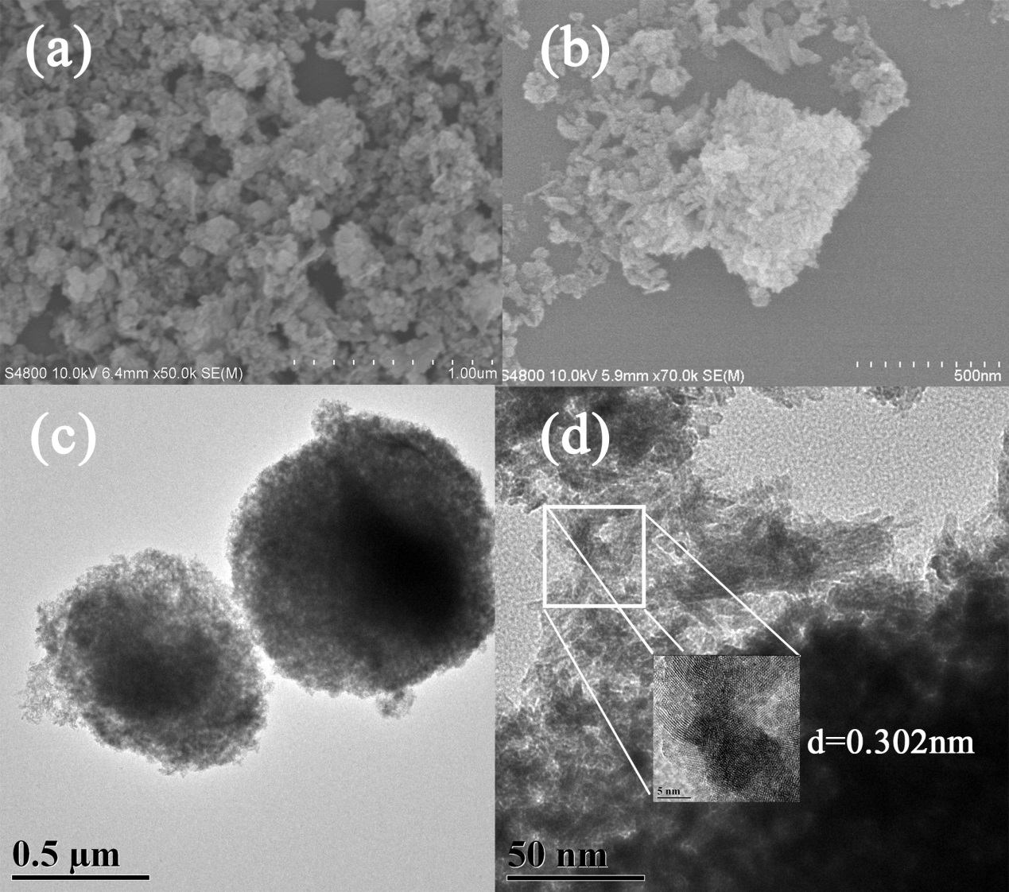

Fig.S1 SEM images of CeO2 (a,b)

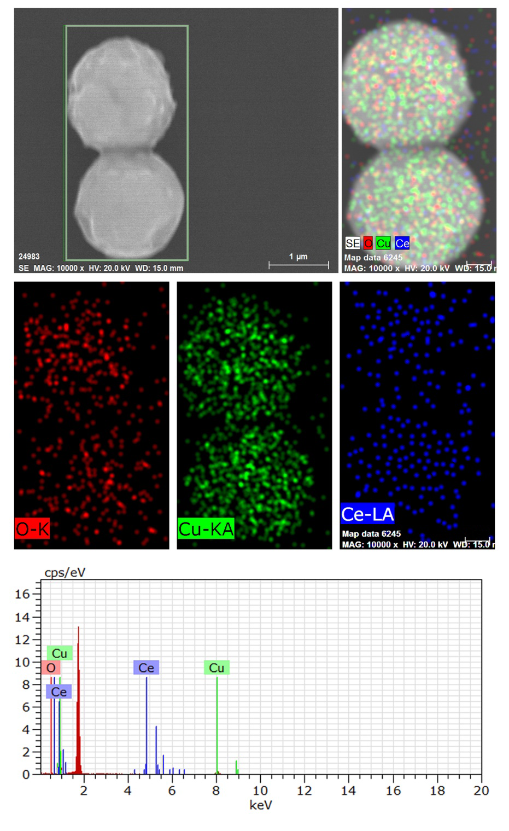

Fig.S2 EDX images of 3Cu2O@CeO2

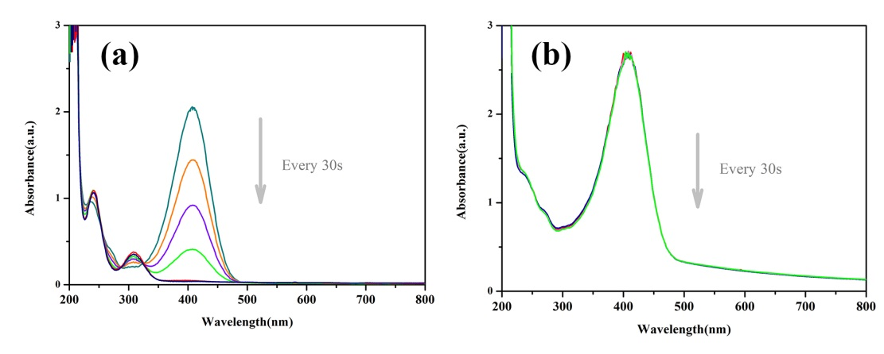

Fig.S3 Reduction of p-NP over (a) the as-prepared Cu2O and (b) the as-prepared CeO2.

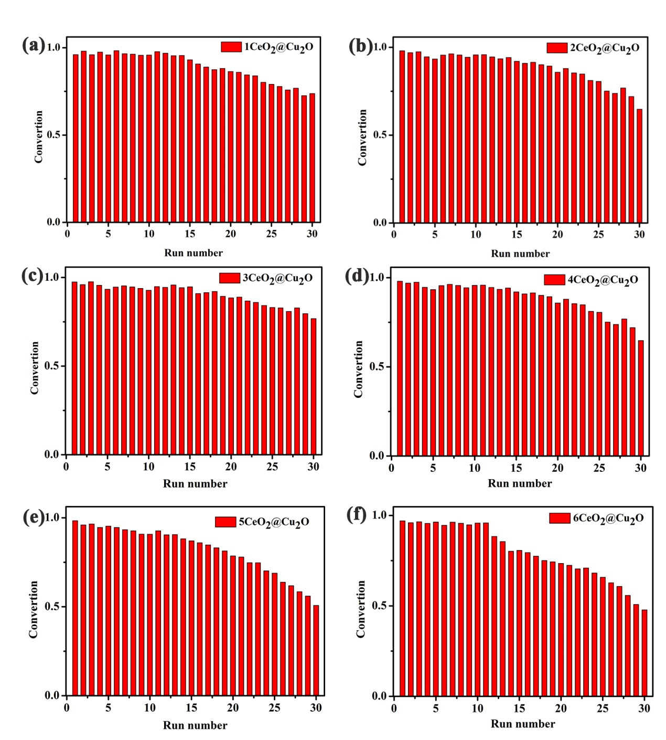

Fig.S4 Recycle performance of p-NP conversion with the as-prepared CeO2@Cu2O

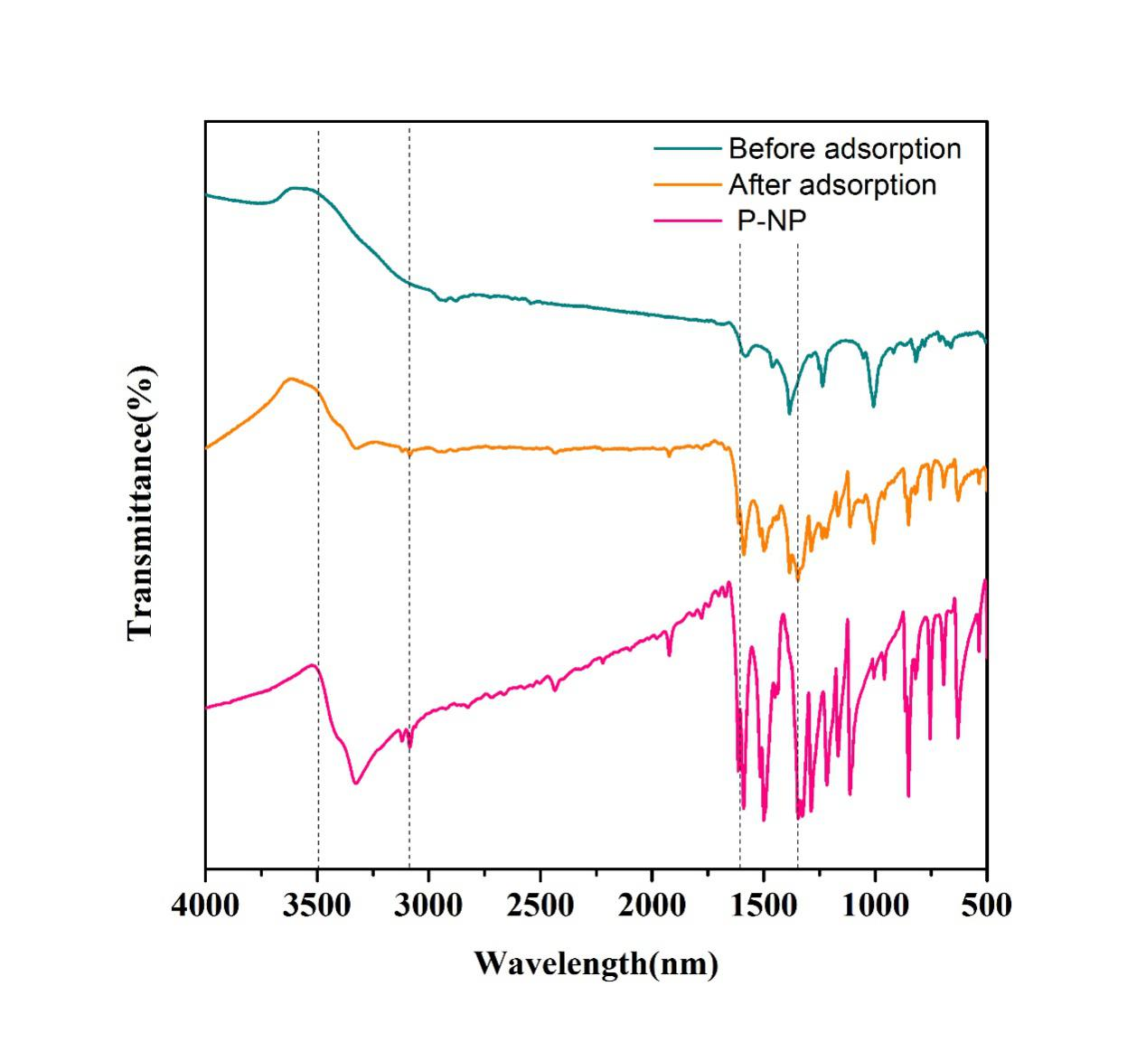

Fig. S5 The IR spectra of 3CeO2@Cu2O before and after adsorption of p-NP.

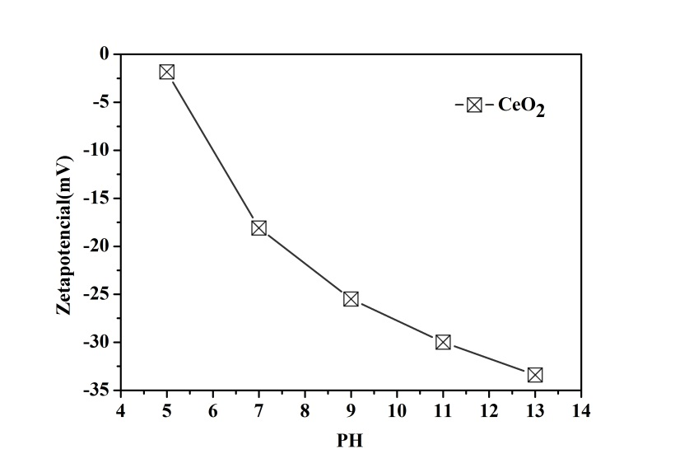

Fig.S6 The Zeta-potential of CeO2.

Table S1 The reaction rate constants k for the reaction of p-NP over the prepared catalysts

|  |  |
| --- | --- |
| As-prepared catalyst | The activity factor k(s-1 mg-1) |
| Cu2O | 0.0083 |
| 1CeO2@Cu2O | 0.01285 |
| 2CeO2@Cu2O | 0.01982 |
| 3CeO2@Cu2O | 0.02529 |
| 4CeO2@Cu2O | 0.02954 |
| 5CeO2@Cu2O | 0.03229 |
| 6CeO2@Cu2O | 0.0328 |

Table S2 Cerium element associated characteristic peak positions

|  |  |  |  |  |  |  |  |
| --- | --- | --- | --- | --- | --- | --- | --- |
| Binding energy of Ce 3d 5/2, 3/2 in Cu2O@CeO2 (after reaction) | | | | Binding energy of Ce 3d 5/2, 3/2 in Cu2O@CeO2 (before reaction) | | | |
| peak | Valence state | binding energy (eV) |  | peak | Valence state | binding energy (eV) |  |
| α1 | +3 | 881.7 |  | α1 | +3 | 881.7 |  |
| α2 | +4 | 882.6 |  | α2 | +4 | 882.6 |  |
| α3 | +3 | 885.2 |  | α3 | +3 | 885.2 |  |
| α4 | +4 | 888.3 |  | α4 | +4 | 888.3 |  |
| α0 | +4 | 897.9 |  | α0 | +4 | 897.9 |  |
| β1 | +3 | 899.2 |  | β1 | +3 | 899.2 |  |
| β2 | +4 | 901.0 |  | β2 | +4 | 901.0 |  |
| β3 | +3 | 903.3 |  | β3 | +3 | 903.3 |  |
| β4 | +4 | 907.2 |  | β4 | +4 | 907.2 |  |
| β0 | +4 | 916.7 |  | β0 | +4 | 916.7 |  |