**Supplementary Material**

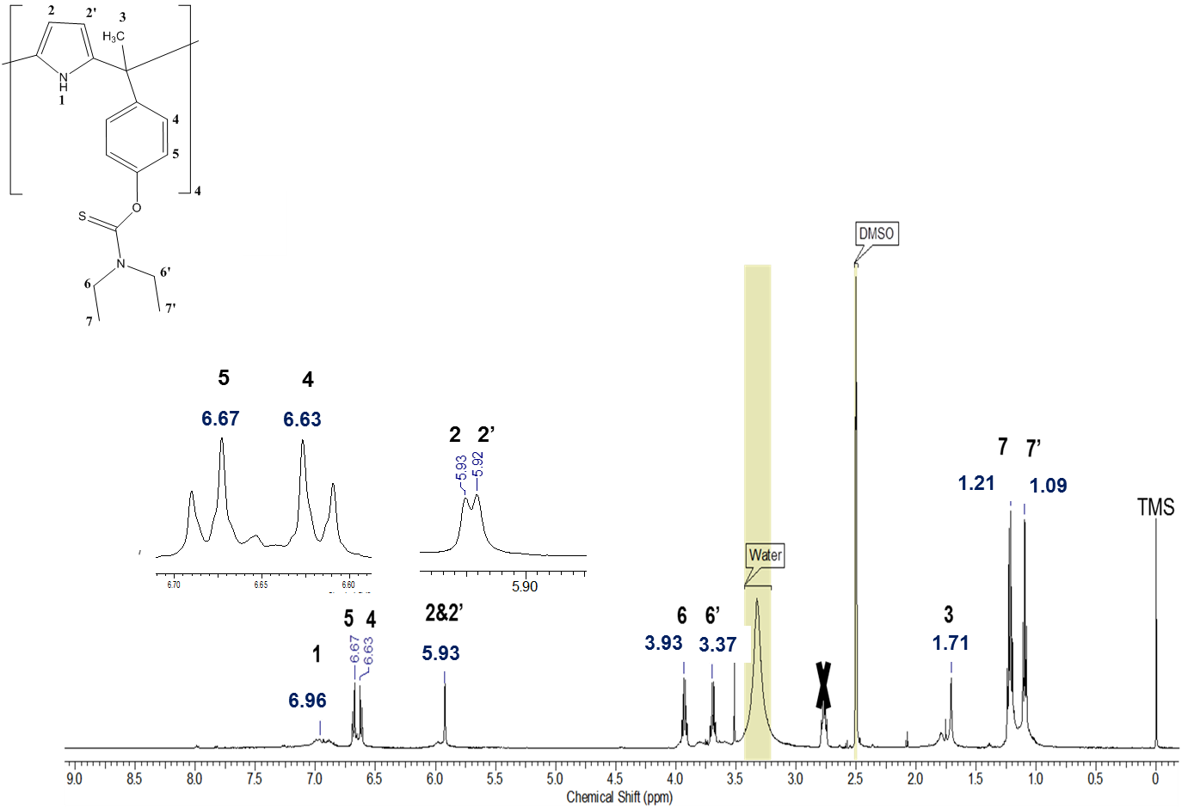

**Figure S1** 1H NMR spectrum of*meso*-tetramethyl-tetrakis[(diethylthiocarbamoyl)phenoxy] calix[4]-pyrrole,**1** in DMSO-d6



**Figure S2**1H NMR spectrum of 5,11,17,23-tetra-tert-butyl[25,27 bis(diethylthiocarbamoyl)oxy]calix[4]arene, **2** in CD3CN at 298 K.

**Results and Discussion**

**Soaking time effect on the behaviour of Hg(II)-ISEs**

The results indicate that the optimal soaking time for Hg(II)-ISE based on **1** (E-5) is 30h and 24h based on **2** (E-10). However, at longer soaking periods, the response characteristics of E-5 and E10 did not change. In fact, electrode conditioning activates the ionophore sites thereby generating stable potential responses. Therefore, storing the electrodes (E-5 & E-10) in Hg(NO3)2 solution (1x10-2mol dm-3) is recommended when not in use to obtain a stable potential response.



**(a)**



**(b)**

**(b)**

**Fig S3**Calibration plots for Hg(II)-ISE based on **1** (a) and **2** (b) after 6 h,12 h, 24 h, 30 h, 36 h and 48 h of soaking the ISE in a 1x10-2mol dm-3 Hg(NO3)2 solution.

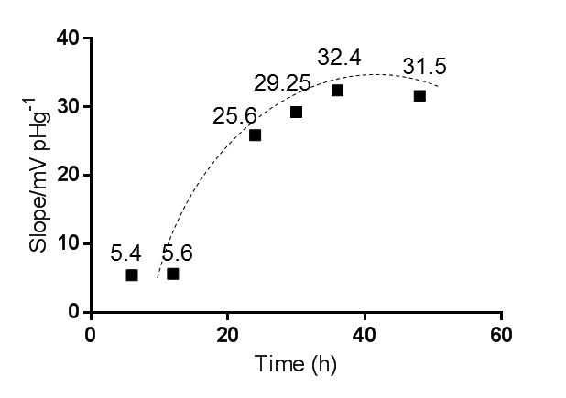

**(a)**

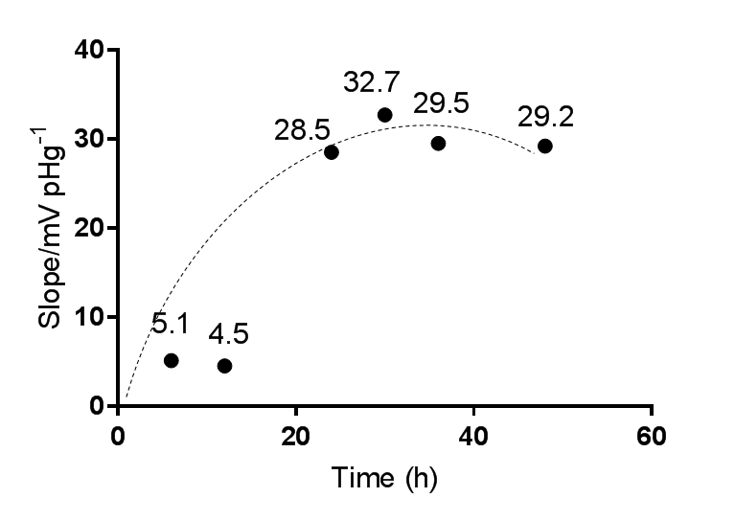

**(b)**

**Fig S4**Soaking time effect on the slope of Hg (II)-ISE based on **1** (a) and **2**(b).

**Effect of solution pH on the Hg(II)-ISEs response**

The effect of the pH of the solution on the ISEs’ response was investigated at different concentrations of the electrode internal solutionHg(NO3)2 (1x10-3& 1x10-2mol dm-3) where the potential variations over a pH range of 1.5-12 were recorded. Findings revealed that the optimum electrode response for E-5 is in the 4-8 range, while for E-10 the optimal pH range was 3-8.

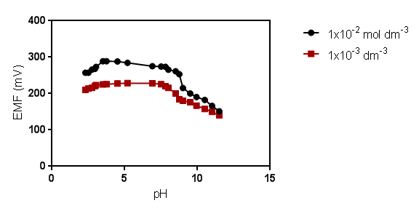

**(a)**

**(b)**

**Fig S5** pH effect on the potential response of Hg(II)-ISEs based on **1** (a) and **2** (b).

**Dynamic response time and reversibility of the Hg(II)-ISEs**

The time response of an ISE is the time needed to reach steady potential following the addition of a series of Hg(NO3)2 solutions, each with 10 fold higher concentration difference. Thus, the potential response of the ISE became steady after 11±1 sec. and for E10, stability was reached at 10±1 sec. It is therefore concluded that the time response of these electrodes is the same. Both are considered to be fast, and this is attributed to the fast kinetics through a chemical equilibrium reaction of Hg(II) cation with the ionophore at the test solution interface.

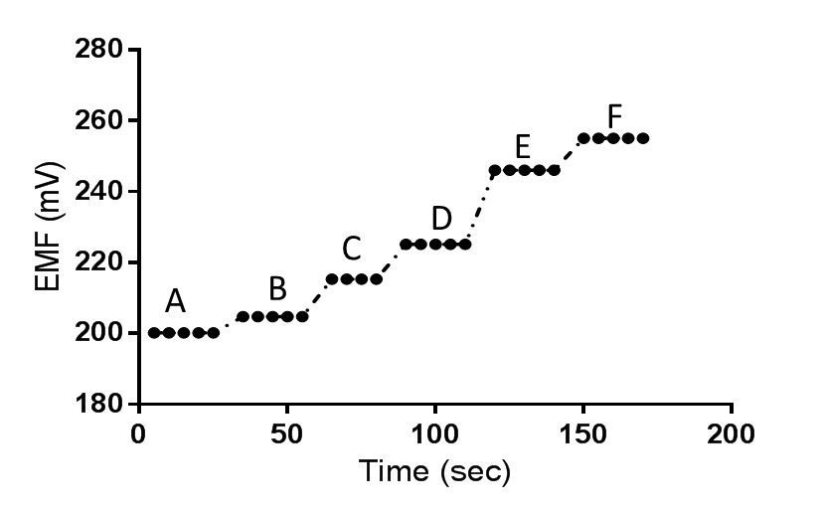

**(a)**



**(b)**

**Fig S6** Dynamic Response time of **1** (a) and **2** (b) based Hg(II)-ISE for changes in mercury concentration at 298 K.

A: 1.06 x 10-7; B: 1.06 x 10-6; C: 1.06 x 10-5; D: 1.06 x 10-4; E: 1.06 x 10-3; and F: 1.06 x 10-2mol dm-3.

Reversibility of these electrodes was examined through dipping the electrode in two different concentrations of Hg(NO3)2. For both electrodes, the time response for attaining a stable potential in the investigated concentrations did not change. However, the potential values (mV) observed were found to be higher than expected. This might be due to the electrode being dipped in solutions of different concentrations of Hg(NO3)2 in the previous experiment which led to an increase in the potential values (EMF).



**(a)**



**(b)**

**Fig S7**Reversibility of the **1** (a) and **2** (b) based ISE at 298 K;

A) 1.0×10-4, and B) 1.0×10-3mol dm-3.

**Life-time of Hg(II)-ISEs at 298 K**

Findings showed that the electrode exhibited potential stability for about 65 days for the ISE based on **1** and 60 days for that involving **2.** During this period, the response characteristics of E-5 and E-10 did not change significantly. However after that period, the detection limit and the calibration experiments decrease dramatically. Therefore, it can be concluded that E-5 and E-10 have life time periods of 65 and 60 days respectively, without significant changes in their response characteristics towards the Hg(II) cation.



**(a)**



**(b)**

**Fig S8** Calibration plots for Hg(II)-ISE based on **1** (a) and **2** (b) over a period of time from 1 to 120 days.

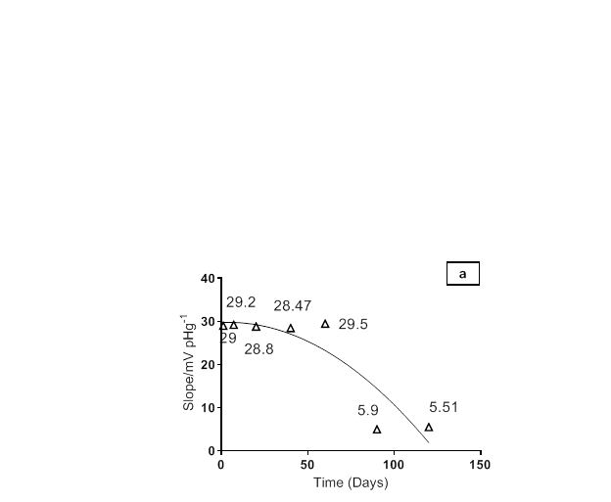



**Fig S9** Slope variation of Hg(II)-ISE based on **1** (a) and **2** (b) over a period of time from 1 to 120 days.