**Supplementary Information**

Highly Efficient and Metal-Free Synthesis of Tri- and Tetra-Substituted Imidazoles Catalyzed by 3-Picolinic Acid

Abu Zafar Al Munsur, a, b * Harendra Nath Roy,a Mohiuddin Khan Imon, a

**General experimental data:**

The melting points of the compound were recorded on an electrothermal melting point apparatus (Gallenkamp) and the melting points incorporated are uncorrected. Infrared spectra (IR) were recorded on KBr pellets for solids and neat for liquids by FT-IR 8400 PerkinElmer 883 grating spectrometer. 1H NMR spectra were recorded on AC-Bruker 500 MHz spectrometer in D6-DMSO or CDCl3, containing TMS as an internal standard. All ‘*J’* values are given in Hz and chemical shifts *δ-* in ppm units. Reactions were monitored by thin-layer chromatographic (TLC) plates over silica gel (60 GF254. E. Merck).

**General Procedure for the Synthesis of 2, 4, 5-Triary-1H-Imidazoles:**

A mixture of benzyl/benzoin (1 mmol), aldehyde (1 mmol), ammonium acetate (2.5mmol), and 3-Picolinic acid (10 mol %) in ethanol (2 mL) was stirred at reflux temperature for 2~3 hr. The progress of the reaction was monitored by TLC. After completion of the reaction, the mixture was cooled to room temperature, neutralized with 5% NaHCO3 solution, diluted with water and poured on crushed ice. The obtained crude solid product was filtered, dried, and recrystallized from ethanol.

**Spectral data:**

**Entry I:** 2-(2-Chlorophenyl)-4, 5-diphenyl-1H-imidazole (**1**)



Mp: 195-197 °C. 1HNMR (CDCl3, 500 MHz): 10.48 (brs, 1Н, NH), 8.38 (dd, *J* = 2.5, 8 Hz, 2H, Ar-H), 7.68-7.29 (m, 11H, Ar-H), 2.08 (S, 1H); 13C NMR (300 MHz, DMSO-d6): 143.3, 130.4, 128.9, 128.5, 128.3, 128.3, 127.8, 127.4, 127, 100; HRMS: calcd.for C21H15ClN2, 330.8123; found: 330.8121.

**Entry II:** 2-(4-Methoxyphenyl)-4, 5- diphenylimidazole (**2**)

N

N

H

O

C

H

3

Mp: 229-231 °C. 1HNMR (DMSO-d6, 500MHz): 12.52 (s, 1H, NH), 7.99(t, *J* = 7.5 Hz, 2H), 7.55 (d, *J* = 8.5 Hz, 4H), 7.31-7.22 (m, 6H, Ar-H), 6.93 (t, *J* = 8 Hz, 2H), 3.83 (q, *J* = 2.5, 3, 4.5 Hz, 3H, -CH3);13C NMR (300 MHz, DMSO-d6): 159.9, 146.4, 128.3, 128.1, 127.2, 127, 123.2, 114, 55.3; HRMS:calcd.for C22H18N2O, 326.3927; found: 326.3925.

**Entry III:** 2-(α-Napthyl)-4, 5-diphenylimidazole (**3**)



Mp: 215-217 °C. 1HNMR (DMSO-d6, 500MHz): 12.80 (s, 1H, NH), 9.19 (d, *J* = 8 Hz, 1H,), 8.01 (t, *J* = 8 Hz, 2H), 7.97 (s, 1H), 7.64-7.25 (m, 13H, Ar-H); 13C NMR (300 MHz, DMSO-d6): 146, 137.6, 135.8, 135.1, 131.5, 130.8, 129.4, 129.1, 128.8, 128.7, 128.4, 128.2, 127.9, 127.7, 127.2, 127, 126.6, 125.7; HRMS: calcd. for C25H18N2, 346.4215; found: 346.4214.

**Entry IV:** 2-(benzo[d] [1, 3] dioxol-5-yl)-4, 5-diphenyl-1H-imidazole (**4**)

Mp: 295-297 °C. 1HNMR (DMSO-d6, 500MHz): 12.51 (s, 1H, NH), 7.49-7.03 (m, 13H, Ar-H), 6.09 (s, 2H); 13C NMR (300 MHz, DMSO-d6): 148.1, 145.8, 131.6, 123, 129.1, 128.8, 128.6, 128.3, 128.2, 127.5, 126.9, 125.1, 119.8, 109, 106, 101.7; HRMS: calcd. for C22H16N2O2, 340.3712; found: 340.3710.

**Entry V:** 4-(4, 5-Diphenyl-1H-imidazol-2-yl)-phenol (**5**)

Mp: 269-270 °C. 1HNMR (DMSO-d6, 500MHz): 12.41 (s, 1H, NH), 9.71 (s, 1H, OH), 7.90 (d, *J* = 8.5 Hz, 2H), 7.55-7.21 (m, 10H, Ar-H), 6.86 (d, *J* = 8.5 Hz, 2H); 13C NMR (300 MHz, DMSO-d6): 158.2, 146.5, 137, 135.8, 131.8, 130, 129.1, 128.8, 129, 128.6, 128, 127.8, 127.5, 127.3, 126.8, 122.1, 115.9; HRMS: calcd. for C21H16N2O, 312.3638; found: 312.3635.

**Entry VI:** 2-(3-Bromophenyl)-4, 5-diphenyl-1H-imidazole (**6**)



Mp: 200-201 °C. 1HNMR (DMSO-d6, 500MHz): ) 12.83 (brs, 1Н, NH), 8.31 (t, *J* = 2 Hz, 1H), 8.10 (d, *J* = 8 Hz, 1H), 7.57-7.23 (m, 12H, Ar-H);13C NMR (300 MHz, DMSO-d6): 144.3, 137.8, 135.3, 132.9, 131.4, 131.3, 131.2, 129.3, 129.2, 128.8, 128.7, 128.4, 128, 127.6, 127.2, 124.5, 122.6; HRMS: calcd. for C21H15BrN2, 375.2622; found: 375.2619.

**Entry VII:** 4-[4-(4, 5-Diphenyl-1H-imidazole-2-yl)-phenyl]-dimethylamine (**7**)

Mp: 259-261 °C. 1H NMR (500 MHz, DMSO-d6): 12.32 (s, 1H, NH), 7.91 (d, *J* = 9 Hz, 2H), 7.37–7.20 (m, 10H, Ar-H), 6.80 (d, *J* = 9 Hz, 2H), 2.98 (s, 6H (CH3)2N); 13CNMR (300 MHz, DMSO-d6): 150.7, 146.9, 129.1, 128.7, 128.6, 127.9, 127.5, 126.8, 118.8, 112.4; HRMS: calcd. for C23H21N3, 339.4358; found: 339.4356.

**Entry VIII:** 3-(4, 5-diphenyl-1H-imidazol-2-yl)-1H-indole (**8**)



Mp: 181-182 °C.1H NMR (500 MHz, DMSO-d6): 12.14 (br. s, 1H, NH), 9.94 (t, *J* = 3 Hz, 1H, NH-Indole), 8.30-7.22 (m, 14H, Ar-H); 13CNMR (300 MHz, DMSO-d6): 195.3, 185.4, 138.9, 137.5, 136, 132.7, 130.1, 123, 124.6, 123.9, 122.6, 121.3, 118.6, 112.9; HRMS: calcd. for C23H17N3, 335.4032; found: 335.4030.

**Entry IX:** 2-(3-Nitrophenyl)-4, 5-diphenyl-1H-imidazole (**9**)



Mp: >300 °C. 1HNMR (DMSO-d6, 500MHz): 13.11 (s, 1H, NH), 8.97 (t, *J* = 2 Hz, 1H, NO2-Ar-H), 8.53 (dt, *J* = 1.5, 9.5 Hz, 1H, NO2-Ar-H), 8.23 (dq, *J* = 1.5, 11 Hz, 1H, NO2-Ar-H), 7.79 (t, *J* = 8 Hz, 1H, NO2-Ar-H), 7.57-7.40 (m, 10H, Ar-H);13C NMR (300 MHz, DMSO-d6): 148.9, 143.9, 131.7, 129, 128.9, 128.9, 123.1, 119.9; HRMS:calcd. for C21H15N3O2, 341.3653; found: 341.3650.

**Entry X:** 2-(furan-2-yl)-4, 5-diphenyl-1H-imidazole (**10**)

Mp: 200-202 °C. 1HNMR (DMSO-d6, 500MHz): 12.83 (s, 1H NH), 7.81 (s, 1H, furan-H), 7.53-7.22 (m, 10 H, Ar-H), 6.98 (s, 1H, furan-H), 6.66 (dd, *J* = 1.5, 8 Hz 1H, furan-H); 13C NMR (300 MHz, DMSO-d6): 143.2, 128.8, 112.5, 107.6; HRMS:calcd. for C19H14N2O, 286.3321; found: 286.3319.

**Entry XIV:** 2-(4-Chlorophenyl)-1, 4, 5-triphenyl-1H-imidazole (**11**)



Mp: 162-163 °C. 1H NMR (500 MHz, DMSO-*d6*): 7.63–7.57 (m, 4H, Ar-H), 7.38-7.35 (m, 5H, Ar-H), 7.29-7.16 (m, 8H Ar-H), 6.84 (dd, *J* = 1.5, 8 Hz, 2H), 5.12 (s, 2H) ppm; 13C NMR (300 MHz, DMSO-*d6*): 146.9, 138.3, 137.3, 135, 134.3, 131, 130.8, 130.4, 130.3, 129.4, 128.8, 128.8, 128.8, 128.7, 128.1, 127.5, 126.8, 126.5, 125.9, 48.3; HRMS:calcd. for C28H21ClN2, 420.9347; found: 420.93451429.

**Entry XV:** 2-(benzo[d] [1, 3] dioxol-5-yl)-1-benzyl-4, 5-diphenyl-1H-imidazole (**12**)



Mp: 130-132 °C.1H NMR (500 MHz, DMSO-*d6*): 7.85 (dd, *J* = 1.5, 8 Hz, 2H, Ar-H), 7.36-7.12 (m, 13H, Ar-H), 6.83 (dt, *J* = 1.5, 8.5 Hz, 3H, Ar-H), 6.01 (s, 2H, dioxol-H), 5.11 (s, 2H, benzyl-H); 13C NMR (300 MHz, DMSO-*d6*): 148.2, 147.8, 147.7, 137.8, 137.5, 134.4, 131.1, 129.9, 128.8, 128.6, 128.1, 126.8, 126.3, 126, 124.8, 123.1, 109.8, 108.4, 101.3, 48.3; HRMS:calcd. for C29H22N2O2, 430.5042; found: 430.5039.

**Entry XVI:** 4-(1-benzyl-4, 5-diphenyl-1H-imidazol-2-yl)-N, N-dimethylaniline (**13**)



Mp: 180-182 °C.1H NMR (500 MHz, DMSO-*d6*): 7.59 (dd, *J* = 1.5, 8.5 Hz, 2H, Aniline-H), 7.56 (dd, *J* = 2, 7 Hz, 2H, Ar-H), 7.34-7.14 (m, 11H, Ar-H), 6.87 (t, *J* = 8 Hz, 2H, Ar-H), 6.73 (dt, *J* = 2, 9.5 Hz, 2H), 5.17 (s, 2H, -CH2), 3.00 (s, 6H, CH3); 13C NMR (300 MHz, DMSO-*d6*): 150.8, 148.8, 137.9, 131.3, 131.1, 129.4, 128.5, 128, 127.2, 126.9, 126, 112, 100, 48.3, 40.3; HRMS:calcd. for C30H27N3, 429.5621; found: 429.5620.

**Entry XVII:** 1-benzyl-2-(4-nitrophenyl)-4, 5-diphenyl-1H-imidazole (**14**)



Mp: 170-172 °C. 1H NMR (500 MHz, DMSO-*d6*): 8.26 (dt, *J* = 2, 9.5 Hz, 2H, NO2-Ar-H), 7.87 (dt, *J* = 2, 6 Hz, 2H, NO2-Ar-H) 7.60 (d, *J* = 7.5 Hz, 2H, Ar-H), 7.43-7.19 (m, 11H, Ar-H), 6.89 (d, *J* = 6 Hz, 2H, Ar-H), 5.19 (s, 2H, -CH2); 13C NMR (300 MHz, DMSO-*d6*): 147.6, 145.4, 139.3, 137, 136.9,133.9, 131.8, 131, 130.3, 129.3, 129.1, 129, 128.9, 128.2, 127.8, 126.8, 125.7, 123.9, 48.6; HRMS:calcd. for C28H21N3O2, 431.4968; found 431.4966.

**Entry XVIII:** 2-(4-methoxyphenyl)-1, 4, 5-triphenyl-1H-imidazole (**15**)



Mp: 174-176 °C. 1H NMR (500 MHz, DMSO-*d6*): 7.63 (d, *J* = 7.5 Hz, 2H, MeO- Ar-H), 7.39 (dd, *J* = 2, 8.5 Hz, 2H, Ar-H), 7.30-7.06 (m,13H, Ar-H), 6.798 (dd, *J* = 2.5, 8.7 Hz, 2H, MeO-Ar-H), 3.80 (s, 3H, -CH3O); 13C NMR (300 MHz, DMSO-*d6*): 159.6, 146.9, 138, 137.3, 134.5, 131.2, 130.8, 130.3, 130.3, 128.5, 128.3, 128.1, 127.4, 126.5,123.1, 113.6, 55.2; HRMS:calcd. for C28H22N2O, 402.4965; found: 402.4963.

**Entry XIX:** 3-(1, 4, 5-triphenyl-1H-imidazol-2-yl)-1H-indole (**16**)



Mp: 247-249 °C.1H NMR (500 MHz, DMSO-*d6*): 8.47 (dd, *J* = 2.5, 6 Hz, indole-H), 8.43 (s, 1H indole-H), 7.73 (dd, *J* = 2, 7 Hz, 2H, Ar-H), 7.30-7.17 (m, 15H, Ar-H), 6.35 (d, *J* = 2.5 Hz, 1H, Ar-H); 13C NMR (300 MHz, DMSO-*d6*): 143.6, 137.6, 137.4, 135.5, 134.8, 131.2, 131, 129.2, 128.3, 128.1, 127.8, 127.2, 126.5, 126.4, 123.8, 122.7, 122.1, 120.7, 110.8, 107; HRMS:calcd. for C29H21N3, 411.5078; found:411.5076.

**Entry XX:** N, N-dimethyl-4-(1, 4, 5-triphenyl-1H-imidazol-2-yl) aniline (**17**)



Mp: 238-240 °C. 1H NMR (500 MHz, DMSO-*d6*): 7.64(d, *J* = 8 Hz, 2H, Aniline-H), 7.32-7.08 (m, 15H Ar-H), 6.59 (dd, *J* = 2, 9.5 Hz, 2H, Aniline-H), 2.96 (s, 6H N-CH3); 13C NMR (300 MHz, DMSO-*d6*): 150.1, 147.6, 137.5, 131.2, 130.9, 129.9, 128.3, 128.1, 128, 127.5, 126.5, 111.5, 40.2; HRMS:calcd. for C29H25N3, 415.5346; found: 415.5344.

**Entry XXI:** 4-(4, 5-diphenyl-1-(pyridin-2-yl)-1H-imidazol-2-yl)-N, N-dimethylaniline (**18**)

M. p: 254-256 °C. 1HNMR (CDCl3, 500MHz): 7.81(d, *J* = 8.6 Hz, 2H, Ar-H), 7.57 (d, *J* = 6.7 Hz, 4H, Ar-H), 7.37 (t, *J* = 7.2 Hz,4H, Ar-H), 7.28-7.27 (m, 3H, Ar-H), 6.77 (d, *J* = 8.6 Hz, 2H, Ar-H), 3.04 (s, 6H, 2×CH3); 13C NMR (300 MHz, CDCl3): 40.3, 112.1, 117.8, 126.4, 127.2, 127.8, 128.5, 146.9, 150.8; HRMS: calcd. for C28H24N4, 416.5254; found: 416.5251

**Entry XXII:** 4-(1-(4-chlorophenyl)-4, 5-diphenyl-1H-imidazol-2-yl)-N, N-dimethylaniline (**19**)

M. p. 168-170 0C; 1H NMR (CDCl3, 500 MHz): 7.61 (d, *J* = 8.2 Hz, 2H, Ar-H), 7.28-7.20 (m, 10H, Ar-H), 7.12 (m, 2H, Ar-H), 7.00 (dd, *J* = 2, 6.6 Hz, 2H, Ar-H), 6.61 (d, *J* = 8.9 *Hz*, 2H, Ar-H), 2.97 (s, 6H, 2×CH3); 13C NMR (300 MHz, CDCl3): 40.2, 111.6, 117.9, 126.5, 127.9, 128.4, 129.8, 133.8, 134.5, 136.1, 138.1, 147.7, 150.2. HRMS: calcd. for C29H24N3Cl, 449.9763, found: 449.9761.

**Entry XXIII:** 4-(1-(2, 4-dinitrophenyl)-4, 5-diphenyl-1H-imidazol-2-yl)-N, N-dimethylaniline (**20**)

M. p. 218-220 0C; 1HNMR (CDCl3 500MHz): 9.10 (d, *J* = 2.6 Hz, 1H, Ar-H), 8.12 (dd, *J* = 2.6, 9.3 Hz, 1H, Ar-H), 7.78 (dd, *J* = 1.9, 7.0 Hz,2H, Ar-H), 7.55 (d, *J* = 7.3 Hz, 4H, Ar-H), 7.33 (t, *J* = 7.6 Hz, 4H, Ar-H), 7.27 (t, *J* = 7.7 Hz, 2H, Ar-H), 6.82 (d, *J* = 9.3 Hz*,* 1H, Ar-H), 6.76 (d, *J* = 8.9 Hz, 2H, Ar-H), 3.03 (s, 6H, 2×CH3); 13C NMR (300 MHz, CDCl3): 40.3, 112.1, 117.8, 119, 123.9, 126.4, 127.2, 127.8, 128.6, 129.6, 147, 148.5, 150.8. HRMS: calcd. C29H23N3O4 505.5251 found 505.5255.

**Entry XXIV:** N-(4-(2-(4-(dimethylamino) phenyl)-4, 5-diphenyl-1H-imidazol-1-yl) phenyl) acetamide (**21**)

M. p. 157-158 0C; 1H NMR (CDCl3, 300 MHz): 8.31 (s, 1H, NH), 7.97 (d, *J* = 8.5 Hz, 2H, Ar-H), 7.66 (d, *J* = 7.4 Hz, 4H, Ar-H), 7.55-7.51 (m, 6H, Ar-H), 7.16 (t, *J* = 7.4 Hz,2H, Ar-H), 6.96 (d, *J* = 8.7 Hz, 2H, Ar-H), 6.72 (d, *J* = 8.8 Hz, 2H, Ar-H), 3.04 (s, 6H, 2×N-CH3), 2.14 (s, 3H, -COCH3); 13C NMR (CDCl3, 300 MHz): 168.5, 159.9, 152.6, 150.3, 149.1, 147.9, 135.4, 135.1, 133.3, 131.1, 130.5, 130, 129.9, 129.2. 128.4, 128.2, 127.9, 127.6, 126.5, 124.4, 121.5, 120.9, 119.7, 111.7, 40.3, 40.2, 24.6; HRMS: calcd. for C31H28N3O, 472.5854, found 472.5852.

**Entry XXV:** 8-(2-(4-(dimethylamino) phenyl)-4, 5-diphenyl-1H-imidazol-1-yl) naphthalen-2-ol (**22**)

M. p: 247-249 °C. 1HNMR (DMSO-d6, 500MHz): 9.68 (s, 1H, Ar-H), 8.46 (s, 1H, Ar-H), 7.78 (d, *J* = 8.9 Hz, 2H, Ar-H), 7.69 (m, 2H, Ar-H), 7.57 (dd, *J* = 1.9, 7.05, Hz,1H, Ar-H), 7.48 (m, 2H, Ar-H), 7.29- 7.09 (m, 7H, Ar-H), 7.02 (dd, *J* = 2.2, 8.9, Hz, 1H, Ar-H), 6.80 (d, *J* = 8.8 Hz,1H, Ar-H), 6.46 (d, *J* = 9.1 Hz, 2H, Ar-H), 2.81 (s, 6H, 2×CH3); 13C NMR (300 MHz, DMSO-d6): 40.1, 103.8, 111.5, 111.7, 112, 112.4, 118.3, 122.2, 126.7, 127.5, 128.5, 128.6, 129, 130.4, 131, 146.9, 147.6, 150.4; HRMS: calcd. for C33H27N3O, 481.5946; found: 481.5943

**Entry XXVI:** 4-(1-(2-aminoethyl)-4, 5-diphenyl-1H-imidazol-2-yl)-N, N-dimethylaniline (**23**)

Mp: 233-235 °C. 1H NMR (CDCl3, 500MHz): 8.16 (d, *J* = 8.9 Hz, 1H, Ar-H), 7.59 (d, *J* = 8.9 Hz, 2H, Ar-H), 7.38-7.51(m, 4H, Ar-H), 7.28-7.37 (m, 3H, Ar-H), 7.18-7.28 (m, 4H, Ar-H), 6.69 (d, *J* = 8.7 Hz, 2H, Ar-H), 4.47 (t, *J* = 8.5 Hz, 2H, -CH2-), 3.19 (t, *J* = 8.6 Hz, 2H, -CH2-) 3.02 (s, 6H, 2×CH3); 13C NMR (300 MHz, CDCl3): 39, 40.2, 45.8, 62.1, 111, 111.6, 124.5, 127.8, 127.9, 128.1, 137.8, 152, 160.3, 162.4; HRMS: calcd. for C25H26N4, 382.5066, found 382.5064

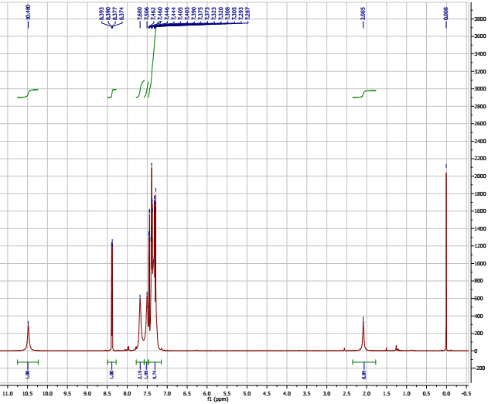

×

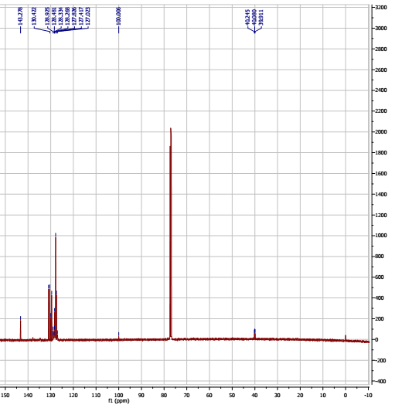

×

×

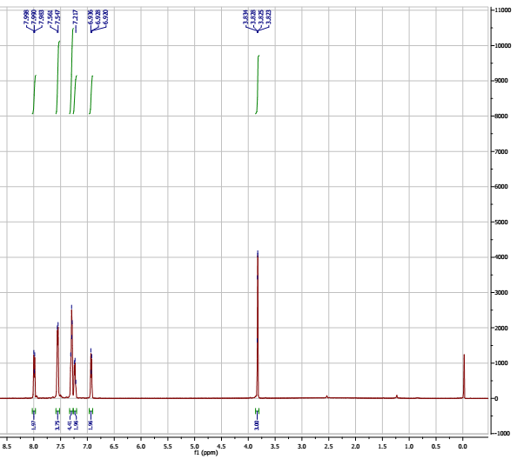

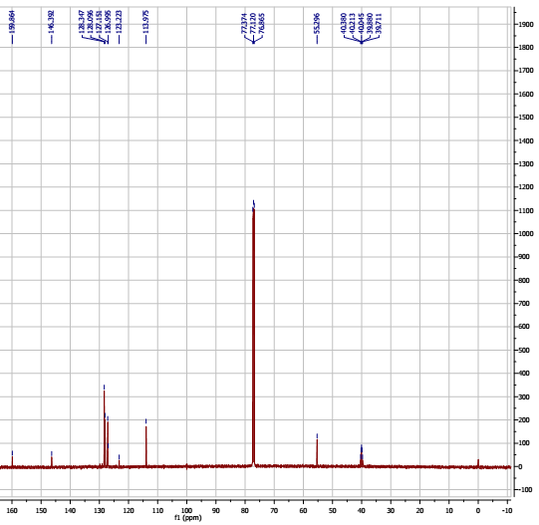

×

×

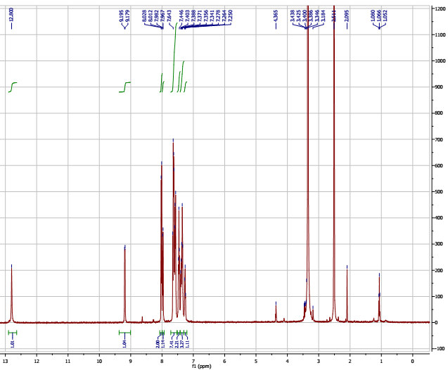

×

×

×

×

×

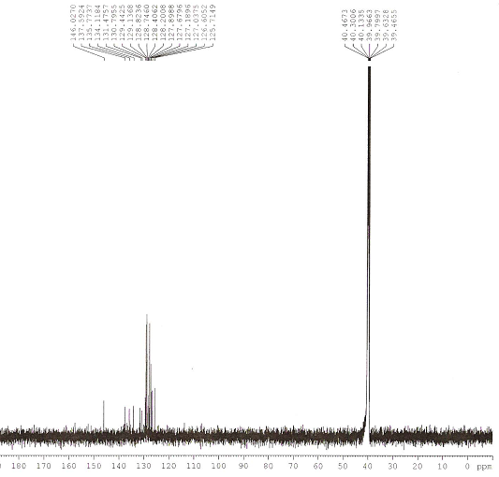

×

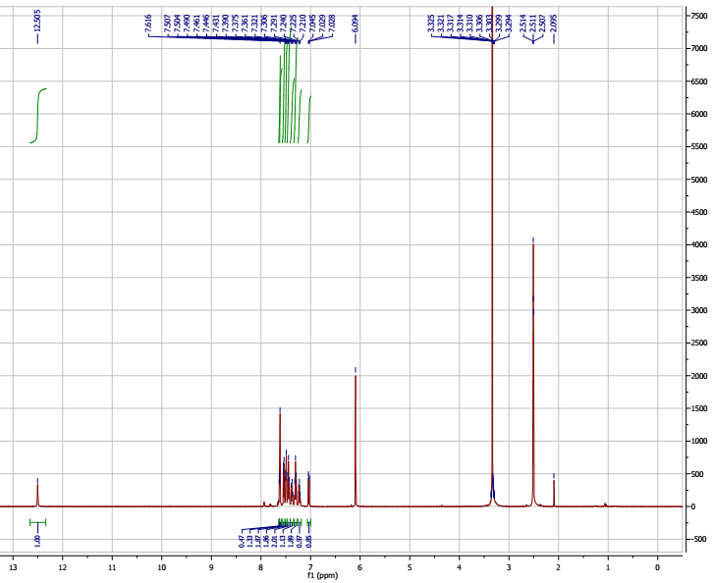

×

×

×

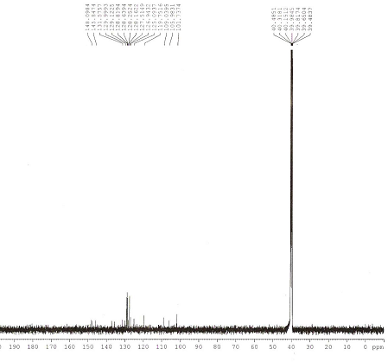

×

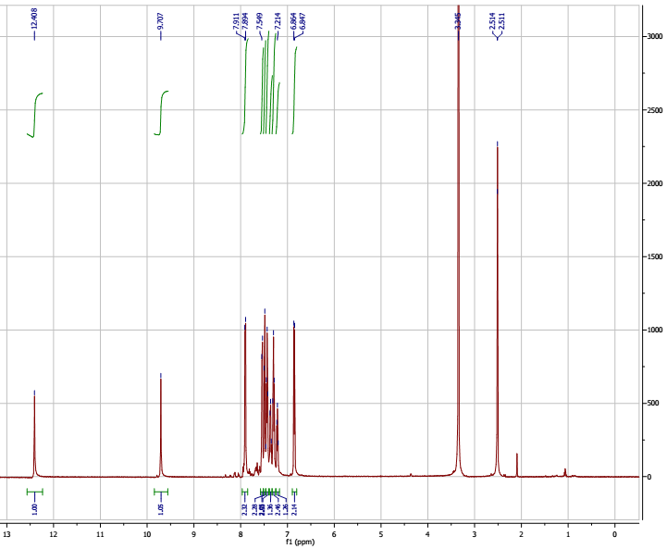

×

×

×

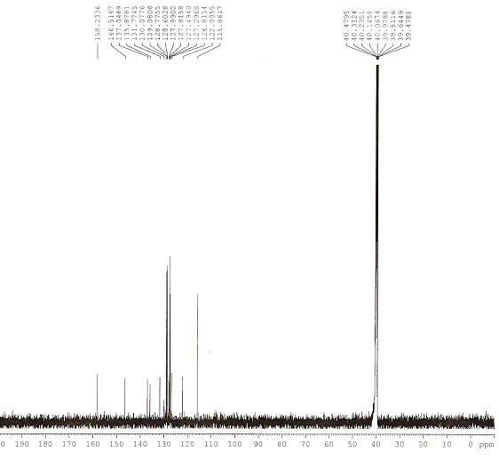

×

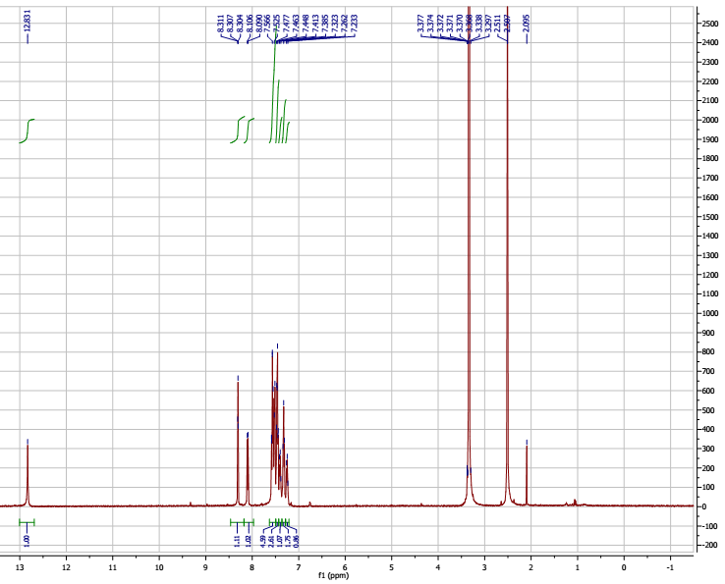

×

×

×

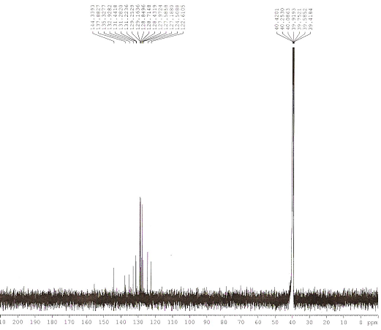

×

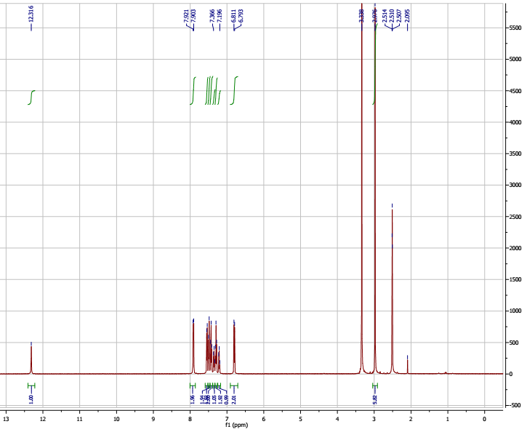

×

×

×

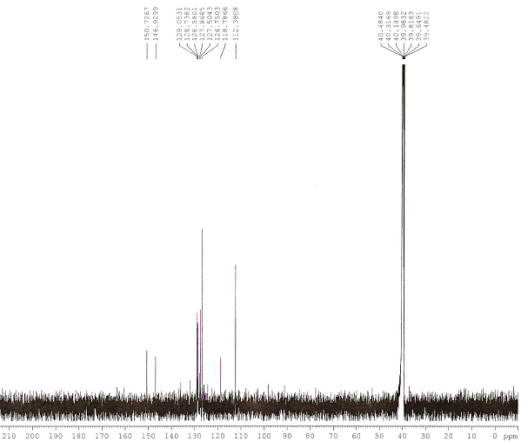

×

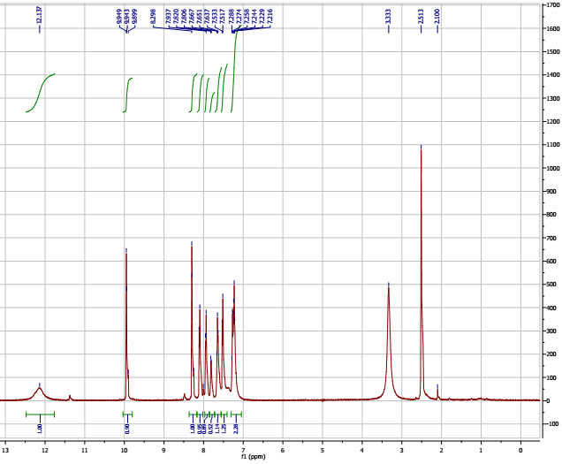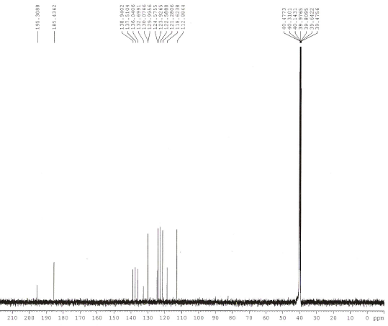

×

×

×

×

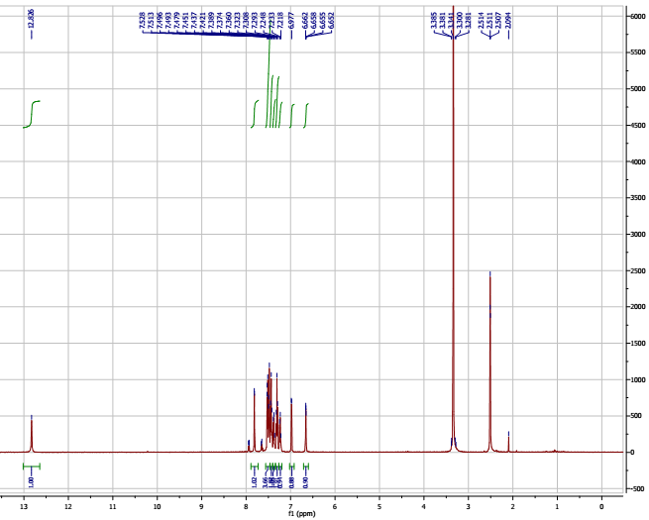

×

×

×

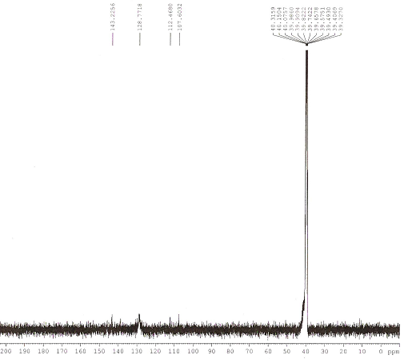

×

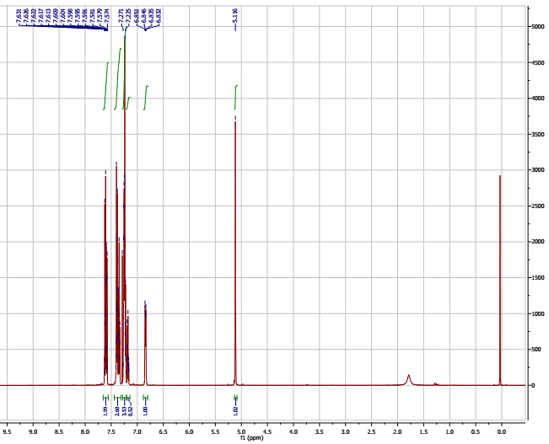

×

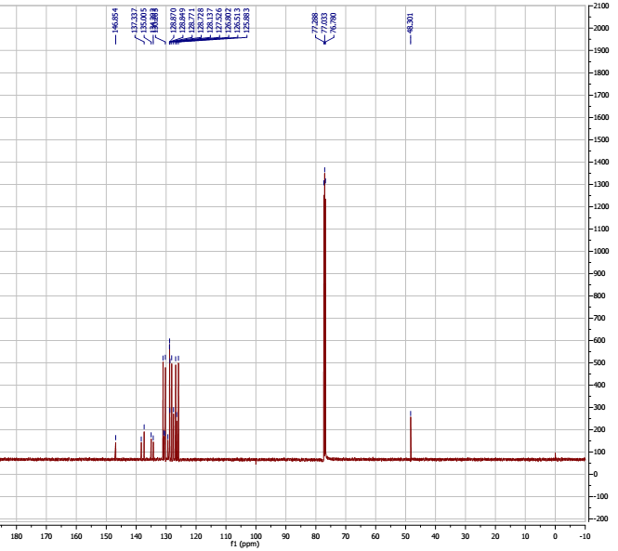

×

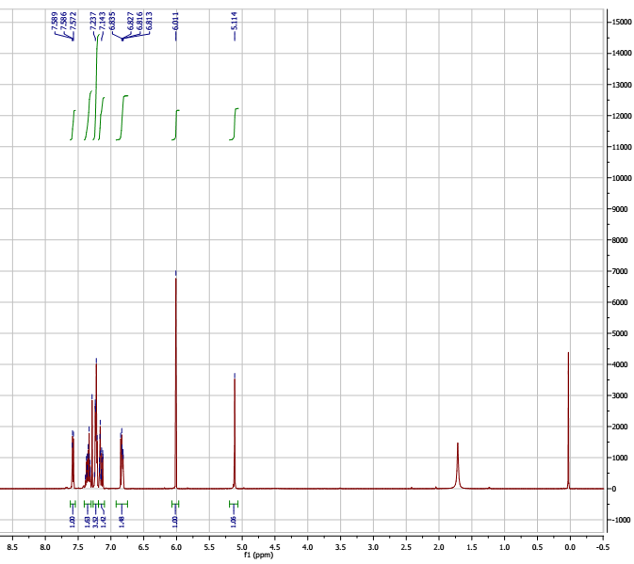

×

N

N

O

O

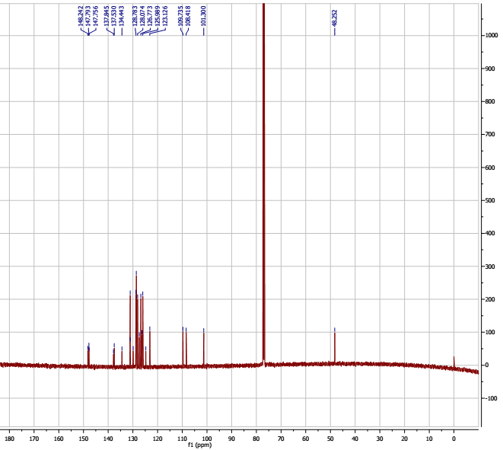

×

N

N

O

O

