**Supplementary Material**

**Untargeted-metabolomics differentiation between poultry samples slaughtered with and without detaching spinal cord**

**Nasir Abbasa,‡, Arslan Alib,‡, Sindhia Kumaria, Ayesha Iqbalb, Adnan Husainc, Talat Saeedc, Zainab AbdulAmer Al-Ballamc, Nisar Ahmedc, Hesham R. El-Seedid,e,*,and Syed Ghulam Musharraf a,b,f,\***

*a H. E. J. Research Institute of Chemistry, International Center for Chemical and Biological Sciences, University of Karachi, Karachi-75270, Pakistan*.

*bDr. Panjwani Center for Molecular Medicine and Drug Research, International Center for Chemical and Biological Sciences, University of Karachi, Karachi-75270, Pakistan.*

*cEnvironment & Life Science Research Center, Kuwait Institute for Scientific Research (KISR), Safat, 13109, Kuwait*

*dPharmacognosy Group, Department of Pharmaceutical Biosciences, Biomedical Centre, Uppsala University, SE- 751 23, Uppsala, Sweden*

*eInternational Research Center for Food Nutrition and Safety, Jiangsu University, Zhenjiang, 212013, China*

*fHalal Testing Laboratories, Industrial Analytical Center, International Center for Chemical and Biological Sciences, University of Karachi, Karachi-75270, Pakistan*.

**‡**Equal Contribution

Correspondence:

**Prof. Dr. Syed Ghulam Musharraf**

H.E.J. Research Institute of Chemistry, International Center for Chemical and Biological Sciences, University of Karachi, Karachi-75270, Pakistan

Tel.: +92 213 4824924-5; 4819010; fax: + 92 213 4819018-9.

*E-mail address:* [musharraf1977@yahoo.com](mailto:musharraf1977@yahoo.com)

**Prof. Dr. Hesham R. El-Seedi**

Pharmacognosy Group, Department of Pharmaceutical Biosciences, Biomedical Centre, Uppsala University, SE- 751 23, Uppsala, Sweden

Tel.: +46 73 5668234

*E-mail address:* hesham.el-seedi@farmbio.uu.se

**Supplementary Figure Legends**

**Supplementary Figure S1.** Stacked base peak chromatogram (BPC) of aqueous phase extracts of two represented samples from Zabiha and Non-Zabiha slaughtered chicken meat samples acquired in positive ionization mode during LC-MS analysis

**Supplementary Figure S2.** Box plots of unidentified compounds in Non-Zabiha (red) and Zabiha (blue) with ≥ 2-fold change and p-value ≤ 0.0339

**Supplementary Figure S3.** PCA plot for aqueous extracts from meat sample of Zabiha and Non-Zabiha chicken meat samples show incomplete separation along y-axis.

**Supplementary Figure S4.** PCA plot for meat sample of Zabiha (blue) and Non-Zabiha (red) chicken along with QC (yellow) samples.

**Supplementary Figure S5.** Hotelling’s T2 with 99% and 95% confidence limit showing outlier of chicken meat samples from both groups.

**Supplementary Figure S6.** Permutation plots of Zabiha and Non-Zabiha samples for the validation of OPLS-DA plot (500 iterations).

**Supplementary Figure S7.** Receiver operating characteristic (ROC) plot for OPLS-DA model showing sensitivity on y-axis and 1-specificity on x-axis. Non-Zabiha (red) and Zabiha (blue).

**Supplementary Figure S8.** OPLS-DA score plot showing the original model with 10 blind samples for external validation studies, Zabiha (blue), Non-Zabiha (red), and Unknown blind samples (grey).



**Supplementary Figure S1.** Stacked base peak chromatogram (BPC) of aqueous phase extracts of two represented samples from Zabiha and Non-Zabiha slaughtered chicken meat samples acquired in positive ionization mode during LC-MS analysis.

|  |  |  |  |
| --- | --- | --- | --- |
| 212.1206 |  | 395.2815 |  |
| 379.2864 |  | 427.3080 |  |
| 295.1210 |  | 430.2484 |  |
| 418.3940 |  | 302.1997 |  |
| 456.2798 |  | 227.1068 |  |
| 444.4100 |  | 485.3641 |  |
| 464.3190 |  | 303.2330 |  |
| 851.4080 |  | 353.2338 |  |
| 852.4109 |  | 507.3351 |  |
| 679.4260 |  | 395.2815 |  |
| 637.3129 |  | 377.2707 |  |
| 619.2796 |  | 456.2798 |  |
| 316.2155 |  |  |  |

**Supplementary Figure S2.** Box plots of unidentified compounds in Non-Zabiha (red) and Zabiha (blue) with ≥ 2-fold change and p-value ≤ 0.05.

**A close up of a map

Description generated with very high confidence**

**Supplementary Figure S3.** PCA plot for aqueous extracts from meat sample of Zabiha and Non-Zabiha chicken meat samples show incomplete separation along y-axis.

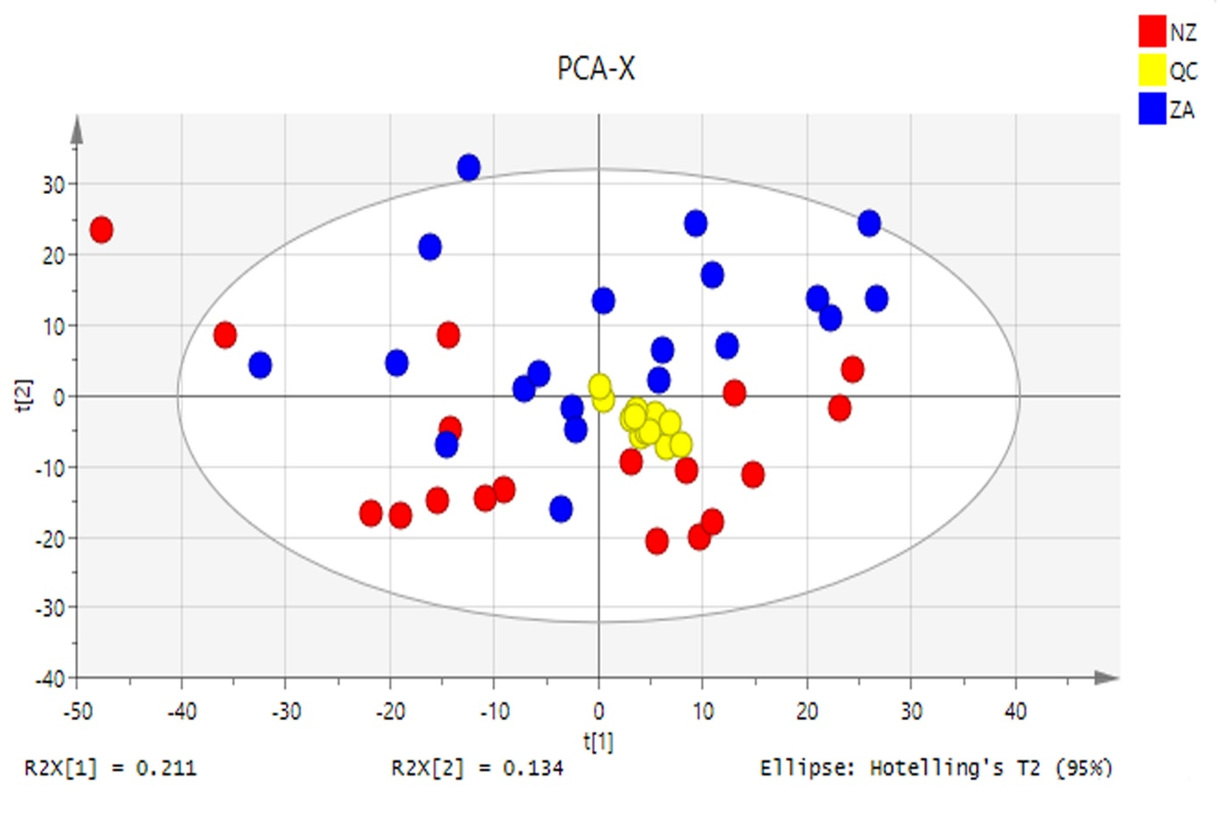

**Supplementary Figure S4.** PCA plot for meat sample of Zabiha (blue) and Non-Zabiha (red) chicken along with QC (yellow) samples.

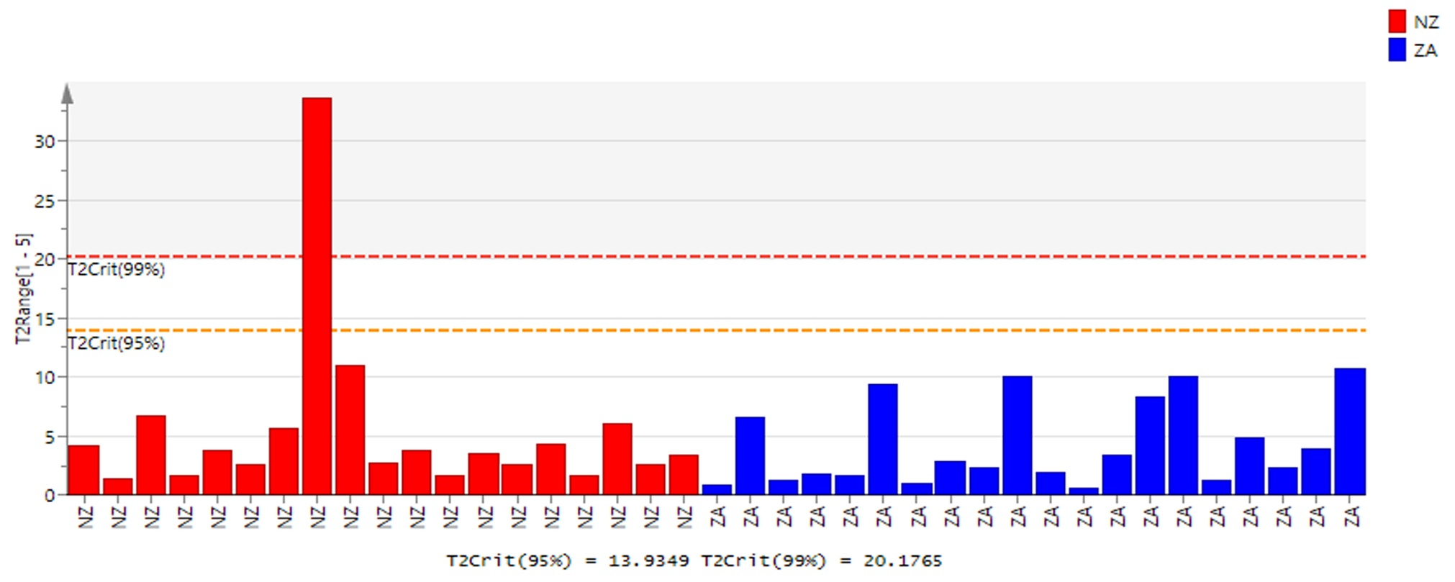

**Supplementary Figure S5.** Hotelling’s T2 with 99% and 95% confidence limit showing outlier of chicken meat samples from both groups.

**A close up of a map

Description generated with high confidenceA close up of a map

Description generated with high confidence**

**Supplementary Figure S6.** Permutation plots of Zabiha and Non-Zabiha samples for the validation of OPLS-DA plot (500 iterations).



**Supplementary Figure S7.** Receiver operating characteristic (ROC) plot for OPLS-DA model showing sensitivity on y-axis and 1-specificity on x-axis. Non-Zabiha (red) and Zabiha (blue).



**Supplementary Figure S8.** OPLS-DA score plot showing the original model with 10 blind samples for external validation studies, Zabiha (blue), Non-Zabiha (red), and Unknown blind samples (grey).

**Supplementary Table Legends**

**Supplementary Table S1** List of annotated compounds by HMDB database based on exact mass measurements.

**Supplementary Table S2:** Misclassification table for OPLS-DA after removing outlier from PCA.

**Supplementary Table S1.** List of annotated compounds by HMDB database based on exact mass measurements.

|  |  |  |  |  |  |  |  |
| --- | --- | --- | --- | --- | --- | --- | --- |
| **S. No.** | **Name of compound** | **RT** | **Formula** | **Ion type** | **Calculated Mass** | **Observed Mass** | **Error (ppm)** |
| **1** | 1,3-dimethyluracil | 3.05 | C6H8N2O2 | [M+H]+ | 141.0658 | 141.0658 | 0 |
| **2** | 1-Methyladenosine | 4.3 | C11H15N5O4 | [M+H]+ | 282.1196 | 282.1197 | 0.4 |
| **3** | 1-Methylhistidine | 1.19 | C7H11N3O2 | [M+H]+ | 170.0924 | 170.0926 | 1.2 |
| **4** | 2-oxoarginine | 2.11 | C6H11N3O3 | [M+H]+ | 174.0873 | 174.087 | -1.7 |
| **5** | 2-Oxoargnine | 1.4 | C6H11N3O3 | [M+H]+ | 174.0873 | 174.0876 | 1.7 |
| **6** | 3-hexenedioic acid | 3.75 | C6H8O4 | [M+H]+ | 145.0495 | 145.0496 | 0.7 |
| **7** | 3-Hydroxymethylglutric acid | 11.41 | C6H10O5 | [M+H]+ | 163.0601 | 163.0609 | 4.9 |
| **8** | 4-Guanidinobutanoic acid | 2.12 | C5H11N3O2 | [M+H]+ | 146.0924 | 146.0925 | 0.7 |
| **9** | 5-Methoxytryptophol | 10.42 | C11H13NO2 | [M+H]+ | 192.1019 | 192.1024 | 2.6 |
| **10** | 5-Methylthioadenosine | 6.85 | C11H15N5O3S | [M+H]+ | 298.0968 | 298.0969 | 0.3 |
| **11** | 7-Methylguanine | 5.23 | C6H7N5O | [M+H]+ | 166.0723 | 166.0724 | 0.6 |
| **12** | Adenosine | 4.54 | C10H13N5O4 | [M+H]+ | 268.104 | 268.1044 | 1.5 |
| **13** | Adenosine3,5-diphosphate | 1.65 | C10H15N5O10P2 | [M+H]+ | 428.0366 | 428.0367 | 0.2 |
| **14** | Adenosine-monophosphate | 2.67 | C10H14N5O7P | [M+H]+ | 348.0703 | 348.0707 | 1.1 |
| **15** | Anserine | 1.6 | C10H16N4O3 | [M+H]+ | 241.1295 | 241.1296 | 0.4 |
| **16** | Carnosine | 1.18 | C9H14N4O3 | [M+H]+ | 227.1138 | 227.1141 | 1.3 |
| **17** | Cinnamic acid | 6.79 | C9H8O2 | [M+H]+ | 149.0597 | 149.06 | 2 |
| **18** | Citrulline | 2.53 | C6H13N3O3 | [M+H]+ | 176.1029 | 176.1031 | 1.1 |
| **19** | Creatine | 1.23 | C4H9N3O2 | [M+H]+ | 132.0767 | 132.0771 | 3 |
| **20** | Cytidine | 3.3 | C9H13N3O5 | [M+H]+ | 244.0927 | 244.093 | 1.2 |
| **21** | D-Arginine | 1.17 | C6H14N4O2 | [M+H]+ | 175.1189 | 175.1192 | 1.7 |
| **22** | Dimethyl-L-arginine | 2.34 | C8H18N4O2 | [M+H]+ | 203.1502 | 203.1505 | 1.5 |
| **23** | DL-2-Aminooctanoic acid | 2.8 | C8H17NO2 | [M+H]+ | 160.1332 | 160.1334 | 1.2 |
| **24** | Epinephrine | 6.12 | C9H13NO3 | [M+H]+ | 184.0968 | 184.097 | 1.1 |
| **25** | Glucose -1-phosphate | 0.94 | C6H13O9P | [M+H]+ | 261.0369 | 261.0376 | 2.7 |
| **26** | Glutamine | 1.08 | C5H10N2O3 | [M+H]+ | 147.0764 | 147.0766 | 1.4 |
| **27** | Glutathione | 2.06 | C10H17N3O6S | [M+H]+ | 308.091 | 308.0911 | 0.3 |
| **28** | Glycerophosphocholine | 1.05 | C8H20NO6P | [M+H]+ | 258.1101 | 258.1103 | 0.8 |
| **29** | Glycolproline | 2.4 | C7H12N2O3 | [M+H]+ | 173.092 | 173.0922 | 1.2 |
| **30** | Glycylproline | 1.4 | C7H12N2O3 | [M+H]+ | 173.092 | 173.092 | 0 |
| **31** | Guanine | 4.7 | C5H5N5O | [M+H]+ | 152.0566 | 152.0569 | 2 |
| **32** | Guanosine | 4.69 | C10H13N5O5 | [M+H]+ | 284.0989 | 284.0989 | -0.2 |
| **33** | Guanosine 5-monophosphate | 3.3 | C10H14N5O8P | [M+H]+ | 364.0652 | 364.0656 | 1.1 |
| **34** | Heptadecanoic acid | 19.54 | C17H34O2 | [M+Na]+ | 293.2451 | 293.2458 | 2.4 |
| **35** | Homoarginine | 4.01 | C7H16N4O2 | [M+H]+ | 189.1346 | 189.1348 | 1.1 |
| **36** | Homocitrulline | 4.38 | C7H15N3O3 | [M+H]+ | 190.1186 | 190.119 | 2.1 |
| **37** | Hypoxanthine | 4.66 | C5H4N4O | [M+H]+ | 137.0457 | 137.046 | 2.2 |
| **38** | Indoleacrylic acid | 7.95 | C11H9N02 | [M+H]+ | 188.0706 | 188.0708 | 1.1 |
| **39** | Inosine | 4.66 | C10H12N4O5 | [M+H]+ | 269.088 | 269.088 | 0 |
| **40** | Inosinic acid | 2.61 | C10H13N408P | [M+H]+ | 349.0543 | 349.0544 | 0.3 |
| **41** | Isovalerylcarnitine | 7.84 | C12H23NO4 | [M+H]+ | 246.1699 | 246.17 | 0.4 |
| **42** | L-Acetylcarnitine | 10.16 | C9H17NO4 | [M+Na]+ | 226.1049 | 226.1052 | 1.3 |
| **43** | L-Carnitine | 1.21 | C7H15NO3 | [M+H]+ | 162.1124 | 162.1126 | 1.2 |
| **44** | L-Glutamic acid | 1.16 | C5H9NO4 | [M+H]+ | 148.0604 | 148.0608 | 2.7 |
| **45** | L-Histidine | 1.33 | C6H9N3O2 | [M+H]+ | 156.0767 | 156.0769 | 1.3 |
| **46** | Linoleic acid | 18.27 | C18H32O2 | [M+Na]+ | 303.2294 | 303.2302 | 2.6 |
| **47** | L-Lysine | 1.12 | C6H14N2O2 | [M+H]+ | 147.1128 | 147.1131 | 2 |
| **48** | L-Phenylalanine | 1.41 | C9H11NO2 | [M+H]+ | 166.0862 | 166.0864 | 1.2 |
| **49** | L-Tryptophan | 7.95 | C11H12N2O2 | [M+H]+ | 205.0971 | 205.0971 | 0 |
| **50** | L-Tyrosine | 5.23 | C9H11NO3 | [M+H]+ | 182.0811 | 182.0813 | 1.1 |
| **51** | m-coumaric acid | 5.23 | C9H8O3 | [M+H]+ | 165.0546 | 165.0548 | 1.2 |
| **52** | Methionine | 4.14 | C5H11NO2S | [M+H]+ | 150.0583 | 150.0586 | 2 |
| **53** | N6-Acetyl-L-lysine | 5.9 | C8H16N2O3 | [M+H]+ | 189.1233 | 189.1232 | -0.5 |
| **54** | Nonadecanoic acid | 19.2 | C19H38O2 | [M+H]+ | 299.2944 | 299.2952 | 2.7 |
| **55** | Nutriacholic | 18.82 | C24H38O4 | [M+Na]+ | 413.2662 | 413.2669 | 1.7 |
| **56** | Oleic acid | 17.87 | C18H34O2 | [M+H]+ | 283.2631 | 283.2639 | 2.8 |
| **57** | Pantothenic acid | 6.12 | C9H17NO5 | [M+H]+ | 220.1179 | 220.1181 | 0.9 |
| **58** | Paraxanthine | 1 | C7H8N4O2 | [M+H]+ | 181.072 | 181.0711 | -5 |
| **59** | Pentadecanoic acid | 17.94 | C15H30O2 | [M+H]+ | 243.2318 | 243.233 | 4.9 |
| **60** | Perillic acid | 10.7 | C10H14O2 | [M+H]+ | 167.1066 | 167.1049 | -10.2 |
| **61** | Phosphoserine | 1 | C3H8NO6P | [M+H]+ | 186.0162 | 186.0167 | 2.7 |
| **62** | Phthalic acid | 18.82 | C8H6O4 | [M+H]+ | 167.0338 | 167.0344 | 3.6 |
| **63** | Pregnenolone | 19.11 | C21H32O2 | [M+H]+ | 317.2475 | 317.2464 | -3.5 |
| **64** | Rhamnose | 10.85 | C6H12O5 | [M+H]+ | 165.0758 | 165.0759 | 0.9 |
| **65** | Spermine | 1.38 | C10H26N4 | [M+H]+ | 203.223 | 203.2231 | 0.5 |
| **66** | Sphinganine | 15.15 | C18H39NO2 | [M+H]+ | 302.3053 | 302.3058 | 1.7 |
| **67** | Sphingosine | 14.08 | C18H37NO2 | [M+H]+ | 300.2897 | 300.2899 | 0.7 |
| **68** | Stearic acid | 19.2 | C18H36O2 | [M+Na]+ | 307.2607 | 307.2615 | 2.6 |
| **69** | Succeinylacetone | 5.16 | C7H10O4 | [M+H]+ | 159.0652 | 159.0657 | 3.2 |
| **70** | Taurine | 1.02 | C2H7NO3S | [M+K] | 163.9778 | 163.9779 | 0.6 |
| **71** | Tyramine | 6.2 | C8H11NO | [M+H]+ | 138.091 | 138.0918 | 5.8 |
| **72** | Umbelliferone | 11.53 | C9H6O3 | [M+H]+ | 163.0389 | 163.0396 | 4.3 |
| **73** | Uric acid | 2.48 | C5H4N4O3 | [M+H]+ | 169.0356 | 169.0358 | 1.2 |
| **74** | Xanthine | 3.21 | C5H4N4O2 | [M+H]+ | 153.0407 | 153.0408 | 0.7 |
| **75** | Xanthosine | 5.14 | C10H12N4O6 | [M+H]+ | 285.0829 | 285.0834 | 1.8 |

**Supplementary Table S2:** Misclassification table for OPLS-DA after removing outlier from PCA.

|  |  |  |  |  |
| --- | --- | --- | --- | --- |
|  | Members | Correct | Non-Zabiha | Zabiha |
| Non-Zabiha | 18 | 100% | 18 | 0 |
| Zabiha  Blind samples | 20  10 | 100%  100% | 0  5 | 20  5 |
| Total | 48 | 100% | 23 | 25 |