**Appendix 1**

**Tailored Functionalized Polymer Nanoparticles using Gamma Radiation for Selected Adsorption of Barium and Strontium in Oilfield Wastewater**

**Sherif A. Younis*a,b, Mohamed M. Ghobashyc, Ghada Bassioni*d,e,Ashwani K. Guptae**

**a**Analysis and Evaluation Department, Egyptian Petroleum Research Institute, Nasr City P.O. Box 11727, Cairo, Egypt. **b**Water Unit at Central Laboratories, Egyptian Petroleum Research Institute, Nasr City P.O. Box 11727, Cairo, Egypt; cNanotechnology laboratory, Radiation Research of Polymer department, National Center for Radiation Research and Technology (NCRRT), Atomic Energy Authority, P.O. Box 29, Nasr City, Cairo, Egypt; dChemistry Department, Faculty of Engineering, Ain Shams University, P. O. Box 11517, Cairo, Egypt; eMechanical Engineering Department, University of Maryland, College Park, MD 20742, USA.

**\*corresponding authors:**

S. A. Younis; Email: sherifali_r@yahoo.com; sherifali@epri.sci.eg; Tel: +20 1228877458; Fax: +20 22747433

G. Bassioni; E-mail: [bassioni@umd.edu](mailto:bassioni@umd.edu); [ghada_bassioni@eng.asu.edu.eg](mailto:ghada_bassioni@eng.asu.edu.eg); Tel:+12406464540; Fax: +13013149477.

**S1. ANOVA Statistics and optimization modeling**

Based on the statistical regression and Pareto charts, the first order model equations (Eqs. A1 – A4) were developed using PBD experimental design matrix to simulate the studied Ba2+ and Sr2+ adsorption responses by SAB and SASB sorbents and further confirm the statistical results.

$Y_{\%}\left(SAB\right)=20.96-0.31X_{pH}+6.46X_{D}-0.018X_{Co}-0.603X_{TDS}+0.162X_{T} (R^{2}=97.9\%)$ (Eq. A1)

$Y_{\%}\left(SASB\right)=57.90-1.045X_{pH}+6.984X_{D}+0.019X_{Co}-0.639X_{TDS}+0.376X_{T} (R^{2}=96.1\%)$ (Eq. A2)

$Y_{mg/g}\left(SAB\right)=24.9+0.97X_{pH}-6.0X_{D}+0.11X_{Co}-0.98X_{TDS}-0.10X_{T} (R^{2}=78.9\%)$ (Eq. A3)

$Y_{mg/g}\left(SASB\right)=145.1-1.46X_{pH}-57.5X_{D}+0.51X_{Co}-1.04X_{TDS}-0.184X_{T} (R^{2}=86.9\%)$ (Eq. A4)

The PBD design first order regression results are comparatively surprising especially for $Y_{mg/g}\left(SASB\right)$ and $Y_{mg/g}\left(SASB\right)$, because it is already known that the $X_{TDS}$, and $X_{T}$ are the key variables which influence the adsorption percentage rates by both adsorbents (Eqs. A1 and A2).

**S2. Main and interaction effects of sorption variables using PBD factorial design**

The described SASB blend polymer NPs possesses high electron density [(SBR-SO3H/AN-COOH)] in aim to promote the sorption of metal ions from salt solution. This reflects the importance of optimization solution specifications (e.g. adsorbent dose, metal concentrations, pH, ionic strength, temperature, or time) that affect the preferences for metal ions to be adsorbed on SASB NPs. Hence, a 38 runs of full factorial two-level five variables PBD matrix was conducted in this application to evaluate the potential solution variables that may have significant effect on the sorption of total Ba2+ and Sr2+ ions (*i.e*., sorption rate (%) and $q_{e}$ (mg/g)) from salt water environments, as seen in Table 1. Obviously, thesorption responses were found to be highly dependent on solution conditions, as indicated by a wide variation for total Ba2+ and Sr2+ removal ranging from 1.6% t- 43.7% and 55.4% - 99.1%, and $q_{e}$ (mg/g) responses ranging from 0.7 - 120.4 mg/g and 1.9 - 417.7 mg/g onto SAB and SASB sorbents, respectively. Aalthough all the five variables have significant effect on total Ba2+ and Sr2+ sorption removal rates %, both the metal concentration, $X_{Co}$, and ionic strength, $X_{TDS}$, variables were only of high significant effect (percentage contribution, PC% = 55.86% and 17.12%, respectively) on capacity responses ($q_{e}$; mg/g) when using SAB or SASB sorbent, seen in the Pareto chart (Fig. A1). In addition, it was seen that the increase amounts of Ba (II) and Sr (II) adsorbed with increasing temperature from 25 to 50oC was varied either onto SAB or SASB NPs. This direct proportional with temperature is due to the increase ions diffusion rate in solution and adsorbent surface and/or creation of other binding sites on the surface for additional sorption which is indicative of physical or exchange/chemical type adsorption. In this context, sorption capacity response (Eq. A2) was selected to be a response functions to attain near actual optimization because its dependency on both sorbent dose and initial metals concentration.

Graphical representations of the linear effect of the sorption variables on the $q_{e}$ (mg/g) sorption response of total Ba2+ and Sr2+ ionsare presented in Fig. A2. It is seen that the maximum $q_{e}$ (mg/g) by SAB and SASB nano-sorbents were obtained at zero salt contents ($X_{TDS}$ ≈ deionized water) even at high metals levels of $X_{Co}$ ≈ 500 mg/L, and lowest amount of sorbents dose ($X_{D}$ ≈1 g/L). In the presence of other alkali metal ions (*i.e*., Na+, K+ , Ca2+, Mg2+) in concentration $X_{TDS}$ ≈1-30 g/L, a lower $q_{e}$ (mg/g) was recorded, but interestingly it is evident that the presence of low alkali ions, $X_{TDS}$ ≤ 10 g/L, has no apparent effect on the sorption of Ba2+ and Sr2+ onto SASB NPs, while a decrease in the $Y_{mg/g}$ appear then after at higher concentrations (~ > 10 - 30 g/L) with a lower significance comparable to the original SAB blend (Fig. A2). The improved selectivity of SASB towards the sorption of Ba (II) and Sr (II) cations in the presence of low alkali concentration may be due to the limited competition efficiency onto SASB, even scarce or negligible. However, sorption deviations at higher alkali concentrations of > 10 g/L seem to be attributed to the competition with the SASB NPs surfaces binding sites, due to larger volume specie(s) that decrease the distribution coefficient of Ba2+ and Sr2+ ions and increase alkali retention in SASB NPs by complexation and ionic exchange mechanism(Fard et al., 2017; Mishra & Singh, 1995; Missana, García-Gutiérrez, Mingarro, & Alonso, 2017; Visa, Bogatu, & Duta, 2010). This may magnitude the competition factor and decrease the affinity of Ba2+ and Sr2+ metal ions to SASB sorbent. Results were confirmed by statistical regression analysis in Tables (2), which recorded lower statistical effect of ionic strength (TDS) on the sorption when using SASB comparative to SAB sorbent with Fisher “F” values of 2.42 and 22.77 at p≈ 0.05 and 0.01, respectively.

Using SASB NPs sorbent showed favorable Ba2+ and Sr2+ sorption capacities for acidic or alkaline pH solutions with insignificant statistical response difference (PC% =0.09%) compared to SAB that attained highest sorption at acidic pH value. This was because of the displacement of the Ba(II) and Sr (II) ions from their salts in both alkali and acidic solutions, even though Ba (II) and Sr (II) have much greater affinity for the -SO3H group containing SASB sorbent through a complexation mechanism (Ba-SO3H and Sr-SO3H) rather than other metal ions do (Holmes, 1962). Statistical regression results further confirmed the negligible effect of solution pH () on Ba2+ and Sr2+ sorption by SASB NPs compared to SAB sorbent with F-values of 0.19 and 1.89, respectively, at probability level of p <0.05 (Table 2).

A comparison between interactive effects of the sorption variables considering the importance effect of all variable on the sorption capacity of Ba (II) and Sr (II) onto SAB and SASB sorbents was investigated and is shown in Fig. (4) (see main text). Fig. (4a) shows that there were high interactions between SAB amount and TDS ($X_{D}*X_{TDS}$), and initial metal ions concentration and TDS ($X_{Co}*X_{TDS}$**)**, but weak to insignificant interactions were observed by other terms on Br2+ and Sr2+ adsorption response. However, three interaction effects were found between the studied variables in terms of (${ X}_{D}*X_{Co}$), ($X_{Co}*X_{TDS}$) and (${ X}_{Co}*X_{T}$) that had high significant effect on total (Ba2+ and Sr2+) sorption ($Y_{mg/g}$) response using SASB blend NPs (Fig. 4b). These observations were confirmed by regression results in Tables A1 and 3 (see main text).

|  |
| --- |
|  |
|  |

**Figure A1.** Linear effect of adsorption variables on the total Ba2+ and Sr2+ adsorption responses (mg/g) using (a) SAB and (b) SASB blend nano-adsorbents.

|  |  |
| --- | --- |
|  |  |
|  |  |

**Figure A2.** Standardized (P < 0.05) first-order Pareto charts of the PBD factorial for the total Ba2+ and Sr2+ responses of (A & B) adsorption rate % and (C & D) adsorption capacity (mg/g) by SAB and SASB nano-sorbent.

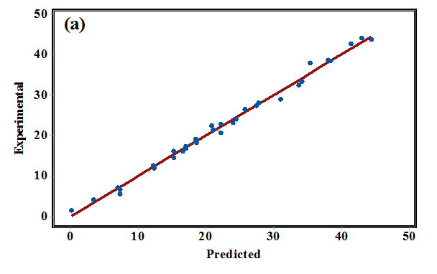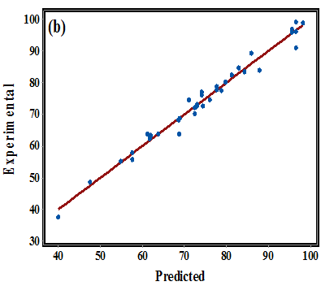

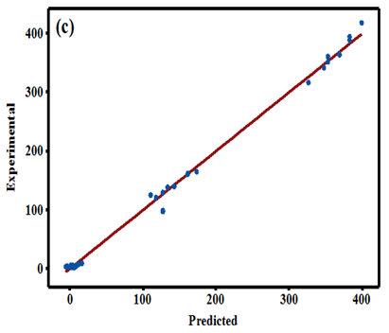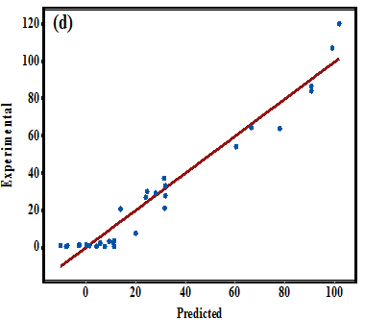

**Figure A3.** Experimental versus predicted polynomial model responses of adsorption % by (a) SAB and (b) SASB and adsorption capacity (mg/g) by (c) SAB and (d) SASB nano-adsorbents.

|  |  |  |  |  |  |  |  |  |  |  |  |  |  |
| --- | --- | --- | --- | --- | --- | --- | --- | --- | --- | --- | --- | --- | --- |
| **Source** | **DF** | **Seq. SS** | | | | **F-value** | | | | **p-value** | | | |
| **adsorption %** | | **capacity mg/g** | | **adsorption %** | | **capacity mg/g** | | **adsorption %** | | **capacity mg/g** | |
| **SAB** | **SASB** | **SAB** | **SASB** | **SAB** | **SASB** | **SAB** | **SASB** | **SAB** | **SASB** | **SAB** | **SASB** |
| Regression | 16 | 5481.46 | 7510.8 | 43470.2 | 799255.0 | 220.77 | 69.48 | 33.47 | 721.66 | <0.0001 | <0.0001 | <0.0001 | <0.0001 |
| pH | 1 | 31.15 | 353.6 | 304.2 | 693.0 | 3.25 | 0.55 | 0.14 | 27.24 | 0.09 | 0.47 | 0.92 | <0.001 |
| Dose | 1 | 1504.04 | 1756.1 | 1294.2 | 119148.0 | 68.91 | 33.59 | 0.05 | 0.23 | <0.001 | <0.001 | 0.83 | 0.64 |
| Co | 1 | 708.95 | 778.0 | 25345.8 | 557848.0 | 48.38 | 11.04 | 50.19 | 797.77 | <0.001 | <0.001 | <0.001 | <0.001 |
| TDS | 1 | 2942.5 | 3303.3 | 7769.1 | 8742.0 | 131.20 | 33.36 | 7.61 | 4.21 | <0.001 | <0.001 | 0.01 | 0.05 |
| Temp | 1 | 212.9 | 1143.7 | 80.3 | 273.0 | 10.59 | 25.95 | 0.01 | 1.35 | <0.001 | <0.001 | 0.94 | 0.26 |
| pH*Dose | 1 | 7.51 | 0.8 | 0.9 | 45.0 | 3.86 | 0.63 | 0.96 | 0.01 | 0.06 | 0.44 | 0.34 | 0.92 |
| pH*Co | 1 | 0.83 | 14.5 | 41.3 | 319.0 | 0.61 | 2.36 | 0.20 | 1.19 | 0.44 | 0.14 | 0.66 | 0.29 |
| pH*TDS | 1 | 13.59 | 0.2 | 163.0 | 2404.0 | 4.62 | 0.00 | 0.41 | 1.10 | 0.04 | 0.97 | 0.53 | 0.31 |
| pH*Temp | 1 | 15.3 | 0.4 | 246.4 | 540.0 | 5.83 | 0.17 | 0.26 | 0.10 | 0.03 | 0.68 | 0.62 | 0.76 |
| Dose*Co | 1 | 13.17 | 28.7 | 610.9 | 103078.0 | 11.95 | 4.31 | 4.75 | 652.33 | <0.001 | 0.05 | 0.04 | <0.001 |
| Dose*TDS | 1 | 2.73 | 0.0 | 868.4 | 244.0 | 2.75 | 0.33 | 16.00 | 8.40 | 0.11 | 0.57 | <0.001 | 0.04 |
| Dose*Temp | 1 | 12.3 | 43.2 | 70.4 | 11.0 | 10.43 | 3.40 | 0.45 | 3.42 | <0.001 | 0.08 | 0.51 | 0.08 |
| Co*TDS | 1 | 6.42 | 49.5 | 6530.2 | 3161.0 | 5.28 | 7.96 | 73.31 | 47.88 | 0.03 | 0.01 | <0.001 | <0.001 |
| Co*Temp | 1 | 2.09 | 26.5 | 108.0 | 899.0 | 1.28 | 3.92 | 1.17 | 13.01 | 0.27 | 0.06 | 0.29 | <0.001 |
| TDS*Temp | 1 | 6.2 | 0.0 | 34.5 | 4.0 | 4.00 | 0.00 | 0.38 | 0.06 | 0.06 | 0.97 | 0.54 | 0.81 |
| Error | 21 | 32.59 | 141.9 | 1902.3 | 1454.0 |  |  |  |  |  |  |  |  |
| Lack-of-Fit | 11 | 28.12 | 103.6 | 1883.6 | 1387.0 | 5.72 | 2.46 | 91.83 | 18.96 | 0.01 | 0.08 | <0.001 | <0.001 |
| Pure Error | 10 | 4.47 | 38.2 | 18.6 | 66.0 |  |  |  |  |  |  |  |  |
| Total | 37 | 5514.05 | 7652.6 | 45372.5 | 800708.0 |  |  |  |  |  |  |  |  |

**Table A1. *ANOVA results for the quadratic polynomial regression models developed using SAB and SASB nano-adsorbents***

**References**

Fard, A. K., Mckay, G., Chamoun, R., Rhadfi, T., Preud’Homme, H., & Atieh, M. A. (2017). Barium removal from synthetic natural and produced water using MXene as two dimensional (2-D) nanosheet adsorbent. *Chemical Engineering Journal*, *317*, 331–342. https://doi.org/10.1016/j.cej.2017.02.090

Holmes, F. L. (1962). From elective affinities to chemical equilibria: Berthollet’s law of mass action. *Chymia*, *8*, 105–145.

Mishra, S. P., & Singh, V. K. (1995). Radiotracer Technique in Adsorption study-XI. Adsorption of Barium and Strontium Ions on Hydrous Ceric Oxide. *Applied Radiation and Isotopes*, *46*(2), 75–81.

Missana, T., García-Gutiérrez, M., Mingarro, M., & Alonso, U. (2017). Analysis of barium retention mechanisms on calcium silicate hydrate phases. *Cement and Concrete Research*, *93*, 8–16. https://doi.org/10.1016/j.cemconres.2016.12.004

Visa, M., Bogatu, C., & Duta, A. (2010). Simultaneous adsorption of dyes and heavy metals from multicomponent solutions using fly ash. *Applied Surface Science*, *256*(17), 5486–5491. https://doi.org/10.1016/j.apsusc.2009.12.145