Supporting Information

ZnO-Bi₂O₃/Graphitic Carbon Nitride Photocatalytic System with H₂O₂-Assisted Enhanced Degradation of Indigo Carmine under Visible Light

Bui The Huy§†, Da Seul Paeng§, Chu Thi Bich Thao§, Nguyen Thi Kim Phuong^{δ}*, Yong-Ill Lee§*

§Department of Chemistry, Changwon National University, Changwon 51140, Republic of Korea
†Institute for Research and Development, Duy Tan University, 03 Quang Trung, Da Nang, Vietnam
^{δ}HoChiMinh city Institute of Resources Geography, Vietnam Academy of Science and Technology, 01 Mac Dinh Chi, District 1, Ho Chi Minh City, Vietnam

Synthesis
200 mL of Melamine solution at various levels of molarity (x = 0, 1, 2, and 4) was heated to 75 ± 5 °C until melamine was dissolved completely. Then, the mixture of Zn(NO₃)₂. 6H₂O and Bi(NO₃)₃. 5H₂O with molar ratio of 3:1 in 100 mL of nitric acid solution (5%) and an alkaline solution of 1M NaOH were added to melamine solution at a flow rate of 2 mL⋅min⁻¹ using syringe pump. The pH of the mixture was maintained at 10 during the synthesis. The mixture was fixed at 75 ± 5 °C for 24 h. After that the prepared materials were centrifuged, washed, and dried at 70 °C for 10 h, followed by heating at 520 °C for 3 h to get the mixed-metal oxides (ZnO-Bi₂O₃) and mixed-metal oxides-graphitic carbon nitride (ZnO-Bi₂O₃-xC₃N₄). The as-prepared materials were labeled as ZnO-Bi₂O₃-xC₃N₄ (x = 0, 1, 2, and 4) and are hereafter referred to as ZnO-Bi₂O₃, ZnO-Bi₂O₃-1C₃N₄, ZnO-Bi₂O₃-2C₃N₄, and ZnO-Bi₂O₃-3C₃N₄.

Characterizations of the prepared materials
XRD patterns of powder samples were obtained using a Rigaku Ultima IV X-ray diffractometer (Japan). The XRD patterns of C₃N₄, ZnO-Bi₂O₃, and ZnO-Bi₂O₃-xC₃N₄ are shown in Figure S1(A). As seen in the XRD pattern of ZnO-Bi₂O₃, there are several strong peaks at 2θ = 28.0, 31.8, 32.8, 46.3, 47.0, 54.4, 55.8, and 58.0 corresponding to tetragonal zinc bismuth oxide (JCPDS No. 043-0449) and peaks at 2θ = 31.5, 34.4, 36.1, 57.0, and 63.0 corresponding to pristine hexagonal zinc oxide (JCPDS No. 079-0207). Most of the diffraction peaks are sharp and symmetrical, indicating good crystallinity. Pristine C₃N₄ typically presents main diffraction peaks around 27.3° (JCPDS No. 87-1526). The diffraction patterns of the ZnO-Bi₂O₃-xC₃N₄ samples were characterized by a new peak at 24.7° in comparison with pristine ZnO-Bi₂O₃. In addition, the ZnO-Bi₂O₃-xC₃N₄ patterns showed a sharp and strong peak at 27.7°. There are slight shift of the diffraction peak in comparison with the peak at 28° of ZnO-Bi₂O₃ and 27.3° of C₃N₄ to indicate hybridization between C₃N₄ and ZnO-Bi₂O₃.
(D)
(C)
(A)
(B)
Figure S1: (A) XRD patterns; (B) FT-IR spectra, (C) UV-Vis absorption spectra, and (D) Tauc plot with a) C₃N₄; b) ZnO-Bi₂O₃ ; and c–e) ZnO-Bi₂O₃-xC₃N₄ (x = 1, 2, and 3).

The FT-IR spectra of the C₃N₄, ZnO-Bi₂O₃, and ZnO-Bi₂O₃-xC₃N₄ samples are displayed in Figure S1(B). The broad bands around 3200 cm⁻¹ are assigned O-H stretching vibration of adsorbed water [3]. The absorption band at 510-520 cm⁻¹ in ZnO-Bi₂O₃ and ZnO-Bi₂O₃-xC₃N₄ spectra verified the existence of Zn-O bond. The bands at 1250-1650 cm⁻¹, 800 cm⁻¹, and 3200 cm⁻¹ in FT-IR spectrum of C₃N₄ shows the typical stretching mode of C-N heterocycles, the breathing mode of the tri-s-triazine ring, and the stretching vibration mode of Na-H, respectively [4 -6].
The UV-Vis diffuse reflectance spectrum (DRS) was recorded on a Jasco V670 UV-Vis spectrophotometer (Japan) with an integrating sphere attachment. The UV-Vis absorption edges of the as-prepared samples are shown in Figure S1(C). The absorption edges of ZnO-Bi₂O₃-xC₃N₄ are blue-shifted in comparison with those of pristine C₃N₄ and pristine ZnO-Bi₂O₃. The moving absorption edges of the ZnO-Bi₂O₃-xC₃N₄ samples compared to those of pristine C₃N₄ and ZnO-Bi₂O₃ are attributed to the strong interaction between C₃N₄ and ZnO-Bi₂O₃ in the resulting ZnO-Bi₂O₃-xC₃N₄ photocatalysts. The band gap energy (E_{g}) of the as-prepared materials was estimated using the Kubelka-Munk function and the results are shown in Figure S1(D). The band gap energy of the pristine ZnO-Bi₂O₃ appeared at 2.95 eV and 2.20 eV, indicating beside mixed metal oxides ZnO-Bi₂O₃ phase, a single ZnO impurity phase has appeared. For pristine C₃N₄, the band gap energy appeared at 2.67 eV. In case of ZnO-Bi₂O₃-xC₃N₄ catalysts, the band gap energy appeared at 2.60 and ~3.05 eV. These band gap values further suggest the visible light-responsive properties of the ZnO-Bi₂O₃-xC₃N₄ catalysts and their promising ability as photocatalysts under visible light irradiation.
For observing morphology of the samples, SEM images were recorded using a Tescan MIRA-3 LM scanning electron microscope (U.S.) with an accelerating voltage of 20 kV. Figure S2 shows SEM image of C₃N₄, ZnO-Bi₂O₃, and ZnO-Bi₂O₃-xC₃N₄. The C₃N₄ sample consisted of layers, as shown in Figure S2(A). The as-prepared ZnO-Bi₂O₃ sample (Figure S2(B)) exhibited morphological abnormalities with stacked particles by the collapse of the layered structure. The individual plates of ZnO-Bi₂O₃ are flat and the edges of the plates appear in the form of round shapes. An interesting observation was made in case of ZnO-Bi₂O3-xC₃N₄ samples, which tend to grow flower/rod-like shapes (Figure S2(C)-(E)).
(B)
(C)
(E)
(A)
(D)
Figure S2: SEM images of as-prepared materials A) C₃N₄; B) ZnO-Bi₂O₃ ; and C–E) ZnO-Bi₂O₃-xC₃N₄ (x = 1, 2, and 3).

The specific surface area (BET surface area) was measured with an Autosorb-1 (Quantachrome, USA) apparatus. Multi-point BET plot of catalysts are shown in Figure S3.

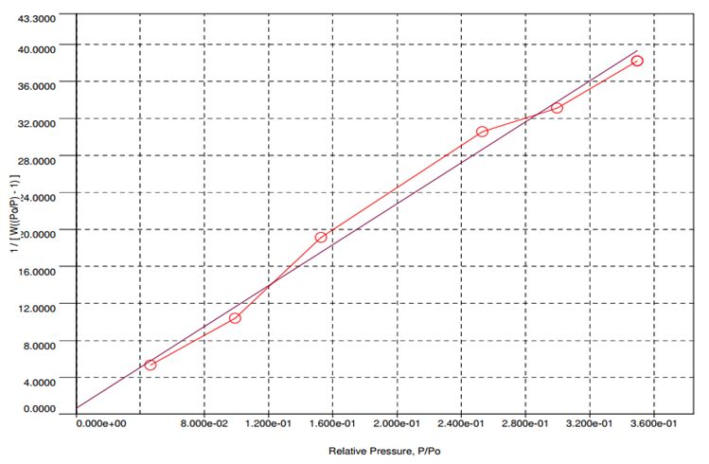  (A) | 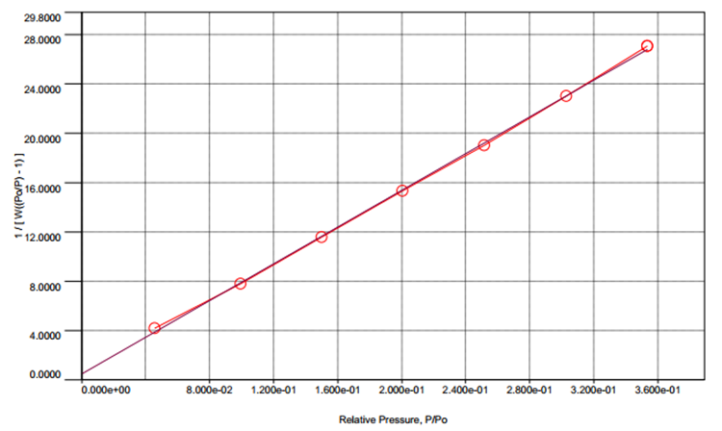  (B)
Figure S3: BET curves of the sample (A) ZnO-Bi₂O₃ and (B) ZnO-Bi₂O₃-2C₃N₄.

References

[1] X. Wang, K. Maeda, A. Thomas, K. Takanabe, G. Xin, J.M. Carlsson, K. Domen, M. Antonietti, A metal-free polymeric photocatalyst for hydrogen production from water under visible light, Nat. Mater., 8 (2009) 76-80.
[2] S. Nayak, L. Mohapatra, K. Parida, Visible light-driven novel g-C₃N₄/NiFe-LDH composite photocatalyst with enhanced photocatalytic activity towards water oxidation and reduction reaction, J. Mater. Chem. A, 3 (2015) 18622-18635
[3]M. Shekofteh-Gohari, A. Habibi-Yangjeh, Novel magnetically separable ZnO/AgBr/Fe₃O₄/Ag₃VO₄ nanocomposites with tandem n-n heterojunctions as highly efficient visible-light-driven photocatalysts, RSC Adv., 6 (2016) 2402-2413.
[4] S.W. Hu, L.W. Yang, Y. Tian, X.L. Wei, J.W. Ding, J.X. Zhong, P.K. Chu, Non-covalent doping of graphitic carbon nitride with ultrathin graphene oxide and molybdenum disulfide nanosheets: An effective binary heterojunction photocatalyst under visible light irradiation, J. Colloid Interface Sci., 431 (2014) 42-49.
[5] H. Sun, Y. Cao, L. Feng, Y. Chen, Immobilizing photogenerated electrons from graphitic carbon nitride for an improved visible-light photocatalytic activity, Scientific Reports, 6 (2016) 22808.
[6] J. Hong, C. Chen, F.E. Bedoya, G.H. Kelsall, D. O'Hare, C. Petit, Carbon nitride nanosheet/metal-organic framework nanocomposites with synergistic photocatalytic activities, Catal. Sci. Technol., 6 (2016) 5042-5051.

