Supporting Information

Synthesis and Characterization of Fluorescent N-CDs/ZnONPs Nanocomposite for Latent
Fingerprint Detection by using Powder Brushing Method

ESWARAN PRABAKARANª, and KRIVESHINI PILLAY^{a*}

ªDepartment of Applied Chemistry, University of Johannesburg, Johannesburg, South Africa

*Corresponding author: Tel: +27 11 5596128, Fax: +27 11 5596425 (NB)
Email address: kriveshinip@uj.ac.za (KP)

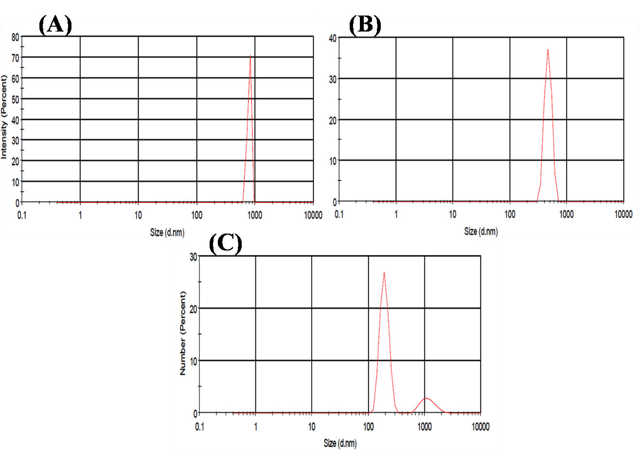

Fig.S1 Zeta characterization recorded from dispersion in water medium (A) N-CDs, (B) ZnONPs and (C) N-CDs/ZnONPs nanocomposite of zeta average size distribution.

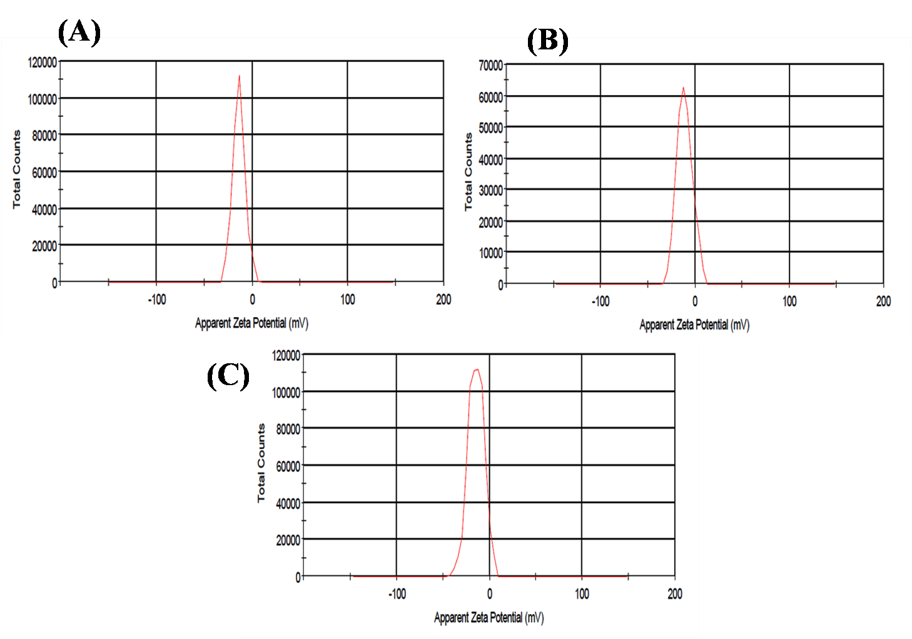

Fig.S2 Zeta characterization recorded from dispersion in water medium (A) N-CDs, (B) ZnONPs and (C) N-CDs/ZnONPs nanocomposite of Zeta potential.

