**Supporting information’s**

**Spectral characterization, electrochemical‎, antimicrobial and cytotoxic studies on new metal(II) complexes containing N2O4 donor hexadentate Schiff base ligand**

**Asma A. Alothmana*, Eida S. Al-Farrajb, Wedad A. Al-Onazia, Zainab M. Almarhoona and Amal M. Al-Mohaimeeda**

a Department of Chemistry, College of Science, King Saud University, P.O. Box 22452, Riyadh 11495, Saudi Arabia

b Department of Chemistry, College of Science, Al-Imam Mohammad Ibn Saud Islamic University (IMSIU), 13623, Riyadh, Saudi Arabia

**Corresponding author**: **Asma A. Alothman**

**Email**: aaalothman@ksu.edu.sa

Department of Chemistry, College of Science, King Saud University, P.O. Box 22452, Riyadh 11495, Saudi Arabia

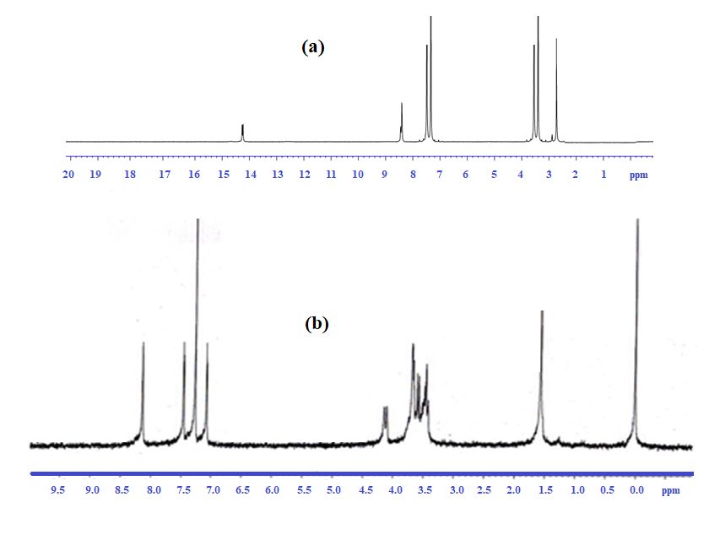**Figure S1:** 1H NMR spectra of the Schiff base ligand H2L and complex 4.

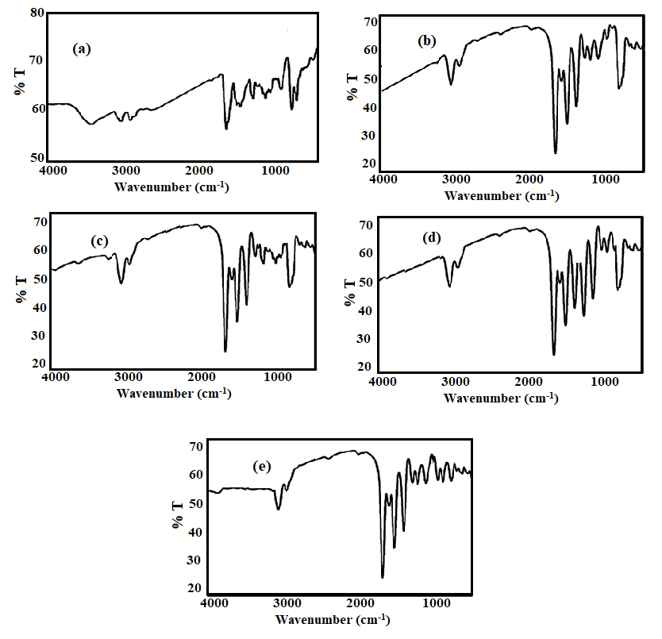

**Figure S2:** FT-IR spectrum of the Schiff base ligand H2L and its metal (II) complexes 1-4 (a-e), respectively.

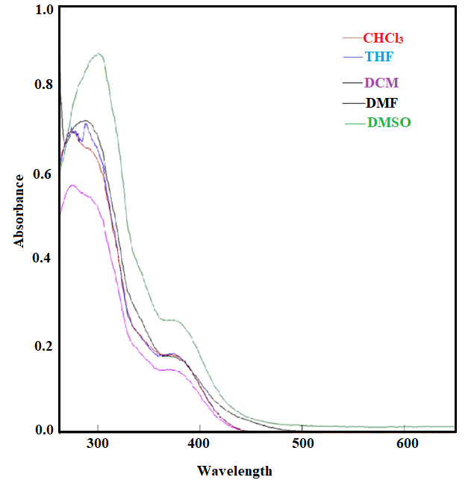

**Figure S3:** UV-visible spectra of Schiff base ligand (H2L) at 1.5 × 10–5M in different solvent (CHCl3, THF, DCM, DMF and DMSO.

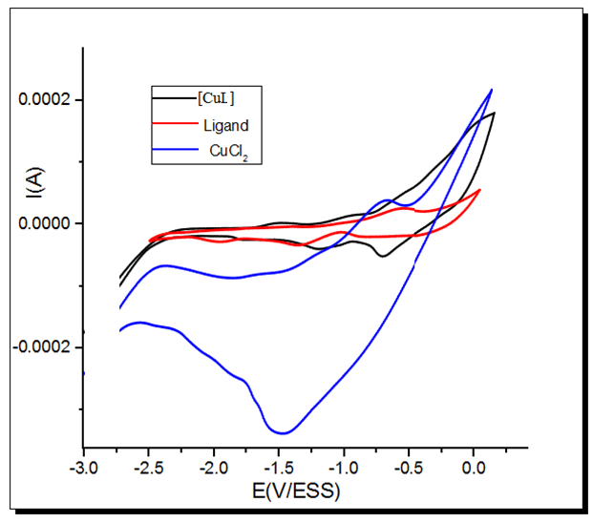

**Figure S4**. CVs of ligand, CuCl2, and [CuL] complexes.

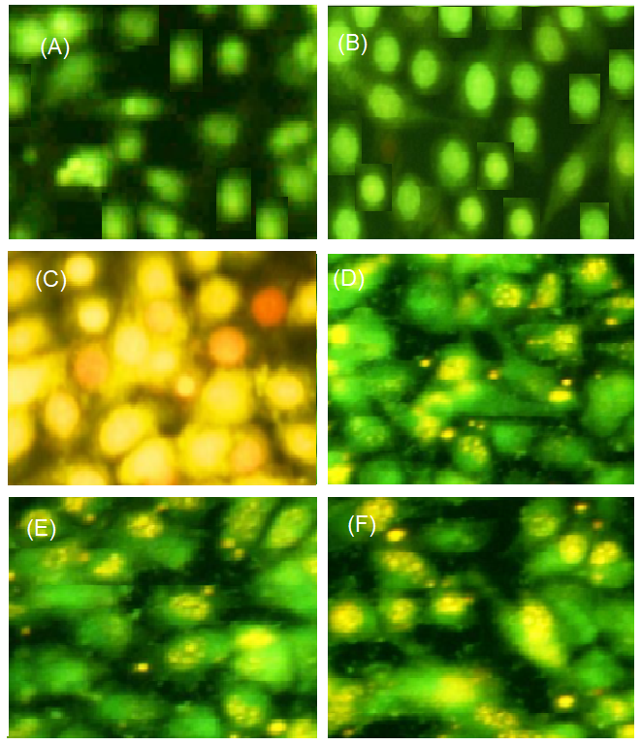

**Figure S5.** Fluorescence images of (a) MCF-7 cancer cells (control) treated with (b) Shiff base ligand H2L, (c) complex 1, (d) complex 2, (e) complex 3 and (f) complex 4.