**Supplementary Data**

**Synthesis, characterization, quantum-chemical investigation and antibacterial studies of new fluorescent Cr(III) complexes**

Shohreh Rastegarnia, Mehdi Pordel\* and Sadegh Allameh

*Department of Chemistry, Mashhad Branch, Islamic Azad University, Mashhad, Iran*

*\*Corresponding author. Tel.: ‏+98 0513 8414182; fax: +98 0513 8424020. E-mail:* [*mehdipordel58@mshdiau.ac.ir*](mailto:mehdipordel58@mshdiau.ac.ir)

**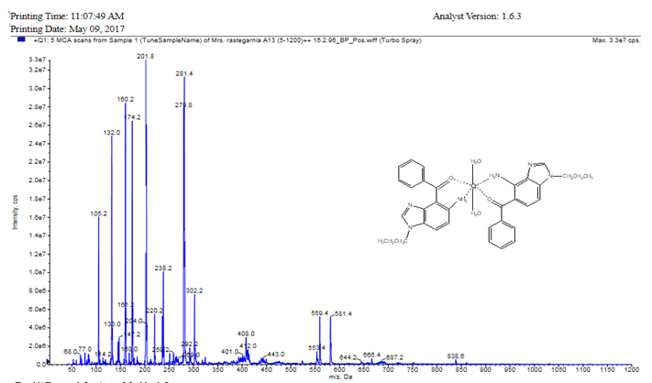**

MS Data for complex **5b**

F:\Document 1\Ph._D_&_Karshensai_Arshad\Ph.D\Mis. Rastegarnia\Article 2\fig 1.tif

**Figure S1.** The optimized geometry of the complex **5a**.

**Table S1**. Selected structural parameters of Cr(III) complex **5a**.

|  |  |  |  |  |  |
| --- | --- | --- | --- | --- | --- |
| Bond | Bond length (A0) | Angle | (°) | Dihedral angle | (°) |
| Cr-O1 | 1.782 | N1-Cr-N5 | 179.89 | O1-O2-O3-O4 | 179.519 |
| Cr-O4 | 1.799 | O1-Cr-O4 | 179.85 | N3-O2-N6-O3 | -0.034 |
| Cr-N3 | 1.956 | O2-Cr-O3 | 179.66 | O1- Cr-O4-N3 | -92.732 |
| Cr-N6 | 1.934 | Cr-O1-C8 | 129.28 | N3- Cr-N6-O3 | -7.214 |
| Cr-O3 | 2.272 | O1-C8-C6 | 119.63 | N6-C22-C27-C29 | -3.545 |
| Cr-O2 | 2.331 | Cr-N3-C1 | 113.34 | N4-C25-C26-N5 | 1.082 |
| N3-C1 | 1.459 | Cr-O2-N3 | 36.804 | N5-C28-N4-C42 | -177.602 |
| O1-C8 | 1.384 | Cr-O4-C29 | 129.112 | C26-C27-C36-C41 | 0.425 |
| N6-C22 | 1.448 | C29-C36-C37 | 121.650 | O1-C8-C15-C20 | 22.554 |
| C27-C29 | 1.469 | O4-C29-C27 | 119.128 | C15-C8-C6-C5 | 38.818 |
| C27-C26 | 1.421 | C27-C26-N5 | 129.589 | C5-N2-C7-N1 | -0.152 |
| C25-C26 | 1.422 | N4-C28-N5 | 114.394 | N2-C5-C6-C1 | -175.70 |
| C36-C38 | 1.414 | N4-C42-C30 | 113.900 | C7-N1-C21-C9 | -123.142 |
| C25 –N4 | 1.385 | C42- C30-C35 | 120.231 | C14-C9-C21-N1 | 56.594 |
| C26-N5 | 1.371 | C31-C30-C31 | 119.245 | C10-C11-C12-C13 | 0.219 |
| C28-N5 | 1.319 | C30-C31-C32 | 120.449 | C28-N4-C42-C30 | -121.17 |
| C28-N4 | 1.370 | C32- C33-C34 | 119.812 | C26-C27-C29-C36 | -38.985 |
| N4-C42 | 1.474 | O1-C8-C15 | 119.868 | C2-C39-C40-C41 | -179.402 |
| C42-C30 | 1.515 | C8-C15-C16 | 121.748 | C37-C38-C39-Cl2 | -179.097 |
| O4-C29 | 1.278 | C8-C6-C5 | 122.366 | O4-C29-C36-C41 | -22.380 |

**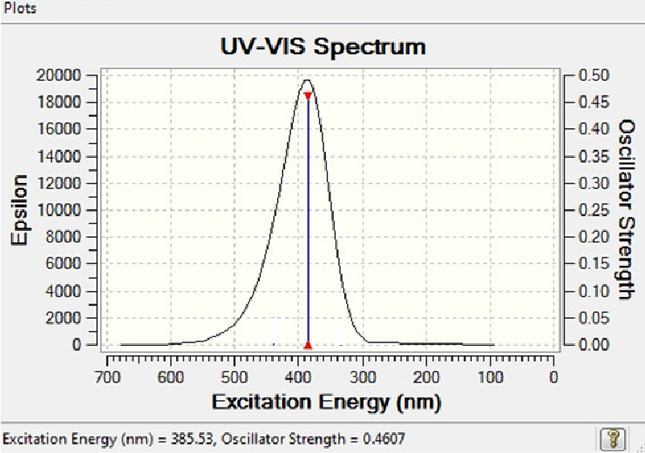**

**Figure S2.** Calculated electronic absorption spectra of compounds **5a**