**Water soluble gold-polyaniline nanocomposite: A substrate for surface enhanced Raman scattering and catalyst for dye degradation**

Palash Mondala,b*, Chengchen Guoa, Jeffery L. Yargera

aSchool of Molecular Sciences, Magnetic Resonance Research Center, Arizona State University, Tempe, Arizona, 85287-1604, USA.

bDepartment of Chemistry (UG & PG), Vivekananda Mahavidyalaya, Burdwan, Burdwan, West Bengal, 713103, India.

*Corresponding Author: Palash Mondal, Tel: (+91-9123942819), Fax: (0342)-2646914 E-mail: [polchemvb2005@gmil.com](mailto:polchemvb2005@gmil.com)

**Synthesis of citrate capped gold nanoparticles**

Citrate-encapsulated gold nanoparticles (AuNPs) were synthesized by a modified ‘Turkevich’ method [39,40]. An aqueous solution of chloroauric acid (100 mL, 1mM) was brought to a boil. Then, a specific amount (0.5 mL, 1.0 mL, 1.5 mL, or 3 mL) of sodium citrate (1% w/w) was added rapidly to the boiling solution. The solution kept as a boil for another 30 minutes during which the color of the solution changes from yellow to wine red (Scheme-1). The change of color from yellow to wine red signifies the formation of citrate capped AuNPs after which the solution was cooled to room temperature with stirring.

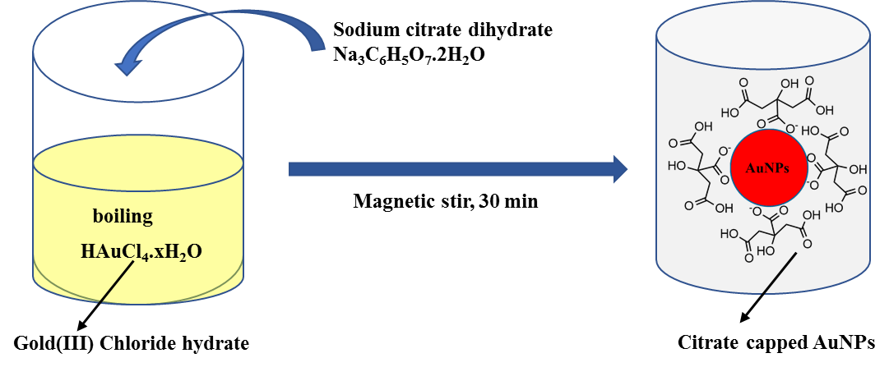

Scheme-S-1: Proposed scheme for citrate capped gold nanoparticles

**Preparation of gold/polyaniline nanocomposite**

The AuNP-PANI nanocomposite was prepared by in-situ polymerization of aniline monomer in the presence of AuNPs. In a typical experimental procedure, distilled aniline (0.4 mL, 0.0044 moles) was taken in 10 mL of 0.1MHCl and it was mixed with 0.01M CTAB (100 mL, 0.01M, 0.365g) which was previously taken in 250 mL round bottom flask with continuous stirring by magnetic stirrer at room temperature for 2h. Then the resulting mixture was added to 100 mL of prepared 13 nm size AuNPs solution. APS (0.94 g, 0.0043 moles) solution in 10 mL 0.1N HCl was added into the above mixtures with a flow rate of 1 mL/min. The suspended solution of AuNP-PANI nanocomposite was obtained after constant stirring for 12 h at room temperature. During this time the color of the solution changed from greenish to black which signifies the formation AuNP-PANI nanocomposite (Scheme-2). The suspended solution was centrifuged for 15 minutes (500 rpm) and then it was washed with distilled water first and then methanol several times to remove unreacted substances and then dried in vacuum for overnight. The pure PANI was synthesized using same chemical polymerization method as described above in the absence of AuNPs.

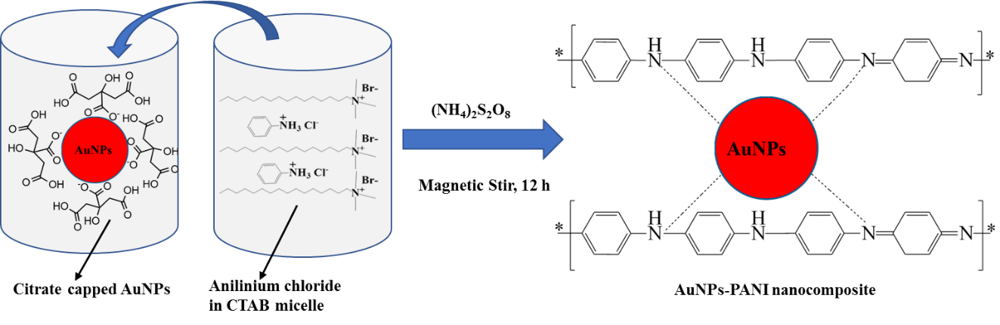

Scheme-S-2: Proposed structure for AuNP-PANI nanocomposite

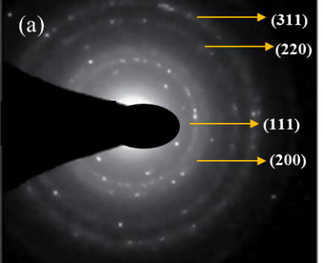 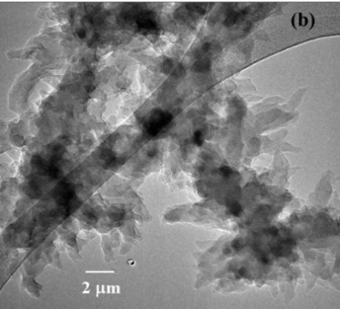

Fig.S-1: (a) Selected Area Diffraction Pattern (SAED), (b) Scanning Transmission Electron Microscope (STEM) and (c) Energy Dispersive X-ray Spectroscopy (EDS) elemental map of AuNP-PANI.

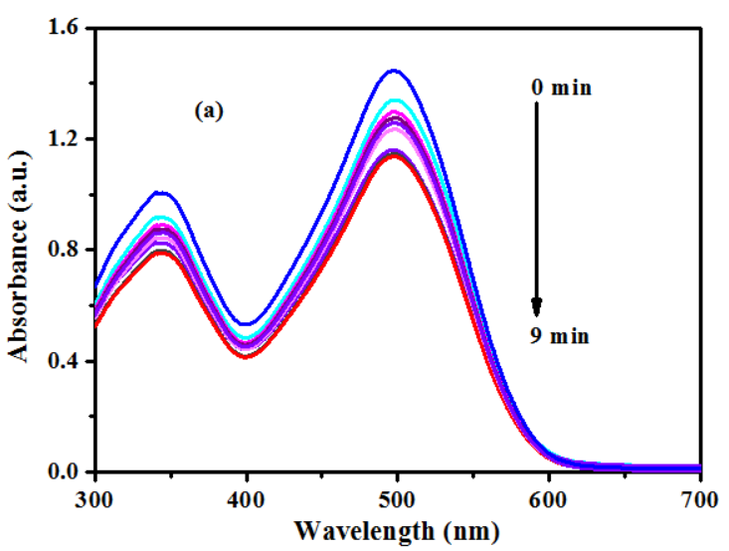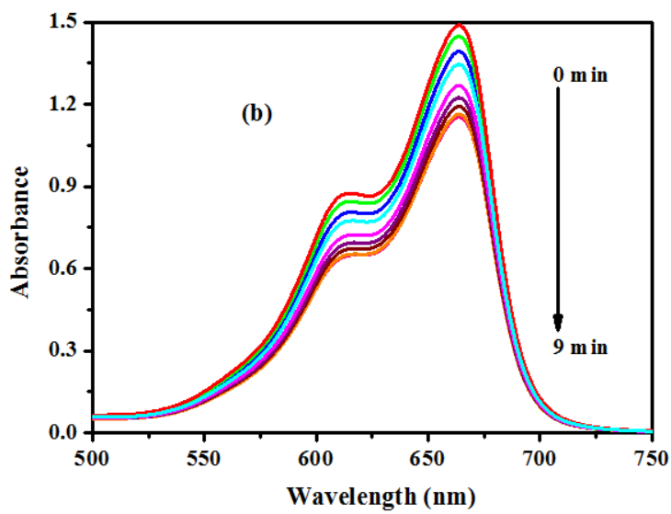

Fig.S-2 Reduction of (a) CR and (b) MB dye in the presence of NaBH4 and absence of AuNP-PANI nanocomposite

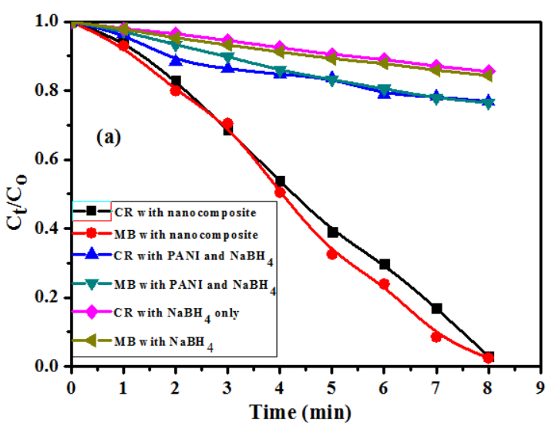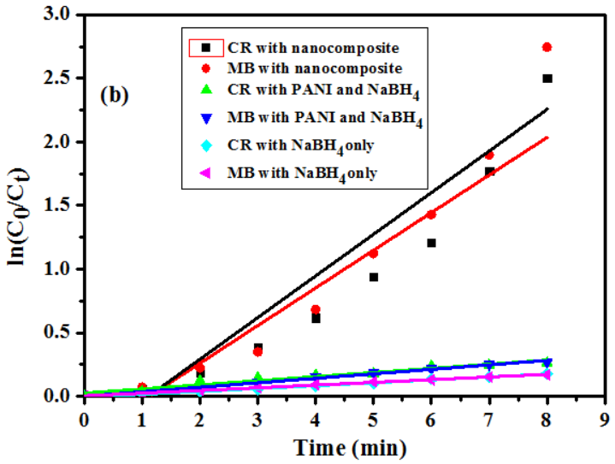

Fig S-3 (a) The kinetic results showing the reductive degradation of CR and MB dyes under different conditions and (b) Plot of ln(C0/Ct) versus reaction time for reductive degradation of CR and MB dyes under different conditions. The concentrations of CR, MB and NaBH4 were kept constant in all cases.

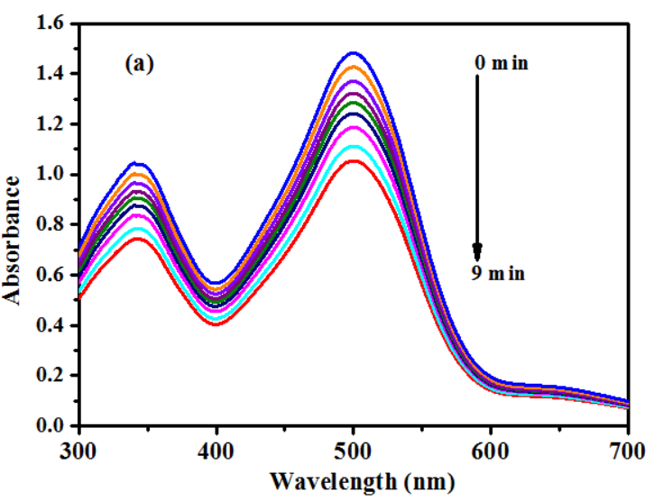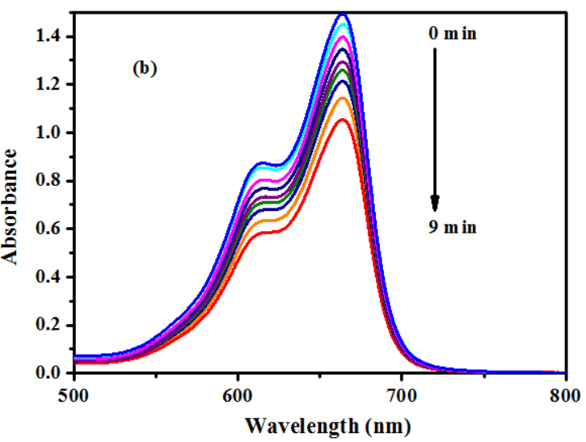

Fig.S-4 Reduction of (a) CR and (b) MB dye in the presence of PANI nanofiber with NaBH4 but in absence of AuNP-PANI nanocomposite.

Table S1: Assignment of vibrational spectra obtained Raman spectra

|  |  |  |
| --- | --- | --- |
| Bulk 4-ATP  (cm-1) | Bulk 4-ATP onto AuNP-PANI surface (cm-1) | Vibrational peak assignments |
| 387 | 387 | υC-S |
| 463 | 463 | υC-C-C |
| 1005 | 1005 | υC-C + υC-C-C |
| 1091 | 1086 | υC-S |
| 1175 | 1179 | δC-H |
| 1291 | 1288 | υC-H |
| 1488 | 1488 | υC-C + δC-H |
| 1593 | 1591 | υC-C |

Table S2: Assignment of vibrational spectra obtained Raman spectra

|  |  |  |
| --- | --- | --- |
| Bulk 4-DMAP  (cm-1) | Bulk 4-DMAP onto AuNP-PANI surface (cm-1) | Vibrational peak assignments |
| 751 | 736 | C-N-C wagging |
| 950 | 939 | Ring breathing  CH3 rocking |
| 984 | 973 | Trigonal bending  C-H out-plane bending |
| 1063 | 1053 | CH3 rocking |
| 1232 | 1223 | C-H in-plane bending |

Table S-3: A comparison of catalytic activities of AuNP-PANI nanocomposite with different catalysts for the chemical reduction of CR and MB.

|  |  |  |  |
| --- | --- | --- | --- |
| Catalyst | τcompletion  CR/min | τcompletion  MB/min | References |
| AuNPs capped by salmalia malabarica gum | 11 | 9 | 41 |
| AuNP nanorods by controlled coating of platinum | - | 8 | 59 |
| Aucore–PANIshell | - | 6 | 30 |
| Au-loaded Fe3O4@C composite Microspheres  Gold nanoparticles by Bacillus maris flavi  Polydopamine modified gold nanoparticles | -  15  25 | 10  11  - | 60  61  62 |
| AuNP-PANI nanocomposite | 8 | 7 | This work |