**Supplementary Data**

**Erysacleuxins C and D, new isoflavones from the twigs of *Erythrina sacleuxii* Hua and their cytotoxic activity**

Japheth O. Ombitoa*, Gomotsang Bojasea, Runner R.T. Majindaa, Ishmael B. Masesanea, Anja Schüfflerb, Till Opatzc

a*Department of Chemistry, University of Botswana, Private Bag 0022, Gaborone, Botswana*

b*Institut für Biotechnologie und Wirkstoff-Forschung gGmbH, Erwin-Schrödinger-Straße 56, D-67663 Kaiserslautern, Germany*

*cJohannes Gutenberg University Mainz, Institute of Organic Chemistry, Duesbergweg 10–14,*

*D-55128 Mainz, Germany*

**Abstract**

Two previously undescribed isoflavones, erysacleuxin C (**1**) and erysacleuxinD (**2**), together with seven known compounds (**3**-**9**), were isolated and identified from the EtOAc extract of the twigs of *Erythrina sacleuxii* Hua (Leguminosae). The structures of the isolated compounds were determined on the basis of their spectroscopic and spectrometric data. Evaluation of their cytotoxicity against the human cancer HeLa-S3 cell lines indicated IC50 values of 130.4, 54.9 and 73.9 µM for erysacleuxinC(**1**), erysacleuxinD(**2**) and butin (**9**), respectively.

*Corresponding author

Email: jeffombito@gmail.com (J. O. Ombito).

Table of contents

S1: 1H NMR spectrum of compound 1

S2: 13C NMR spectrum of compound 1

S3: COSY spectrum of compound 1

S4: HSQC spectrum of compound 1

S5: HMBC spectrum of compound 1

S6: ESI-HRMS spectrum of compound 1

S7: UV-Vis spectrum of compound 1

S8: IR spectrum of compound 1

S9: 1H NMR spectrum of compound 2

S10: 13C NMR spectrum of compound 2

S11: COSY spectrum of compound 2

S12: HSQC spectrum of compound 2

S13 HMBC spectrum of compound 2

S14: ESI-HRMS spectrum of compound 2

S15: UV-Vis spectrum of compound 2

S18: IR spectrum of compound 2

Scheme S17: Proposed biosynthetic pathway of compounds 1, 2 and 7 from compound 5



S1: 1H NMR spectrum of compound 1



S2: 13C NMR spectrum of compound 1



S3: COSY spectrum of compound 1



S4: HSQC spectrum of compound 1



S5: HMBC spectrum of compound 1

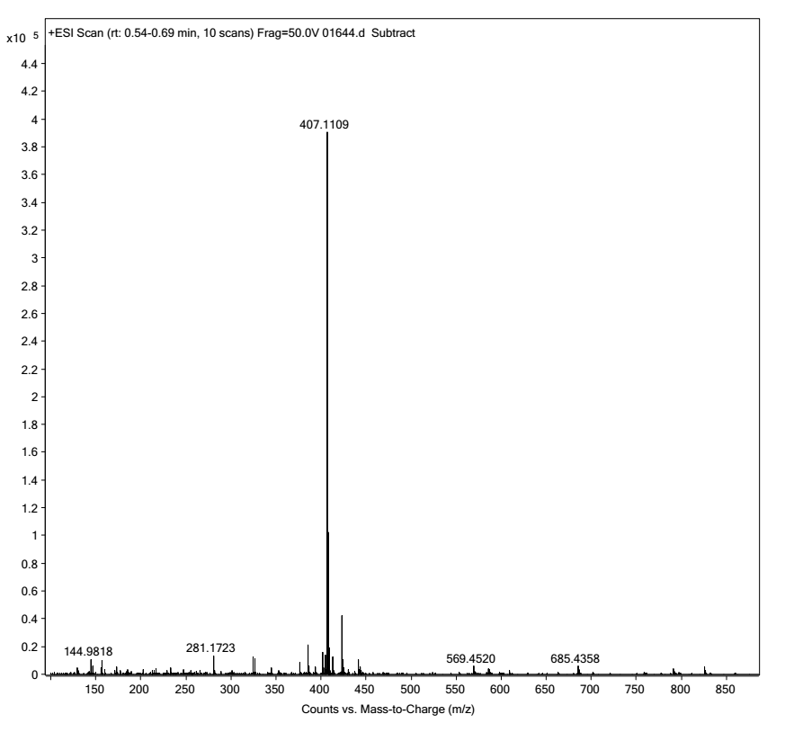

S6: HRESIMS spectrum of compound 1

S7: UV-Vis spectrum of compound 1

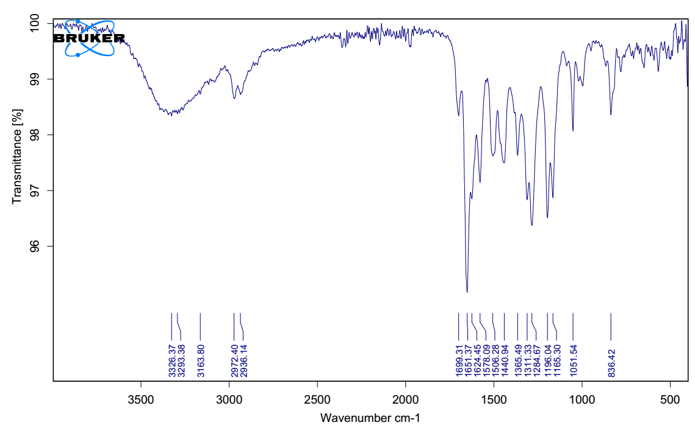

S8: IR spectrum of compound 1



S9: 1H NMR spectrum of compound 2



S10: 13C NMR spectrum of compound 2



S11: COSY spectrum of compound 2



S12: HSQC spectrum of compound 2



S13: HMBC spectrum of compound 2

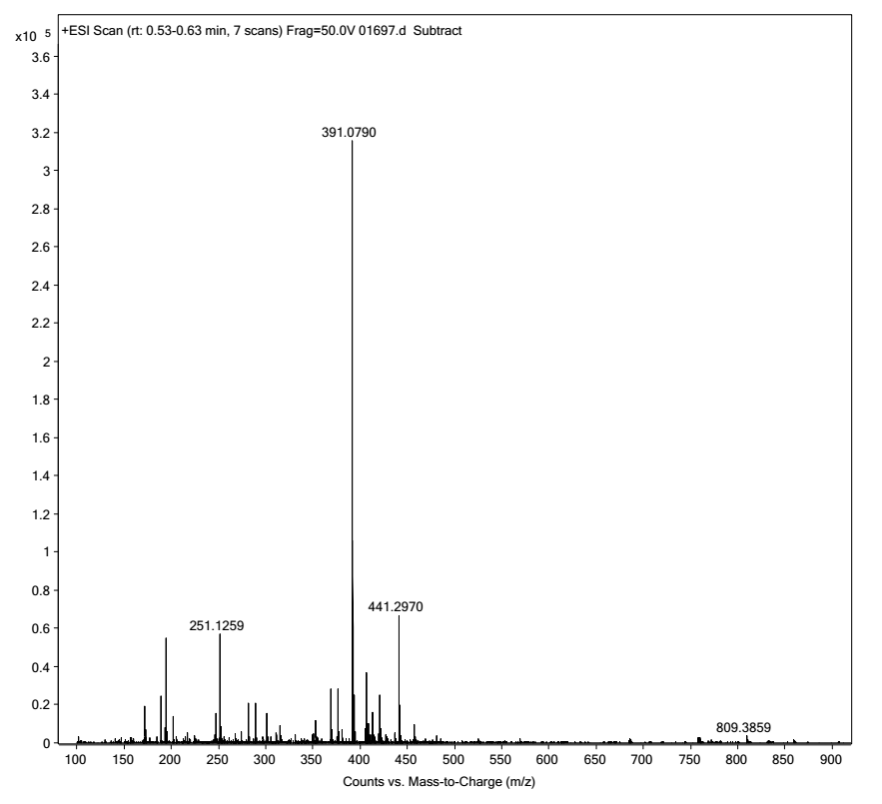

S14: HRESIMS spectrum of compound 2

S15: UV-Vis spectrum of compound 2

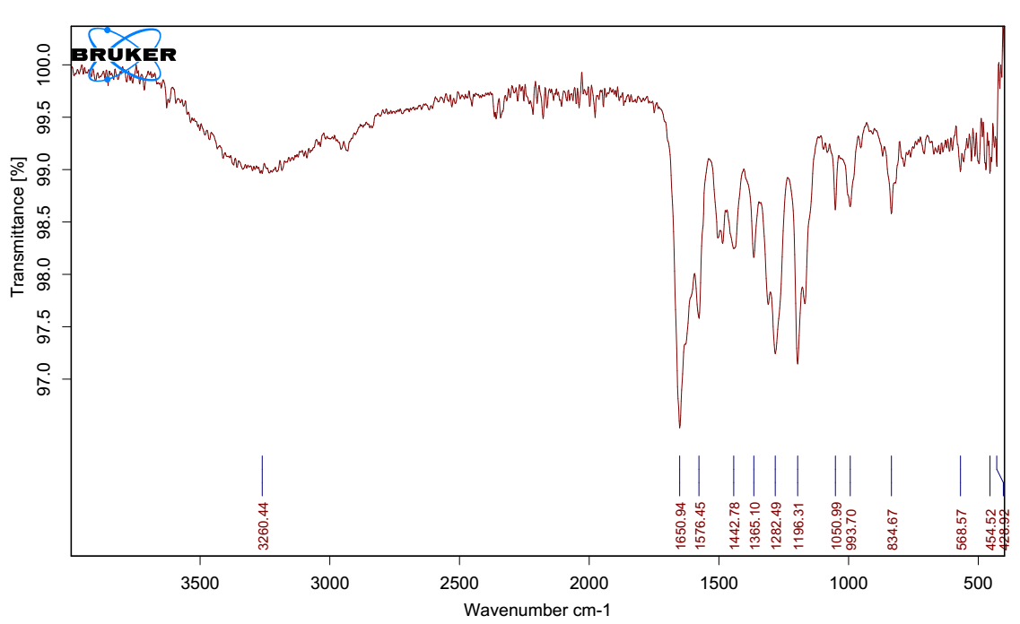

S16: IR spectrum of compound 2



Scheme S17: Proposed biosynthetic pathway of compounds 1, 2 and 7 from compound 5