Supplementary Information
Experimental details:
Synthesis of 350 nm PS colloidal crystal template:
Polystyrene spheres were synthesized by a surfactant-free emulsion polymerization technique (B. T. Holland, C. F. Blanford, T. Do and A. Stein, Chem Mater, 1999, 11, 795-805). Polystyrene spheres of 350 nm diameter were prepared as follows: styrene was pre-washed 3 times with 2 M NaOH to remove the inhibitors and washed with distilled water to pH ≈ 7. 16 mL of prewashed styrene and 240 mL of water were heated to 70 °C in an oil bath under N₂ atmosphere. Then 0.28 g of K₂S₂O₈ was added to activate the polymerization, the reaction was kept at 70 °C for 5 h. Before use, the obtained monodispersed polystyrene spheres were continuous centrifuged at 3000 rpm for 10h, then dried room temperature to obtain the 350 nm PS colloidal crystal template.
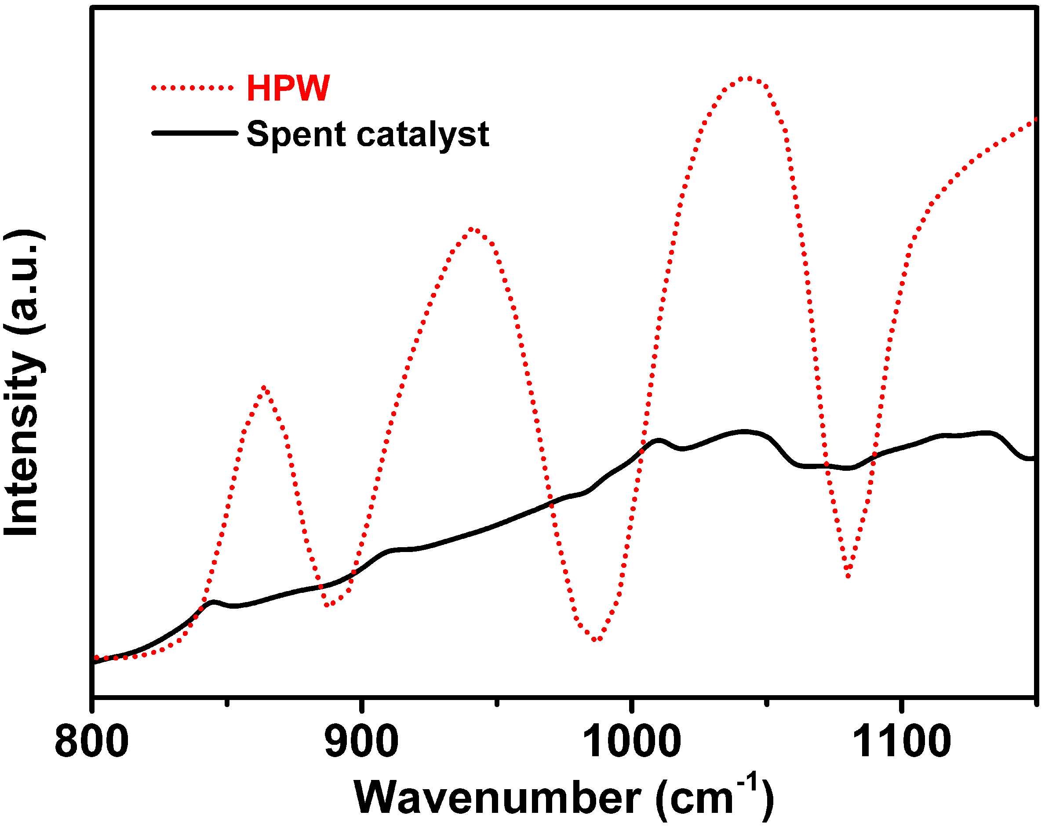
Fig S1 The FTIR spectra of spent catalyst and HPW.

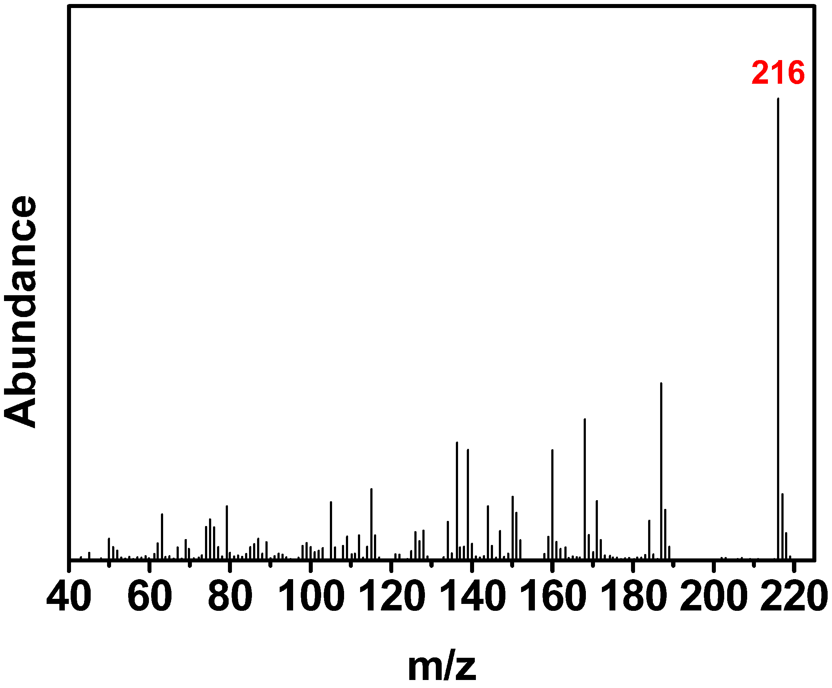
Fig S2 The HPLC-MS of main compounds of oil phase and acetonitrile phase in ODS processes.

Table S1 Catalytic oxidative desulfurization by POM/H₂O₂ systems.
Entry | Catalyst | Substrate | Catalyst usage  (g) | O/S  molar ratio | Temperature  (°C) | Conversion  (%)
1^{[1]} | 3DOM HPW/TiO₂ | DBT | 0.03 | 4:1 | 50 | >98
2^{[2]} | Mesoporous HPW/TiO₂ | DBT | 0.2 | 12:1 | 60 | >95
3^{[2]} | [Bmim]₃PW₁₂O₄₀/SiO₂ | DMDBT | 0.1 | 3:1 | 50 | >91
4^{[3]} | Mesoporous HPMo/SiO₂ | DBT, BT | 0.05 | 3:1 | 70 | >99
5^{[4]} | 3DOM HPW/SiO₂ | DBT | 0.1 | 12:1 | 60 | >99
6^{[5]} | Mesoporous (C₁₉H₄₂N)₄H₃(PW₁₁O₃₉)/SiO₂ | DBT | 0.1 | 4:1 | 60 | >98
7^{[6]} | Meso/macroporous HPW/SiO₂ | DBT | 0.1 | 12:1 | 60 | >97
8^{[7]} | Amphiphilic meso/macroporous HPW/SiO₂ | DBT | 0.05 | 4:1 | 60 | >99
9^{[8]} | Mesoporous HPW/SiO₂ | DBT | 0.2 | 12:1 | 60 | >85
This work | 3DOM Ce-doped HPW/TiO₂ | DBT | 0.03 | 4:1 | 60 | >99

References
[1] Du Y, Lei J, Peng Y, et al. Three-dimensional ordered phosphotungstic acid/TiO₂ with superior catalytic activity for oxidative desulfurization[J]. Fuel, 2018,226:148-155.
[2] Yan X M, Mei P, Lei J H, et al. Synthesis and characterization of mesoporous phosphotungstic acid/TiO₂ nanocomposite as a novel oxidative desulfurization catalyst[J]. Journal of Molecular Catalysis A-Chemical, 2009,304:52-57.
[3] Qiu J H, Wang G H, Zhang Y Q, et al. Direct synthesis of mesoporous H₃PMo₁₂O₄₀/SiO₂ and its catalytic performance in oxidative desulfurization of fuel oil[J]. Fuel, 2015,147:195-202.
[4] Du Y, Yang P, Lei J, et al. Three-dimensionally Ordered Macroporous Phosphotungstic Acid/SiO₂ for Efficient Catalytic Oxidative Desulfurization[J]. Journal of Wuhan University of Technology-Mater. Sci. Ed., 2018,33:849-854.
[5] Abdalla Z, Li B S, Tufail A. Direct synthesis of mesoporous (C₁₉H₄₂N)₄H₃(PW₁₁O₃₉)/SiO₂ and its catalytic performance in oxidative desulfurization[J]. Colloids and Surfaces A-Physicochemical and Engineering Aspects, 2009,341:86-92.
[6] P Y, S Z, Du Y, et al. Synthesis of ordered meso/macroporous H₃PW₁₂O₄₀/SiO₂ and its catalytic performance in oxidative desulfurization[J]. Rsc Advances, 2016,6:53860-53866.
[7] Yue D, Lei J, Zhou L, et al. Oxidation Desulfurization of Fuels by Using Amphiphilic Hierarchically Meso/Macroporous Phosphotungstic Acid/SiO₂ Catalysts[J]. Catalysis letters, 2018,148:1100-1109.
[8] Yan X, Lei J, Liu D, et al. Synthesis and catalytic properties of mesoporous phosphotungstic acid/SiO₂ in a self-generated acidic environment by evaporation-induced self-assembly[J]. Materials Research Bulletin, 2007,42:1905-1913.

