**Supporting Information**

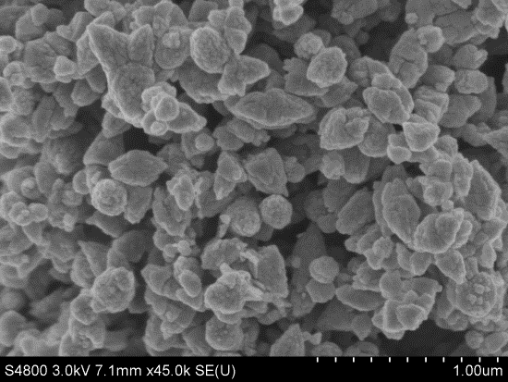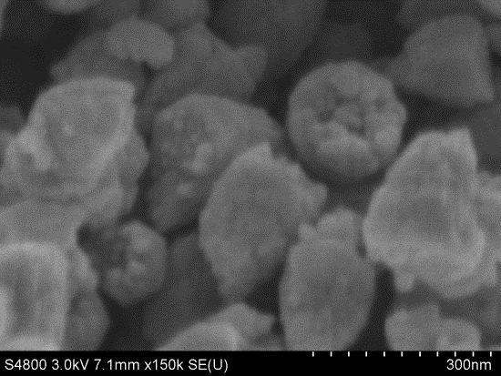

Fig. S1. FESEM images of ZnO sample synthesized with 50% water content in mixture solvents.

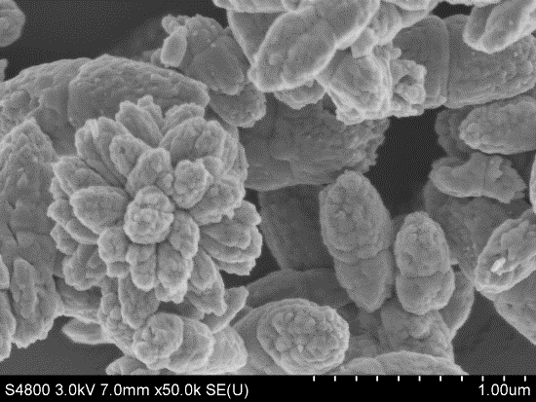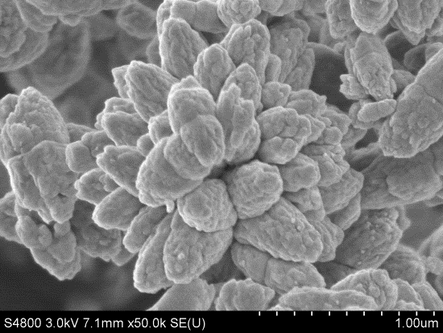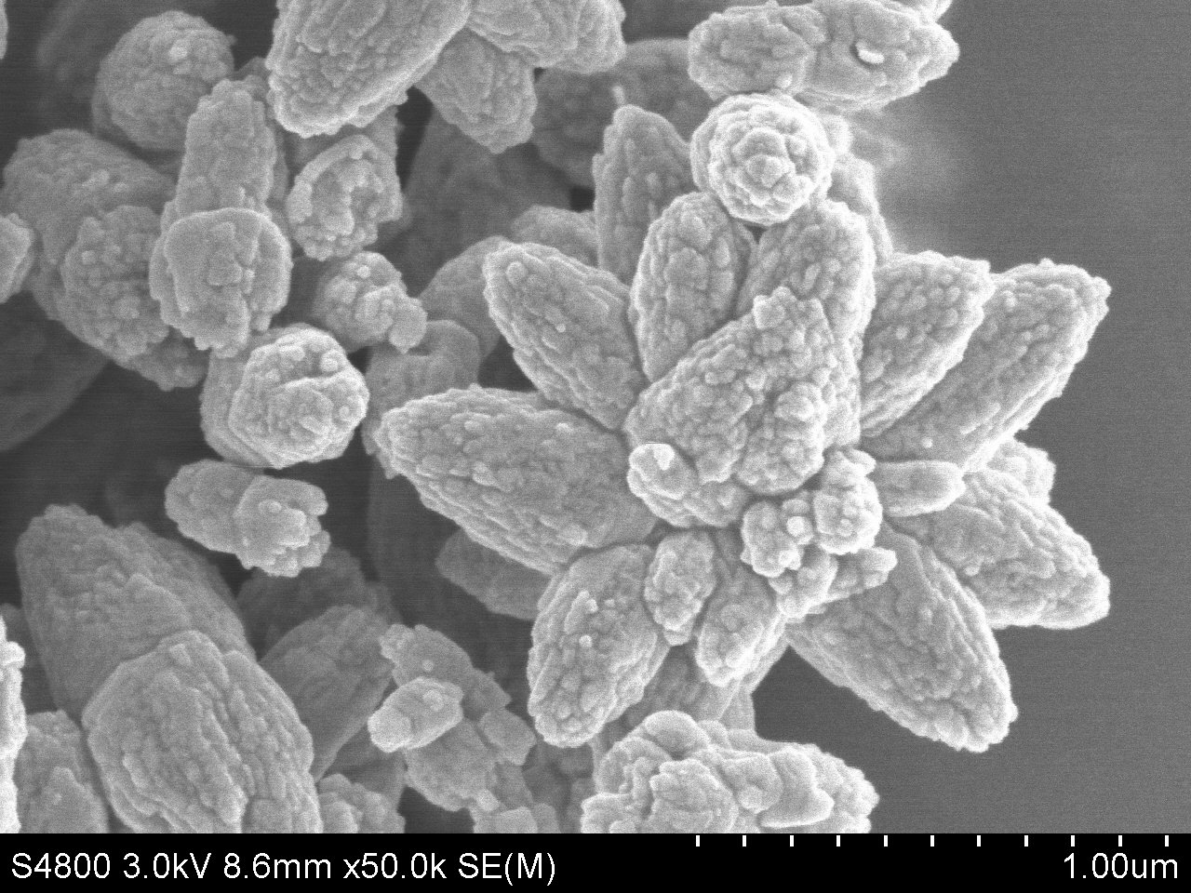

**(d)**

**(a)**

**(c)**

**(b)**

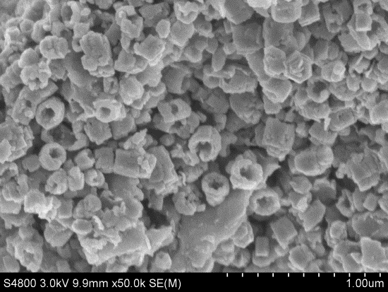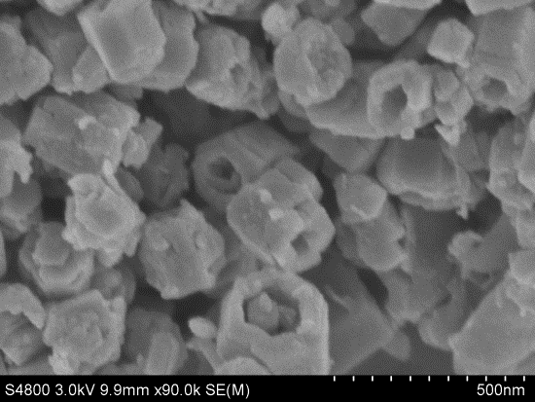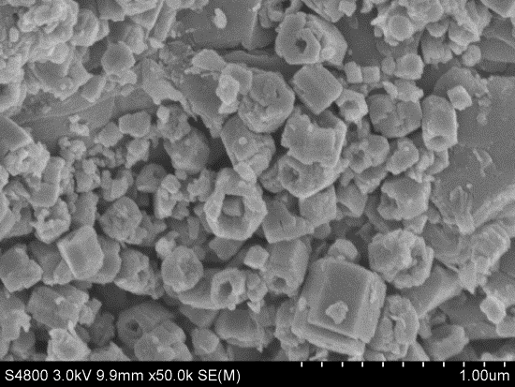

**(e)**

**(f)**

Fig. S2. FESEM images of (a, b, c) flower-like ZnO and (d, e, f) hexagonally ring-like ZnO fabricated via three times of repeated experiment, severally.

**(a)**

**(c)**

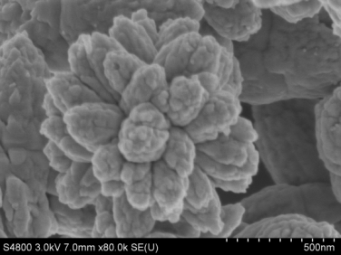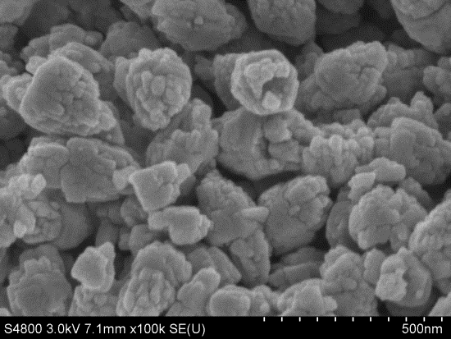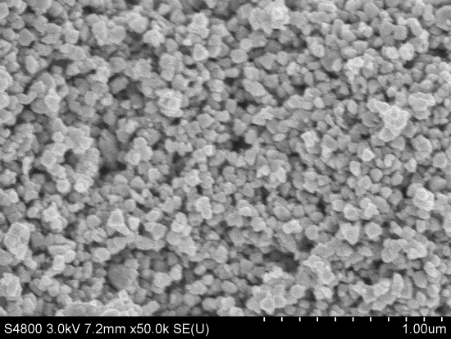

**(b)**

Fig. S3. FESEM images of ZnO samples fabricated in 10% water content via the following three operations: (a) triethylamine joined directly; (b) triethylamine added dropwise; (c) solution of zinc acetate dihydrate added dropwise.

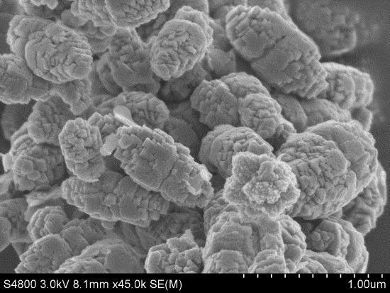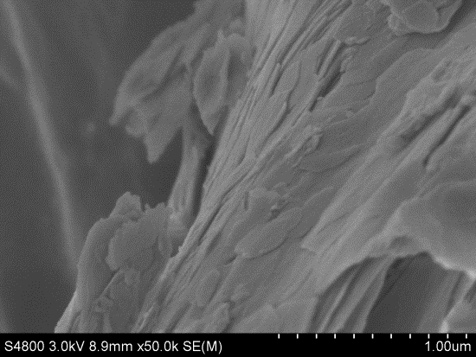

**(a)**

**(b)**

**(c)**

Fig. S4. FESEM images of ZnO samples fabricated in 0% water content via the following three operations: (a) triethylamine joined directly; (b) triethylamine added dropwise; (c) zinc acetate dihydrate powder added dropwise.



Fig. S5. XRD pattern of the laminar product fabricated in 0% water content via zinc acetate dihydrate powder added dropwise.