**Supplementary figures and tables**

**Fig. S 1 Graphical abstract**

**C:\Users\Grace\Desktop\arabian\Fig.1.tif**

**Fig. S 2 Optimization of solvents**

1: Acetonitrile, 2: Chloroform, 3: Toluene , 4: Methanol

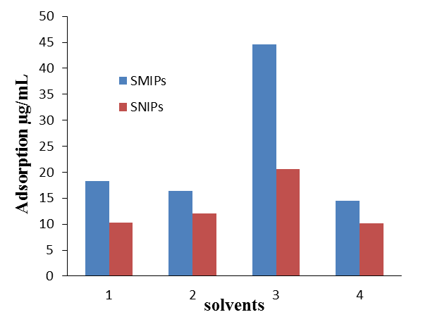

**Fig. S 3 Chemical structures for selectivity test**

1: griseofulvin, 2: fluconazole, 3: clotrimazole, 4: ketoconazole, 5: dehydrogriseofulvin, 6: naproxen, 7: dexamethasone

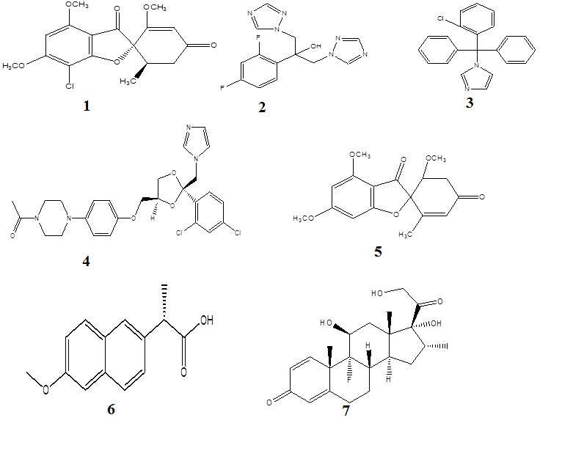

**Fig. S 4 Reuse-ability of SMIPs**

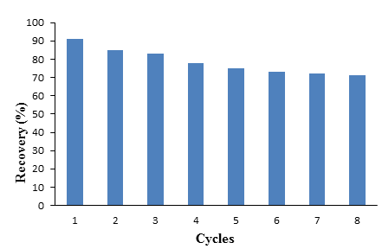

**Table. S1 Optimization of SMIPs**

|  |  |  |  |  |  |  |
| --- | --- | --- | --- | --- | --- | --- |
| **Polymers** | **Molar ratio of GSF: MAA:EDMA** | **AIBN**  **(mg)** | **Toluene**  **(mL)** | **QSMIPs**  **(µg/mg)** | **QSNIPs**  **(µg/mg)** | **IF** |
| SMIPs-A | 1:2:8 | 16.4 | 20 | 15.2 | 10.2 | 1.4 |
| SMIPs-B | 1:3:8 | 16.4 | 20 | 18.4 | 12.3 | 1.4 |
| SMIPs-C | 1:4:8 | 16.4 | 20 | 32.7 | 19.3 | 1.6 |
| SMIPs-D | 1:5:8 | 16.4 | 20 | 30.5 | 20.5 | 1.4 |
| SMIPs-E | 1:4:9 | 16.4 | 20 | 33.5 | 20.4 | 1.6 |
| SMIPs-F | 1:4:10 | 16.4 | 20 | 44.5 | 20.5 | 2.2 |
| SMIPs-G | 1:4:11 | 16.4 | 20 | 35.6 | 21.6 | 1.6 |