**Fractal evolution of dual pH- and temperature-responsive P(NIPAM-co-AA)@BMMs with bimodal mesoporous silica core and coated-copolymer shell during drug delivery procedure via SAXS characterization**

Jiayu Maa, Jihong Suna*, Li Fanb*, Shiyang Baia, Hamida Panezaia, Yuwen Jiaob

a Beijing Key Laboratory for Green Catalysis and Separation, Department of Chemistry and Chemical Engineering, Beijing University of Technology, Beijing, 100124, China

b Department of Pharmaceutical chemistry and analysis, School of Pharmacy, The Fourth Military Medical University, Xi’an, 7100032, Shaanxi Province, China

Electronic Supporting Information

**Lists of Figures and Tables captions:**

**Figure S1.** The calibrated curve of IBU concentration through HPLC analysis.

**Figure S2.** The calibrated curve of IBU concentration generated through UV analysis under different releasing media in pH value of (A) pH 2.0 and (B) pH 7.4.

**Figure S3.** TG curves of pre and after copolymer-coated samples (A), as well as drug-loaded samples (B). (a) BMMs, (b) BMMs-MPS, (c) P@BMMs(1), (d) P@BMMs(2), (e) P@BMMs(4), (f) P@BMMs(7), (g) I/P@BMMs(1)-48, (h) I/P@BMMs(2)-48, (i) I/P@BMMs(4)-48, and (j) I/P@BMMs(7)-48.

**Figure S4.** FT-IR spectra of (a) BMMs, (b) BMMs-MPS, (c) P@BMMs(7), (d) I/P@BMMs(7)-48, (e) I/P@BMMs(7)-48-24 obtained after release at 37 oC in pH 2.0, (f) I/P@BMMs(7)-48-24 obtained after release at 37 oC in pH 7.4, and (g) IBU.

**Figure S5.** A: SAXS patterns of I/P@BMMs(1)-48-24 and corresponding *Dm* values (inset); B: r-p(r) chart of I/P@BMMs(1)-48-24 under different conditions of drug releasing. (a) 25 oC, pH 2.0, (b) 25 oC, pH 7.4, (c) 37 oC, pH 2.0, (d) 37 oC, pH 7.4.

**Figure S6.** A: SAXS patterns of I/P@BMMs(2)-48-24 and corresponding *Dm* values (inset); B: r-p(r) chart of I/P@BMMs(2)-48-24 under different conditions of drug releasing. (a) 25 oC, pH 2.0, (b) 25 oC, pH 7.4, (c) 37 oC, pH 2.0, (d) 37 oC, pH 7.4.

**Figure S7.** A: SAXS patterns of I/P@BMMs(7)-48-24 and corresponding *Dm* values (inset); B: r-p(r) chart of I/P@BMMs(7)-48-24 under different conditions of drug releasing. (a) 25 oC, pH 2.0, (b) 25 oC, pH 7.4, (c) 37 oC, pH 2.0, (d) 37 oC, pH 7.4.

**Table S1**. Elemental composition of all related samples.

**Table S2.** The textural parameters of all related samples.

**Figure S1.**



**Figure S1.** The calibrated curve of IBU concentration through HPLC analysis

**Figure S2.**

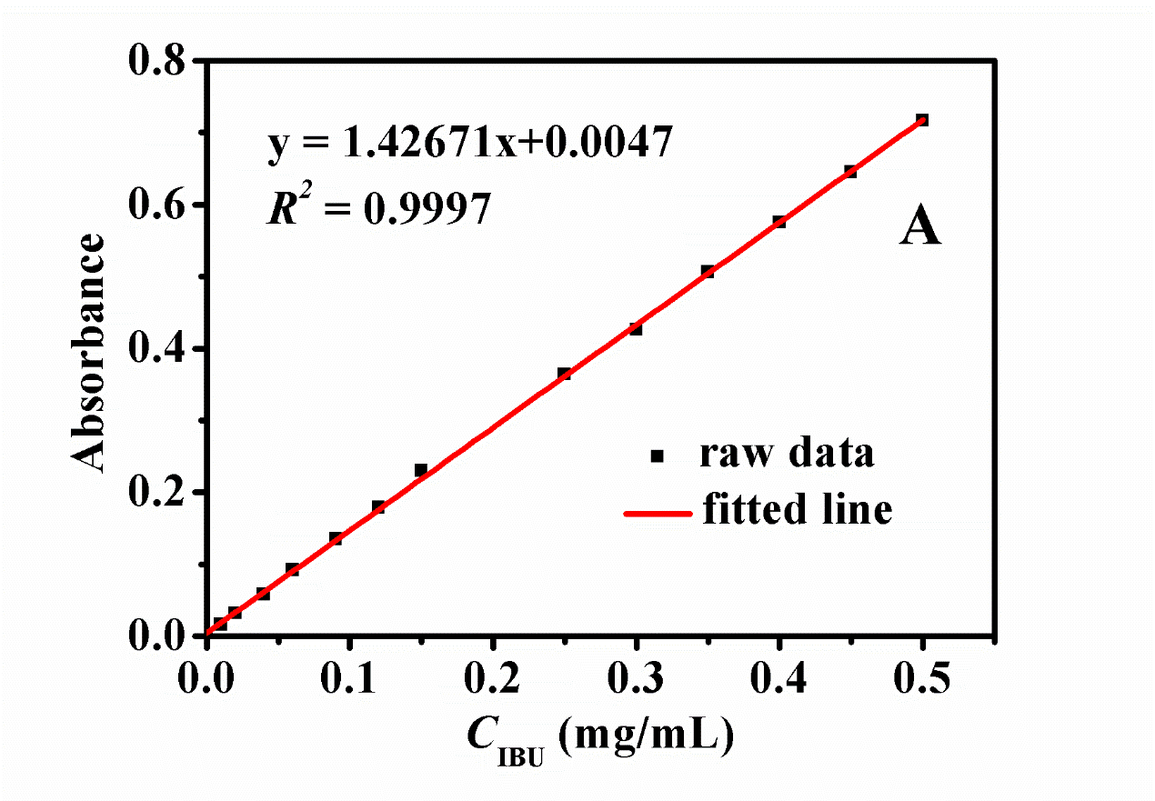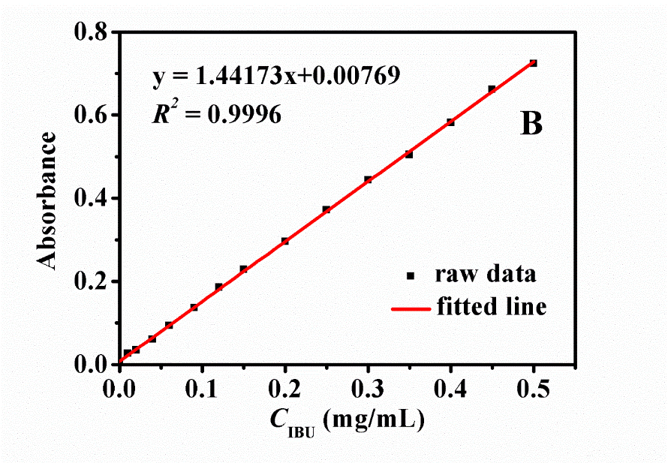

**Figure S2.** The calibrated curve of IBU concentration generated through UV analysis under different releasing media in pH value of (A) pH 2.0 and (B) pH 7.4

**Figure S3.**

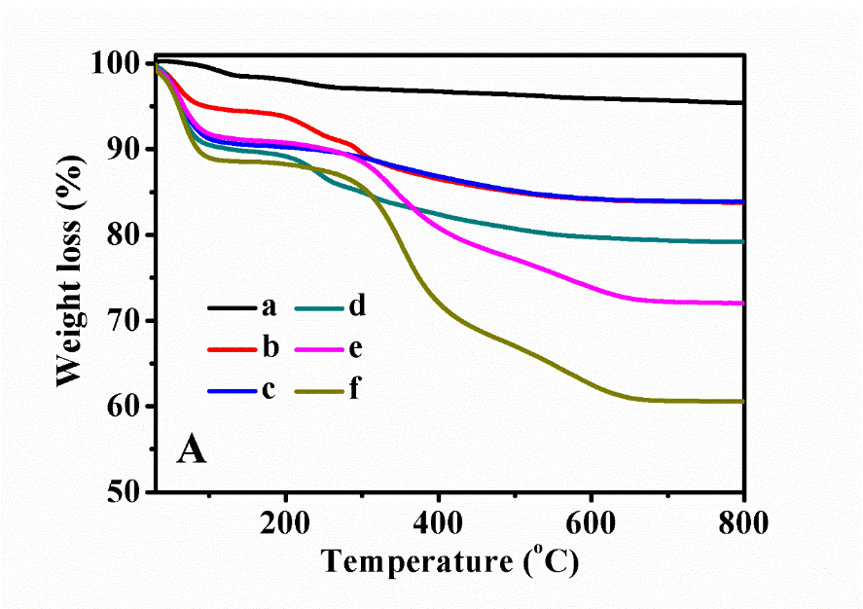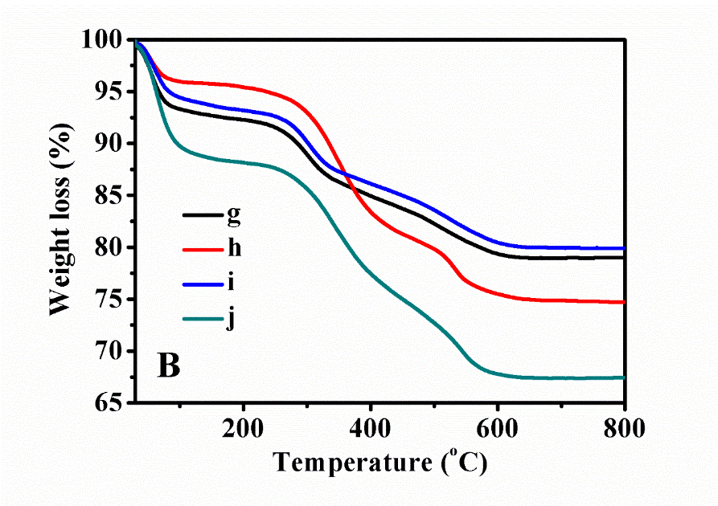

**Figure S3.** TG curves of pre and after copolymer-coated samples (A), as well as drug-loaded samples (B). (a) BMMs, (b) BMMs-MPS, (c) P@BMMs(1), (d) P@BMMs(2), (e) P@BMMs(4), (f) P@BMMs(7), (g) I/P@BMMs(1)-48, (h) I/P@BMMs(2)-48, (i) I/P@BMMs(4)-48, and (j) I/P@BMMs(7)-48

**Figure S4.**



**Figure S4.** FT-IR spectra of (a) BMMs, (b) BMMs-MPS, (c) P@BMMs(7), (d) I/P@BMMs(7)-48, (e) I/P@BMMs(7)-48-24 obtained after release at 37 oC in pH 2.0, (f) I/P@BMMs(7)-48-24 obtained after release at 37 oC in pH 7.4, and (g) IBU

**Figure S5.**

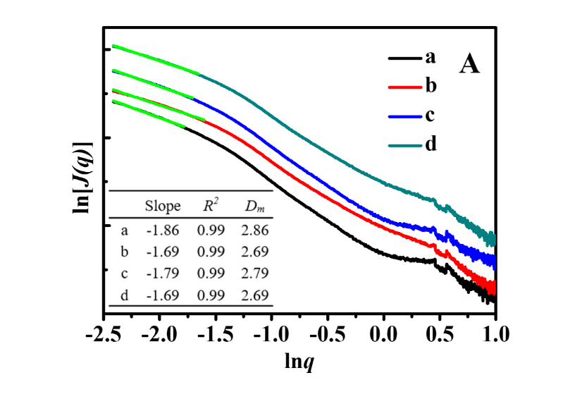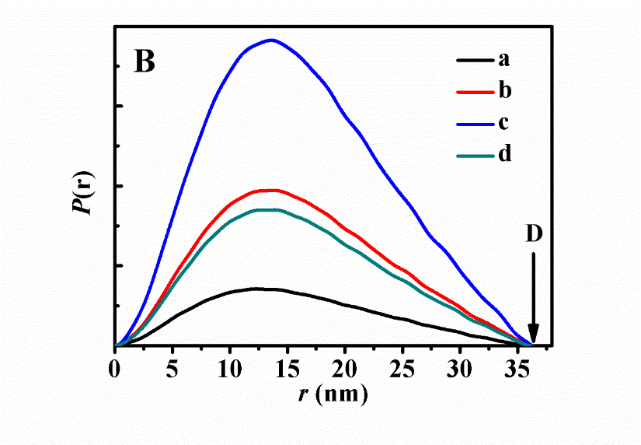

**Figure S5.** A: SAXS patterns of I/P@BMMs(1)-48-24 and corresponding *Dm* values (inset); B: r-p(r) chart of I/P@BMMs(1)-48-24 under different conditions of drug releasing. (a) 25 oC, pH 2.0, (b) 25 oC, pH 7.4, (c) 37 oC, pH 2.0, (d) 37 oC, pH 7.4

**Figure S6.**

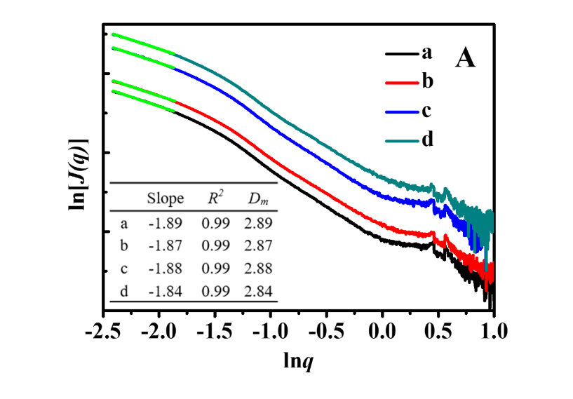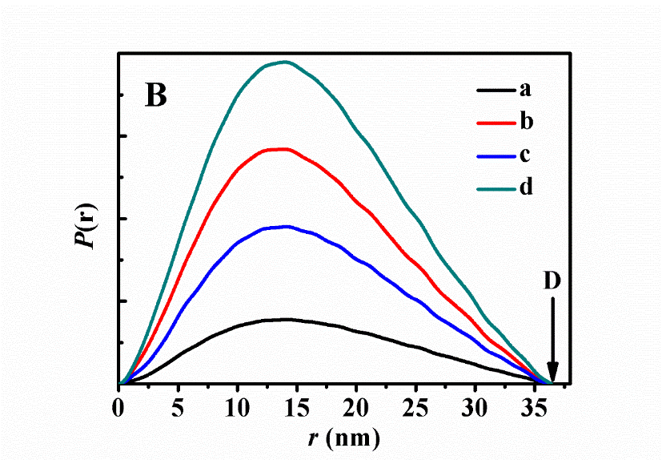

**Figure S6.** A: SAXS patterns of I/P@BMMs(2)-48-24 and corresponding *Dm* values (inset); B: r-p(r) chart of I/P@BMMs(2)-48-24 under different conditions of drug releasing. (a) 25 oC, pH 2.0, (b) 25 oC, pH 7.4, (c) 37 oC, pH 2.0, (d) 37 oC, pH 7.4

**Figure S7.**

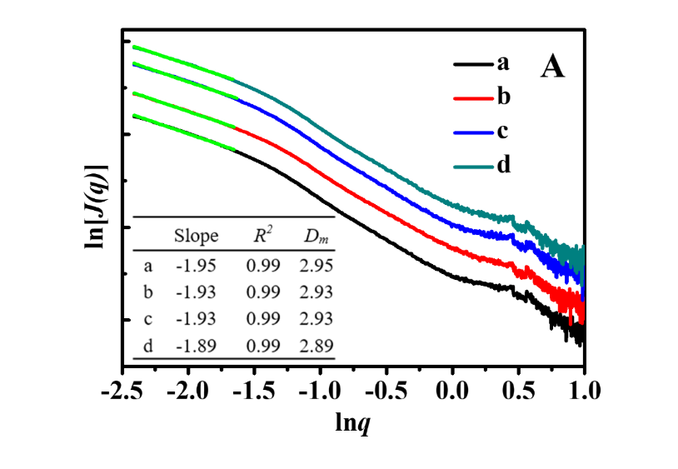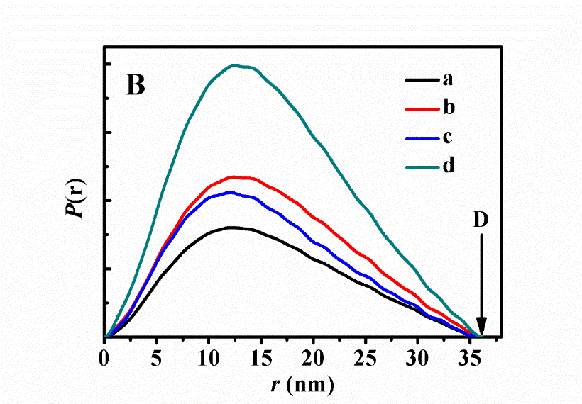

**Figure S7.** A: SAXS patterns of I/P@BMMs(7)-48-24 and corresponding *Dm* values (inset); B: r-p(r) chart of I/P@BMMs(7)-48-24 under different conditions of drug releasing. (a) 25 oC, pH 2.0, (b) 25 oC, pH 7.4, (c) 37 oC, pH 2.0, (d) 37 oC, pH 7.4

**Table S1.**

**Table S1.** Elemental composition of all related samples

|  |  |  |  |  |
| --- | --- | --- | --- | --- |
| Samples | N content (wt%) | C content (wt%) | H content (wt%) | N/C (molar ratio) |
| BMMs | 0 | 3.43 | 1.01 |  |
| BMMs-MPS | 0 | 11.65 | 5.7 |  |
| P@BMMs(1) | 1.58 | 11.67 | 5.83 | 0.12 |
| P@BMMs(2) | 2.34 | 13.18 | 7.96 | 0.15 |
| P@BMMs(7) | 4.35 | 27.36 | 10.82 | 0.14 |
| I/P@BMMs(1)-48 | 0.09 | 10.9 | 2.04 |  |
| I/P@BMMs(2)-48 | 0.14 | 10.32 | 2.26 |  |
| I/P@BMMs(4)-48 | 1.44 | 13.16 | 2.49 |  |
| I/P@BMMs(7)-48 | 1.43 | 20.42 | 3.49 |  |

**Table S2.**

**Table S2.** The textural parameters of all related samples

|  |  |  |  |  |
| --- | --- | --- | --- | --- |
| Samples | *SBET* (m2/g) | *Vp*(cm3/g)a | Small mean pore (nm)b | Large mean pore (nm)b |
| BMMs | 1073 | 1.74 | 3.04 | 19.9 |
| BMMs-MPS | 1043 | 1.74 | 3.19 | 21.1 |
| P@BMMs(1) | 1019 | 1.64 | 3.16 | 20.9 |
| P@BMMs(2) | 988 | 1.44 | 3.26 | 20.3 |
| P@BMMs(4) | 926 | 1.53 | 3.19 | 20.1 |
| P@BMMs(7) | 554 | 1.12 | 3.02 | 18.5 |
| I/P@BMMs(1)-48 | 669 | 1.29 | 2.54 | 27.7 |
| I/P@BMMs(2)-48 | 295 | 0.65 | 2.66 | 28.6 |
| I/P@BMMs(4)-48 | 587 | 1.05 | 2.52 | 33.2 |
| I/P@BMMs(7)-48 | 385 | 0.69 | 2.27 | 40.1 |

*SBET*: BET surface area. *VP*: pore volume.

a. Estimated from the amount adsorbed at a relative pressure (*P/P0*) of 0.99.

b. The pore size distribution was calculated from N2 adsorption branch of isotherm using BJH method.