**Supporting information**

**Synthesis of eco-friendly porous g-C3N4/SiO2/SnO2 nanoplates with excellent visible-light responsive photocatalysis**

Li Peng1, Ren-rong Zheng1 , Da-wei Feng2*, Hui Yu1*, Xiang-ting Dong1

*1School of Chemistry ＆ Environmental Engineering, Changchun University of Science and Technology, Changchun 130022, P. R. China.*

2*Changchun University of Science and Technology Science Park, Changchun 130022, P. R. China.*

Corresponding authors: E-mail: custkjy@163.com (Feng); yh2001101@163.com (Yu )

**Fig.S1**

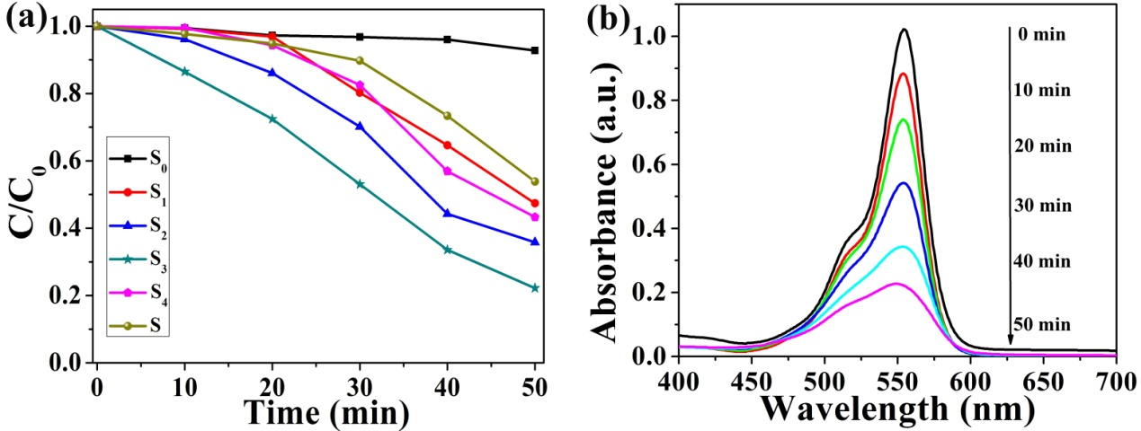

**Fig. S1** (a) Photocatalytic activity of g-C3N4/SiO2/SnO2 (S1, S2, S3, S4), SiO2/SnO2 (S0) and mechanical mixture (S) for RhB, and (b) UV-Visible absorption spectrum of RhB under catalysis of S3 in different visible light radiation time

**Table S1** MO, MB and RhB degradation cycling stability tests results of the S3 sample

|  |  |  |  |
| --- | --- | --- | --- |
| **Pollutant** | **Illumination time (min)** | **Cycle index** | **Degradation rate (%)** |
| MO | 50 | 1 | 95.58 |
| 2 | 95 |
| 3 | 94.76 |
| 4 | 94.07 |
| 5 | 93.88 |
| 6 | 92.43 |
| 7 | 91.81 |
| 8 | 91.03 |
| 9 | 89.74 |
| 10 | 88.91 |
| MB | 50 | 1 | 99.72 |
| 2 | 98.75 |
| 3 | 98.03 |
| 4 | 97.89 |
| 5 | 97% |
| 6 | 96.5 |
| 7 | 95.3 |
| 8 | 94.81 |
| 9 | 93.75 |
| 10 | 92.58 |
| RhB | 90 | 1 | 95.10 |
| 2 | 94.53 |
| 3 | 93.62 |
| 4 | 92.84 |
| 5 | 91.91 |
| 6 | 90.82 |
| 7 | 90.10 |
| 8 | 89.62 |
| 9 | 88.54 |
| 10 | 87.63 |