**Supplementary information**

**Electrochemical sensitive determination of** **acetaminophen in pharmaceutical formulations at iron oxide/graphene composite modified electrode**

Venkata Narayana Palakollua, b, c, Tirivashe E. Chiwunzec, Chen Liua, *, Rajshekhar Karpoormathc, *

*a Shenzhen Key Laboratory of Polymer Science and Technology, Guangdong Research Center for Interfacial Engineering of Functional Materials, College of Materials Science and Engineering, Shenzhen University, Shenzhen, 518055, PR China*

*b Key Laboratory of Optoelectronic Devices and Systems of Ministry of Education and Guangdong Province, College of Optoelectronic Engineering, Shenzhen University, Shenzhen, 518060, PR China*

*c Department of Pharmaceutical Chemistry, College of Health Sciences, University of KwaZulu-Natal, Westville Campus, Durban 4000, South Africa.*

*Corresponding Author

E-mail address:

[karpoormath@ukzn.ac.za](mailto:karpoormath@ukzn.ac.za) (R. Karpoormath)

[liuchen@szu.edu.cn](mailto:liuchen@szu.edu.cn) (C. Liu)

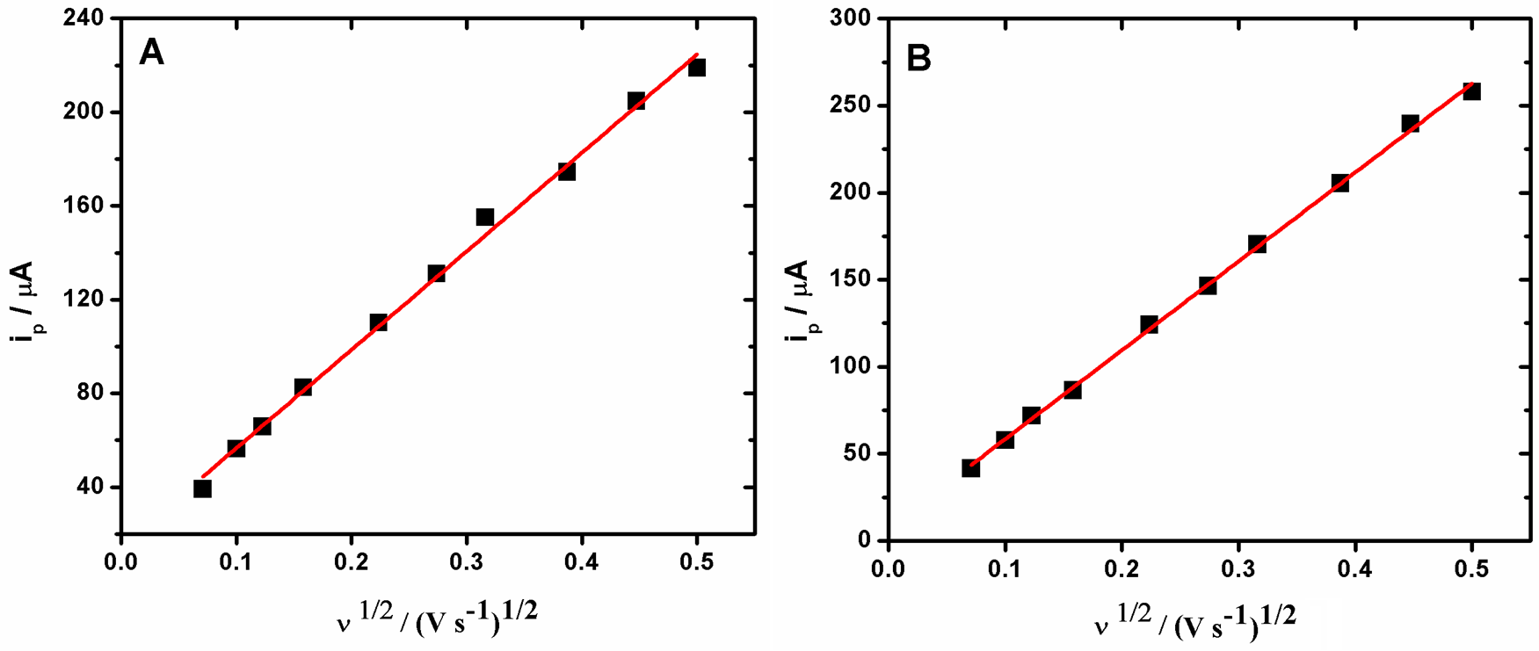

Fig. S1. Calibration plot for the anodic peak current of of 0.1 M KCl containing 2.5mM K3[Fe(CN)6] vs the square root of scan rate at (A) RGO/GCE (B) Fe2O3/RGO/GCE

E:\UKZN- RESEARCH\Submitted\Measurement\PC paper- Electrocatalysis\new images\interference.tif

Fig. S2. Cyclic voltammetric responses of Fe2O3/RGO/GCE for 50 µM AC in 0.1 M PBS (pH 4.0) in presence of various interfering compounds.

E:\UKZN- RESEARCH\PUBLISHED\Arabian Journal of Chemistry\PC paper- Electrocatalysis\new images\stability.tif

Fig. S3. Cyclic voltammetric responses of Fe2O3/RGO/GCE for 50 µM AC in 0.1 M PBS (pH 4.0) in terms of stability

E:\UKZN- RESEARCH\Submitted\Measurement\Supply\supply data\reproduce.tif

Fig. S4. Cyclic voltammetric responses of Fe2O3/RGO/GCE for 50 µM AC in 0.1 M PBS (pH 4.0) in terms of reproducibility for 3 different electrodes under same experimental conditions

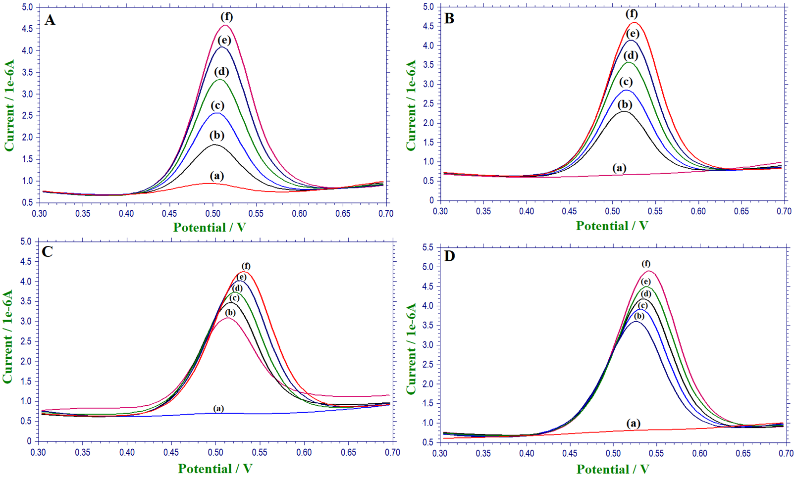

Fig. S5. Cyclic voltammetric responses of Fe2O3/RGO/GCE for standard addition of ( a) blank (b) 5 µM, (c) 10 µM, (e) 15 µM and (f) 20 µM of AC standard sample for (A) 5 µM, (B) 10 µM, (C) 20 µM and (D) 30 µM tablet sample in 0.1 M PBS (pH 4.0).

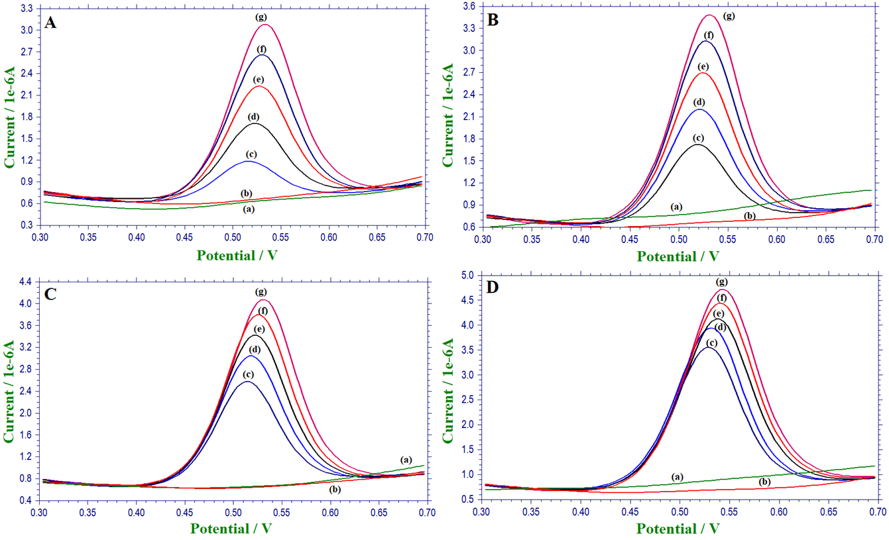

Fig. S6. Cyclic voltammetric responses of Fe2O3/RGO/GCE for standard addition of ( a) blank (b) urine sample (c) 5 µM, (d) 10 µM, (f) 15 µM and (g) 20 µM of AC standard sample for (A) 5 µM, (B) 10 µM, (C) 20 µM and (D) 30 µM AC spiked sample in 0.1 M PBS (pH 4.0).