**A Mononuclear Copper(II) Complex Containing Benzimidazole and Pyridyl Ligands: Synthesis, Characterization, and Antiproliferative Activity against Human Prostate Cancer Cell**

**Sedat Kacar1*, Hakan Unver2, Varol Sahinturk1**

1 Sedat Kacar - Department of Histology and Embryology, Faculty of Medicine, Eskisehir Osmangazi University, Eskisehir, Turkey. E-mail: [skacar@ogu.edu.tr](mailto:skacar@ogu.edu.tr)

2 Hakan Unver - Chemistry Department, Faculty of Science, Eskisehir Technical University, 26470, Eskisehir, Turkey. [hakanunver@eskisehir.edu.tr](mailto:hakanunver@eskisehir.edu.tr)

1 Varol Sahinturk - Department of Histology and Embryology, Faculty of Medicine, Eskisehir Osmangazi University, Eskisehir, Turkey. E-mail: [varols@ogu.edu.tr](mailto:varols@ogu.edu.tr)

\***Corresponding author**: Sedat Kacar, Department of Histology and Embryology, Faculty of Medicine, Eskisehir Osmangazi University, Eskisehir, Turkey. E-mail: skacar@ogu.edu.tr Telephone number: +90 222 239 29 79, Ext. 4469

|  |  |
| --- | --- |
| Entry | Title |
| 1 | **Figure S1**. BenzimCF3 ligand FT-IR Spectrum |
| 2 | **Figure S2.** Copper (II) complex FT-IR Spectrum |
| 3 | **Figure S3.** Single crystal x-ray structure of copper (II) complex |
| 4 | **Figure S4.** 1H-NMR spectrum of copper (II) complex |
| 5 | **Figure S5.** Fluorescence spectrum of copper (II) complex |



**Figure S1**. BenzimCF3 ligand FT-IR Spectrum



**Figure S2.** Copper (II) complex FT-IR Spectrum

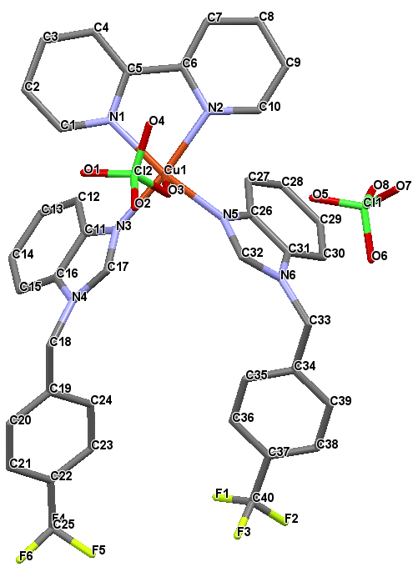

**Figure S3.** Single crystal x-ray structure of copper (II) complex

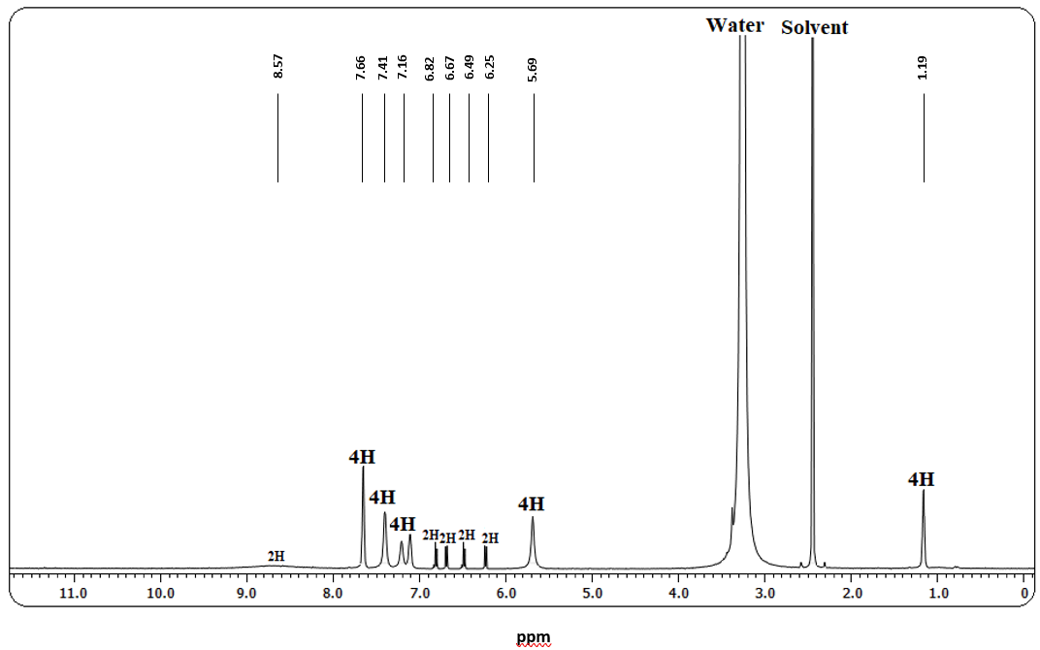

**Figure S4.** 1H-NMR spectrum of copper (II) complex

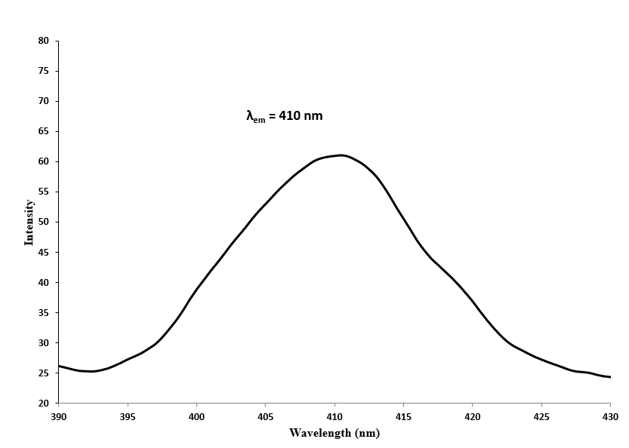

**Figure S5.** Fluorescence spectrum of copper (II) complex in DMSO at 298 K. (λex = 360 nm)