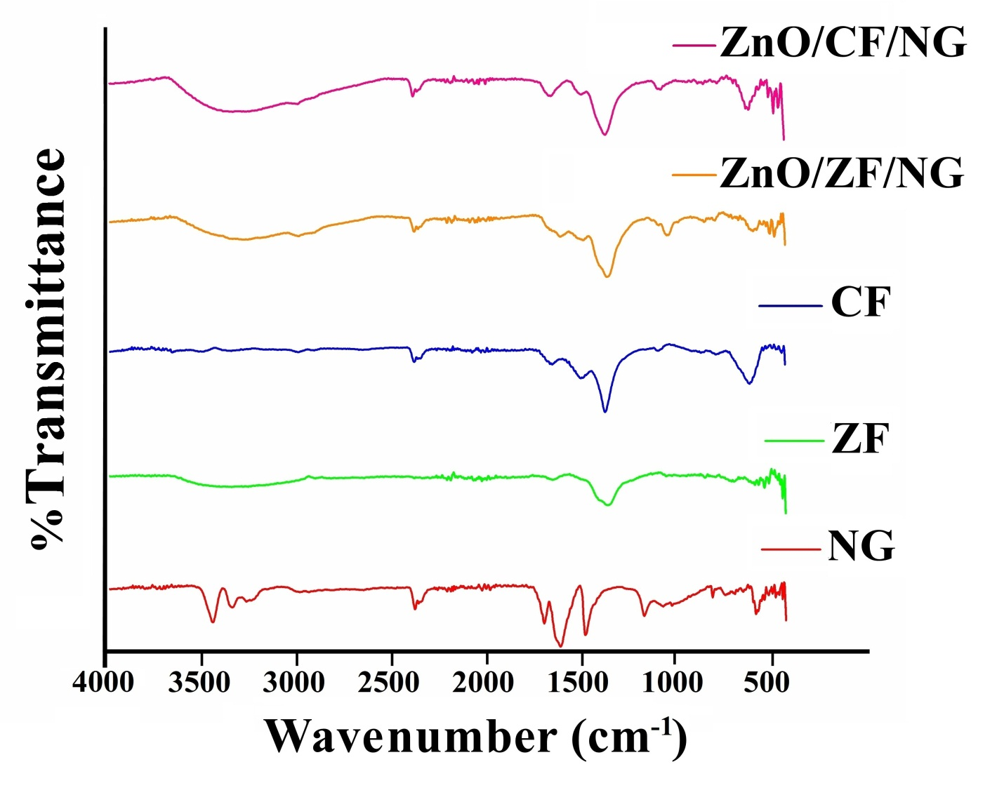

**Fig. S1:** FTIR spectra of NG, ZF, CF, ZnO/ZF/NG and ZnO/CF/NG nanocomposite.

**G:\Kirti paper complied\Fgure\Figures\uv\uv tauc plot.tif**

**Fig. S2:** UV–visible absorption spectra of sample CF, ZF and NG (a), Tauc plot showing band gap of ZnO (b), ZF(c) and CF (d).

C:\Users\abc\Desktop\PL deg.tif

**Fig. S3:** Photoluminescence spectra of CF, ZF, ZnO, ZnO/CF/NG and ZnO/ZF/NG photocatalysts.

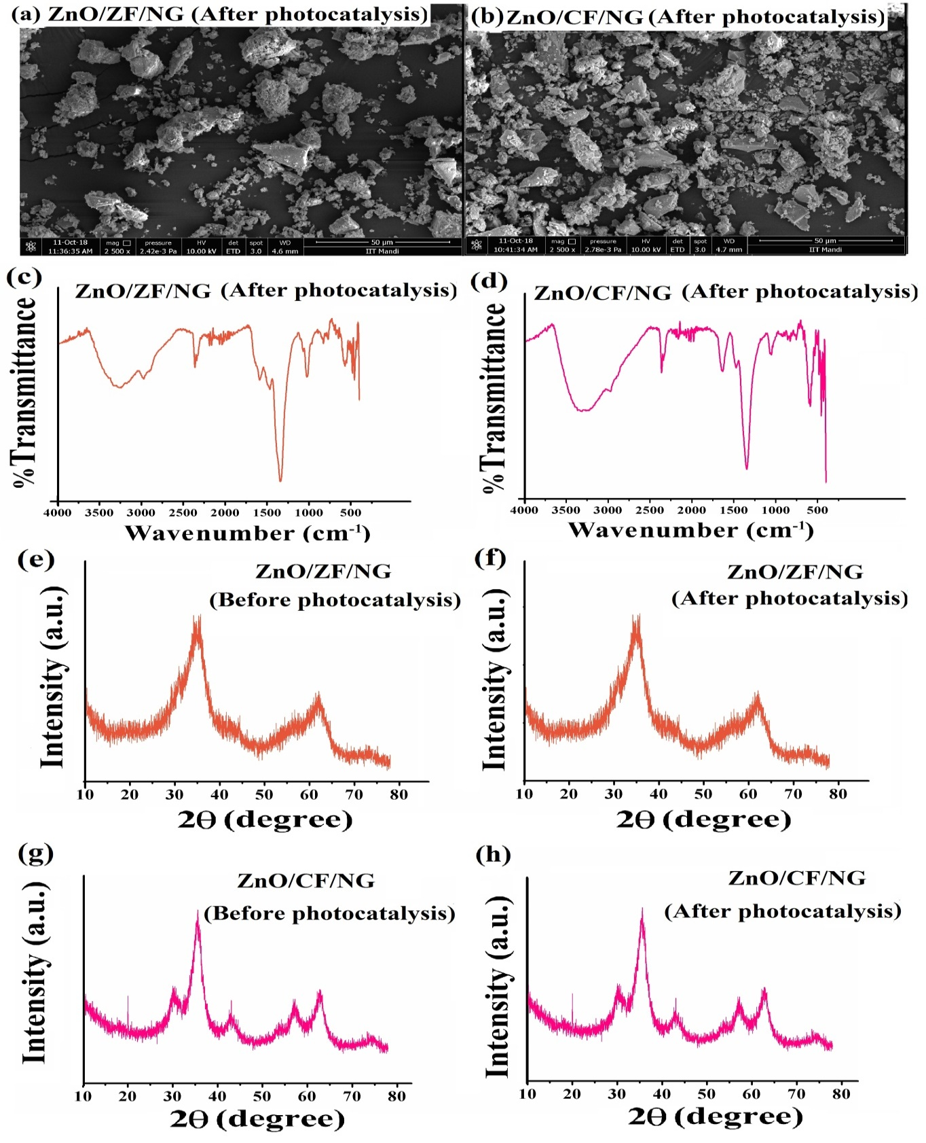

**Fig. S4: SEM, FTIR and XRD results before and after photocatalytic degradation of MO and MG using ZnO/ZF/NG and ZnO/CF/NG nanocomposites.**