Supplementary Material

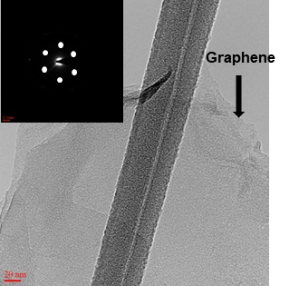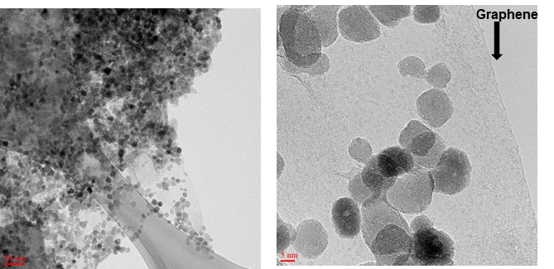

FigureS1. (a) HR-TEM image of Graphene (inset : SAED pattern), (b),(c ) HR-TEM images of aerogel with different magnification.

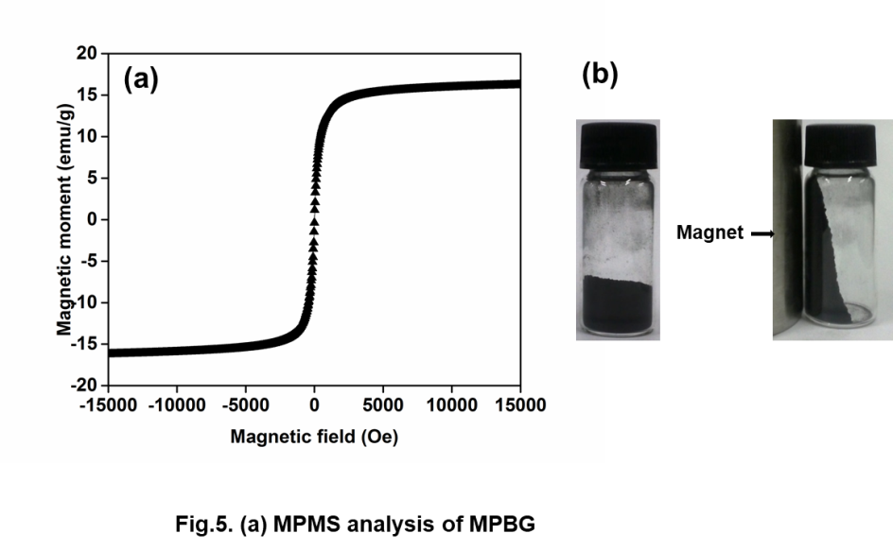

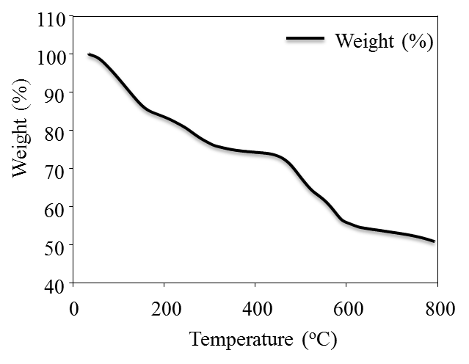FigureS2.(a) MPMS analysis of 3D-MPBRGO and its attraction by external magnet (b).

FigureS3.(a) TGA analysis of 3D-MPBRGO

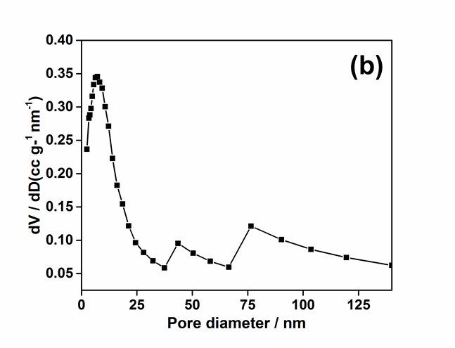

**(a)**

Figure S4. **a) N2 adsorption/desorption isotherm and (b) BJH (Barret-Joyner-Halenda) pore size distribution curves for 3D-MPBRGO aerogel analysis.**

Table S1. BET and pore size values from BET and BJH plot

|  |  |  |  |  |  |  |
| --- | --- | --- | --- | --- | --- | --- |
| **BET plot** | | | | | | |
| Vm | |  | 92.52 | [cm3(STP) g-1] | |  |
| as, BET | |  | **402.68** | **[m2 g-1]** | |  |
| Total pore volume (p/p0=0.990) | | | 0.44 | [cm3 g-1] | |  |
| Mean pore diameter | | | 4.34 | [nm] | |  |
| **BJH plot** | | | | | | |
| Vp |  | | 0.37 | [cm3 g-1] |  | |
| dp,peak |  | | 7.2 | [nm] |  | |

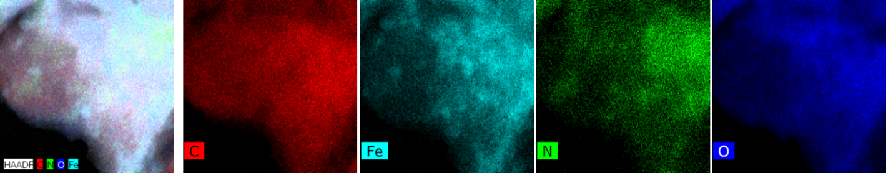

Figure S5. **HR-TEM EDX surface analysis of aerogel before Cesium ion adsorption**

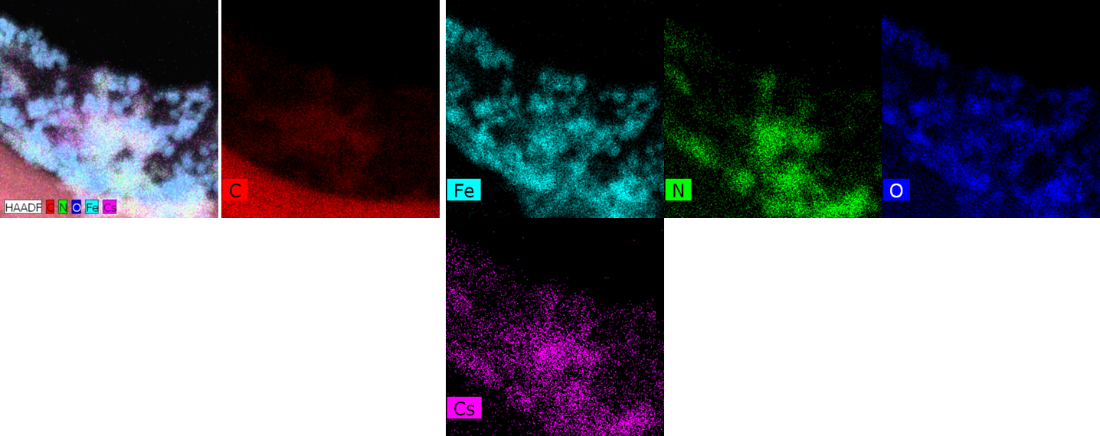

Figure S6. **HR-TEM EDX surface analysis of aerogel after Cesium ion adsorption**

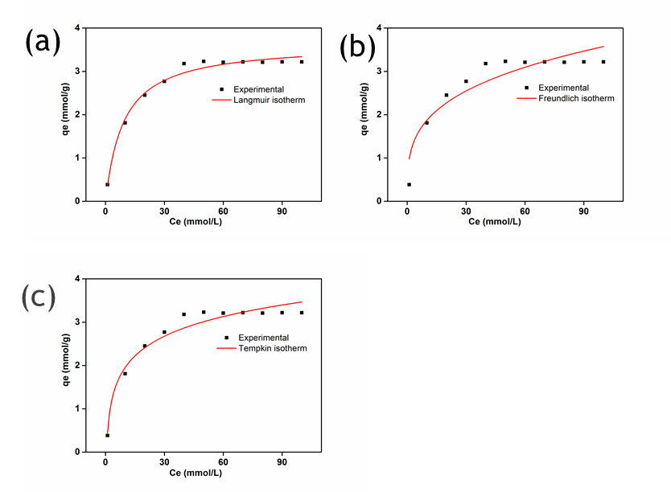

Figure S7. Adsorption isotherm study (a) Langmuir (b) Freundlich (c) Tempkin isotherm