**Efficient photocatalytic treatment of sugar mill wastewater with 2%Ag3PO4/Fe/GTiP nanocomposite**

Noor Ahmed Nahyoon**a**, Lifen Liu**a\***, Waseem Saleem**b**, Sarwan Ahmed Nahyoon**b**, Kané Rabé **a**

**a**Key Laboratory of Industrial Ecology and Environmental Engineering (MOE), School of Environmental Science and Technology, Dalian University of Technology, Dalian 116024. China.

**b** Center of Advance Studies in Water, Mehran University of Engineering and Technology, Jamshoro, Pakistan.

Email: lifenliu@dlut.edu.cn

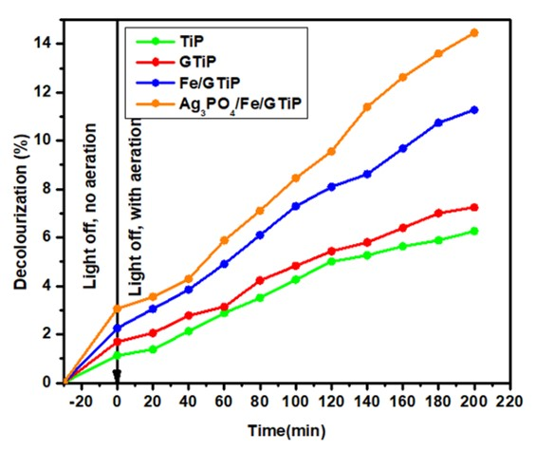

Fig. S1. The decolorization of sugar mill wastewater treated with TiP, GTiP, Fe/GTiP, and 2%Ag3PO4/Fe/GTiP under without light at initial pH-9.5 with catalyst dosage of 50mg/75 ml.

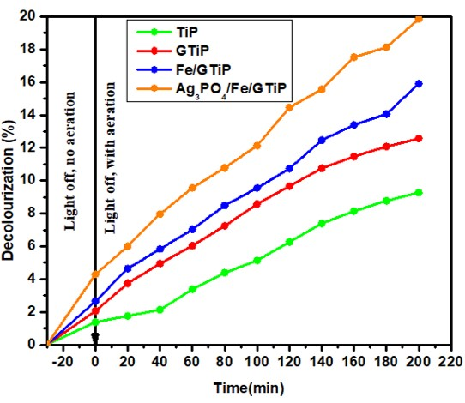

Fig. S2. The decolorization of sugar mill wastewater treated with TiP, GTiP, Fe/GTiP, and 2%Ag3PO4/Fe/GTiP under without light at initial pH-9.5 with catalyst dosage of 100mg/75 ml.

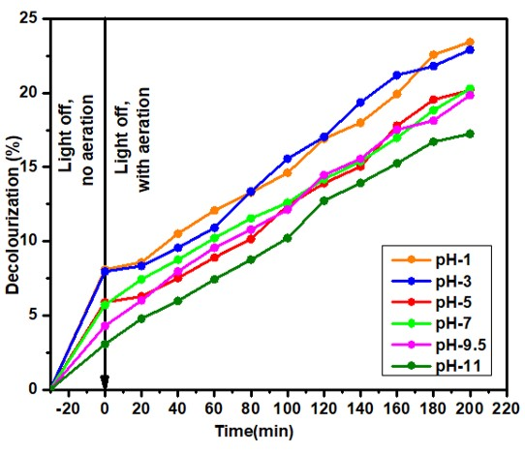

Fig. S3. The decolorization of sugar mill wastewater treated with 2%Ag3PO4/Fe/GTiP catalyst dosage of 100mg/75 ml under without light at different pH.