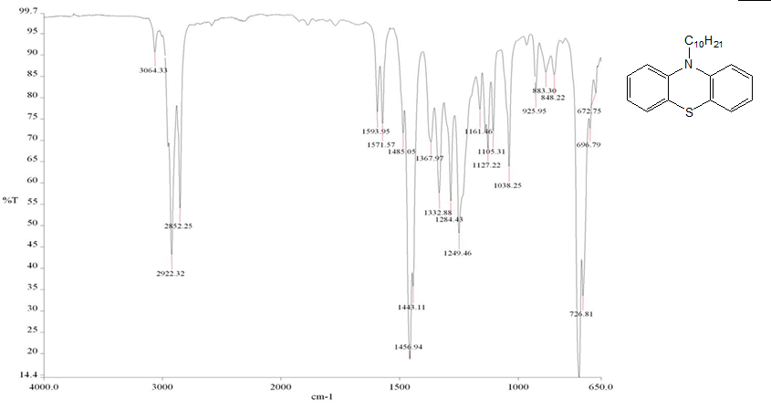

IR of 10-decyl-10 H-phenothiazine **(I).**

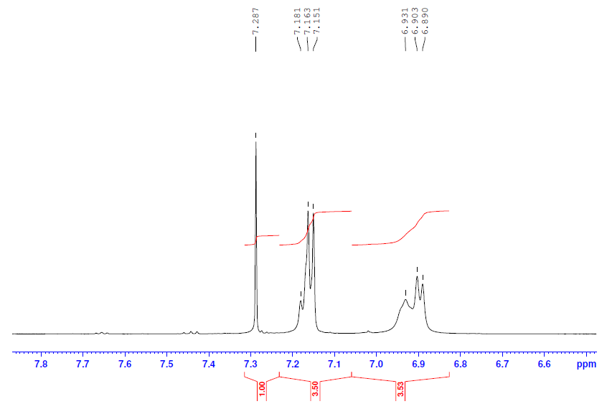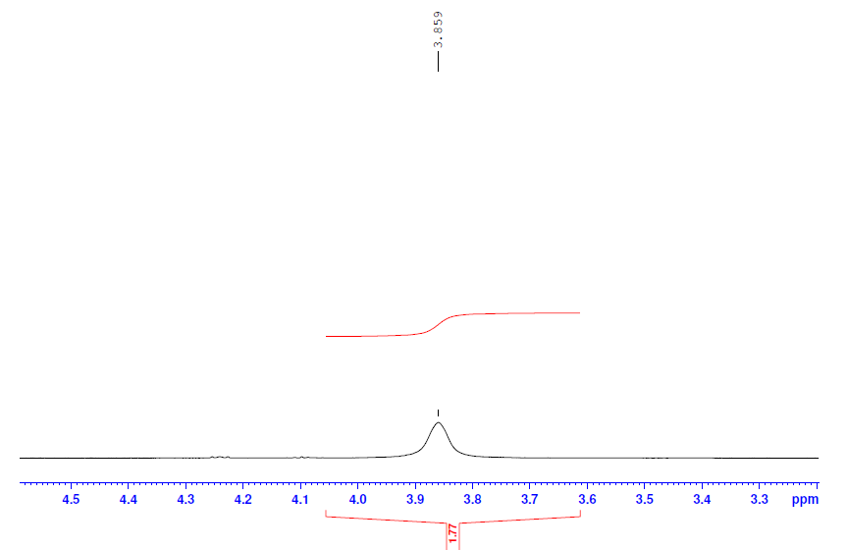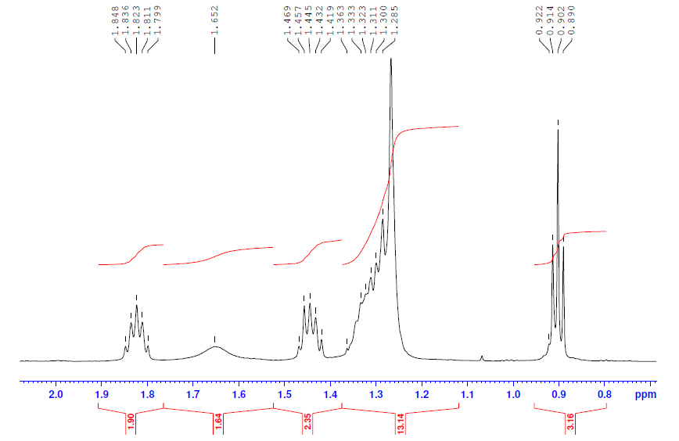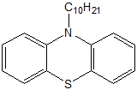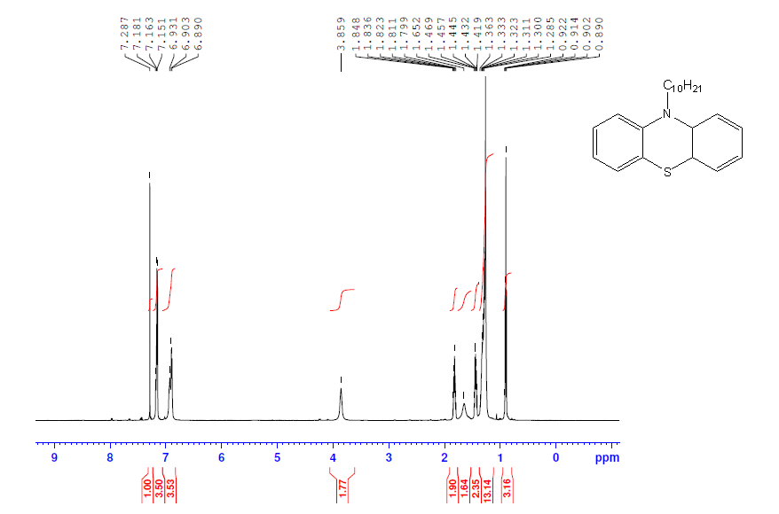

1H NMR of 10-decyl-10 H-phenothiazine **(I).**

****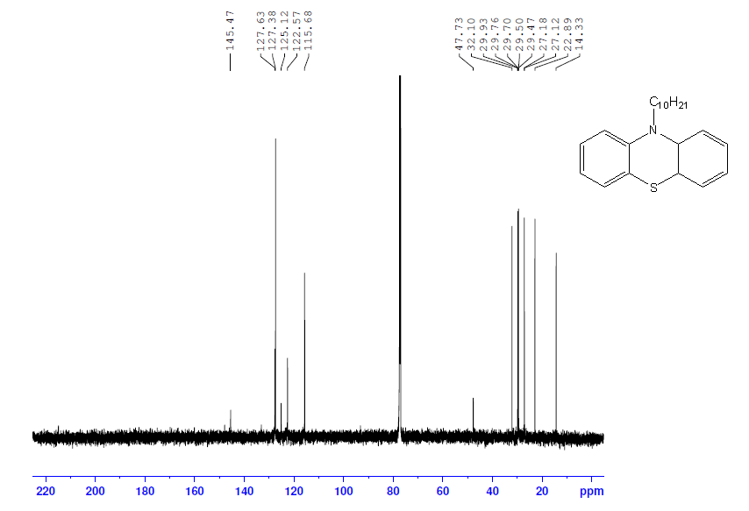

13C NMR of 10-decyl-10 H-phenothiazine **(I).**

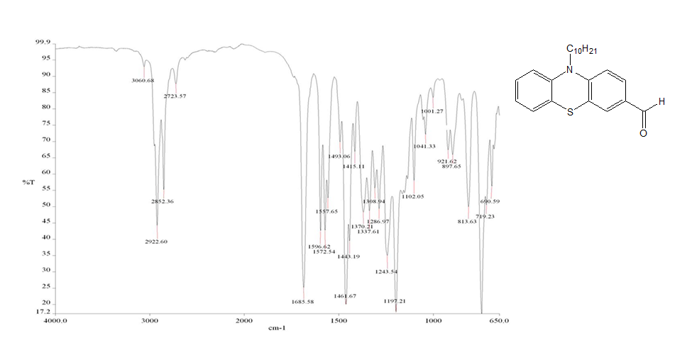

**Fig.2.** Dept of 10-octyl-10 H-phenothiazine-3-carbaldehyde **(IIIb).**

IR of 10-decyl-10 H-phenothiazine-3-carbaldehyde **(II).**

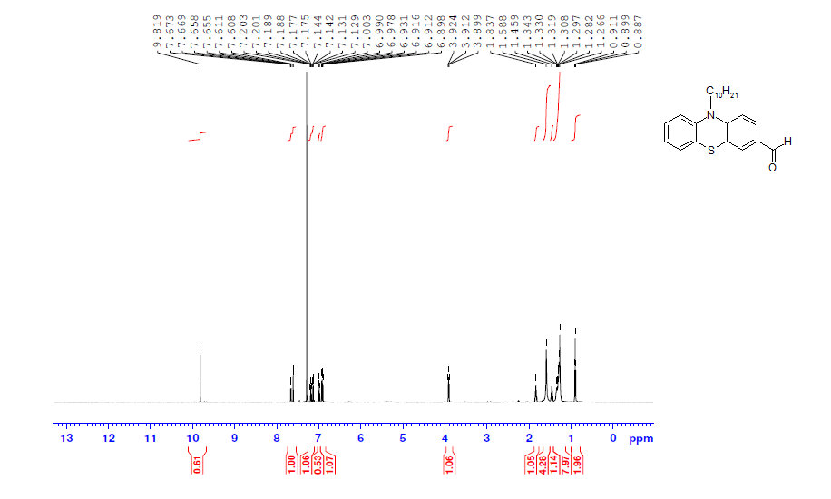

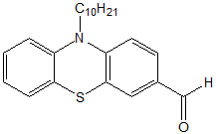

1H NMR of 10-decyl-10 H-phenothiazine-3-carbaldehyde **(II).**

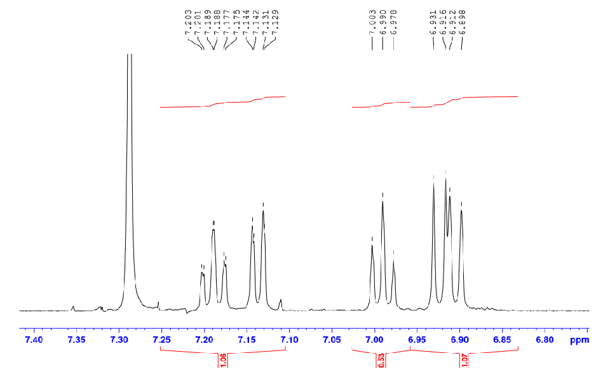

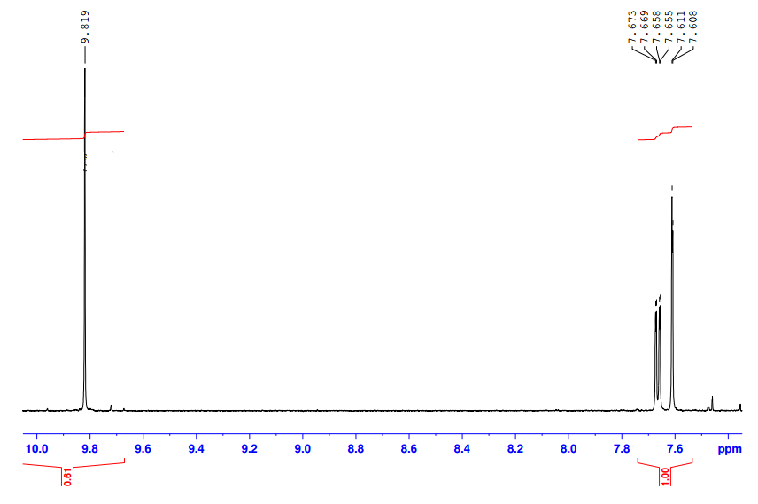

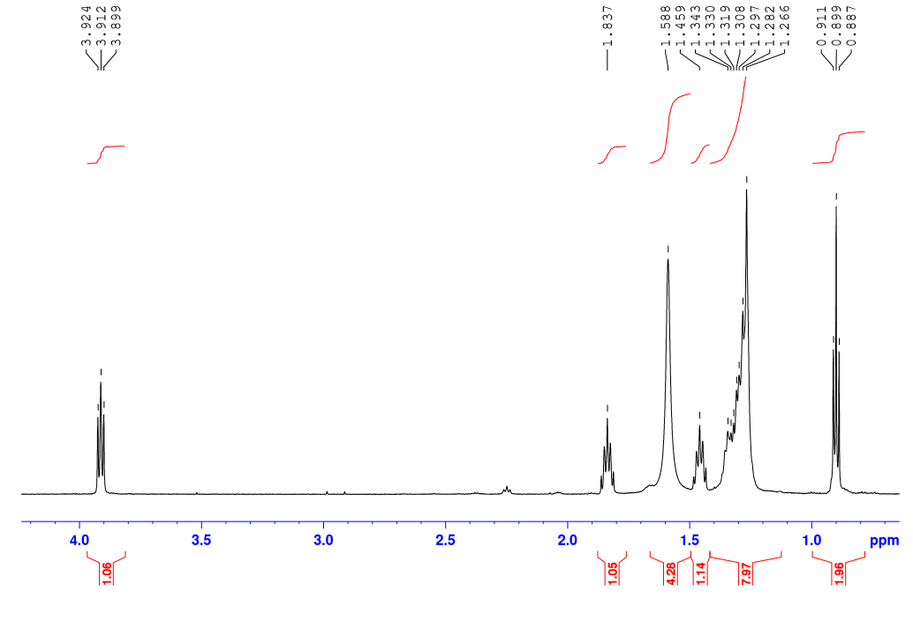



**(IIIc).**

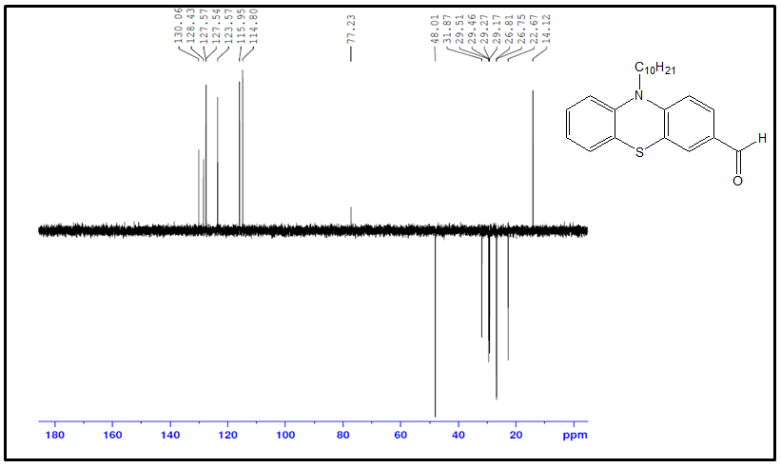

**Figure** خطأ! لا يوجد نص من النمط المعين في المستند..7**:** Dept of 10-decyl-10 H-phenothiazine-3-carbaldehyde **(IIc).**

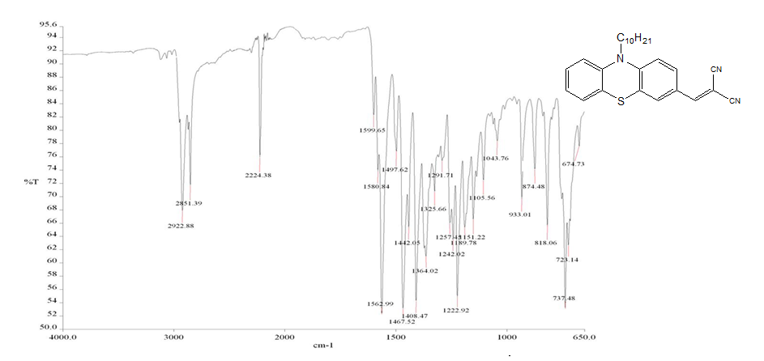

IR of 2-((10-decyl-10H-phenothiazin-3-yl)methylene)malononitrile **( III).**

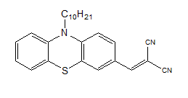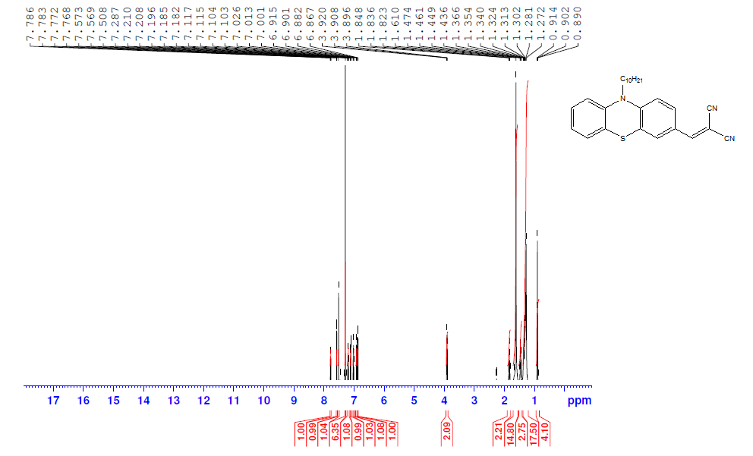

1H NMR of 2-((10-decyl-10H-phenothiazin-3-yl)methylene)malononitrile **(III).**

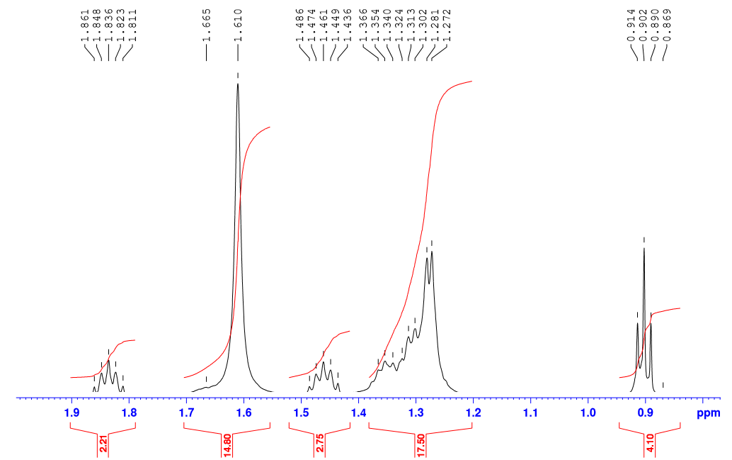

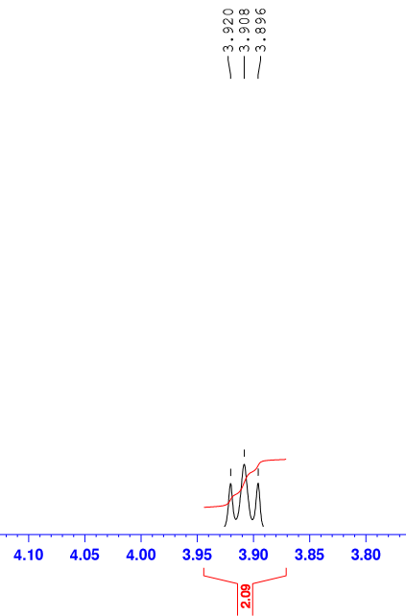

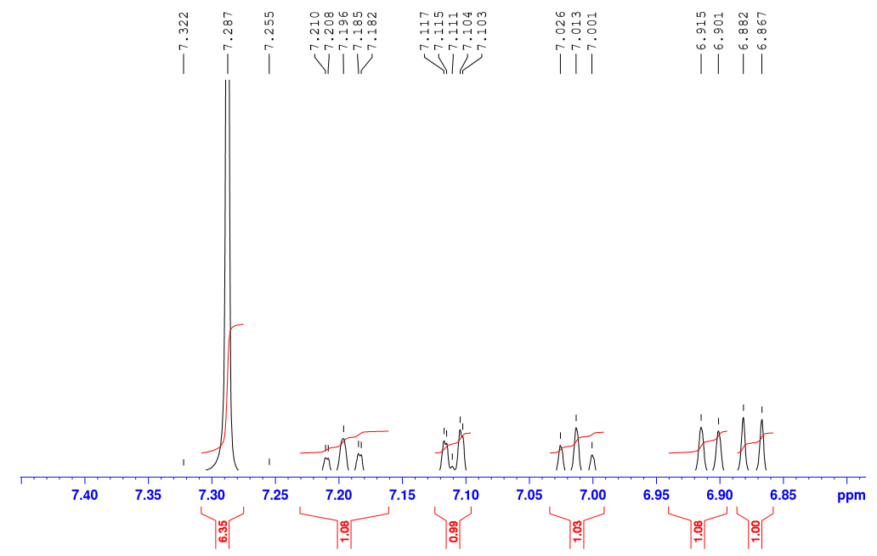

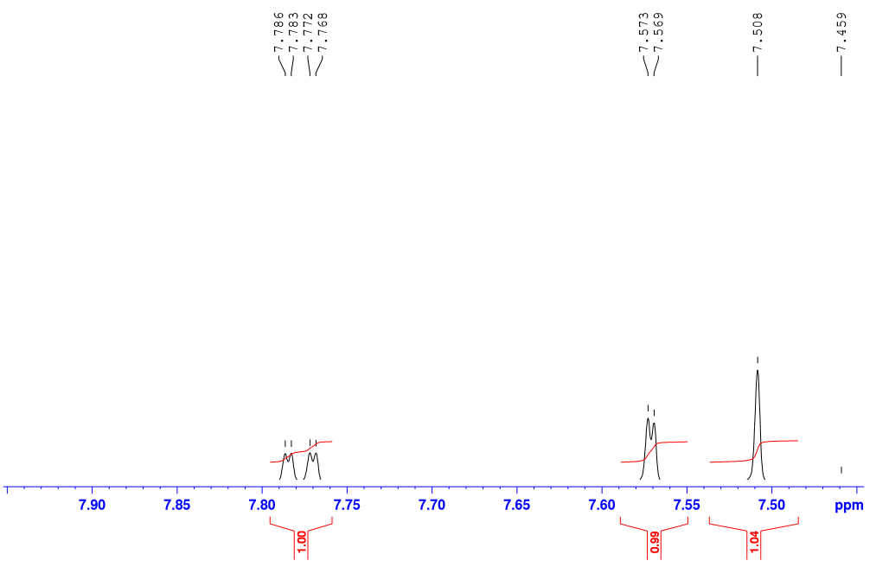

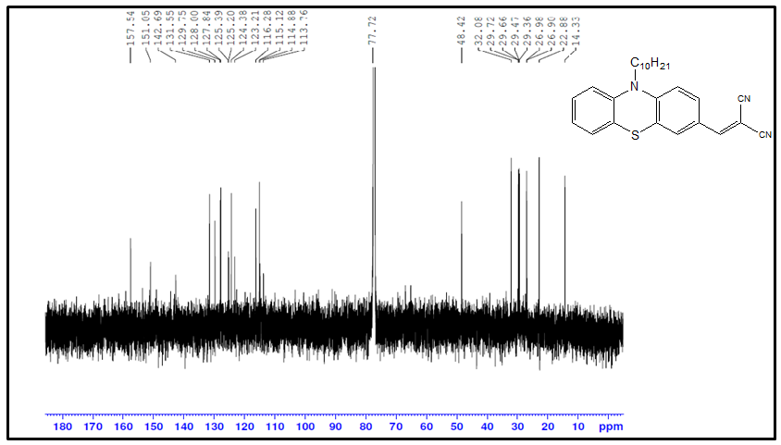

13C NMR of 2-((10-decyl-10H-phenothiazin-3-yl)methylene)malononitrile **(III)**.

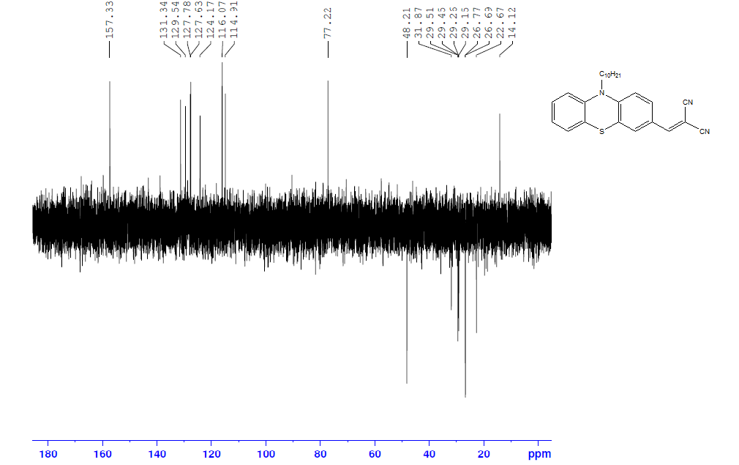

Dept of 2-((10-decyl-10H-phenothiazin-3-yl)methylene)malononitrile **( III).**

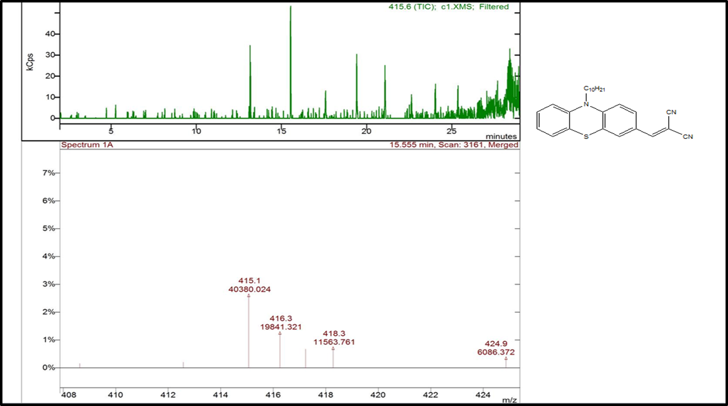

Mass of 2-((10-decyl-10H-phenothiazin-3-yl)methylene)malononitrile **(III).**

Effect of pH on the rate of photocatalytic decolorization of 2-((10-decyl-10H-phenothiazin-3-yl)methylene)malononitrile **(III).**