**Supplementary data**

**Plant Polyphenolics as Prominent Natural Antioxidants: DFT based Structure Activity Relationship Studies**

**Contents:**

* Spectral data of isolated compounds
* **Fig. S1** IUPAC numbering of isolated compounds *Shorea tumbuggaia* (ST) and

*Syzygium alternifolium* (SA).

* **Fig. S2** Frontier molecular orbitals of isolates
* **Fig. S3-S43:** Spectra of isolated componds
* **Fig. S44** Binding interactions of isolated compounds with active site residues of SH3 domain of NADPH.
* **Fig. S45** Binding interactions of isolated compounds with active site residues of SPSB2.
* **Table S1** Total Phenolic and Total Flavonoid contents of the stem bark extract of S*.*

*tumbuggaia* and root extracts of *S. alternifolium*

* **Table. S2** DPPH radical scavenging activity of different extracts of *Shorea tumbuggaia* (ST) and *Syzygium alternifolium* (SA)
* **Table. S3** DPPH radical scavenging activity of isolates of *Shorea tumbuggaia* (ST) and

*Syzygium alternifolium* (SA).

* **Table S4** Lipinski rule of isolated flavonoids.

**Piceatannol (ST-1)**

Brown amorphous Solid (MeOH), Mp: 228-230°C, it gave a transient blue-violet colour with Fe3+ and grey-black colour with Gibb’s reagent. UV (*λmax*, MeOH): 219, 240, 304 (*sh*), 326 nm; IR (KBr,*νmax*): 3400 (free -OH), 3250 (hydrogen bonded-OH), 1600, 1540, 1440, 1350, 1280, 1150, 960 cm-1; 1H NMR (400 MHz,CDCl3): *δ*  9.15 (2H, br s, OH), 9.05 (1H, br s, OH ), 8.88 (1H, br s, -OH), 6.94 (1H, d, *J*=2.0 Hz, H-2 ), 6.83 (1H, d, *J*=11.3 Hz, H-7), 6.71 (1H, dd, *J*=8.1 & 3.7 Hz, H-6 ), 6.70 (1H, d, *J*=11.3 Hz, H-8), 6.68 (1H, d, *J*=4.4 Hz, H-5 ), 6.36 (2H, d, *J*=2.0 Hz, H-2' & H-6'), 6.09 (1H, t, *J*=2.0 Hz, H-4'); 13C NMR (100 MHz, CDCl3): *δ* 159.6 (C-11 & C-13), 146.5 (C-4), 146.4 (C-3), 141.3 (C-9), 131.0 (C-1), 129.7 (C-7), 127.0 (C-8), 120.2 (C-6), 116.4 (C-5), 113.8 (C-2), 105.7 (C-10 & C-14), 102.6 (C-12); ESITOFMS (*m/z*): 245.0803 [M+H]+, 511.1406 [2M+Na]+ (C14H12O4 + H requires 245.0814).

**Resveratrol-12-C-β-D-glucopyranoside (ST-2)**

Brown amorphous Solid (MeOH), Mp 164-166°C, It gave a transient green colour with Fe3+ and violet colour with Gibb’s and Molisch’s reagents; UV(*λmax*, MeOH): 209, 308 nm; IR (KBr,*νmax*): 3399 (-OH), 2362, 1704, 1219, 1093 (-C=C-), 772, 672 cm-1; 1H NMR (400 MHz, Me2CO-*d*6): *δ* 7.42 (2H, d, *J*=8.5Hz, H-2 & 6), 7.03 (1H, d, *J*=16.3 Hz, H-8), 6.86 (1H, d, *J*=16.3 Hz, H-7), 6.83 (2H, d, *J*=8.5Hz, H-3 & 5), 6.55(2H, s, H-10,14 ),4.94 (1H, d, *J*=9.3 Hz, H-1'), 3.87 (1H, m, H-6'), 3.68 (1H, dd, *J*=9.3, 9.0 Hz, H-2'), 3.65 (1H, ddd, *J*=8.6, 9.3, 1.0 Hz, H-4'), 3.57 (1H, dd, *J*=9.0, 8.6 Hz, H-3' ), 3.48 (1H, dt, *J*=9.3,3.5 Hz, H-5'); 13C NMR (100 MHz, Me2CO-*d*6): *δ* 158.1 (C-4), 157.4 (C-11 & C-13), 139.8 (C-9), 129.8 (C-1), 129.2 (C-8), 128.7 (C-2 & C-6), 126.3 (C-7), 116.3 (C-3 & C-5), 111.7 (C-12), 107.1 (C-10 & C-14), 82.0 (C-5'), 79.4 (C-3'), 77.0 (C-1'), 74.9 (C-2'), 70.5 (C-4'), 61.6 (C-6'); ESITOFMS (*m/z*): 391.1357 [M+H]+ (C20H22O8+H requires 391.1392);

**Hopeaphenol (ST-3)**

Brown amorphous Solid (MeOH), Mp: 290-292°C; It gave a violet colour with alcoholic Fe3+; UV(*λmax*, MeOH): 203, 231(sh), 283 nm; IR (KBr,*νmax*): 3582, 3335, 1614, 1514, 1455, 1345, 1245, 1171, 1127, 1088, 1013, 992, 964, 875, 831, 730, 626, 513 cm-1; ; 1H NMR (400 MHz, Me2CO-*d*6): *δ* 8.51(1H, s, OH-13b)*, 8.43 (1H, s, OH-13a)*, 8.18 (1H, s, OH-11a)*, 7.95 (1H, s, OH-4b)*, 7.39 (1H, s, OH-4a)*, 7.14 (4H, d, *J*=8.6 Hz, H-2a/H-6a), 6.79 (4H, d, *J*=8.6 Hz, H-2b/H-6b), 6.78 (4H, d, *J*=8.6 Hz, H-3a/H-5a), 6.75 (4H, d, *J*=8.6 Hz, H-3b/H-5b), 6.55 (2H, d, *J*=2.1, H-12a), 6.28 (2H, d, *J*=3.2, H-14a), 5.80 (2H, br s, H-7b), 5.73 (2H, d, *J*=12.2 Hz, H-7a), 5.72 (2H, d, *J*=2.2 Hz, H-12b), 5.16 (2H, d, *J*=2.2 Hz, H-14b), 4.23 (2H, d, *J*=12.2 Hz, H-8a), 3.92 (2H,br s, H-8b); 13C NMR (100 MHz, Me2CO-*d*6): *δ* 159.2 (C-11a), 158.7 (C-11b), 158.4 (C-4a), 157.2 (C-13a), 157.2 (C-13b), 155.5 (C-4b), 142.4 (C-9a), 140.5 (C-9b), 135.2 (C-1b), 131.1 (C-1a), 130.2 (C-2a/6a), 129.2 (C-2b/6b), 121.1 (C-10a), 118.5 (C-10b), 116.0 (C-3a/5a), 116.0 (C-3b/5b), 111.2 (C-14b), 106.3 (C-14a), 101.0 (C-12a), 88.1 (C-7a), 95.2 (C-12b), 49.7 (C-8a), 48.2 (C-8b), 41.1 (C-7b); ESITOFMS (*m/z*): [M+H]+ 907.2702 (C52H42O12+H requires 907.2755). *Assignments maybe interchangable.

**5,7,8,5'-Tetramethoxy-3',4'- methylenedioxyflavone (SA-1)**

Colourless crystalline Solid (CHCl3), Mp: 185-87o; It was negative to alcoholic Fe3+ and pink colour with both Mg-Hcl and Zn-Hcl; UV(*λmax*, MeOH): 218, 242(sh), 332 nm; IR (KBr,*νmax*): 3073, 2940, 1631 (>C=O), 1511, 1428, 1346, 1250, 1199, 1164, 1114, 1035, 960, 871, 834, 563 cm-1; 1H NMR (400 MHz, CDCl3): *δ* 7.09 (1H, s, H-6′), 7.04 (1H, s, H-2′), 6.78 (1H, s, H-6), 6.62 (1H, s, H-3), 6.08 (2H, s, 3′,4′ -OCH2O-), 3.97 (3H, s, OMe-8, 5′ and 5), 3.90 (3H, s, OMe-7); 13C NMR (75 MHz, CDCl3): *δ* 167 (C-4), 161 (C-2), 158.2 (C-5), 152.8 (C-8), 152.5 (C-8a), 151.8 (C-4′), 143.8 (C-5′), 141.3 (C-3′),140.4 (C-7), 126.5 (C-1′), 111.5 (C-4a), 107.6 (C-3), 106.8 (C-6′), 102.3 (3’,4’ -OCH2O-), 100.5 (C-2′), 96.2 (C-6), 62.2 (OMe-8), 56.4 (OMe-5), 56.3 (OMe-7, 5′); EIMS (*m/z*): 386 [M]+ (C20H18O8 requires 386.1002).

**5-Hydroxy-4′,7-dimethoxy-6,8-di-C-methylflavone (SA-2)**

Pale yellow Solid (MeOH), M.p: 198-200°; It gave a deep violet colour with alcoholic Fe3+ and an orange red colour with both Mg-HCl and NaBH4-HCl; UV (*λmax*, MeOH): 209, 282, 324; IR (KBr,*νmax*): 3424 (-OH), 2924, 2854 , 1647 (>C=O), 1576, 1455, 1354, 1253, 1215, 1163, 1036, 841, 757, 696 cm-1; 1H NMR (400 MHz, Me2CO-*d6*): *δ* 13.07 (1H, s, OH-5), 8.06 (2H d, *J*= 8.2 Hz, H-2′,6′), 7.14 (2H, d, *J*= 8.2 Hz, H-3′,5′), 6.75 (1H, s, H-3), 3.92 (3H, s, OMe-4′), 3.81 (3H, s, OMe-7), 2.39 (3H, s, Me-6), 2.14 (3H, s, Me-8); 13C NMR (75 MHz, Me2CO-*d6*): *δ* 183.0 (C-4), 162.2 (C-7), 161.7 (C-2), 157.7 (C-4′), 157.0 (C-5), 152.7 (C-8a), 129.1 (C-2′,6′), 117.2 (C-1′), 115.5 (C-3′,5′), 113.0 (C-6), 108.6 (C-4a), 106.7 (C-8), 104.5 (C-3), 60.8 (OMe-7), 56.0 (OMe-4′), 8.6 (Me-6), 8.3 (Me-8); ESIMS (m/z) : 327 [M+H]+ (C19H18O5+H requires 327.1232)..

**Quercetin 7-methylether (SA-3)**

Yellow solid (MeOH), M.p: 212-14oC; It gave green colour with alcoholic Fe3+ and orange-red colour with Mg-HCl; UV (*λmax*, MeOH): 256, 295 (*sh*), 371; IR (KBr,*νmax*): 3447 (-OH), 2910, 2850,1654 (>C=O), 1560,1480, 1400, 1210, 1025, 750, 700 cm-1; 1H NMR (300 MHz, Me2CO-*d6*): *δ* 12.89 (1H, s, OH-5), 12.10 (1H, s, OH-3), 9.12 (2H, s, OH-3′& 4′), 7.69 (1H, d, *J* = 2.1 Hz, H-2′), 7.56 (1H, dd, *J* = 8.1, 2.1 Hz, H-6′), 7.00 (1H, d, *J* = 8.1 Hz, H-5′), 6.47 (1H, d, *J* = 2.0 Hz, H-8), 6.23 (1H, d, *J* = 2.0 Hz, H-6), 3.85 (3H, s, OMe-7); 13C NMR: (75 MHz, Me2CO-*d6*) *δ* 179.4 (C-4), 164.8 (C-7), 163.1 (C-5), 157.7 (C-8a), 156.6 (C-2), 149.0 (C-3′), 145.8 (C-4′), 139.2 (C-3), 122.9 (C-1′), 122.0 (C-6′), 116.2 (C-5′), 115.9 (C-2′), 105.8 (C-4a), 99.3 (C-6), 94.3 (C-8), 56.6 (OMe-7); ESITOFMS (*m/z*): 655.0787 [2M+Na]+, 633.0995 [2M+H]+, 339.0309 [M+Na]+, 317.0650 [M+H]+ (C16H12O7 + H requires 317.0661).

**Kaempferol 7,4′-dimethylether 3-O-β-D-glucopyranoside (SA-4)**

Yellow solid (MeOH), M.p: 140-42oC; It gave positive Molisch’s test, green colour with alcoholic Fe3+ and pink colour with Mg-HCl; UV (*λmax*, MeOH): 211, 266, 345; IR (KBr,*νmax*): 3400 (-OH), 2950, 2840, 1650 (>C=O), 1600, 1580, 1500, 1450, 1220, 1200, 1150, 1100 cm-1; 1H NMR (400 MHz, DMSO-*d6*): *δ* 12.55 (1H, s, 5-OH), 8.15 (2H, d, *J* = 9.0 Hz, H-2′ & 6′), 7.07 (2H, d, *J* = 9.0 Hz, H-3′ & 5′), 6.74 (1H, d, *J* = 2.1 Hz, H-8), 6.37 (1H, d, *J* = 2.1 Hz, H-6), 5.50 (1H, d, *J* = 7.3 Hz, H-1′′), 3.85 (3H, s, OMe-7), 3.84 (3H, s, OMe-4′), 3.56 (1H, br d, *J* = 12.0 Hz, H-6′′a), 3.32 (1H, br d, *J* = 12.0 Hz, H-6′′b), 3.22 (1H, ddd, *J* = 9.0, 9.0, 9.0 Hz, H-5′′), 3.18 (1H, dd, *J* = 9.0, 9.0 Hz, H-3′′), 3.07 (1H, dd, *J* = 9.0, 9.0 Hz, H-4′′), 3.06 (1H, dd, *J* = 9.0, 7.3 Hz, H-2′′); 13C NMR (75 MHz, DMSO-*d6*): *δ* 177.6 (C-4), 165.1 (C-7), 161.3 (C-4′), 160.9 (C-5), 156.3 (C-2), 156.1 (C-8a), 133.7 (C-3), 130.8 (C-2′, 6′), 122.4 (C-1′), 113.7 (C-3′, 5′), 105.0 (C-4a), 100.7 (C-1′′), 97.9 (C-6), 92.3 (C-8), 76.4 (C-5′′), 75.5 (C-3′′), 74.2 (C-2′′), 69.9 (C-4′′), 60.8 (C-6′′), 56.1 (OMe-7), 55.4 (OMe-4′); ESITOFMS (*m/z*): 975.1946 [2M+Na]+, 499.0950 [M+Na]+, 477.1376 [M+H]+(C23H24O11 + H requires 477. 1397).

**Taxifolin 3-O-α-L-rhamnopyranoside (SA-5)**

Colourless crystalline Solid (MeOH), Mp: 178-80oC; It gave a green colour with alcoholic Fe3+ and a violet colour with Mg-HCl; UV (*λmax*, MeOH): 206, 286, 332 (sh); IR (KBr,*νmax*): 3422 (-OH), 2928, 1646, (>C=O), 1560, 1472, 1364, 1293, 1174, 1116, 1087, 1065, 1038, 977, 823 cm-1; 1H NMR (300 MHz, DMSO-*d*6): *δ* 11.80 (1H, s, OH-5), 9.05 (3H, brs, OH-7,3′,4′), 6.85 (1H, s, H-5′), 6.70 (2H, s, H-2′,6′), 5.88 (1H, d, *J* = 2.0 Hz, H-8), 5.85 (1H, d, *J* = 2.0 Hz, H-6), 5.20 (1H, d, *J* = 12.0 Hz, H-2), 4.62 (1H, d, *J* = 12.0 Hz, H-3), 4.50 (1H, brs, H-1″), 3.05 - 4.00 (4H, m, H-2″, 3″, 4″, 5″), 1.05 (3H, d, *J* = 6.0 Hz, rhamnosyl CH3-6″); 13C NMR (75 MHz, DMSO-*d*6); *δ* 194.4 (C-4), 166.9 (C-7), 163.4 (C-5), 162.1 (C-8a), 145.8 (C-3′), 145.1 (C-4′), 126.9 (C-1′), 118.8 (C-6′), 115.3 (C-2′), 114.7 (C-5′), 101.0 (C-4a), 100.0 (C-1″), 95.9 (C-6), 95.0 (C-8), 81.5 (C-2), 75.6 (C-3), 71.6 (C-4″), 70.4 (C-2″), 70.1 (C-3″), 68.9 (C-5″), 17.6 (rhamnosyl CH3-6″); EI Mass (*m/z*) 304 [M - rhamnosyl]+; HRCI Mass (*m/z*) 451.123 [M+H]+ (C21H23O11 requires 451.1240).



**Fig. S1** IUPAC numbering of isolated compounds *Shorea tumbuggaia* (ST) and

*Syzygium alternifolium* (SA).

**Fig. S2** Frontier molecular orbitals of isolates

|  |  |  |  |
| --- | --- | --- | --- |
| **Isolates** | **HOMO** | **LUMO** | **MEP** |
| **ST-1** | **st1** | **st1** | **st1** |
| **ST-2** | **st2** | **st2** | **st2** |
| **ST-3** | **st3** | **st3** | **st3** |
| **SA-1** | **sa1** | **sa1** | **sa1** |
| **SA-2** | **sa2** | **sa2** | **sa2** |
| **SA-3** | **sa3** | **sa3** | **sa3** |
| **SA-4** | **sa4** | **sa4** | **sa4** |
| **SA-5** | **sa5** | **sa5** | **sa5** |

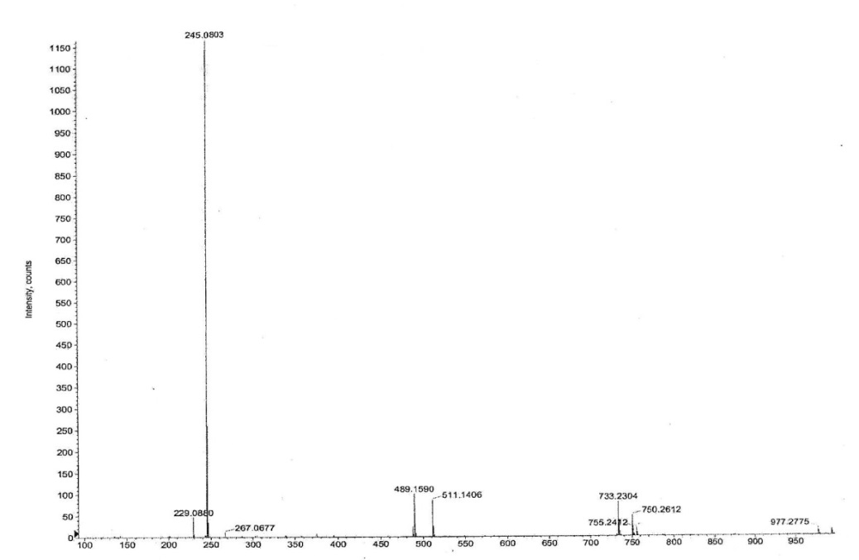

Fig. S3: ESI-TOFM Spectrum of ST-1

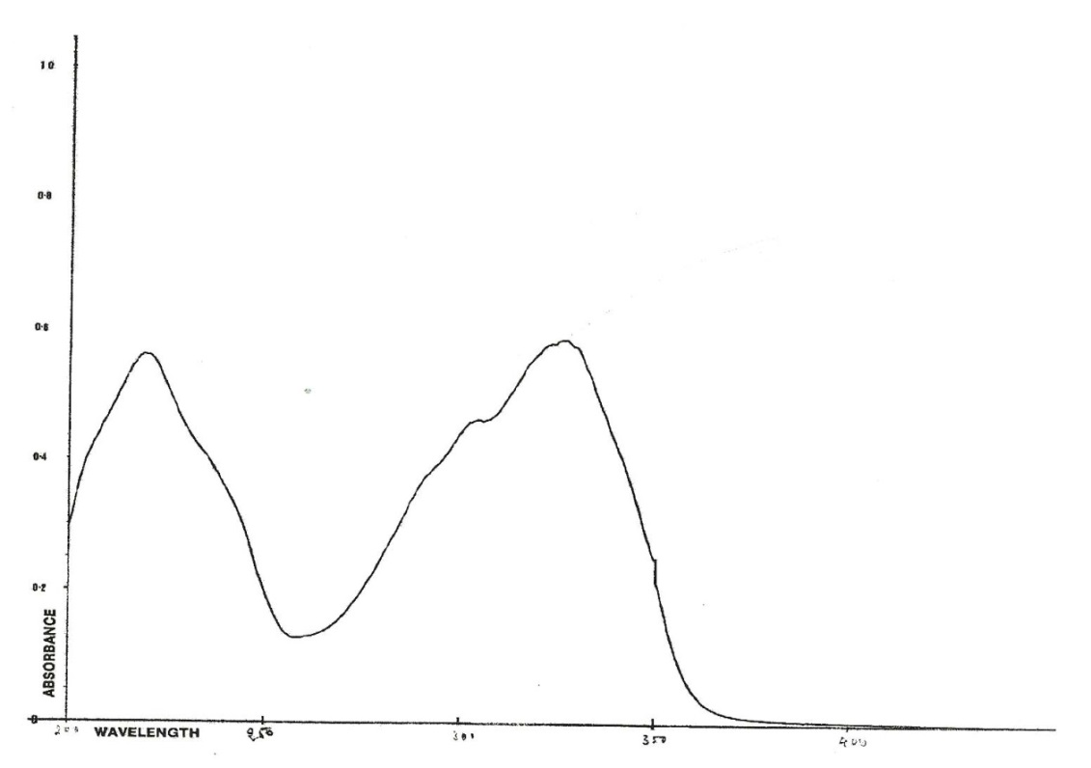

Fig. S4: UV Spectrum of ST-1

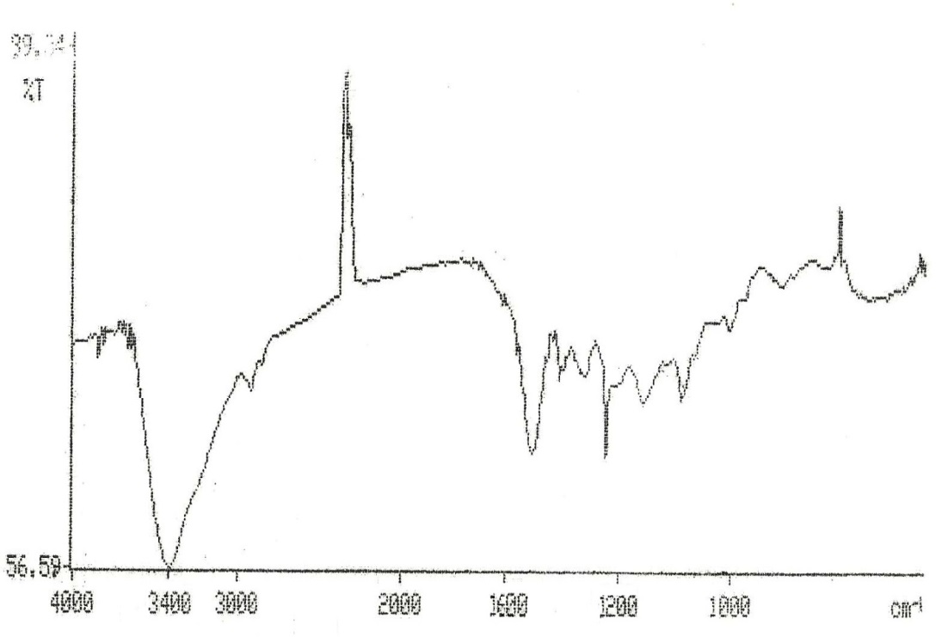

Fig. S5: IR Spectrum of ST-1

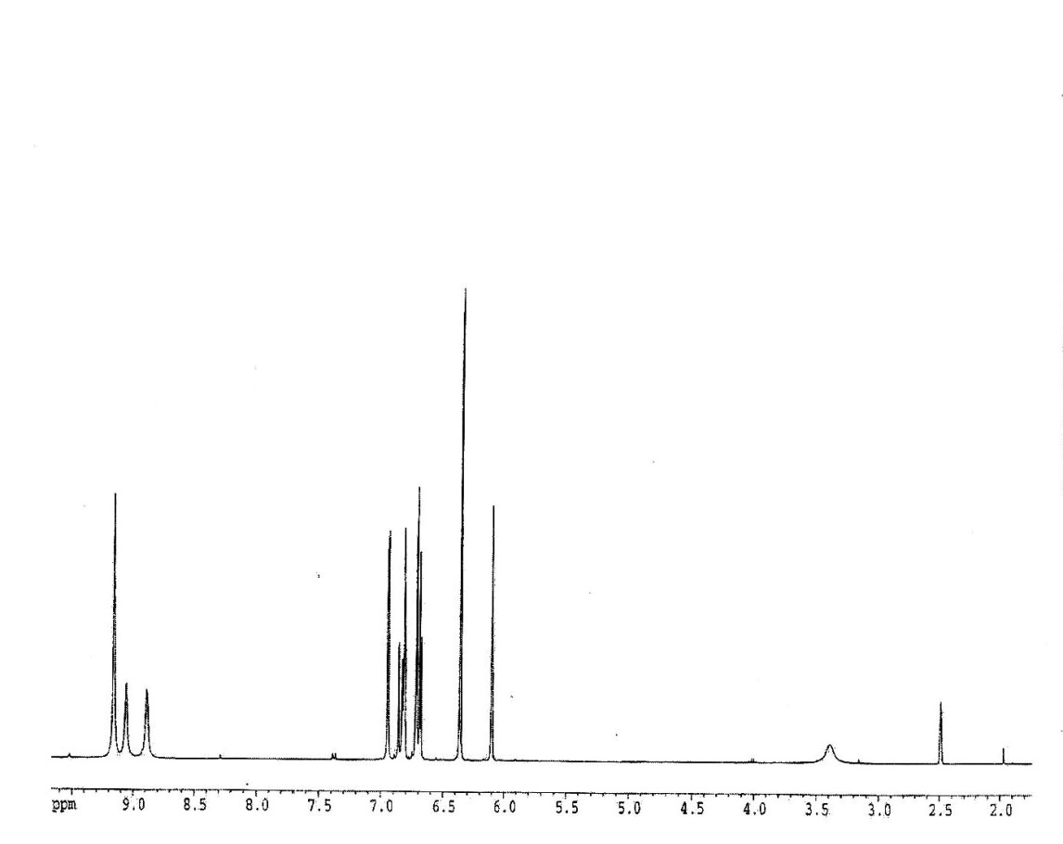

Fig. S6: 1H NMR Spectrum of ST-1

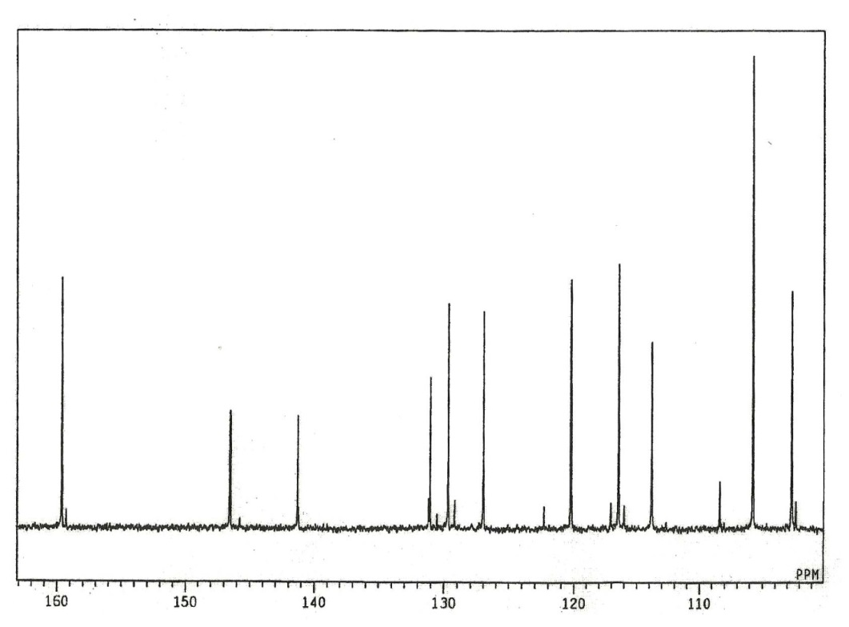

Fig. S7: 13C NMR Spectrum of ST-1

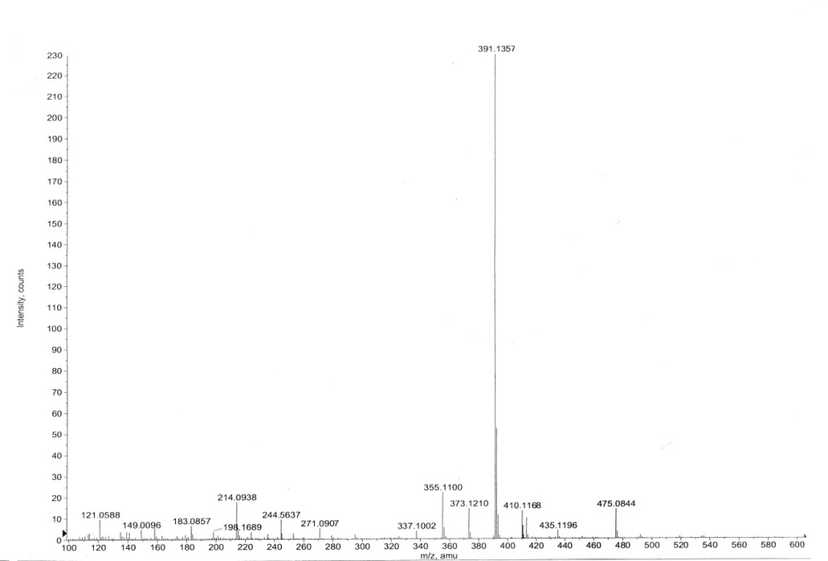

Fig. S8: ESI-TOFM Spectrum of ST-2

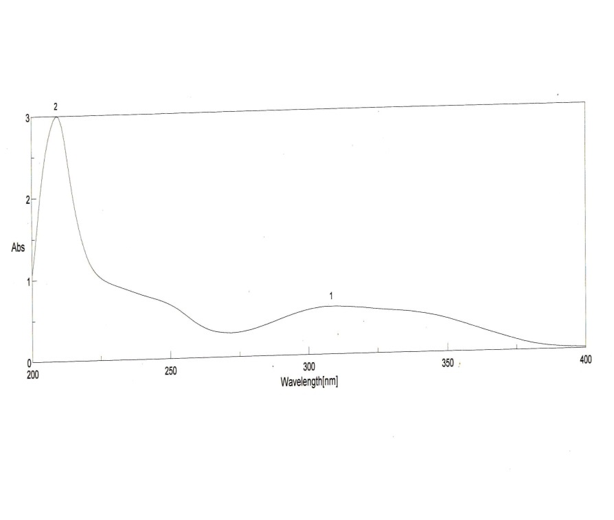

Fig. S9: UV Spectrum of ST-2

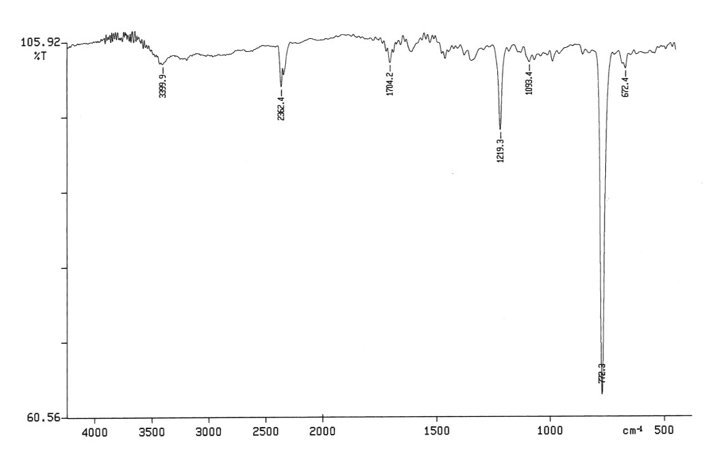

Fig. S10: IR Spectrum of ST-2

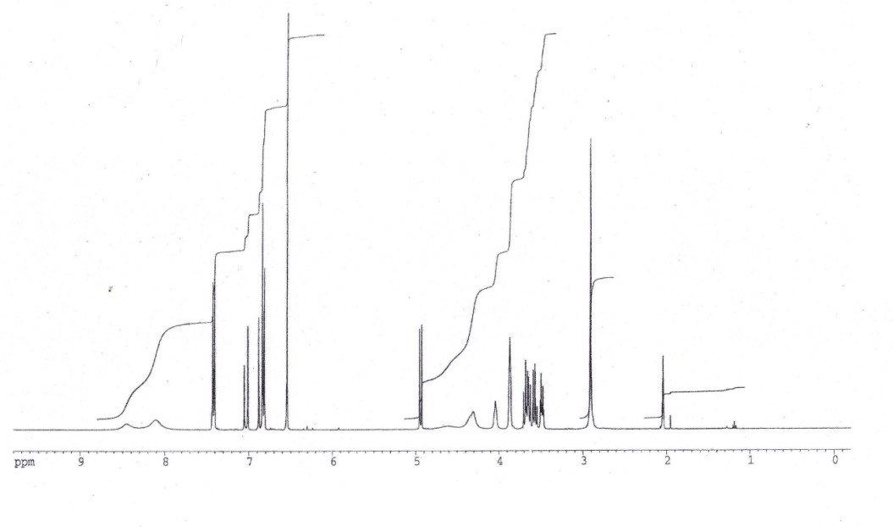

Fig. S11: 1H NMR Spectrum of ST-2

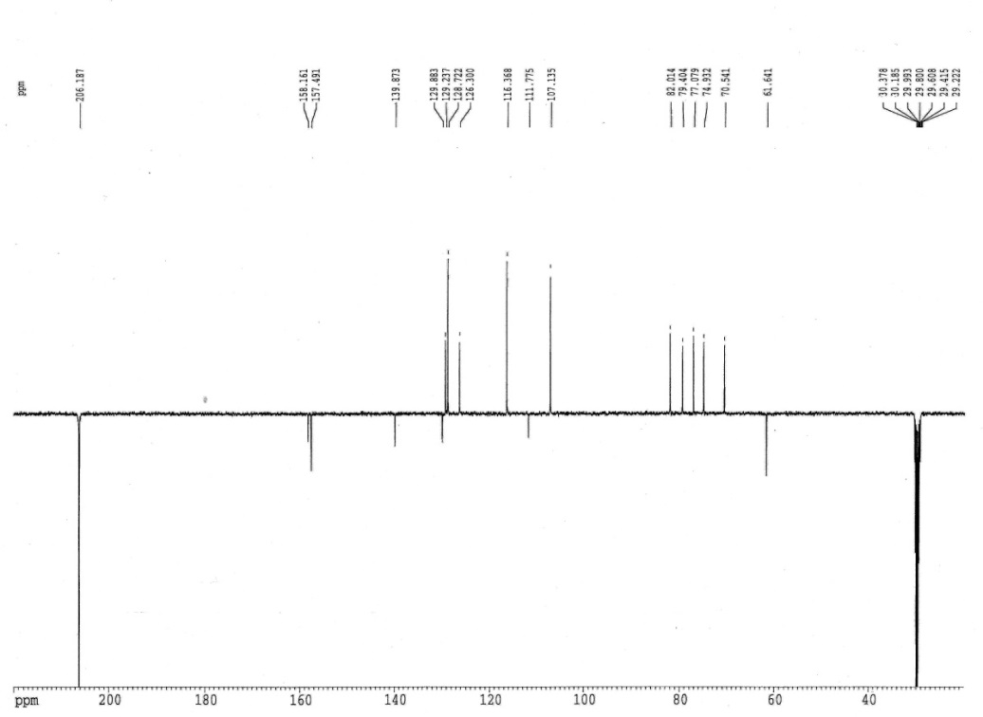

Fig. S12: 13C NMR Spectrum of ST-2

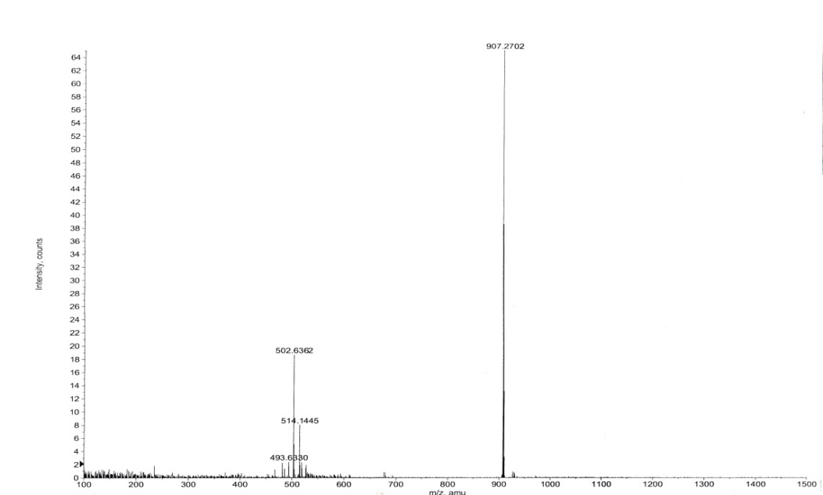

Fig. S 13: ESI-TOFM Spectrum of ST-3

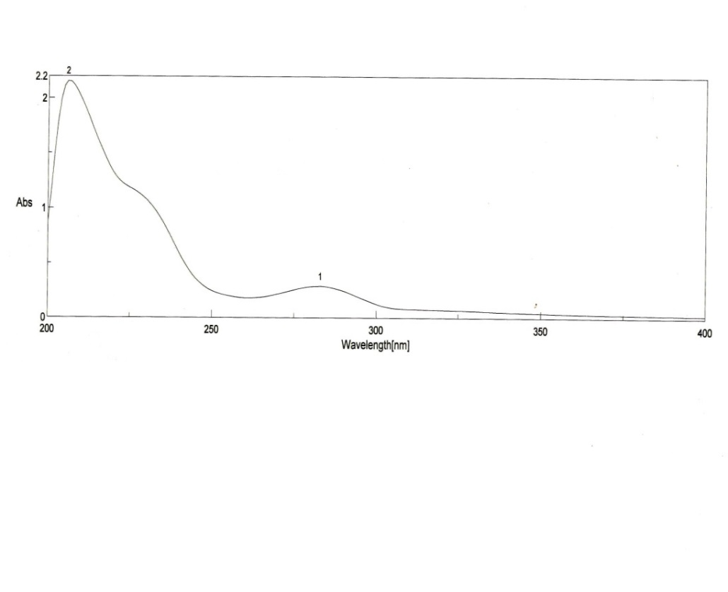

Fig. S 14: UV Spectrum of ST-3

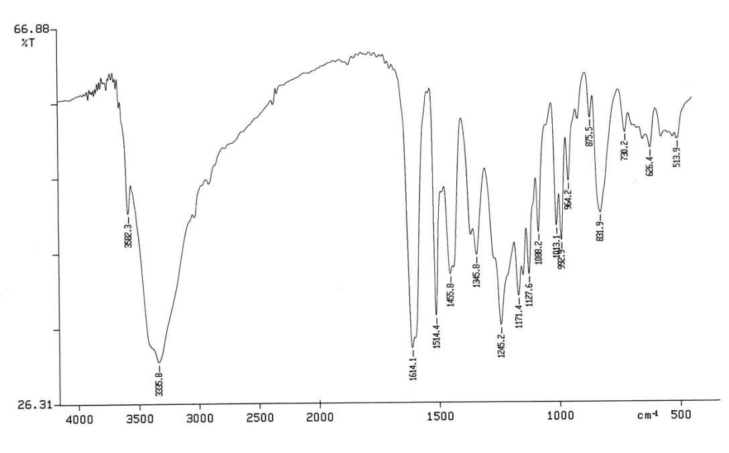

Fig. S 15: IR Spectrum of ST-3

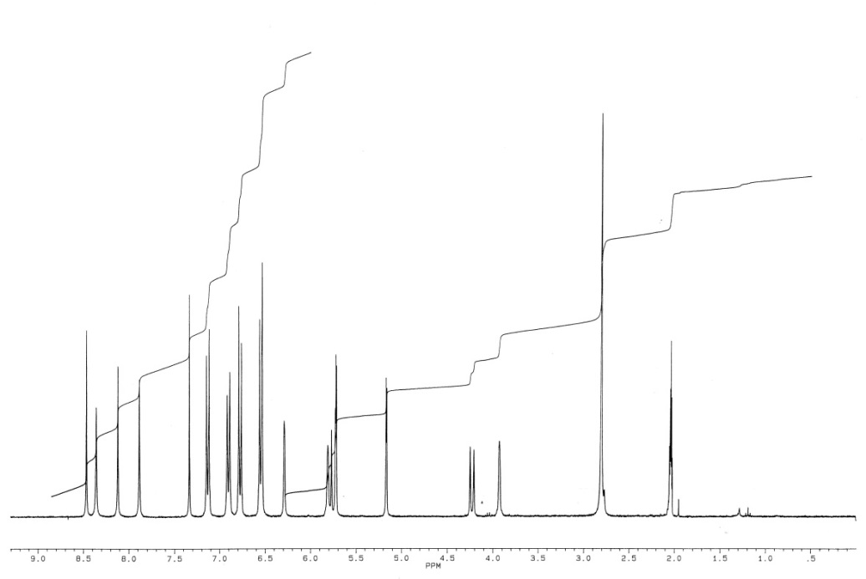

Fig. S 16: 1H NMR Spectrum of ST-3

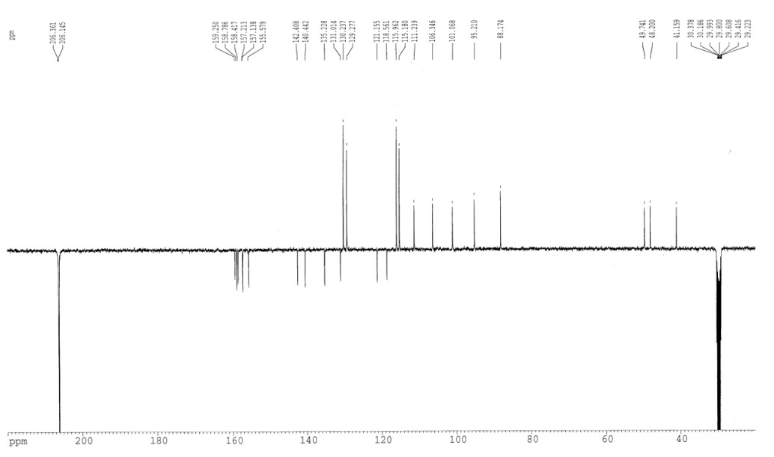

Fig. S 17: 13C NMR Spectrum of ST-3

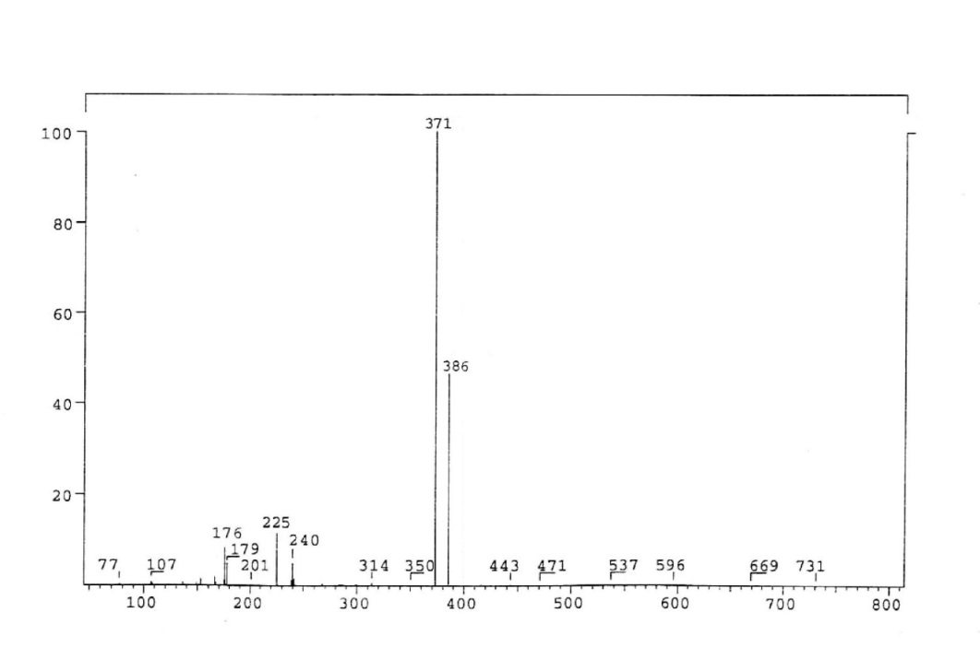

Fig. S 18: EI Mass Spectrum of SA-1

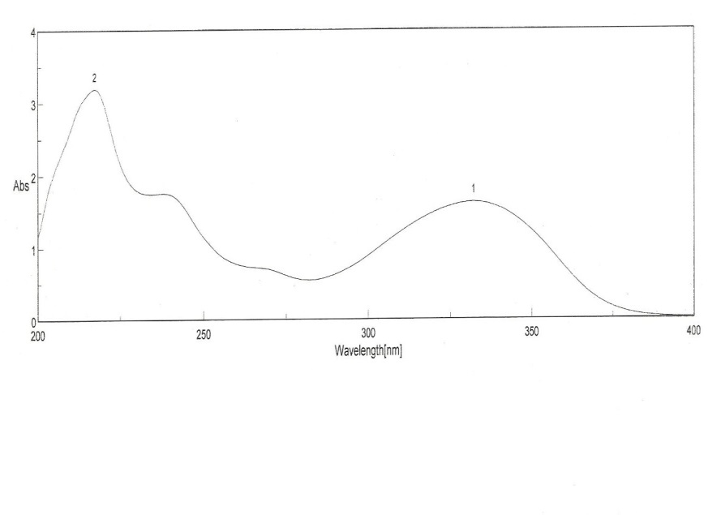

Fig. S 19: UV Spectrum of SA-1

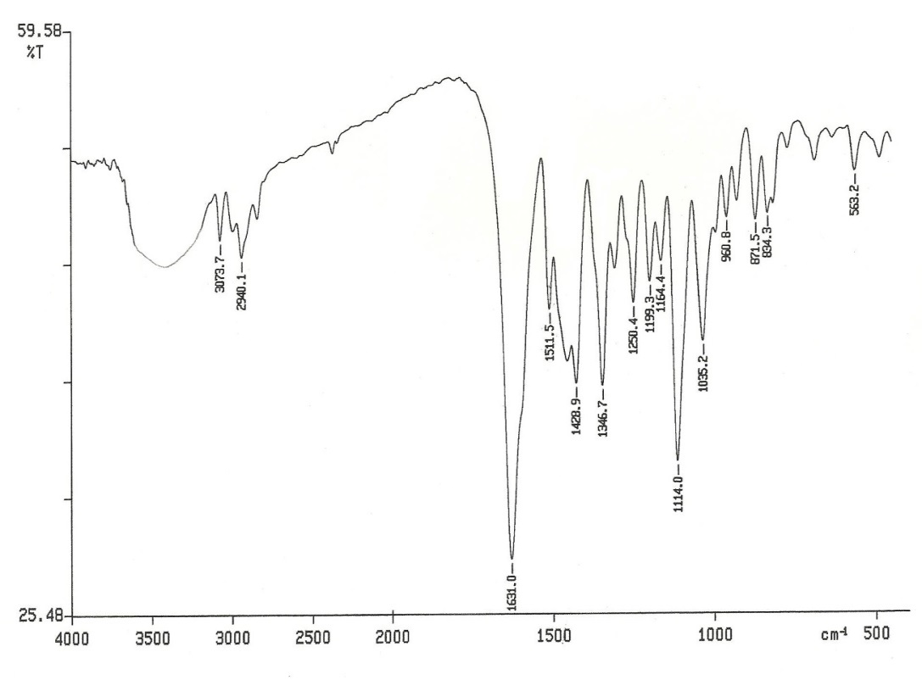

Fig. S 20: IR Spectrum of SA-1

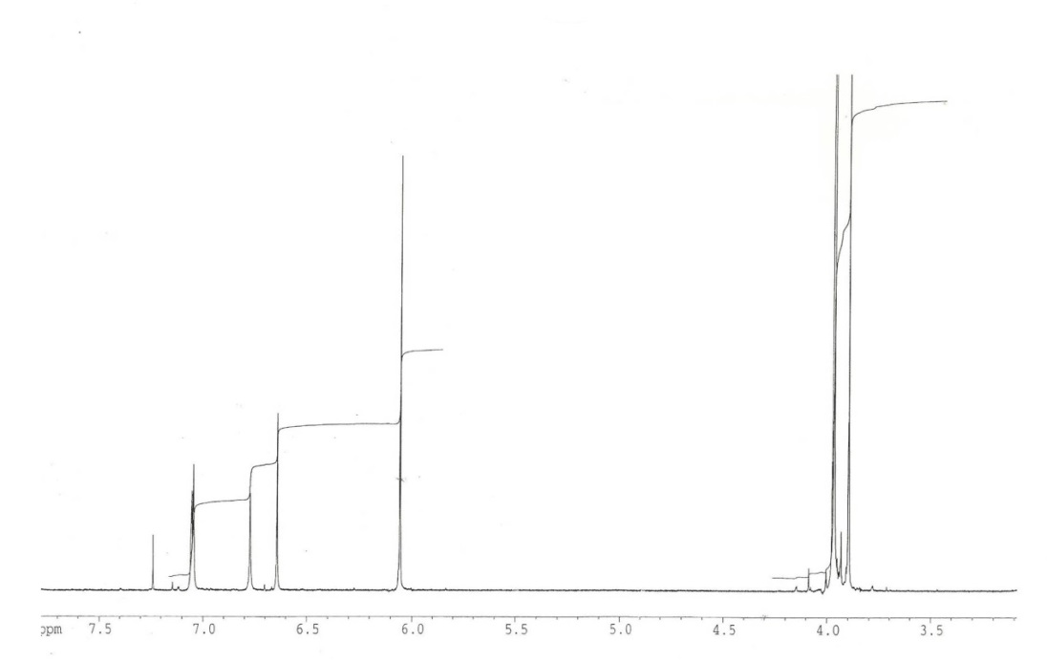

Fig. S 21: 1H NMR Spectrum of SA-1

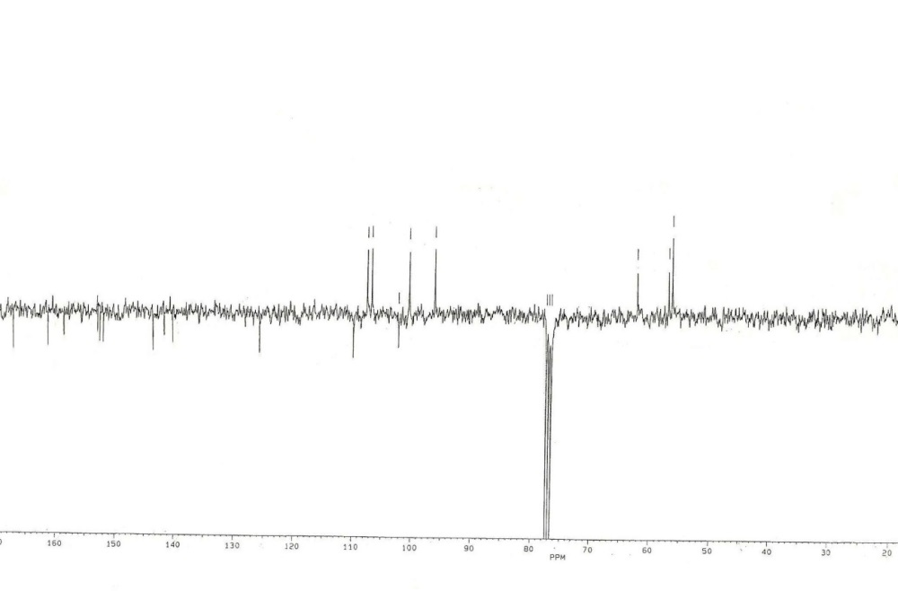

Fig. S 22: 13C NMR Spectrum of SA-1

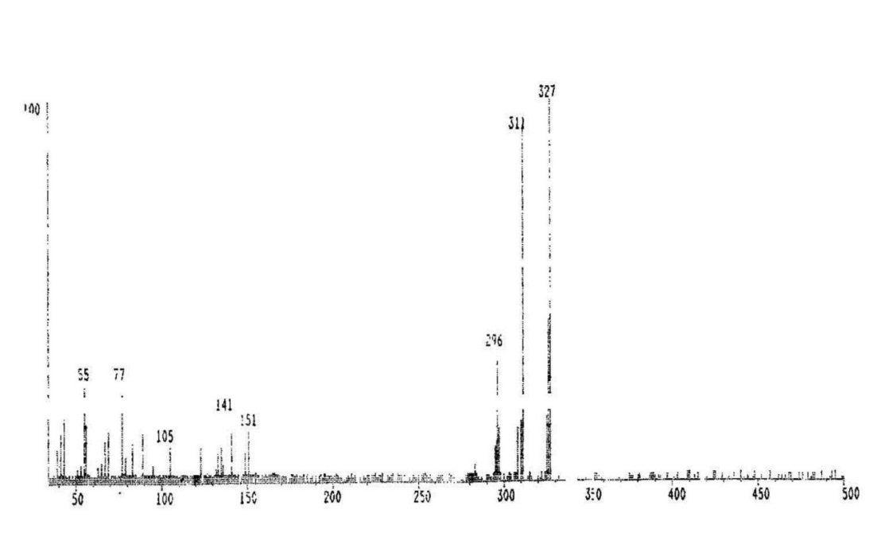

Fig. S 23: ESIMASS Spectrum of SA-2

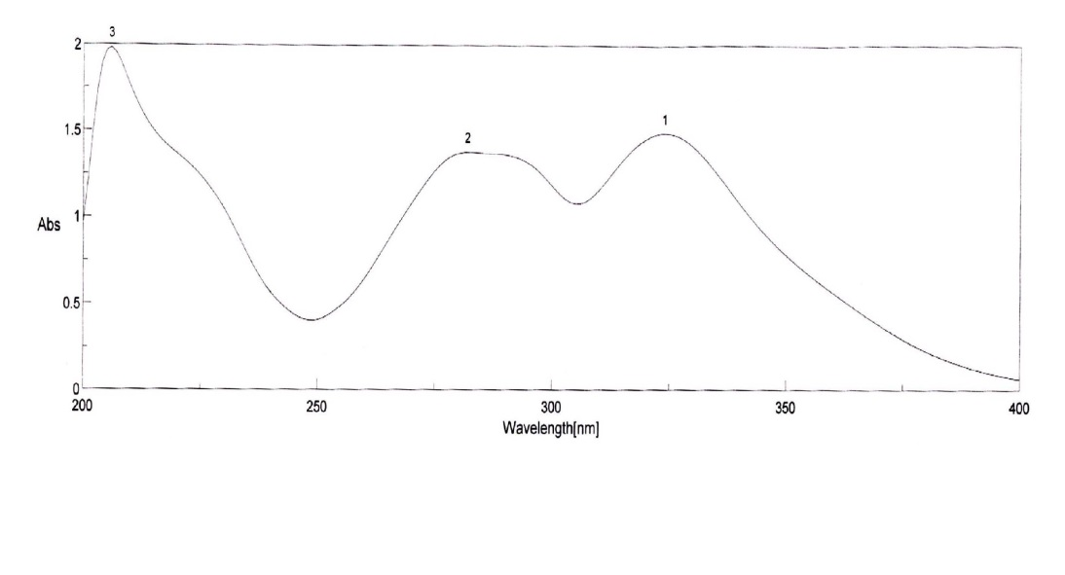

Fig. S 24: UV Spectrum of SA-2

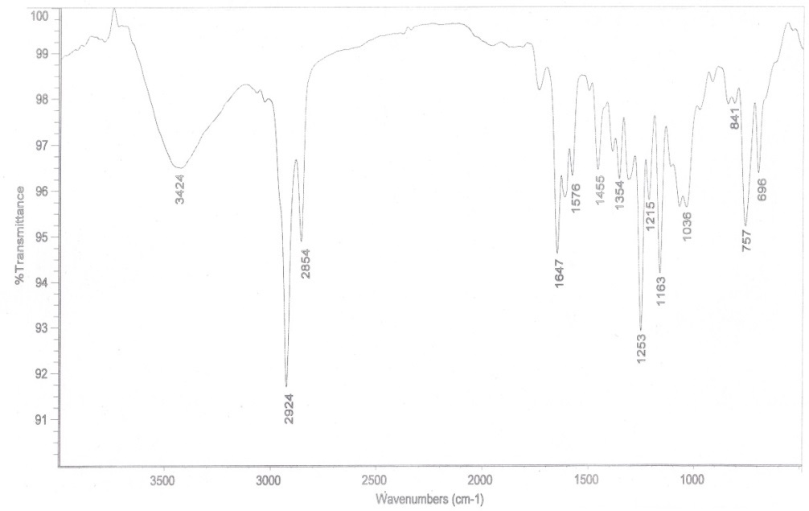

Fig. S 25: UV Spectrum of SA-2

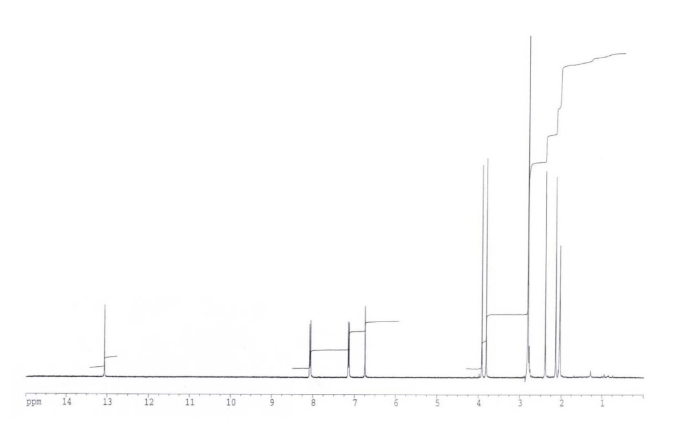

Fig. S 26: 1H NMR Spectrum of SA-2

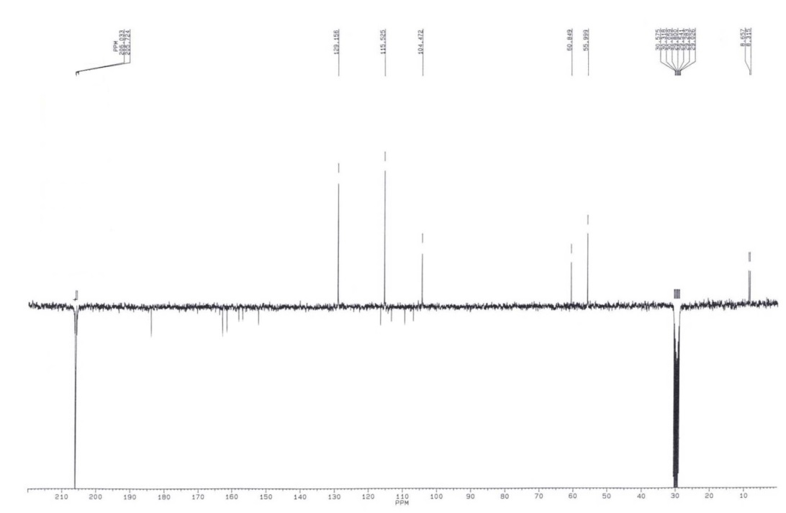

Fig. S 27: 13C NMR Spectrum of SA-2

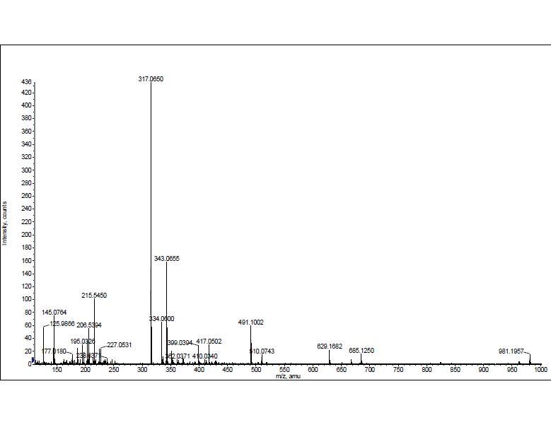

Fig. S 28: ESITOF MASS Spectrum of SA-3

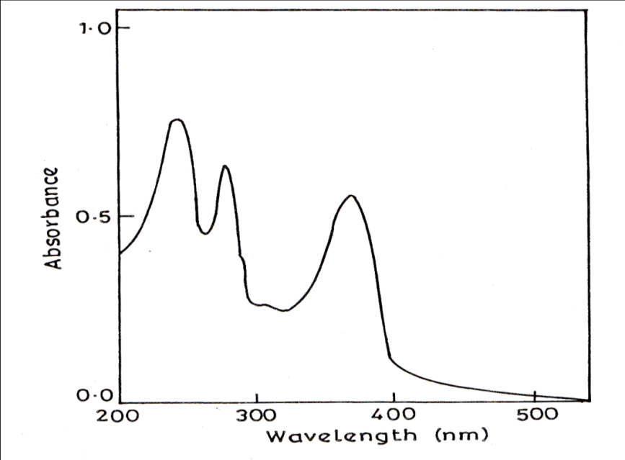

Fig. S 29: UV Spectrum of SA-3

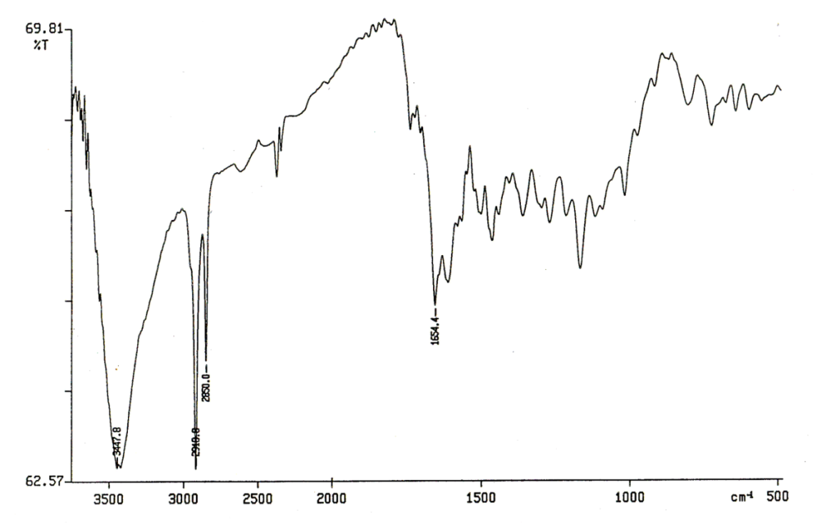

Fig. S 30: IR Spectrum of SA-3

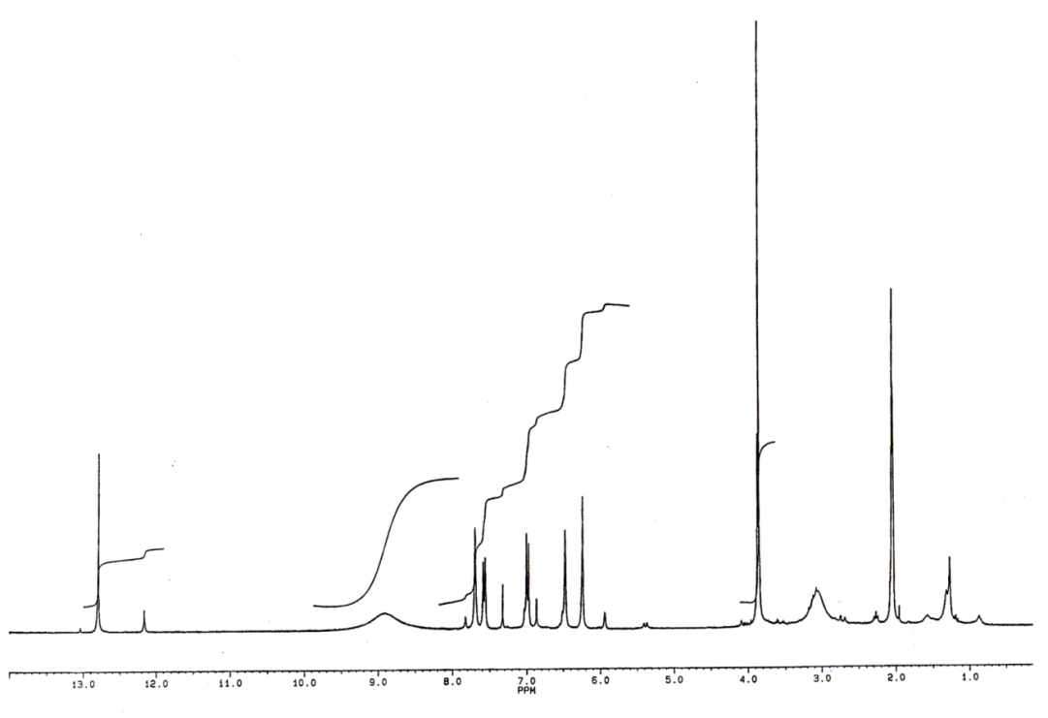

Fig. S 31: 1H NMR Spectrum of SA-3

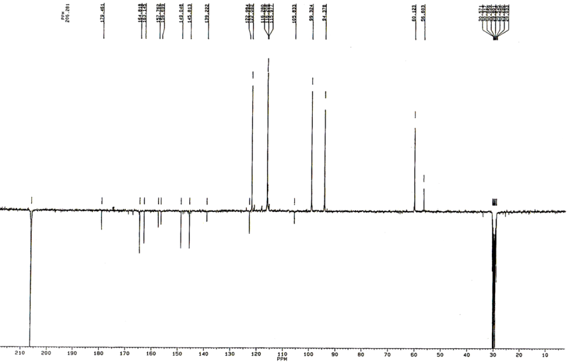

Fig. S 32: 13C NMR Spectrum of SA-3

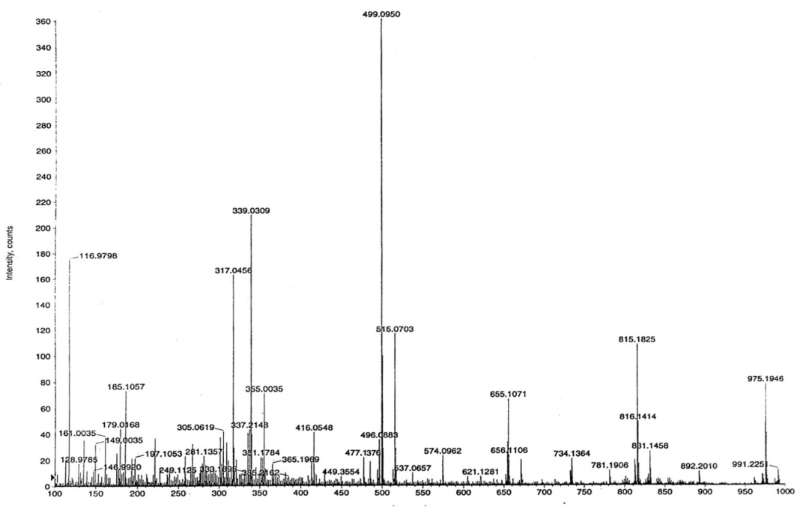

Fig. S 33: ESITOF MASS Spectrum of SA-4

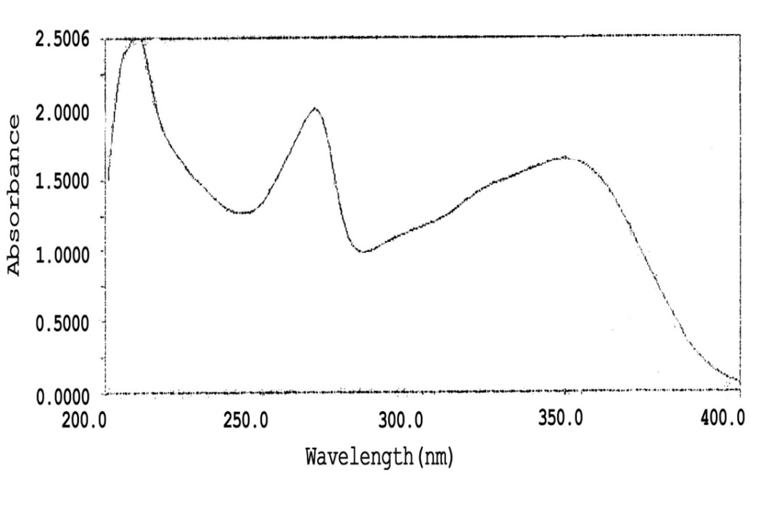

Fig. S 34: UV Spectrum of SA-4

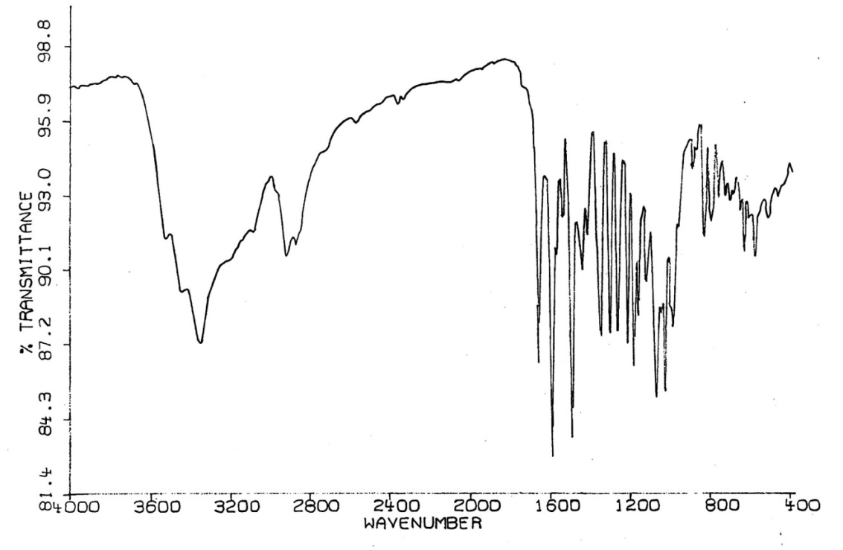

Fig. S 35: IR Spectrum of SA-4

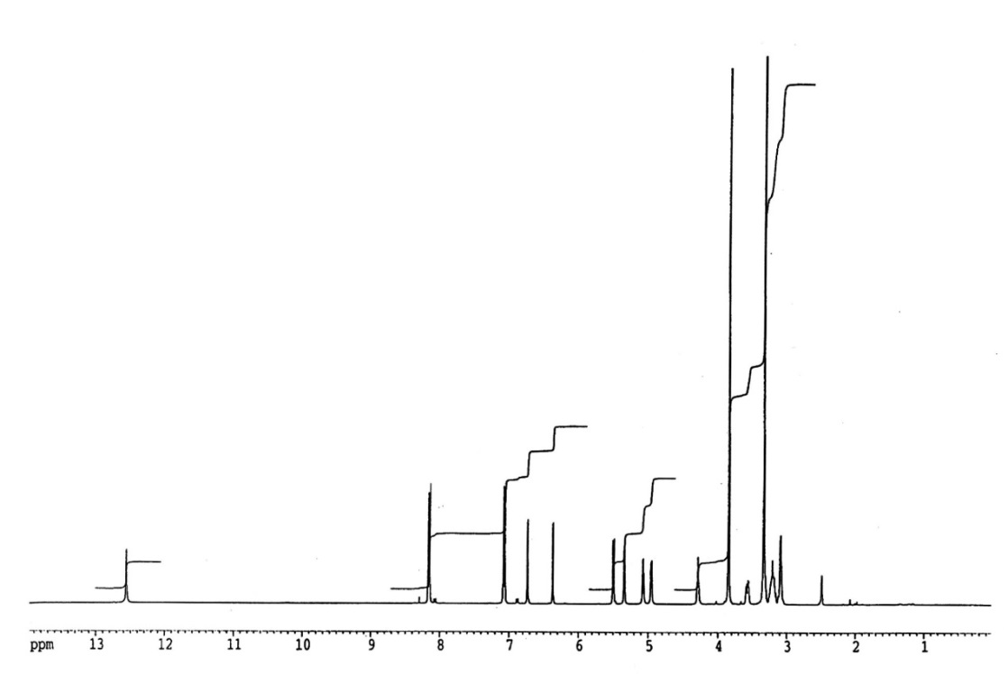

Fig. S 36: 1H NMR Spectrum of SA-4

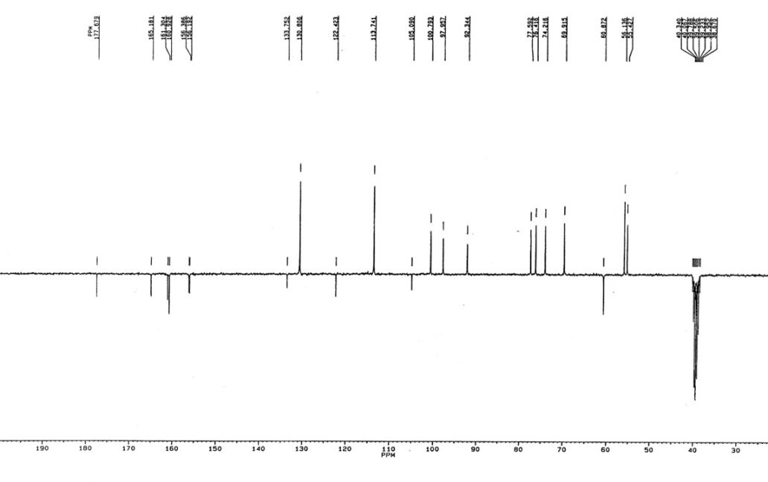

Fig. S 37: 13C NMR Spectrum of SA-4

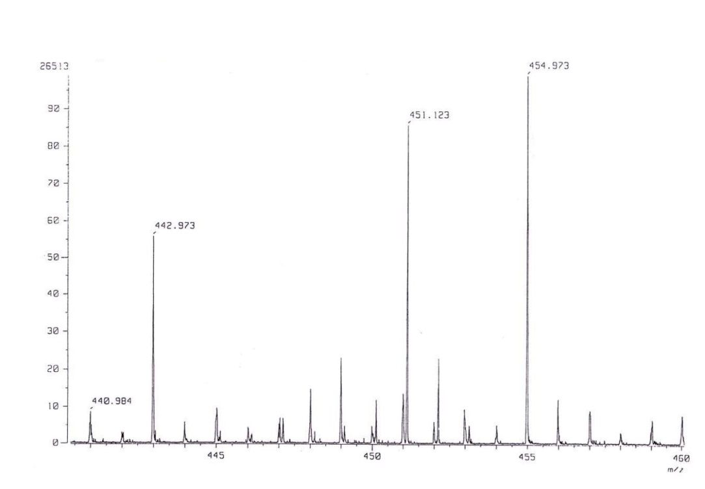

Fig. S 38: HRCI MASS Spectrum of SA-5

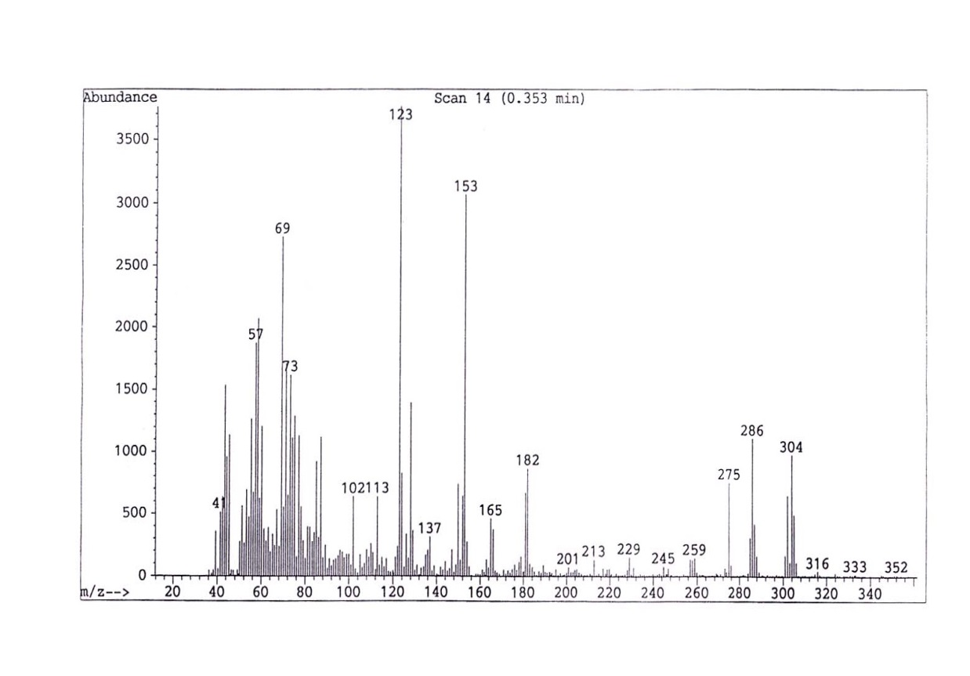

Fig. S 39: EI MASS Spectrum of SA-5

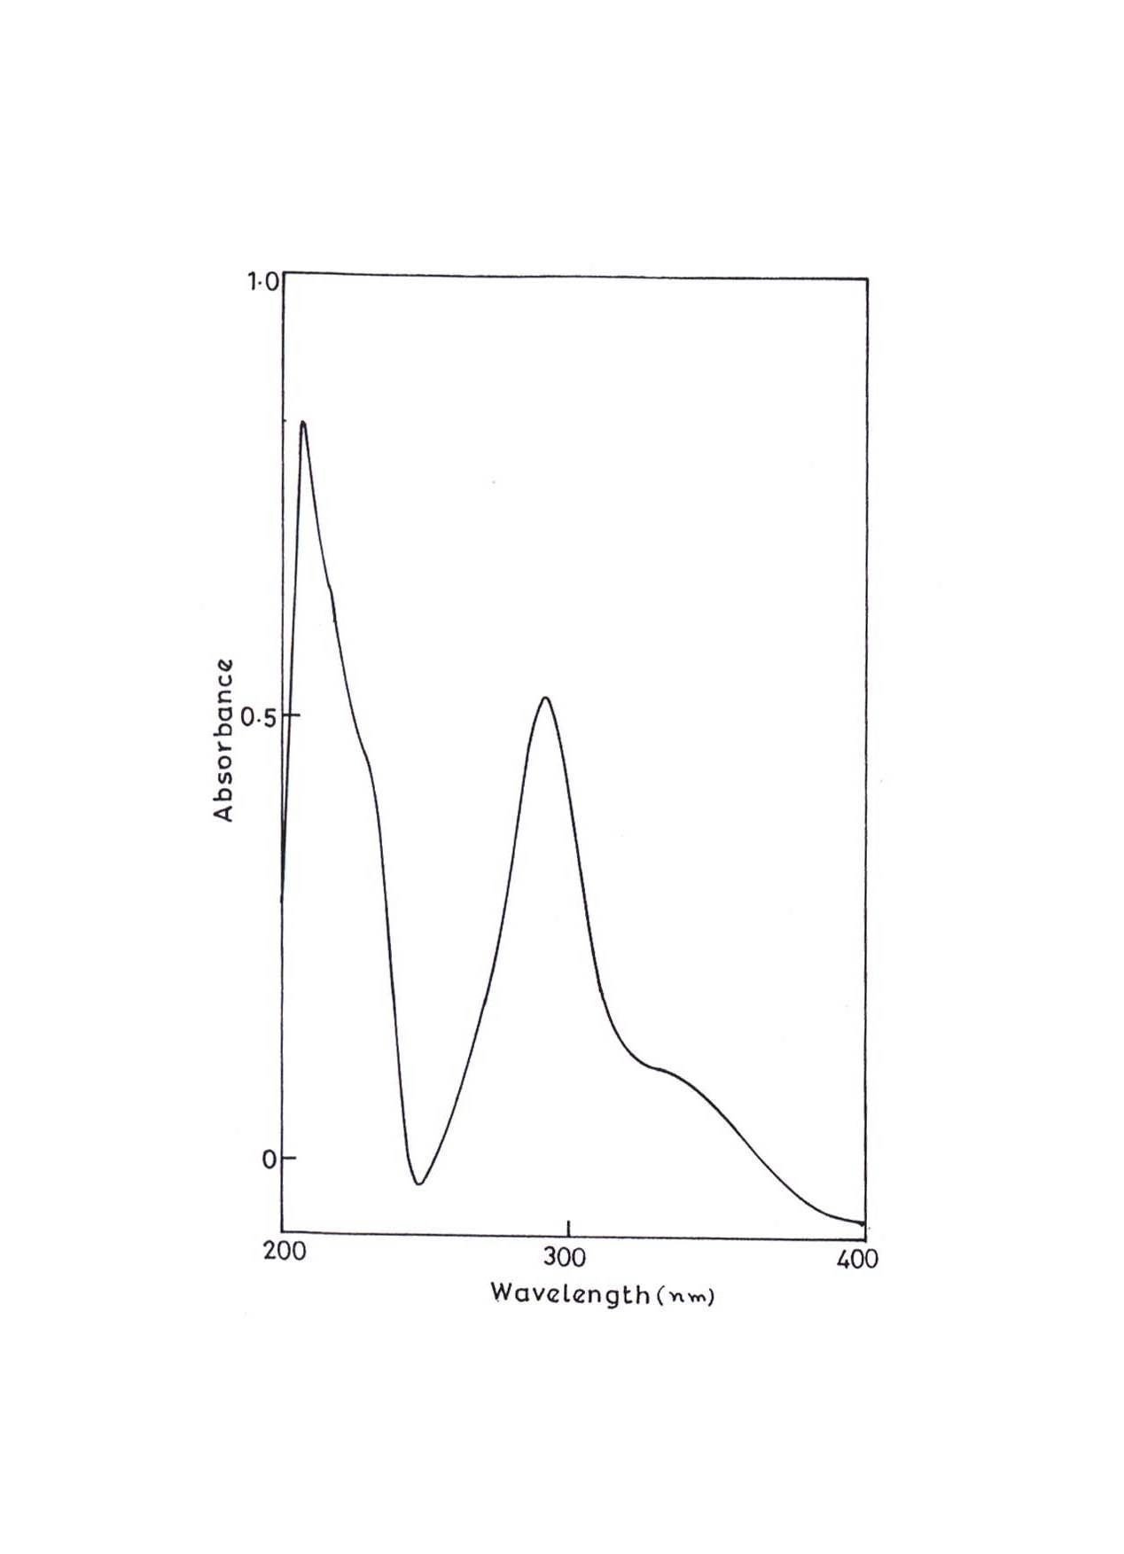

Fig. S 40: UV Spectrum of SA-5

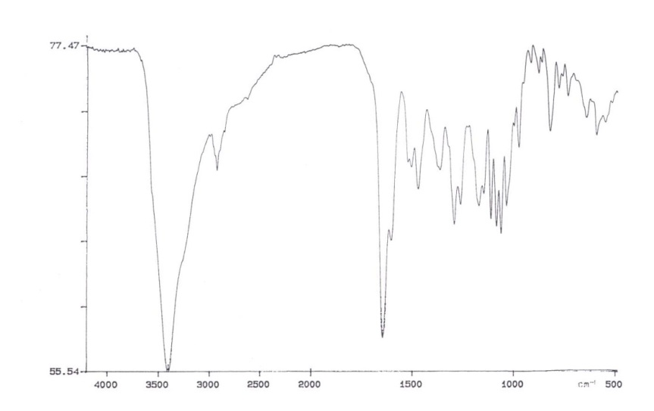

Fig. S 41: IR Spectrum of SA-5

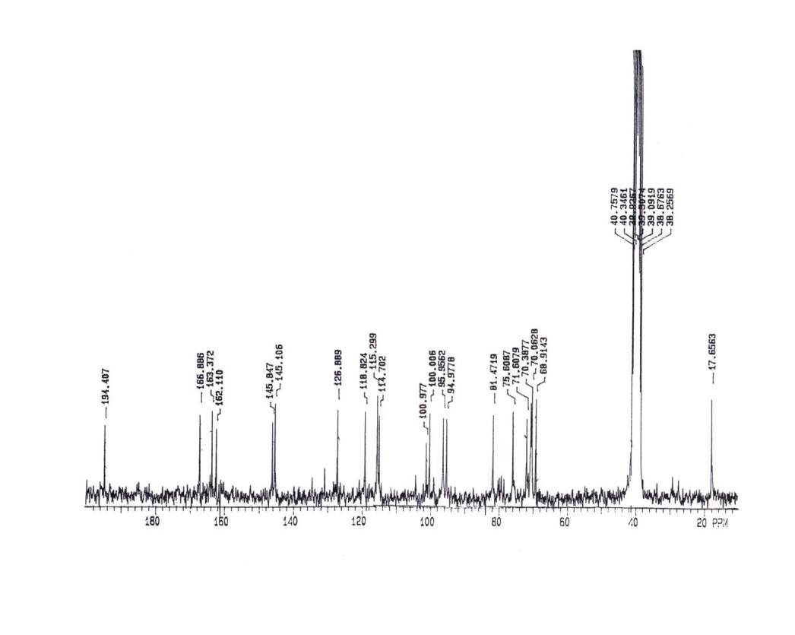

Fig. S 42: 13C NMR Spectrum of SA-5

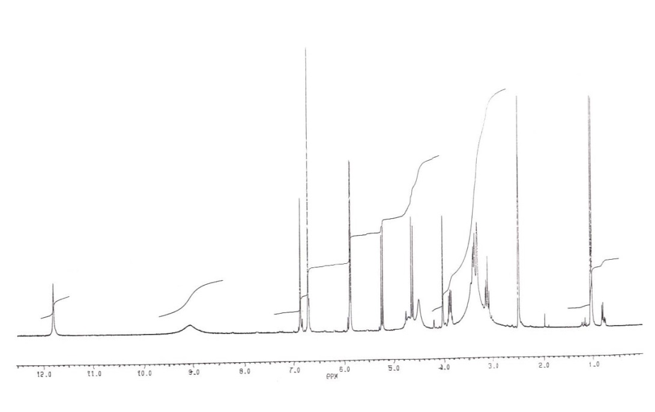

Fig. S 43: 1H NMR Spectrum of SA-5

**Fig S44.** Binding interactions of isolated compounds with active site residues of SH3 domain of

NADPH.

|  |  |
| --- | --- |
| SA1  C:\Users\Administrator\Desktop\Antioxidants\SH3-NADPH\sa-1.png | C:\Users\Administrator\Desktop\Antioxidants\SH3-NADPH\sa-1-3d.png |
| SA2  C:\Users\Administrator\Desktop\Antioxidants\SH3-NADPH\sa-2.png | C:\Users\Administrator\Desktop\Antioxidants\SH3-NADPH\sa-2-3d.png |
| SA3  C:\Users\Administrator\Desktop\Antioxidants\SH3-NADPH\sa-3.png | C:\Users\Administrator\Desktop\Antioxidants\SH3-NADPH\sa-3-3d.png |
| SA4  C:\Users\Administrator\Desktop\Antioxidants\SH3-NADPH\sa-4.png | C:\Users\Administrator\Desktop\Antioxidants\SH3-NADPH\sa-4-3d.png |
| SA5  C:\Users\Administrator\Desktop\Antioxidants\SH3-NADPH\sa-5.png | C:\Users\Administrator\Desktop\Antioxidants\SH3-NADPH\sa-5-3d.png |
| ST1  C:\Users\Administrator\Desktop\Antioxidants\SH3-NADPH\st-1.png | C:\Users\Administrator\Desktop\Antioxidants\SH3-NADPH\st-1-3d.png |
| ST2  C:\Users\Administrator\Desktop\Antioxidants\SH3-NADPH\st2-2d.png | C:\Users\Administrator\Desktop\Antioxidants\SH3-NADPH\st2-3d.png |
| ST3  C:\Users\Administrator\Desktop\Antioxidants\SH3-NADPH\st3-2d.png | C:\Users\Administrator\Desktop\Antioxidants\SH3-NADPH\st3-3d.png |

**Fig. S45.** Binding interactions of isolated compounds with active site residues of SPSB2.

|  |  |
| --- | --- |
| SA1  C:\Users\Administrator\Desktop\Antioxidants\Nitric oxide synthase\sa1-l.png | C:\Users\Administrator\Desktop\Antioxidants\Nitric oxide synthase\sa1-l-3d.png |
| SA2  C:\Users\Administrator\Desktop\Antioxidants\Nitric oxide synthase\sa2-l.png | C:\Users\Administrator\Desktop\Antioxidants\Nitric oxide synthase\sa2-l-3d.png |
| SA3  C:\Users\Administrator\Desktop\Antioxidants\Nitric oxide synthase\sa3-l.png | C:\Users\Administrator\Desktop\Antioxidants\Nitric oxide synthase\sa3-3d.png |
| SA4  C:\Users\Administrator\Desktop\Antioxidants\Nitric oxide synthase\sa4-l.png | C:\Users\Administrator\Desktop\Antioxidants\Nitric oxide synthase\sa4-3d.png |
| SA5  C:\Users\Administrator\Desktop\Antioxidants\Nitric oxide synthase\sa5-l.png | C:\Users\Administrator\Desktop\Antioxidants\Nitric oxide synthase\sa5-3d.png |
| ST1  C:\Users\Administrator\Desktop\Antioxidants\Nitric oxide synthase\sa5-l.png | C:\Users\Administrator\Desktop\Antioxidants\Nitric oxide synthase\st1-3d.png |
| ST2  C:\Users\Administrator\Desktop\Antioxidants\Nitric oxide synthase\st2-l.png | C:\Users\Administrator\Desktop\Antioxidants\Nitric oxide synthase\st2-3d.png |
| ST3  C:\Users\Administrator\Desktop\Antioxidants\Nitric oxide synthase\st3-l.png | C:\Users\Administrator\Desktop\Antioxidants\Nitric oxide synthase\st3-3d.png |

**Table S1** Total Phenolic and Total Flavonoid contents of the stem bark extract of S*.*

*tumbuggaia* and root extracts of *S. alternifolium*

|  |  |  |
| --- | --- | --- |
| **Plant extracts (crude)** | **TPC (µg/mL) as**  **gallic acid equivalents** | **TFC (µg/mL) as**  **catechin equivalents** |
| Hexane extract (STH) | 12.43 ± 1.0 | 10.21± 1.5 |
| Acetone extract (STA) | 62.56 ± 0.9 | 56.55± 1.2 |
| Methanol extract (STM) | 64.67 ± 0.8 | 62.47± 1.1 |
| Hexane extract (SAH) | 44.33 ± 1.4 | 41.14 ±1.6 |
| Acetone extract (SAA) | 84.39 ± 1.2 | 132.28 ±1.6 |
| Methanol extract (SAM) | 54.63 ± 1.2 | 56.45 ± 0.9 |

**Table S2** DPPH radical scavenging activity of different extracts of *Shorea tumbuggaia* (ST)

and *Syzygium alternifolium* (SA)

|  |  |  |  |  |  |  |
| --- | --- | --- | --- | --- | --- | --- |
| **Conc. (****µg/mL)** | **%** **DPPH radical scavenging activity of different extracts** | | | | | |
| **STA** | **STM** | **SAH** | **SAA** | **SAM** | **Vitamin C** |
| 20 | 26.55 ± 0.11 | 20.12 ± 0.11 | 17.03 ± 0.90 | 25.23 ±0.39 | 26.23 ±1.55 | 18.12 ± 0.06 |
| 40 | 31.56 ± 0.09 | 26.52 ± 0.04 | 22.95 ± 0.77 | 39.62 ± 0.90 | 42.35 ± 0.90 | 44.17 ± 0.08 |
| 60 | 36.13 ± 0.07 | 32.96 ± 0.04 | 31.15 ± 0.52 | 52.73±1.93 | 68.40 ±1.42 | 73.14 ± 0.08 |
| 80 | 40.12 ± 0.06 | 37.13 ± 0.09 | 32.51 ± 1.42 | 67.40 ±2.32 | 72.40 ±1.67 | 90.51 ± 0.12 |
| 100 | 44.65 ± 0.06 | 43.32 ± 0.09 | 34.34 ±1.67 | 78.69 ±0.52 | 81.97 ±0.52 | 97.65 ± 0.16 |

**Table S3** DPPH radical scavenging activity of isolates of *Shorea tumbuggaia* (ST) and

*Syzygium alternifolium* (SA).

|  |  |  |  |  |  |  |  |  |  |
| --- | --- | --- | --- | --- | --- | --- | --- | --- | --- |
| **Conc. (µg/mL)** | **% DPPH radical scavenging activity of isolates** | | | | | | | | |
| ST-1 | ST-2 | ST-3 | SA-1 | SA-2 | SA-3 | SA-4 | SA-5 | Vitamin C |
| 20 | 16.54±0.11 | 25.16±0.09 | 18.19±0.13 | 37.25±0.05 | 34.56±0.33 | 13.45±0.03 | 28.19±0.27 | 17.83±0.11 | 18.12±0.06 |
| 40 | 31.43±0.03 | 54.35±0.17 | 41.46±0.22 | 76.54±0.21 | 71.49±0.34 | 28.92±0.10 | 62.87±0.21 | 44.19±0.09 | 36.57±0.08 |
| 60 | 50.27±0.24 | 84.68±0.22 | 69.83±0.21 | 121.36±0.13 | 116.82±0.07 | 46.08±0.07 | 92.14±0.34 | 71.24±0.13 | 54.46±0.08 |
| 80 | 69.04±0.22 | 115.42±0.55 | 104.67±0.11 | 162.14±0.27 | 154.15±0.10 | 61.27±0.17 | 124.35±0.07 | 98.52±0.06 | 75.82±0.12 |
| 100 | 92.45±0.13 | 151.14±0.27 | 148.62±0.016 | 216.54±0.22 | 206.15±0.16 | 78.54±0.05 | 171.25±0.11 | 124.38±0.07 | 91.45±0.16 |

**Table S4.** Lipinski rule of isolated flavonoids.

|  |  |  |  |  |  |  |
| --- | --- | --- | --- | --- | --- | --- |
| **Compounds** | **Weight** | **TPSA** | **LogP** | **LogS** | **H-Don** | **H-Acc** |
| SA-1 | 388.3 | 84.8 | 3.0 | -4.1 | 1 | 7 |
| SA-2 | 326.3 | 64.9 | 3.6 | -4.6 | 1 | 4 |
| SA-3 | 316.2 | 116.4 | 2.3 | -3.1 | 4 | 6 |
| SA-4 | 476.4 | 164.3 | 0.1 | -3.7 | 5 | 10 |
| SA-5 | 450.4 | 189.5 | 0.8 | -2.0 | 8 | 11 |
| ST-1 | 244.2 | 80.9 | 2.6 | -2.8 | 4 | 4 |
| ST-2 | 390.3 | 150.8 | 0.5 | -2.6 | 7 | 8 |
| ST-3 | 920.9 | 220.7 | 10.0 | -11.4 | 10 | 12 |