**Supplementary Material**

**Bioactivity and Molecular Docking of Synthesized Macromolecular Ligand and its Complex**

**Figure S1a:** FT-IR spectrum of Ligand

**Figure S1b:** FT-IR spectrum of Copper Complex.

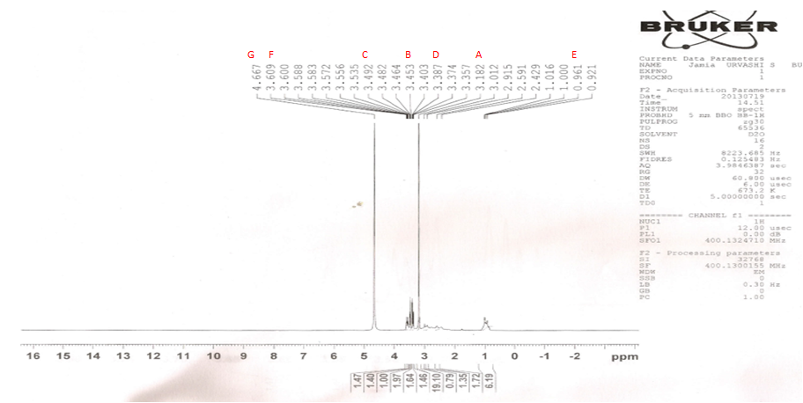

**Figure S2:** 1HNMR Spectrum of Ligand

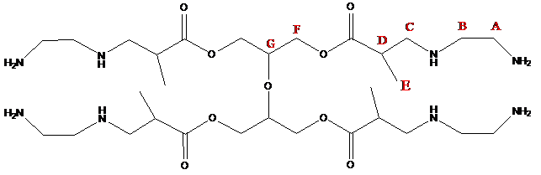

**Figure S3:** Chemical strructure of ligand showing different type of protons (A,B,C,D,E,F and G)

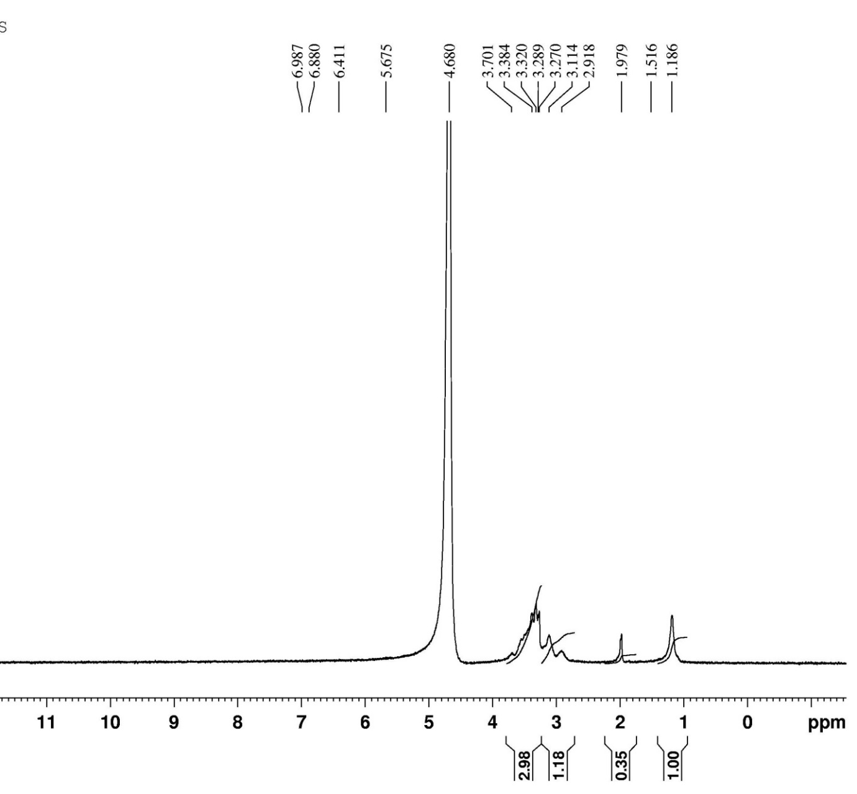

**Figure S4:** NMR spectra of copper complex

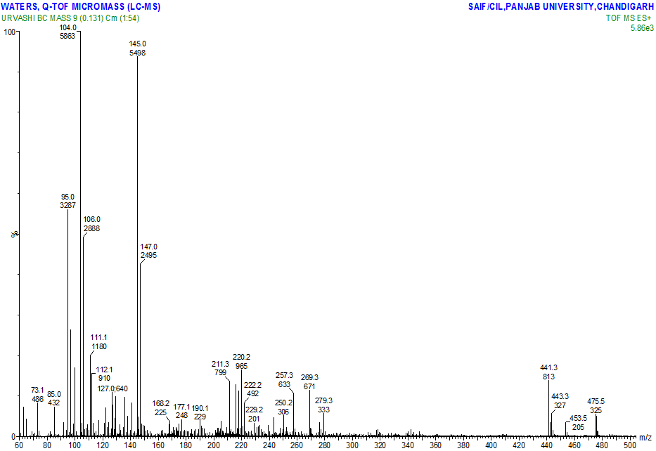

**Figure S5:** ESI-Mass Spectra of Ligand