**Supporting information**

**Graphdiyne-actinyl complexes as potential catalytic materials: a DFT perspective from their structural, bonding, electronic and redox properties**

Raza ullah shah Bacha,† Ting-Ting Lin,† Jun Yao‡ and Qing-Jiang Pan*,†

† Key Laboratory of Functional Inorganic Material Chemistry (Ministry of Education), School of Chemistry and Materials Science, Heilongjiang University, Harbin, 150080, China

‡Inner Mongolia Key Laboratory of Carbon Nanomaterials, College of Chemistry and Chemical Engineering, Inner Mongolia University for Nationalities(IMUN), Tongliao 028000, China

**Corresponding Authors:**

panqjitc@163.com (QJPan)

ORCID: 0000-0003-2763-6976 (QJP)

**Figure S1.** Theoretically simulated IR spectra of GDY-(AnVO2)+ complexes



**Figure S2.** Summary of ADF calculated atomic charges of U, Np and Pu in GDY-(AnmO2)n+ complexes.

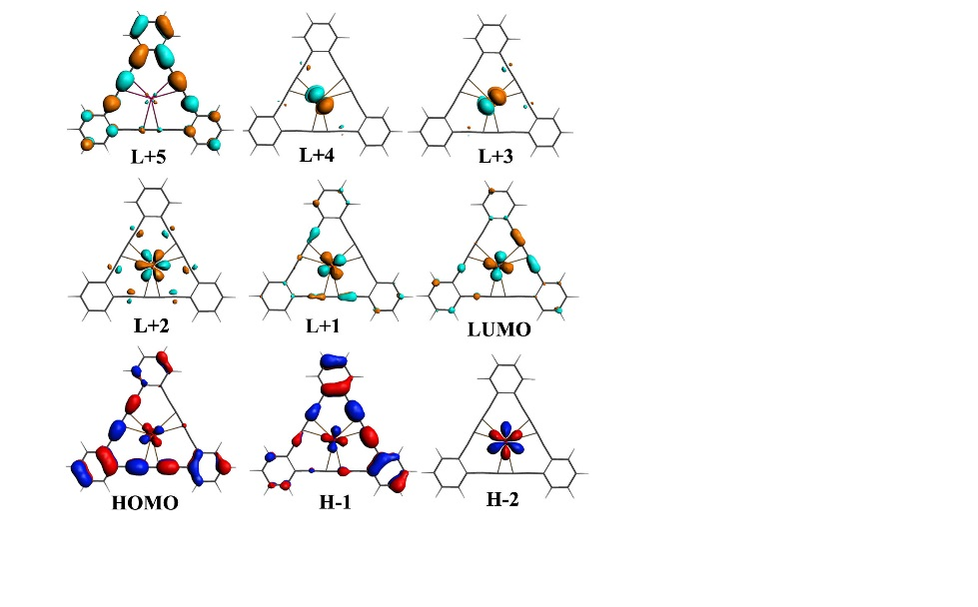

**Figure S3.** Density of states (DOS) of α-spin orbitals of GDY-(NpVIO2)2+ (left) and Orbital structures (right). (The Isosurface value of 0.03 au is used in this and rest of the MO figures)

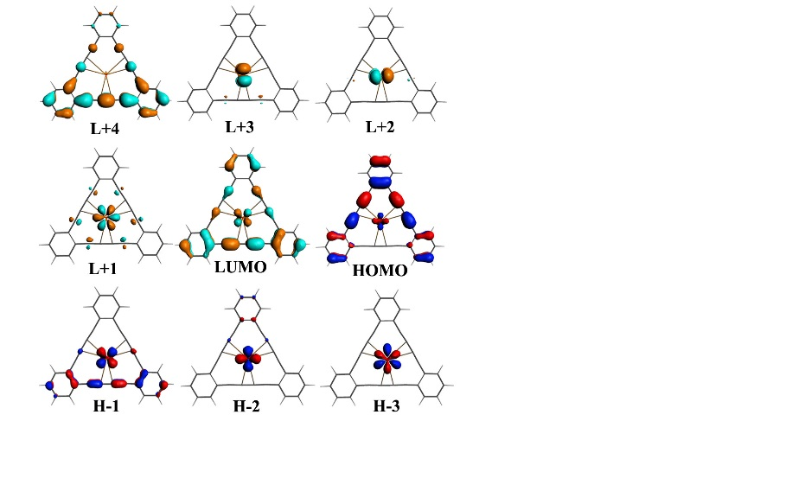

**Figure S4.** Density of states (DOS) of α-spin orbitals of GDY-(PuVIO2)2+ (left) and Orbital structures (right).



**Figure S5.** Density of states (DOS) of α-spin orbitals of GDY-(UVO2)+ complex.

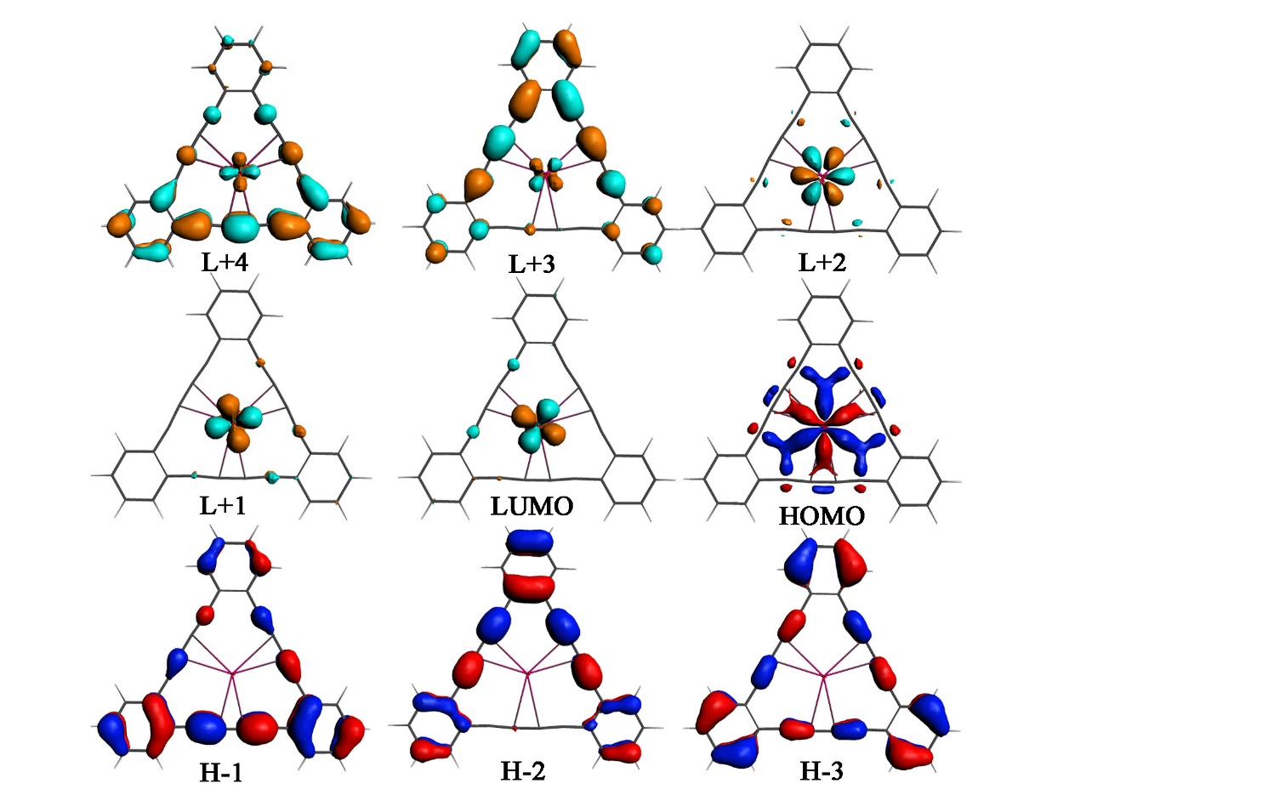

**Figure S6.** Orbital structures of highest occupied molecular orbitals (HOMO) and lowest unoccupied molecular orbitals (LUMO) of GDY-(UVO2)+ complex.



**Figure S7.** Density of states (DOS) of α-spin orbitals of GDY-(NpVO2)+ complex.

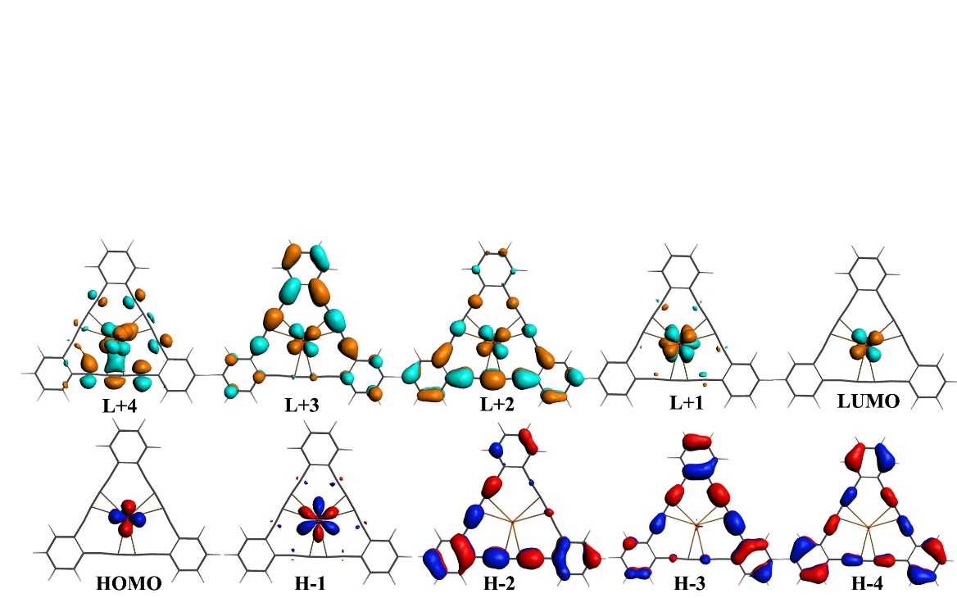

**Figure S8.** Orbital structures of highest occupied molecular orbitals (HOMO) and lowest unoccupied molecular orbitals of GDY-(NpVO2)+ complex.



**Figure S9.** Density of states (DOS) of α-spin orbitals of GDY-(PuVO2)+ complex.

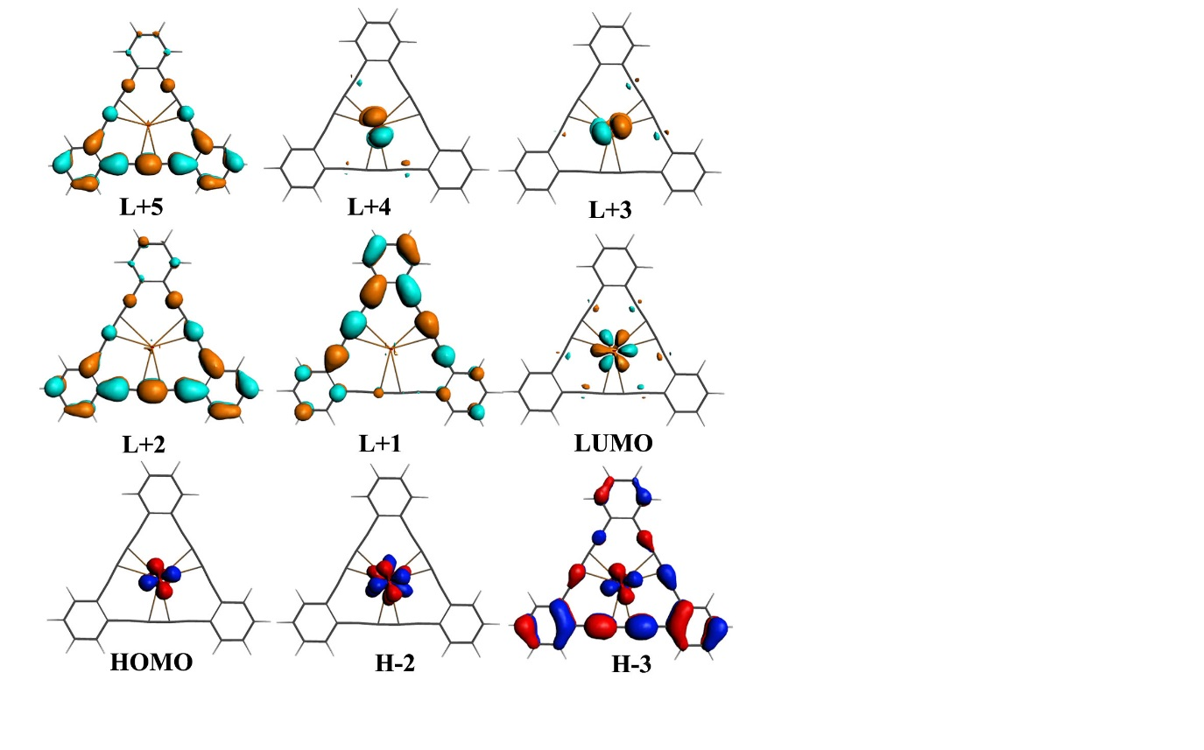

**Figure S10.** Orbital structures of highest occupied molecular orbitals (HOMO) and lowest unoccupied molecular orbitals (LUMO) of GDY-(PuVO2)+ complex.

 **Figure S11.** Energy level diagram α-spin orbitals of GDY-(AnVO2)+ and free GDY, where orbitals of π(GDY) and π*(GDY) are correlated.

**Table S1**. Calculated relative energies (eV) of GDY-(AnmO2)n+ complexes in various electron-spin states (ESS)..

|  |  |  |  |  |  |
| --- | --- | --- | --- | --- | --- |
| An complexes | ESS | ΔE | ΔE0 | ΔH | ΔG |
| GDY-(NpVO2)+ | Triplet | 0.000 | 0.000 | 0.000 | 0.000 |
|  | Singlet | 0.586 | 0.587 | 0.571 | 0.645 |
| GDY-(PuVO2)+ | Quartet | 0.000 | 0.000 | 0.000 | 0.000 |
|  | Doublet | 0.643 | 0.637 | 0.640 | 0.634 |
| GDY-(PuVIO2)2+ | Triplet | 0.000 | 0.000 | 0.000 | 0.000 |
|  | Singlet | 1.369 | 1.364 | 1.376 | 1.285 |

**Table S2.** QTAIM analysis showing (ρ), (∇2ρ), H(r), V(r), G(r), -G(r)/V(r), ɛ, and δ in (a.u.) and Eint in (eV) of GDY-(NpmO2)n+ complexes.a

|  |  |  |  |  |  |  |  |  |  |
| --- | --- | --- | --- | --- | --- | --- | --- | --- | --- |
| GDY-(NpVIO2)2+ | | | | | | | | | |
| Bonds | ρ(r) | 2ρ(r) | H(r) | V(r) | G(r) | -G(r)/V(r) | ɛ | δ | Eint |
| An=O1 | 0.339 | 0.303 | -0.347 | -0.770 | 0.423 | 0.549 | 0.001 | 2.126 | -10.476 |
| An=O2 | 0.339 | 0.306 | -0.347 | -0.770 | 0.423 | 0.550 | 0.000 | 2.134 | -10.472 |
| An–C | 0.033 | 0.097 | -0.002 | -0.027 | 0.026 | 0.942 | 0.604 | 0.202 | -0.373 |
| C1≡C2 | 0.388 | -1.011 | -0.513 | -0.756 | 0.242 | 0.321 | 0.003 | 2.221 | -10.279 |
| C-C1 | 0.293 | -0.753 | -0.284 | -0.381 | 0.162 | 0.424 | 0.103 | 1.202 | -5.177 |
| C2-C3 | 0.317 | -0.827 | -0.329 | -0.450 | 0.122 | 0.270 | 0.033 | 1.380 | -6.125 |
| GDY-(NpVO2)+ | | | | | | | | | |
| Bonds | ρ(r) | 2ρ(r) | H(r) | V(r) | G(r) | -G(r)/V(r) | ɛ | δ | Eint |
| An=O1 | 0.336 | 0.285 | -0.342 | -0.755 | 0.413 | 0.547 | 0.001 | 2.077 | -10.270 |
| An=O2 | 0.335 | 0.288 | -0.341 | -0.754 | 0.413 | 0.548 | 0.000 | 2.087 | -10.264 |
| An–C | 0.032 | 0.101 | -0.001 | -0.027 | 0.026 | 0.963 | 0.522 | 0.146 | -0.370 |
| C1≡C2 | 0.387 | -1.011 | -0.510 | -0.755 | 0.245 | 0.324 | 0.005 | 2.251 | -10.270 |
| C-C1 | 0.293 | -0.751 | -0.282 | -0.377 | 0.095 | 0.251 | 0.099 | 1.195 | -5.129 |
| C2-C3 | 0.317 | -0.829 | -0.329 | -0.450 | 0.121 | 0.270 | 0.024 | 1.375 | -6.123 |

a The density and laplacian for C≡C in GDY were 0.38262 and -0.10022, respectively.

|  |  |  |  |  |  |  |  |  |  |
| --- | --- | --- | --- | --- | --- | --- | --- | --- | --- |
| GDY-(PuVIO2)2+ | | | | | | | | | |
| Bonds | ρ(r) | 2ρ(r) | H(r) | V(r) | G(r) | -G(r)/V(r) | ɛ | δ | Eint |
| An=O1 | 0.331 | 0.310 | -0.328 | -0.733 | 0.405 | 0.553 | 0.000 | 2.143 | -9.969 |
| An=O2 | 0.331 | 0.312 | -0.327 | -0.733 | 0.405 | 0.553 | 0.001 | 2.150 | -9.968 |
| An–C | 0.031 | 0.097 | -0.001 | -0.026 | 0.025 | 0.973 | 0.528 | 0.157 | -0.350 |
| C1≡C2 | 0.388 | -1.108 | -0.512 | -0.755 | 0.242 | 0.321 | 0.007 | 2.228 | -10.270 |
| C-C1 | 0.293 | -0.753 | -0.283 | -0.378 | 0.095 | 0.251 | 0.100 | 1.203 | -5.147 |
| C2-C3 | 0.317 | -0.833 | -0.329 | -0.451 | 0.121 | 0.269 | 0.031 | 1.381 | -6.129 |
| GDY-(PuVO2)+ | | | | | | | | | |
| Bonds | ρ(r) | 2ρ(r) | H(r) | V(r) | G(r) | -G(r)/V(r) | ɛ | δ | Eint |
| An=O1 | 0.329 | 0.297 | -0.324 | -0.723 | 0.398 | 0.551 | 0.000 | 2.107 | -9.834 |
| An=O2 | 0.329 | 0.299 | -0.324 | -0.723 | 0.399 | 0.552 | 0.000 | 2.114 | -9.834 |
| An–C | 0.031 | 0.099 | 0.000 | -0.026 | 0.252 | 9.852 | 0.491 | 0.137 | -0.348 |
| C1≡C2 | 0.387 | -1.106 | -0.511 | -0.755 | 0.245 | 0.324 | 0.005 | 2.257 | -10.276 |
| C-C1 | 0.293 | -0.752 | -0.283 | -0.377 | 0.095 | 0.251 | 0.099 | 1.195 | -5.133 |
| C2-C3 | 0.317 | -0.833 | -0.329 | -0.450 | 0.121 | 0.269 | 0.027 | 1.374 | -6.127 |

**Table S3.** QTAIM analysis showing (ρ), (∇2ρ), H(r), V(r), G(r), -G(r)/V(r), ɛ, and δ in (a.u) and Eint in (eV) of GDY-(PumO2)n+ complexes.

a The density and laplacian for C≡C in GDY were 0.38262 and -0.10022, respectively.

**Table S4.** Calculated atomic charge analysis of GDY-(AnmO2)n+ complexes, calculated at ADF; PBE/TZP/water.

|  |  |  |  |  |  |  |  |  |
| --- | --- | --- | --- | --- | --- | --- | --- | --- |
|  | Mulliken | | Hirshfeld | | Voronoi | | MDC | |
|  | U(VI) | O | U(VI) | O | U(VI) | O | U(VI) | O |
| Charge | 1.201 | -0.536 | 0.821 | -0.248 | 3.150 | -1.032 | 2.344 | -0.772 |
| Spin | 0 | 0 | — | — | — | — | — | — |
|  | U(V) | O | U(V) | O | U(V) | O | U(V) | O |
| Charge | 1.191 | -0.633 | 0.676 | -0.336 | 3.050 | -1.002 | 2.005 | -0.831 |
| Spin | 0.896 | -0.033 | — | — | — | — | — | — |
|  | Np(VI) | O | Np(VI) | O | Np(VI) | O | Np(VI) | O |
| Charge | 1.201 | -0.536 | 0.714 | -0.235 | 3.037 | -1.007 | 1.218 | -2.078 |
| Spin | 1.623 | -0.077 | — | — | — | — | — | — |
|  | Np(V) | O | Np(V) | O | Np(V) | O | Np(V) | O |
| Charge | 1.182 | -0.618 | 0.606 | -0.315 | 2.973 | -0.990 | 3.256 | -1.965 |
| Spin | 2.124 | -0.093 | — | — | — | — | — | — |
|  | Pu(VI) | O | Pu(VI) | O | Pu(VI) | O | Pu(VI) | O |
| Charge | 1.231 | -0.541 | 0.795 | -0.274 | 2.678 | -0.924 | 3.522 | -1.659 |
| Spin | 3.040 | -0.152 | — | — | — | — | — | — |
|  | Pu(V) | O | Pu(V) | O | Pu(V) | O | Pu(V) | O |
| Charge | 1.221 | -0.601 | 0.720 | -0.331 | 2.639 | -0.911 | 1.430 | -0.160 |
| Spin | 3.308 | -0.157 | — | — | — | — | — | — |

**Table S5.** Contribution (%) of molecular orbitals of GDY-(UVIO2)2+ complex. a

|  |  |  |  |  |  |
| --- | --- | --- | --- | --- | --- |
| Orbitals | Energy | % | | | Assignment |
|  | eV | U | GDY | Composition |  |
| L+4 | -4.290 | 1.35 | 90.74 | 90.74 C(pz), 1.35 U(fxyz) | π(GDY) |
| L+3 | -6.016 | 91.46 | — | 79.26 U(fz), 9.25 U(fx), 2.95 U(fxyz) | U(5f) |
| L+2 | -6.019 | 92.21 | — | 89.67 U(fxyz), 2.54 U(fz) | U(5f) |
| L+1 | -6.042 | 86.99 | 6.64 | 74.46 U(fxyz), 10.94 U(fz),1.59 U(fx) 3.13 C(py), 3.51 C(px) | U(5f) |
| LUMO | -6.389 | 90.04 | 2.23 | 90.04 U(fy), 2.23 C(py) | U(5f) |
| HOMO | -6.607 | 3.17 | 87.94 | 87.94 C(pz), 3.17 U(fz) | π(GDY) |
| H-1 | -6.608 | 3.19 | 82.18 | 82.18 C(pz), 3.19 U(fxyz) | π(GDY) |
| H-2 | -6.989 | — | 89.47 | 89.47 C(pz) | π(GDY) |
| H-3 | -7.729 | — | 87.53 | 87.53 C(pz) | π(GDY) |

a *f*x, *f*y and *f*z are used to denote *f*x(x2-3y2), *f*y(3x2-y2) and *f*z(x2-y2), respectively.

**Table S6.** Contribution (%) of molecular orbitals of GDY-(NpVIO2)2+ complex.

|  |  |  |  |  |  |
| --- | --- | --- | --- | --- | --- |
| Orbitals | Energy | % | | | Assignment |
|  | eV | Np | GDY | Composition |  |
| L+5 | -4.263 | — | 89.12 | 89.12 C(pz) | π(GDY) |
| L+4 | -4.528 | 95.29 | — | 39.41 Np(5fz2y), 28.50 Np (5fz2x), 15.41 O(py), 11.57 O(px) | Np(5f) |
| L+3 | -4.529 | 95.70 | — | 39.20 Np(fz2x), 28.50 Np(fz2x), 14.26 O(py), 13.06 O(py) | Np(5f) |
| L+2 | -5.727 | 88.80 | 5.95 | 88.80 Np(fx), 5.95 C(px) | Np(5f) |
| L+1 | -6.362 | 75.57 | 14.62 | 61.63 Np(fxyz), 13.94 Np(fz), 14.62 C(pz) | Np(5f)+ π(GDY) |
| LUMO | -6.376 | 72.53 | 17.72 | 59.01 Np(fz), 13.52 Np(fxyz), 17.72 C(pz) | Np(5f)+ π(GDY) |
| HOMO | -6.593 | 21.84 | 69.01 | 69.01 C(pz), 18.24 Np(fxyz), 3.60 Np(fz) | π(GDY)+ Np(5f) |
| H-1 | -6.598 | 24.89 | 67.28 | 67.28 C(pz), 20.87 Np(fz), 4.02 Np(fxyz) | π(GDY)+Np(5f) |
| H-2 | -6.753 | 93.81 | 0.71 | 93.81 Np(fy), 0.71 C(py) | Np(5f) |
| H-3 | -6.968 | — | 90.25 | 90.25 C(pz) | π(GDY) |

**Table S7.** Contribution (%) of molecular orbitals of GDY-(PuVIO2)2+ complex.

|  |  |  |  |  |  |  |
| --- | --- | --- | --- | --- | --- | --- |
| Orbitals | Energy | | % | | | Assignment |
|  | eV | Pu | | GDY | Composition |  |
| L+4 | -4.315 | — | | 92.52 | 92.52 C(pz) | π(GDY) |
| L+3 | -4.644 | 66.74 | | 28.12 | 66.74 Pu(fz2y), 28.12 C(py) | Pu(5f)+ π(GDY) |
| L+2 | -4.649 | 66.10 | | 28.77 | 66.10 Pu(fz2x), 28.77 C(px) | Pu(5f)+ π(GDY) |
| L+1 | -5.927 | 89.78 | | 4.92 | 88.05 Pu(fx), 1.73 Pu(fx), 4.92 C(py) | Pu(5f) |
| LUMO | -6.449 | 29.09 | | 60.21 | 29.09 Pu(fxyz), 60.21 C(pz) | Pu(5f)+π*(GDY) |
| HOMO | -6.513 | 10.12 | | 81.52 | 10.12 Pu(fz), 81.52 C(pz) | π(GDY) |
| H-1 | -6.651 | 68.06 | | 24.16 | 68.06 Pu(fxyz), 24.16 C(pz) | Pu(5f)+ π(GDY) |
| H-2 | -6.742 | 86.81 | | 4.54 | 86.81 Pu(fz), 4.54 C(pz) | Pu(5f) |
| H-3 | -6.879 | 94.60 | | 0.55 | 94.60 Pu(fy), 0.55 C(py) | Pu(5f) |
| H-4 | -6.971 | — | | 90.36 | 90.36 C(pz) | π(GDY) |

**Table S8.** Contribution % of molecular orbitals of GDY-(UVO2)+ complex.

|  |  |  |  |  |  |
| --- | --- | --- | --- | --- | --- |
| Orbitals | Energy | % | | | Assignment |
|  | eV | U | GDY | Composition |  |
| L+4 | -3.789 | 11.75 | 81.67 | 81.67 C(pz), 11.75 U(fz), | π(GDY) |
| L+3 | -3.789 | 11.74 | 84.16 | 84.16 C(pz), 11.74 U(fxyz) | π(GDY) |
| L+2 | -3.868 | 93.26 | 0.80 | 93.26 U(fx), 0.80 C(py) | U(5f) |
| L+1 | -4.393 | 86.38 | 3.89 | 60.29 U(fz), 26.07 U(fxyz), 3.89 C(pz) | U(5f) |
| LUMO | -4.394 | 86.41 | 3.21 | 60.31 U(fxyz), 26.09 U(fz), 3.21 C(pz) | U(5f) |
| HOMO | -4.977 | 78.63 | 11.97 | 78.63 U(fy), 6.75 C(py), 5.22 C(px) | U(5f)+ π(GDY) |
| H-1 | -6.176 | — | 91.53 | 91.53 C(pz) | π(GDY) |
| H-2 | -6.176 | — | 90.96 | 90.96 C(pz) | π(GDY) |
| H-3 | -6.630 | — | 91.38 | 91.38 C(pz) | π(GDY) |

**Table S9.** Contribution % of molecular orbitals of GDY-(NpVO2)+ complex.

|  |  |  |  |  |  |
| --- | --- | --- | --- | --- | --- |
| Orbitals | Energy | % | | | Assignment |
|  | eV | Np | GDY | Composition |  |
| L+4 | -3.323 | 36.49 | 34.09 | 25.10 Np(fz2y), 11.39 Np(fz2x), 2.47 (dx2-y2), 1.82 (dxy), 34.09 C(py), 13.52 O(py) | Np(5f) +π(GDY) |
| L+3 | -3.830 | 3.29 | 90.52 | 90.52 C(py), 3.29 Np(fxyz) | π(GDY) |
| L+2 | -3.838 | 1.42 | 93.93 | 93.93 C(pz), 1.42 Np(fz) | π(GDY) |
| L+1 | -4.423 | 92.36 | 1.08 | 92.36 Np(fx), 1.08 C(py) | Np(5f) |
| LUMO | -4.800 | 94.68 | — | 89.02 Np(fxyz), 5.66 Np(fz) | Np(5f) |
| HOMO | -5.279 | 96.00 | — | 90.25 Np(fz), 5.75 Np(fxyz) | Np(5f) |
| H-1 | -5.423 | 89.28 | 2.22 | 89.28 Np(fy), 2.22 C(py) | Np(5f) |
| H-2 | -6.171 | — | 89.58 | 89.58 C(pz) | π(GDY) |
| H-3 | -6.178 | 1.12 | 91.17 | 91.17 C(pz), 1.12 Np(fz) | π(GDY) |

**Table S10.** Contribution % of molecular orbitals of GDY-(PuVO2)+ complex.

|  |  |  |  |  |  |
| --- | --- | --- | --- | --- | --- |
| Orbitals | Energy | % | | | Assignment |
|  | eV | Pu | GDY | Composition |  |
| L+5 | -3.227 | 6.55 | 88.54 | 88.54 C(pz), 6.55 Pu(fx) | π(GDY) |
| L+4 | -3.770 | 66.87 | 26.54 | 66.87 Pu(fz2x), 26.54 C(px) | Pu(5f),π(GDY) |
| L+3 | -3.771 | 67.51 | 26.25 | 67.51 Pu(fz2y), 26.25 C(py) | Pu(5f)+π(GDY) |
| L+2 | -3.842 | — | 93.64 | 93.64 C(pz) | π(GDY) |
| L+1 | -3.843 | — | 94.21 | 94.21 C(pz) | π(GDY) |
| LUMO | -4.947 | 93.16 | — | 93.16 Pu(fx) | Pu(5f) |
| HOMO | -5.646 | 94.90 | — | 60.50 Pu(fz), 34.40 Pu(fxyz) | Pu(5f) |
| H-1 | -5.647 | 94.87 | — | 60.60 Pu(fxyz), 34.27 Pu(fz) | Pu(5f) |
| H-2 | -5.895 | 93.67 | 0.74 | 93.67 Pu(fy), 0.74 C(py) | Pu(5f) |
| H-3 | -6.174 | 2.69 | 89.84 | 2.69 Pu(fxyz), 89.84 C(pz) | π(GDY) |