**Supplemental file – 1**

**Title of the work:** Polyphenylsulfone/multiwalled carbon nanotubes mixed ultrafiltration membranes: Fabrication, characterization, and removal of heavy metals Pb2+, Hg2+, and Cd2+ from aqueous solutions

**Experimental**:

**Adsorption studies:**

Below mentioned conditions were followed while performing the adsorption studies.

1. **Pb2+ and Cd2+ adsorption:** 500 mg/L concentrated lead nitrate and cadmium nitrate aqueous solutions prepared and maintained pH of 6.0 ± 0.2, the adsorbent dosage was 2 g/L, performed on orbital shaker with 200 rpm.
2. **Hg2+ adsorption:** 50 mg/L concentrated lead nitrate and cadmium nitrate aqueous solutions prepared and maintained pH of 6.0 ± 0.2, the adsorbent dosage 2 g/L, performed on an orbital shaker with 200 rpm.

The fabricated flat-sheet membrane samples were cut into uniform squares of 0.5x0.5 cm size and used as an adsorbent in this study. The solution concentrations were measured by taking samples of the solution at periodic time intervals (0, 1, 3, 5, 7, 8, 10 and 12 hours). The solution concentration was determined by using an atomic absorption spectrometer (AAS) instrument.

The adsorption capability directed by the equation given below [1, 2, and 3],

$Q_{t}$ = $\frac{C_{0}-C_{t}}{W}×V (Eq. 1)$

Qt – adsorption capacity at time‘t’ (mg/g); C0 – Initial concentration (mg/L);

Ct – Concentration at time‘t’ (mg/L); V – Volume of solution taken (L);

W – Mass of adsorbent taken (g).

**Results:**

The adsorption capacities obtained after a contact time of 12 hours are reported in Table 1 given below.

Table 1 Adsorption capacities of various membrane materials

|  |  |  |  |
| --- | --- | --- | --- |
| Membrane code | Adsorption capacity (mg/g) | | |
| Pb2+ | Cd2+ | Hg2+ |
| PCNT-0 | 5.5705 | 9.437 | 2.061 |
| PCNT-1 | 7.175 | 10.845 | 3.237 |
| PCNT-2 | 7.882 | 12.191 | 3.460 |
| PCNT-3 | 11.072 | 12.585 | 7.985 |

It may be observed from the results of the adsorption study presented in the above table, that the adsorption capacities attained are very low. This result suggests that the fabricated membranes showed quite limited affinity towards heavy metals (Pb2+, Cd2+, and Hg2+) adsorption. 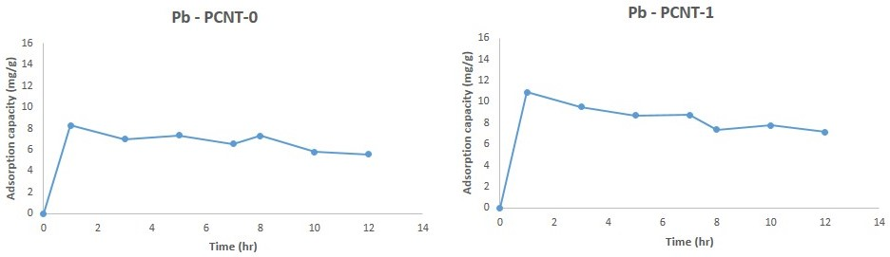

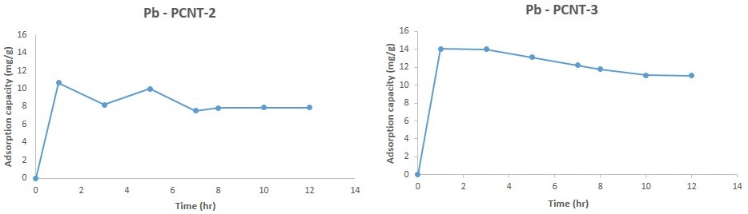

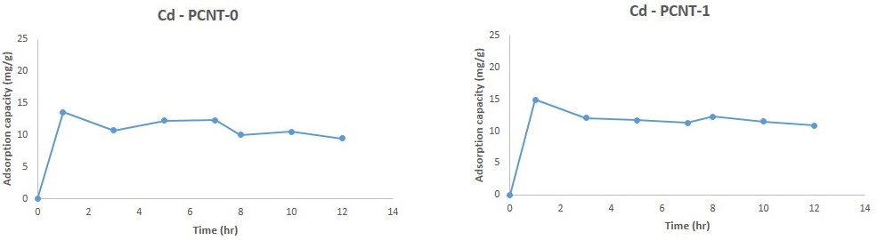

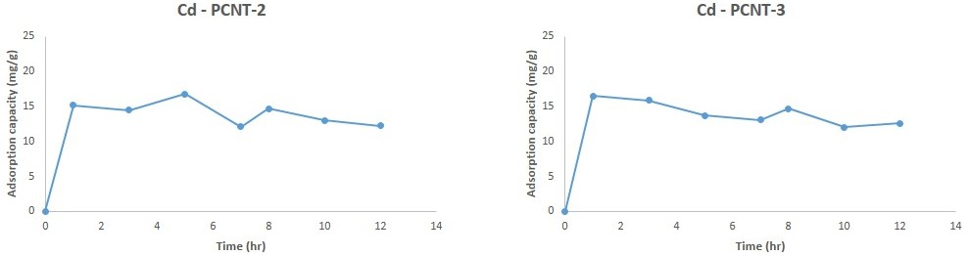

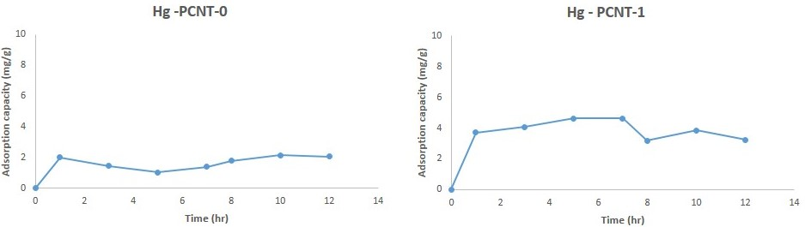

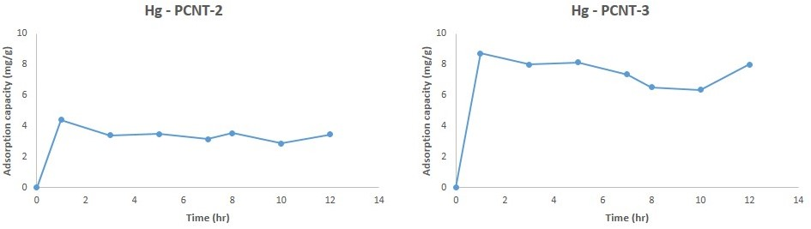

**Conclusion:** The adsorption studies of the fabricated membranes exhibited very limited affinity for the metal ions. Hence, the mechanism of the metal rejection observed during the rejection studies could be mainly due to the sieving mechanism.

**References:**

1. Prabhu, K. B., Saidutta, M. B., Isloor, A. M., & Kamath, G. (2017). A new chitosan biopolymer derivative for the removal of copper (ii) and lead (ii) from aqueous solutions: synthesis, characterization and adsorption studies. JURNAL TEKNOLOGI, 79(6), 1-+.
2. Nethaji, S., Sivasamy, A., Thennarasu, G., & Saravanan, S, (2010). Adsorption of Malachite Green dye onto activated carbon derived from Borassus aethiopum flower biomass. J. Hazard. Mater. 181, 271-280.
3. Shenvi, S. S., Isloor, A. M., Ismail, A. F., Shilton, S. J., & Al Ahmed, A, (2015). Humic acid based biopolymeric membrane for effective removal of methylene blue and rhodamine B. Ind. Eng. Chem. Res. 54(18), 4965-4975.