Electronic Supplementary Material
HPLC-MS/MS multiclass determination of steroid hormones in environmental waters after preconcentration on the carbonaceous sorbent HA-C@silica
Francesca Merlo¹, Andrea Speltini², Federica Maraschi¹, Michela Sturini¹, Antonella Profumo^{1*}
¹Department of Chemistry, University of Pavia, via Taramelli 12, 27100 Pavia, Italy
²Department of Drug Sciences, University of Pavia, via Taramelli 12, 27100 Pavia, Italy
*E-mail: antonella.profumo@unipv.it

Table S1. Physical-chemical parameters of the water samples.
 | Tap water | Staffora River | Ticino River | Tanaro River | Wastewater effluent*
pH | 7.7 | 7.4 | 7.6 | 7.6 | 6.5
Conductivity at 20 °C (μS cm⁻¹) | 270 | 307.8 | 223 | 432 | 551
Cl⁻ (mg L⁻¹) | 5.0 | 4.2 | 9.5 | 15.7 | 52.4
NO₃⁻ (mg L⁻¹) | 0.6 | 1.7 | 7.9 | 8.0 | 9.5
SO₄²⁻ (mg L⁻¹) | 5.0 | 13.5 | 32.6 | 41.2 | 64
Ca²⁺ (mg L⁻¹) | 36.1 | 56 | 31.5 | 63 | 62.1
Mg²⁺ (mg L⁻¹) | 8.1 | 8.1 | 6.2 | 10.0 | 10.1
Mn²⁺ (mg L⁻¹) | < 0.05 | < 0.05 | < 0.05 | < 0.05 | < 0.05
Fe (mg L⁻¹) | 0.045 | 0.12 | 0.06 | 0.3 | 0.076
*other parameters (mg L⁻¹): COD 24, SS 2, P_{tot} 0.45, NH₄⁺ 3.7, NO₂⁻ 0.4.

Table S2. Mean recovery (%) in tap water (500 mL, 1000 ng L⁻¹) at different pH extraction.
 | Mean recovery (%)
 | pH 3 | pH 7.5
E1 | 86 | 104
E2 | 87 | 111
EE2 | 85 | 105
PROG | 48 | 50
H-PROG | 93 | 109
M-PROG | 74 | 99
TST | 81 | 102
RSD < 10%, n=3

Table S3. Mean recovery (%) in tap water (500 mL, 1000 ng L⁻¹) with different elution solvents.
Mean recovery (%)
 | MeOH | MeOH + 2% v/v NH₄OH |  | MeOH + 0.2% v/v formic acid | ACN
E1 | 104 | 101 |  | 89 | 75
E2 | 111 | 99 |  | 84 | 79
EE2 | 105 | 97 |  | 85 | 83
PROG | 50 | 48 |  | 49 | 83
H-PROG | 109 | 97 |  | 99 | 83
M-PROG | 99 | 98 |  | 99 | 86
TST | 102 | 93 |  | 89 | 60
RSD < 10%, n=3

Table S4. Optimized MRM conditions for the HPLC-ESI-MS/MS analysis of GCs.
 | Precursor Ion* (m/z) | MRM product ions  (m/z) | Dwell time | Fragmentor Energy (V) | Collision Energy (V) | Polarity
CORT | 361 | 163.2 | 15 | 130 | 20 | Positive
 |  | 105 | 15 | 130 | 48
H-CORT | 363 | 121.1 | 15 | 124 | 20 | Positive
 |  | 91 | 15 | 124 | 68
PRED | 359 | 341.3 | 15 | 76 | 4 | Positive
 |  | 147.1 | 15 | 76 | 24
PREDLO | 343 | 147.1 | 15 | 112 | 20 | Positive
 |  | 91 | 15 | 112 | 72
BETA | 373 | 355.3 | 15 | 82 | 8 | Positive
 |  | 147.1 | 15 | 82 | 24
DEXA | 373 | 355.3 | 15 | 76 | 4 | Positive
 |  | 91 | 15 | 76 | 80
TRIAM | 415 | 397.3 | 15 | 130 | 8 | Positive
 |  | 91 | 15 | 130 | 80
FLUO | 495 | 475.3 | 15 | 88 | 0 | Positive
 |  | 337.3 | 15 | 88 | 8
*[M+H]⁺ adduct.

Figure S1. A MRM chromatogram of a SPE eluate obtained from pre-concentration of 1 L of Ticino River sample.
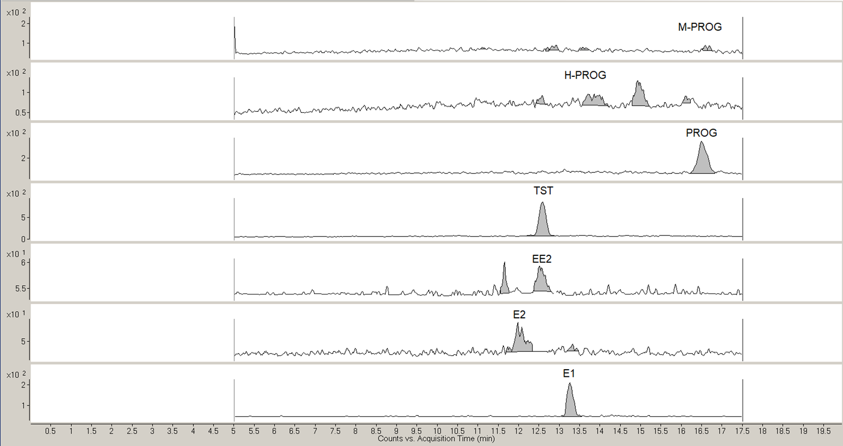

Figure S2. A MRM chromatogram of a SPE eluate obtained from pre-concentration of 1 L of Ticino River sample.
