Supporting Information
¹H and ¹³C NMR Spectra of representative compounds:
¹H NMR spectrum of 4a:
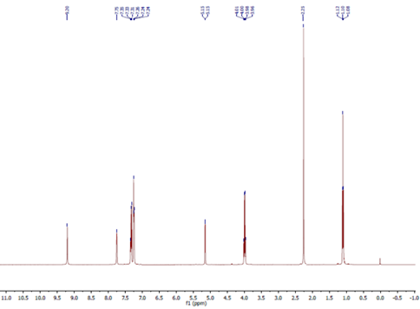
¹³C NMR spectrum of 4a
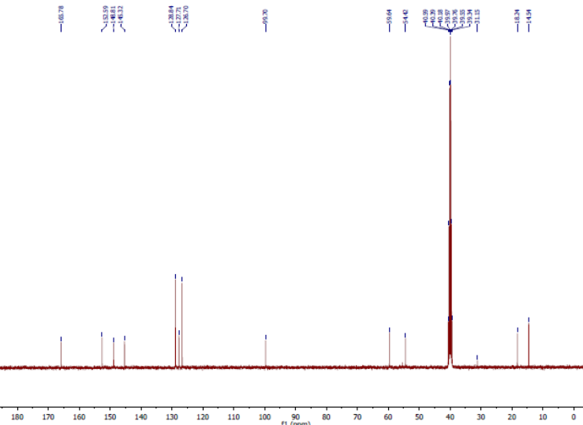
¹H NMR spectrum of 4c:
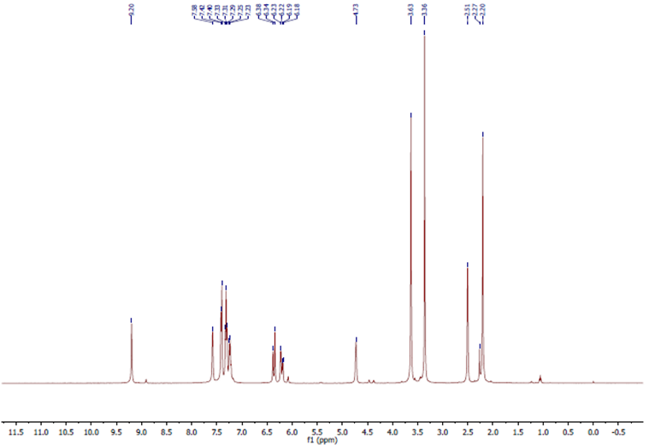
¹³C NMR spectrum of 4c:
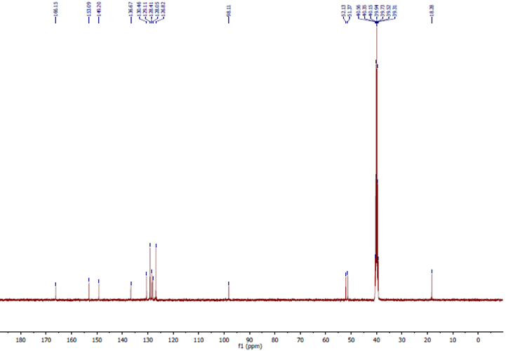
ESI-MS spectrum of 4c
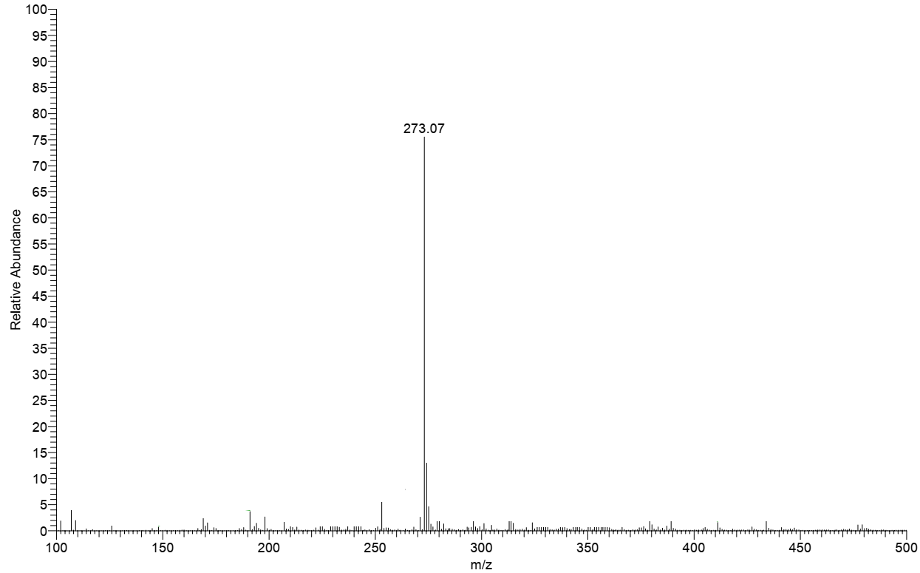

IR spectrum of 4c

¹H NMR spectrum of 4e
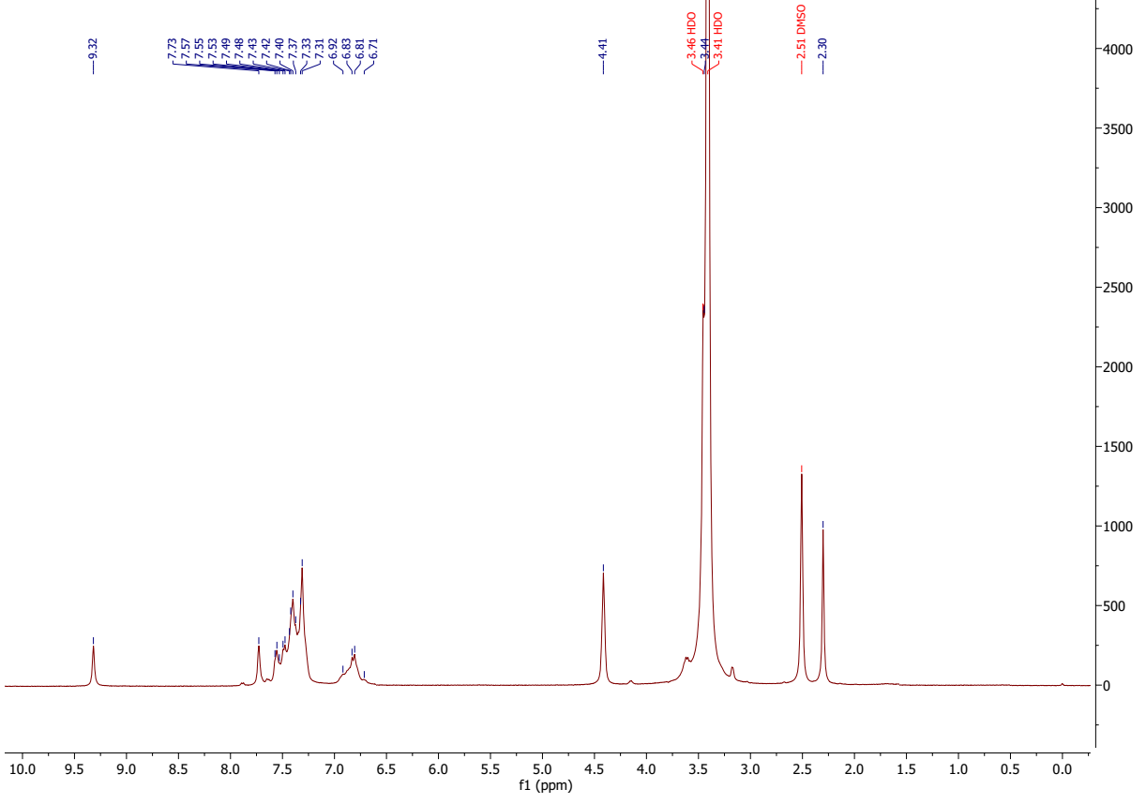
¹³C NMR spectrum of 4e:
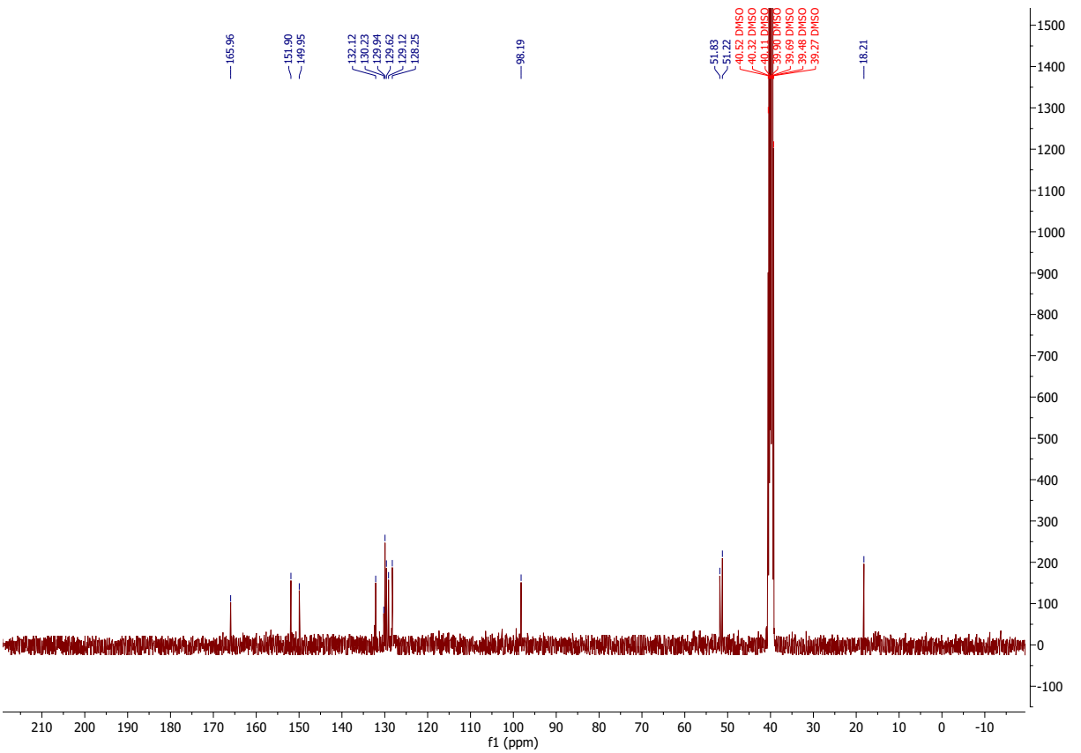
IR spectrum of 4e
¹H NMR spectrum of 4g
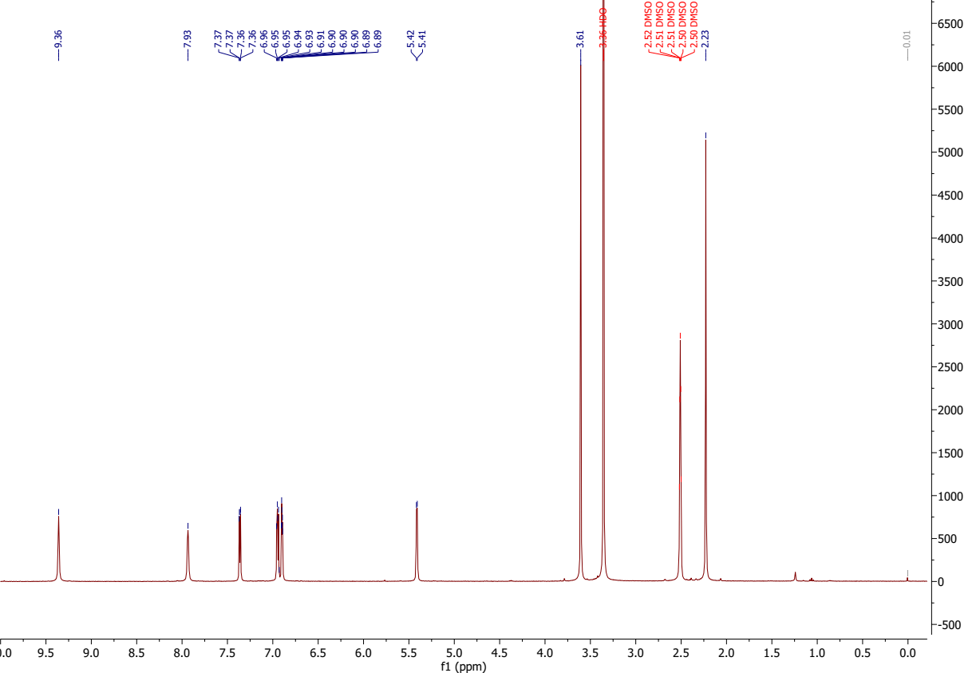
¹³C NMR spectrum of 4g:
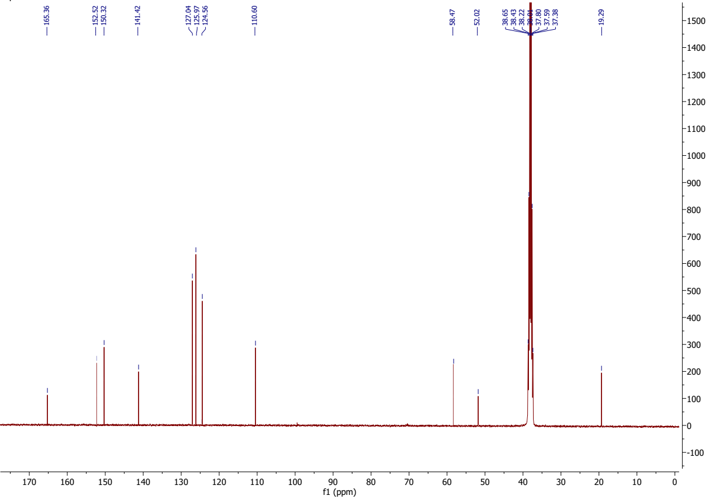
ESI-MS spectrum of 4g:
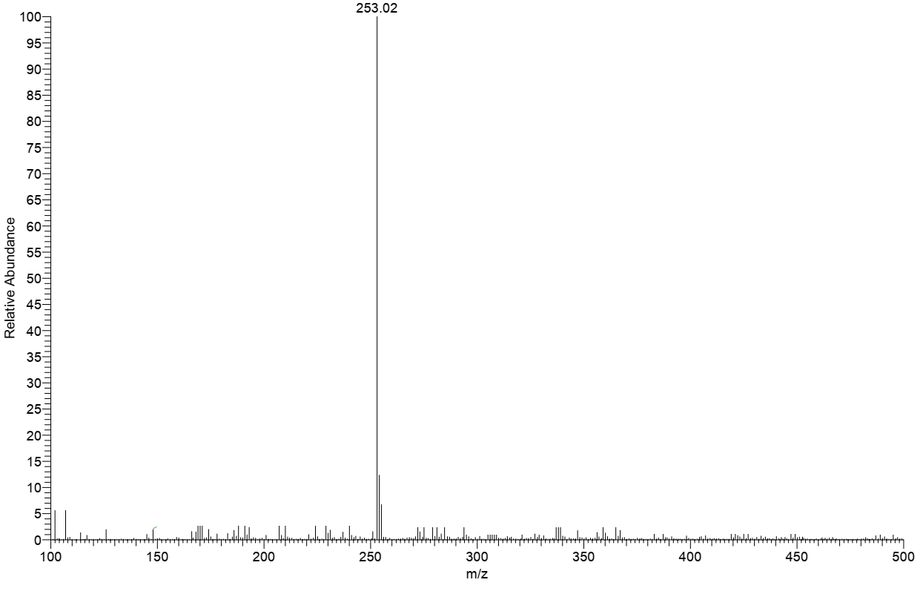

ESI-MS analyses of the reaction mixture after 15 minutes
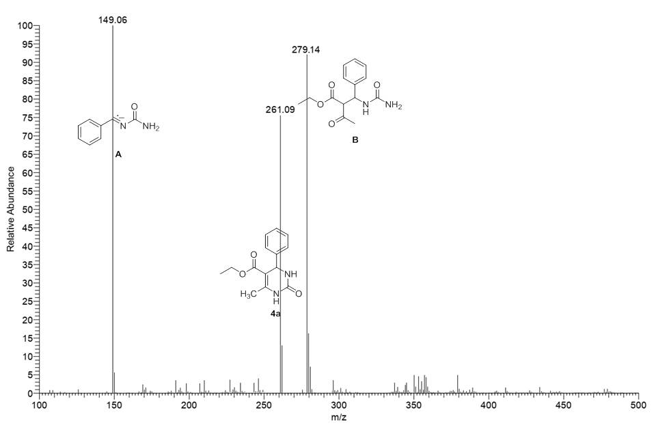
References
1. A. Khalyfa, S. Kermasha, I. Alli, Extraction, purification, and characterization of chlorophylls from spinach leaves, J. Agric. Food Chem. 40 (1992) 215-220.
2. K. Iriyama, N. Ogao, A. Takamiya, A simple method for extraction and partial purification of chlorophyll from plant material, using dioxane, J. Biochem. 76 (1974) 901-904.
3. (a) A. Johnston, J. Scaggs, C. Mallory, A. Haskett, D. Warner, E. Brown, K. Hammond, M.M. McCormick, O.M. McDougal, A Green approach to separate spinach pigments by column chromatography, J. Chem. Educ. 90 (2013) 796-798. (b) A.R. Welburn, The spectral determination of chlorophylls a and b, as well as total carotenoids, using various solvents with spectrophotometers of different resolution, J. Plant Physiol. 144 (1994) 307-313. (c) K.M. Smith, D.A. Goff, R. Abraham, The NMR spectra of porphyrins. 27*—proton NMR spectra of chlorophyll‐a and pheophytin‐a, J. Org. Magn. Reson. 22 (1984) 779-783. (d) R.J. Abraham, A.E. Rowan, In Chlorophylls, ed. H. Sheer, CRC Press, Boca Raton, FL, (1991) 797-834.

