**Supplementary Material**

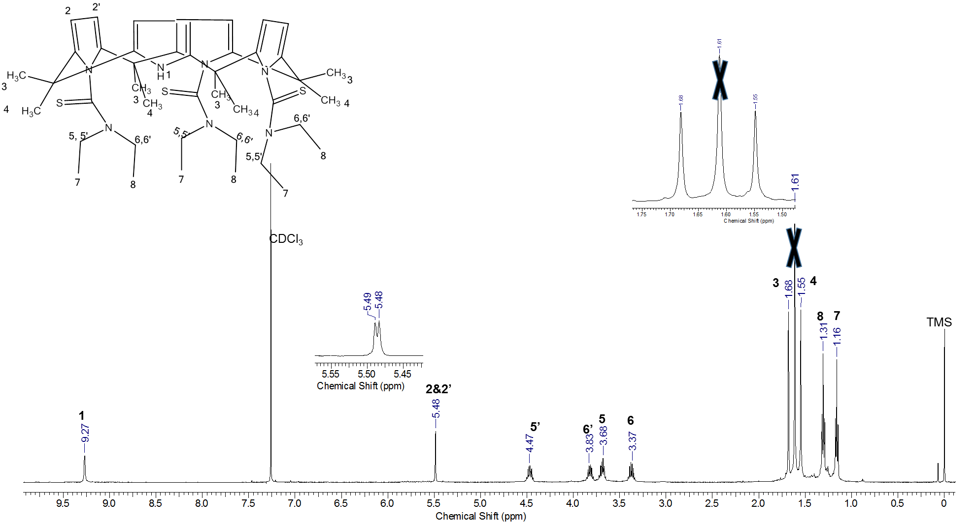

**Figure S1** 1H NMR spectrum of CPII in CDCl3 at 298 K.

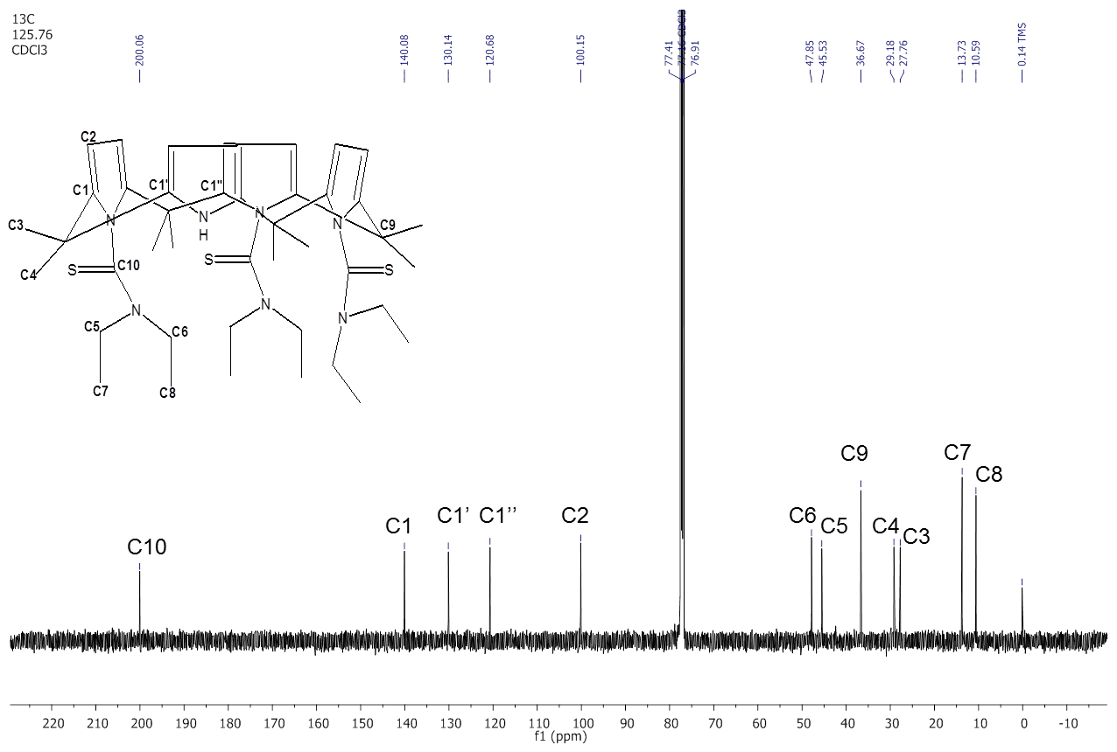

**Figure S2** 13C NMR spectrum of CPII in CDCl3 at 298 K.

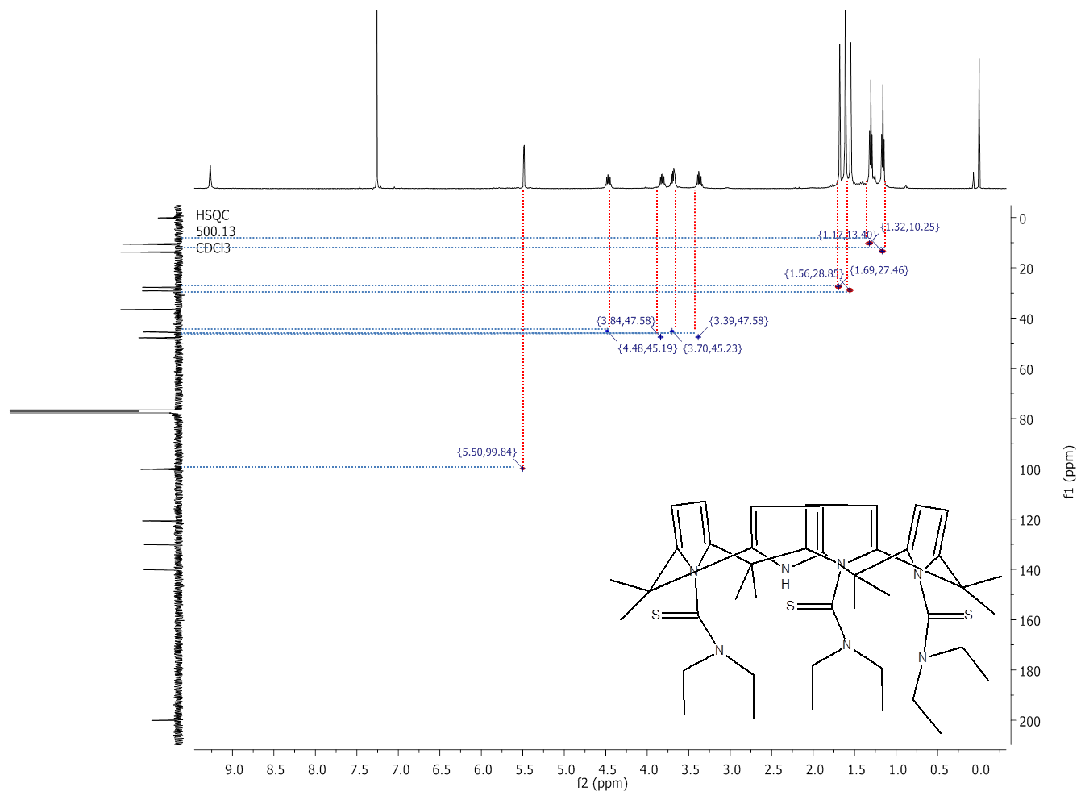

**Figure S3** HSQC NMR spectrum of CPII in CDCl3 at 298 K.



**Figure S4** HMBC NMR spectrum of CPII in CDCl3 at 298 K.

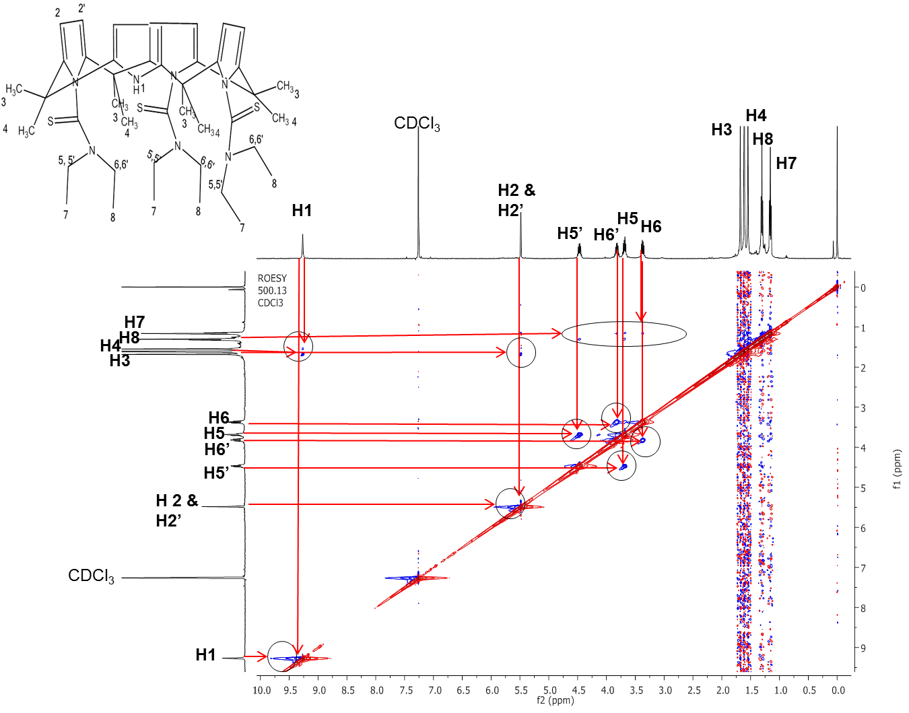

**Figure S5** ROESY 1H NMR spectrum of CPII in CDCl3 at 298 K.