Experimental
Materials synthesis
All the chemical reagents were of analytical grade and used as received. The formation process of ZIF-67/MIL-68 and Co₃O₄/In₂O₃ was shown in Scheme 1. The specific steps of synthesizing ZIF-67/MIL-68 and Co₃O₄/In₂O₃ were as follows:
- Synthesis of MIL-68.
0.382 g In(NO₃)₃·4.5H₂O was dissolved in 6 mL N,N-Dimethylformamide (DMF) which was marked as solution A. The solution B was consisted with 0.2 g 1,4-dicarboxybenzene and 6 mL DMF. Then the solution B was poured into the solution A, the mixture was transferred into a Teflon-lined stainless-steel autoclave and heated at 100°C for 24h. Next, the dispersion was filtered out and washed with ethanol and deionized water three times. Finally, the product was vacuum dried at 60 °C for 12 h.
- Synthesis of ZIF-67/MIL-68 (molar ratio=4:1).
1.164 g Co(No₃)₂·6H₂O and 1.312 g 2-methylimidazole were dissolved in 100 mL methanol and MIL-68 was added into the mixture and stirring for 24h, then let stand 12 h. Subsequently purple solid could be obtained by filtering. Finally, the product was rinsed with methanol and dried.
Synthesis of ZIF-67/MIL-68 (molar ratio=2:1).
The steps and the described above for ZIF-67/MIL-68 (4:1) were alike, but instead, the 0.582 g Co(No₃)₂·6H₂O and 0.656 g 2-methylimidazole were dissolved in 50 mL methanol.
Synthesis of ZIF-67/MIL-68 (molar ratio=1:1).
The steps and the described above for ZIF-67/MIL-68 (4:1) also were alike, but instead, the 0.291 g Co(No₃)₂·6H₂O and 0.328 g 2-methylimidazole were dissolved in 25 mL methanol.
Synthesis of ZIF-67/MIL-68 (molar ratio=0.5:1).
The steps and the described above for ZIF-67/MIL-68 (4:1) also were alike, the difference was that 0.145 g Co(No₃)₂·6H₂O and 0.164 g 2-methylimidazole were dissolved in 12.5 mL methanol.
- Synthesis of Co₃O₄/In₂O₃.
The Co₃O₄/In₂O₃ were synthesized by thermal treatment of ZIF-67/MIL-68 (4:1, 2:1, 1:1, 0.5:1) templates at 400 °C for 2 h with a heating rate of 1 °C min⁻¹ in air and also donated as Co₄In₁, Co₂In₁, Co₁In₁, Co_{0.5}In₁, respectively.
Characterization techniques
Characterization techniques were shown in our previous work in detail.^{[1]}
Catalytic activity measurements
Catalytic activity measurements were shown in our previous work in detail as well.^{[2]}
Detail calculation method of E_{a}
The Arrhenius plots of four catalysts for toluene oxidation reaction were investigated and the linear relations of lnr versus 1000/T were well fitted by the power rate law equation in Fig. 11.
It was reasonable to assume that the oxidation of toluene in the presence of excessive oxygen would obey first-order reaction mechanism with respect to toluene concentration: (1)
Where r, k, A, c and E_{a} are the reaction rate (mol s⁻¹), rate constant (s⁻¹), pre-exponential factor, concentration of toluene in feed stream (mol m⁻³) and apparent activation energy (kJ mol⁻¹), respectively.
(2)
Where F is toluene feeding rate (moles of toluene per s, 4.56x10⁻⁷ mol s⁻¹), W is the weight of the catalyst (0.6 g) and x is toluene conversion. So the equation could be integrated to obtain equation as follows:
(3)
At here, B is a constant.
Therefore, the apparent activation energy (E_{a}) could be estimated from the slope of linear ln r versus 1000/T.

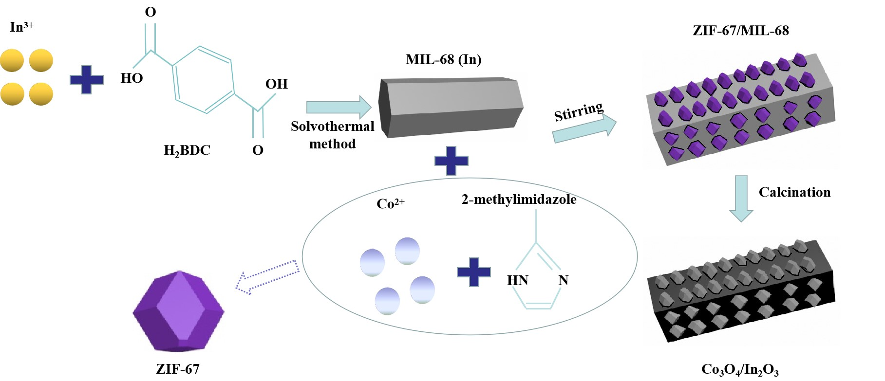

Scheme 1. Schematic showing the synthetic procedures of in situ growth of Co₃O₄ nano-dodecahedra on In₂O₃ hexagonal prisms.

References
- Zhao, J.; Dong, F.; Han, W.; Zhang, J.; Tang Z. Controlled porous hollow Co₃O₄ polyhedral nanocages derived from metal-organic frameworks (MOFs) for toluene catalytic oxidation. Mol. Catal. 2019, 463, 77-86.
[2] Han, W.; Zhao, H.; Dong, F., Tang, Z. Morphology-controlled synthesis of 3D, mesoporous, rosette-like CeCoO_{x} catalysts by pyrolysis of Ce[Co(CN)6] and application for the catalytic combustion of toluene. Nanoscale 2018, 10, 21307-21319.

