Supporting Information
The removal of Cu, Ni, and Zn in industrial soil by washing with EDTA-organic acids

Shuailong Cheng ª, Qintie Lin ^{a,}*, Yupeng Wang ª, Haoyu Luo ª, Zhuofan Huang ª, Hengyi Fu ª Hengrui Chen ^{b}, Rongbo Xiao ª

ª Guangdong Industrial Contaminated Site Remediation Technology and Equipment Engineering Research Center, School of Environmental Science and Engineering, Guangdong University of Technology, Guangzhou 510006, P. R. China

^{b} International Dept. The Affiliated High School of South China Normal University, Guangzhou 510000, PR China

Corresponding Author:
Qintie Lin; E-mail: qintlin@163.com;

The supporting information (total of 9 pages including a cover sheet) contains 1 text (Text S1) and 4 figures (Figure S1-S4).
Text S1.
3.7 The treatment of soil washing wastewater
Per 200 mL washing wastewater was added 10 mmol/L sodium persulfate solution (SPS), and mixed sufficiently, then a nanocomposite material synthesized by loading nanoscale zerovalent iron (nZVI) onto biochar (BC) was also added with a dose of 1 g/L. The sample was taken at a certain time gradient (0, 15, 30, 60, 120 and 240 min), then per sample was preserved some samples at 4 ℃ to measure the COD value. Then the pH of mixed liquids was adjusted to 10.0±0.1 by sulfuric acid and sodium hydroxide. Finally, the content of heavy metals in supernatant was determined.

Figure captions

Figure S1. Removal rates of copper (Cu), nickel (Ni) and zinc (Zn) by citric acid (a), oxalic acid (b), tartaric acid (c) and EDTA (d) at different concentrations under an initial pH of 3.0, solid-liquid ratio of 1:10 and washing time of 6 h.
Figure S2 Removal rates of Cu, Ni and Zn by EDTA-citric acid (a), EDTA-oxalic acid (b), and EDTA-tartaric acid (c) under a solid-liquid ratio of 1:5, 1:7.5, 1:10, 1:15 and 1:20, initial pH of 3.0, and washing time of 6 h.
Figure S3. Removal rates of Cu, Ni and Zn by EDTA-citric acid (a), EDTA-oxalic acid (b), and EDTA-tartaric acid (c) after 0.5, 1, 2, 6, 12 and 24 h under a solid-liquid ratio of 1:10 and initial pH of 3.0.
Figure S4. The removal of Cu，Ni , Zn and COD in soil washing wastewater by AOP and alkaline precipitation (pH was adjusted to 10.0±0.1).
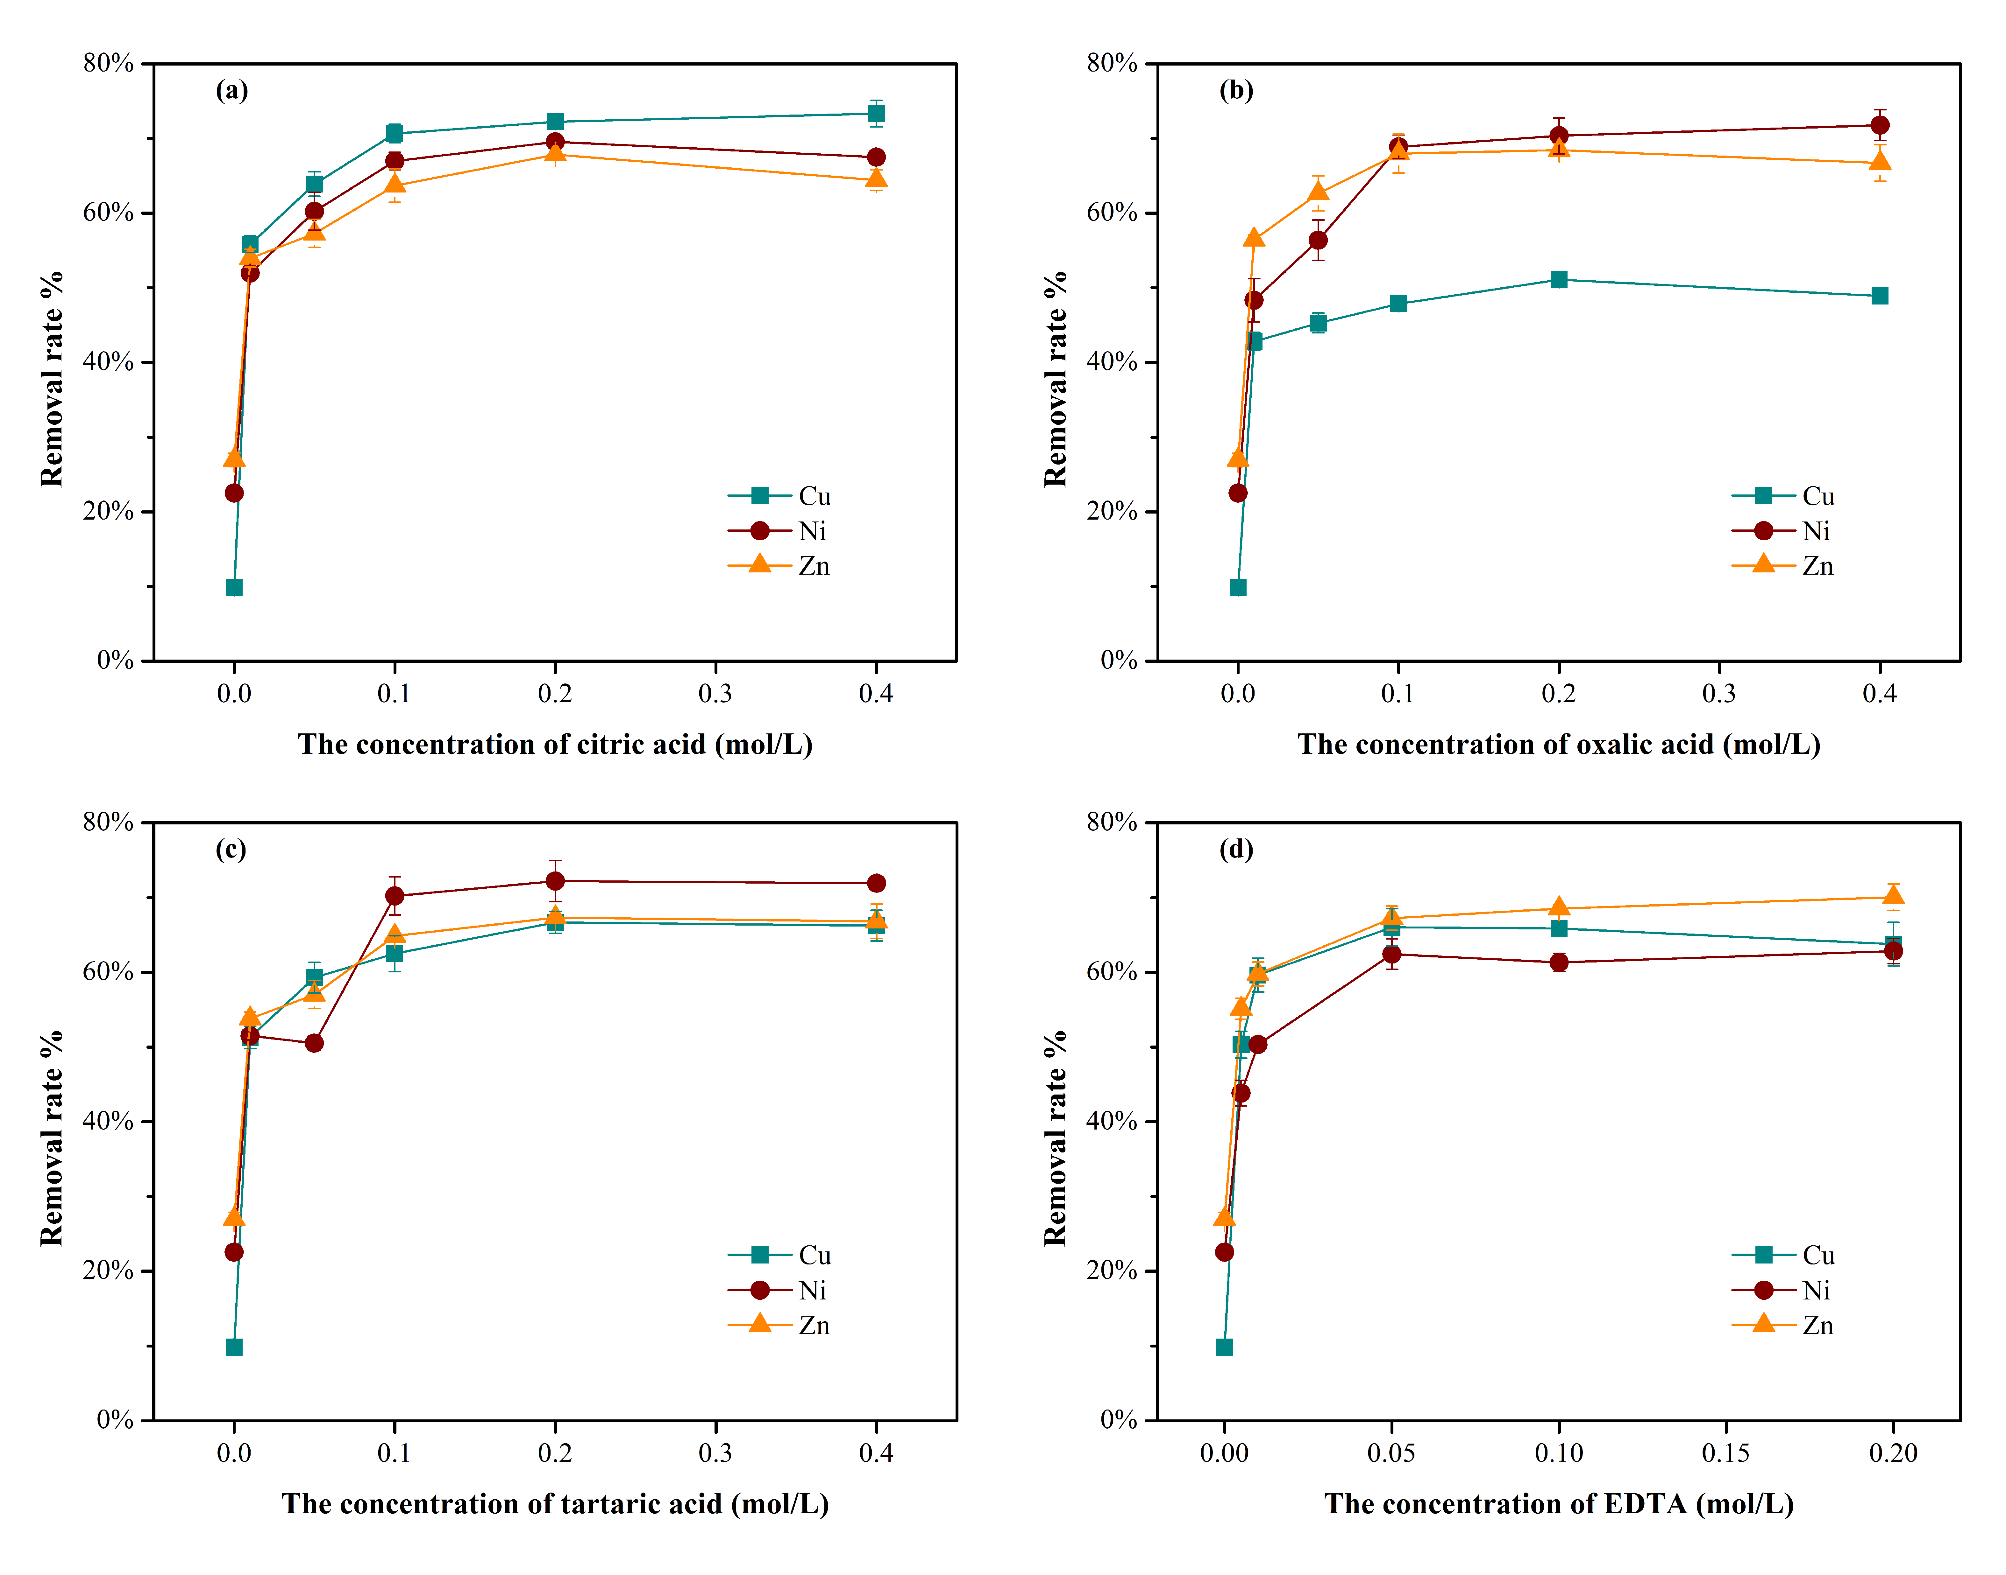
Figure S1. Removal rates of copper (Cu), nickel (Ni) and zinc (Zn) by citric acid (a), oxalic acid (b), tartaric acid (c) and EDTA (d) at different concentrations under an initial pH of 3.0, solid-liquid ratio of 1:10 and washing time of 6 h.
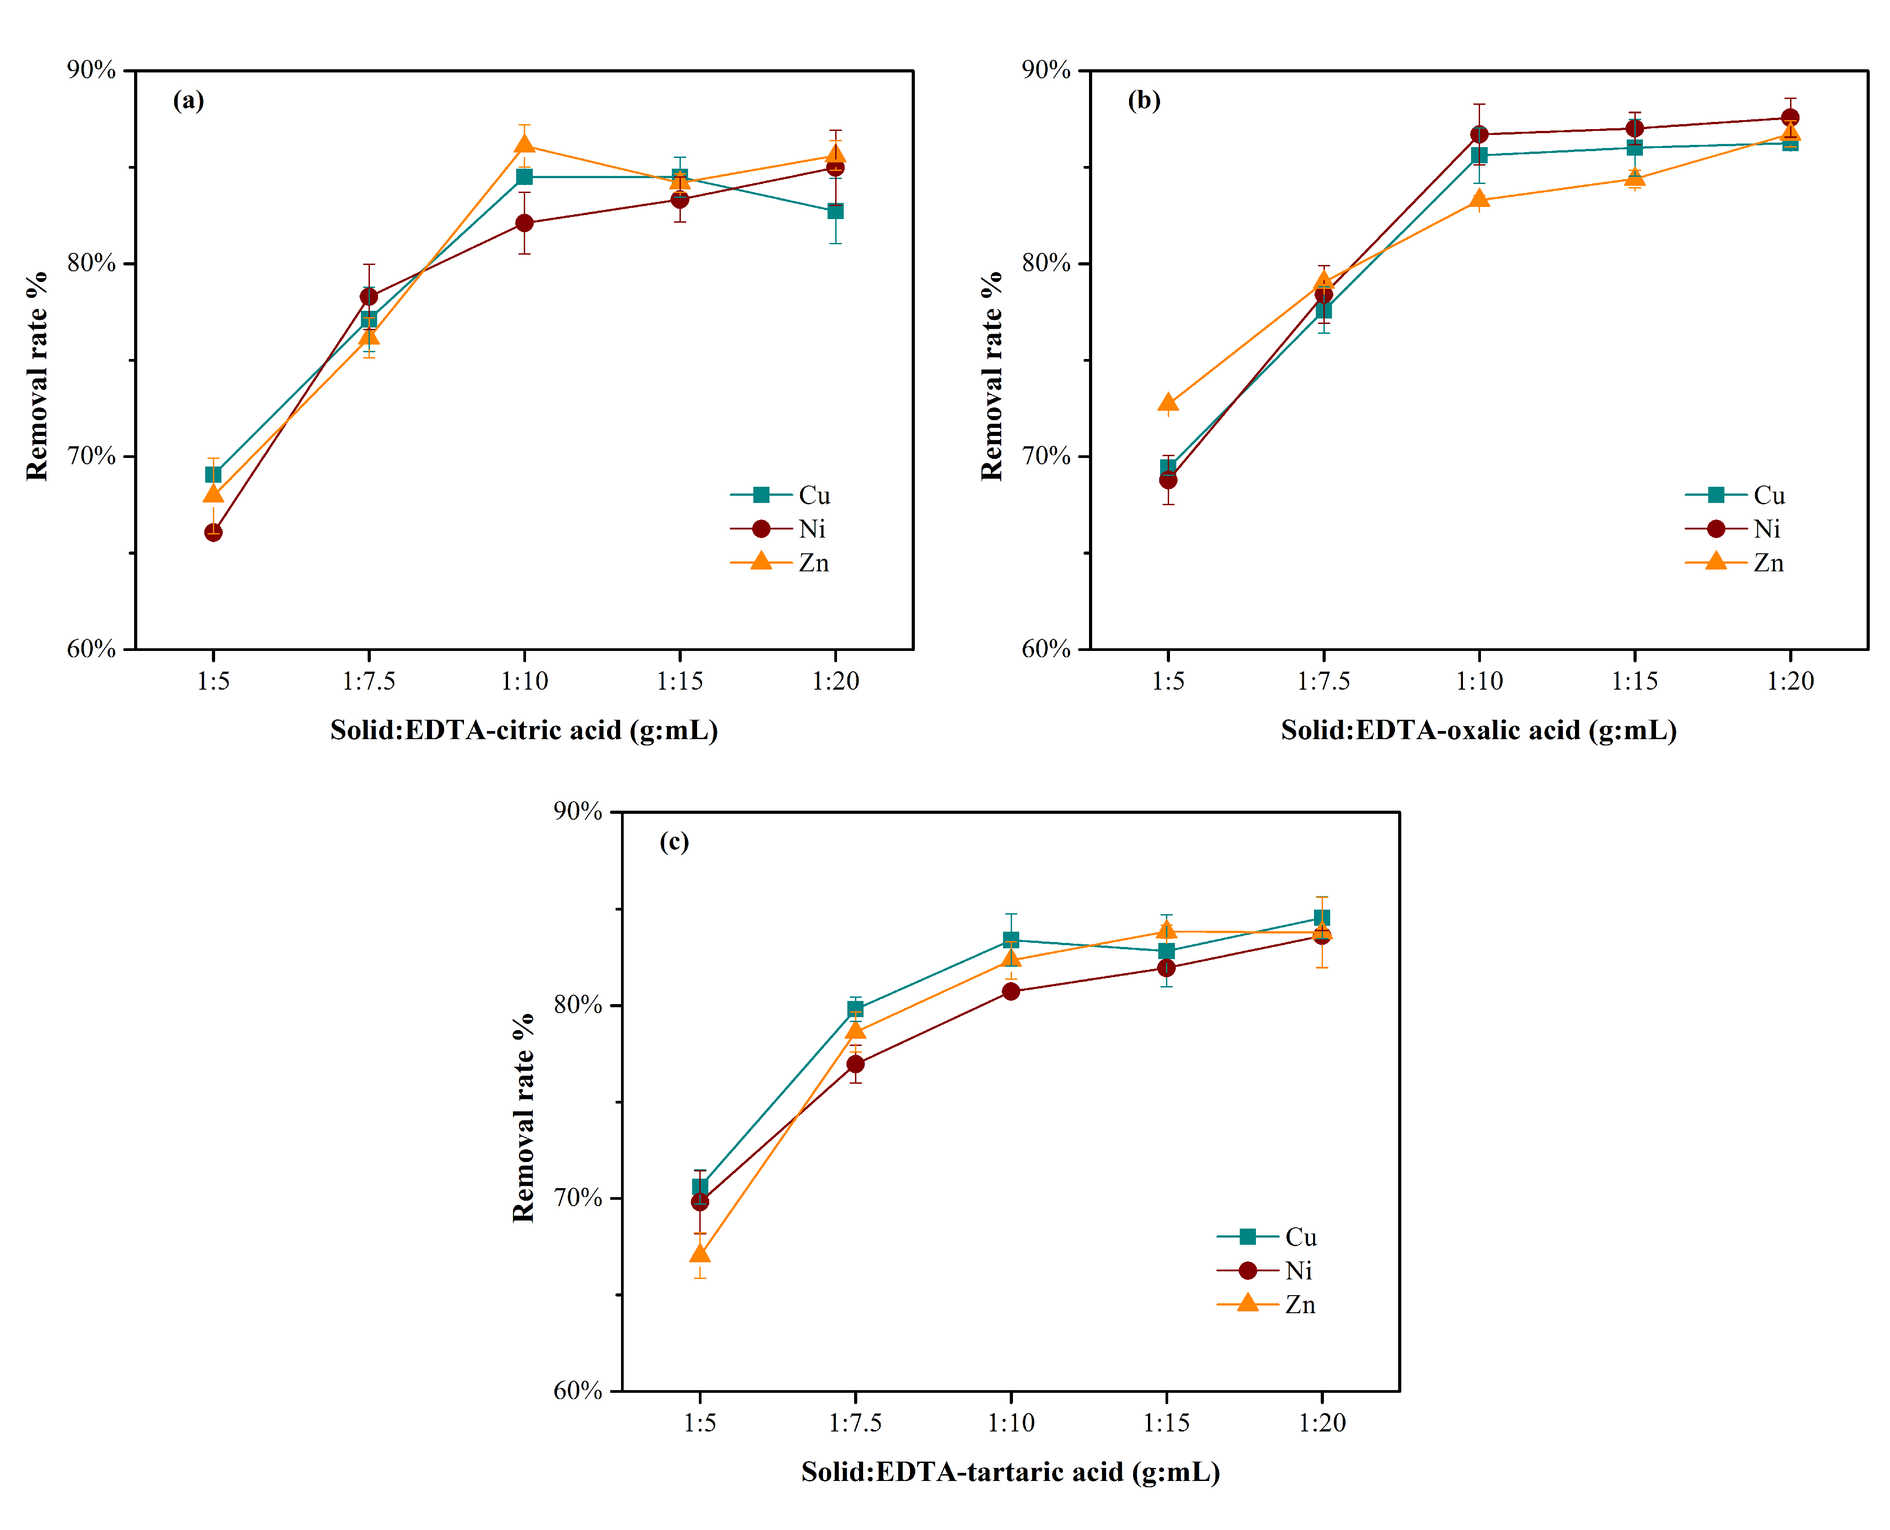
Figure S2. Removal rates of Cu, Ni and Zn by EDTA-citric acid (a), EDTA-oxalic acid (b), and EDTA-tartaric acid (c) under a solid-liquid ratio of 1:5, 1:7.5, 1:10, 1:15 and 1:20, initial pH of 3.0, and washing time of 6 h.
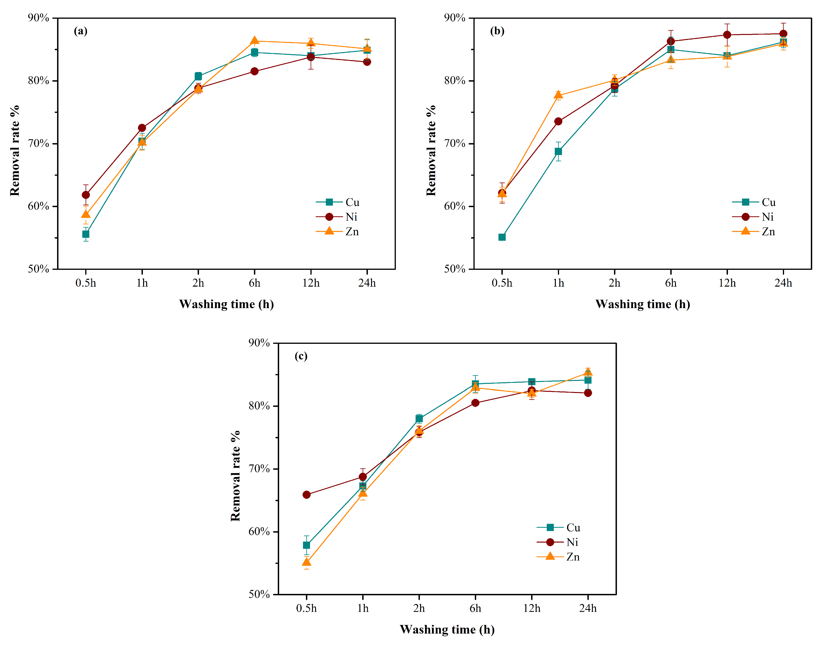
Figure S3. Removal rates of Cu, Ni and Zn by EDTA-citric acid (a), EDTA-oxalic acid (b), and EDTA-tartaric acid (c) after 0.5, 1, 2, 6, 12 and 24 h under a solid-liquid ratio of 1:10 and initial pH of 3.0.
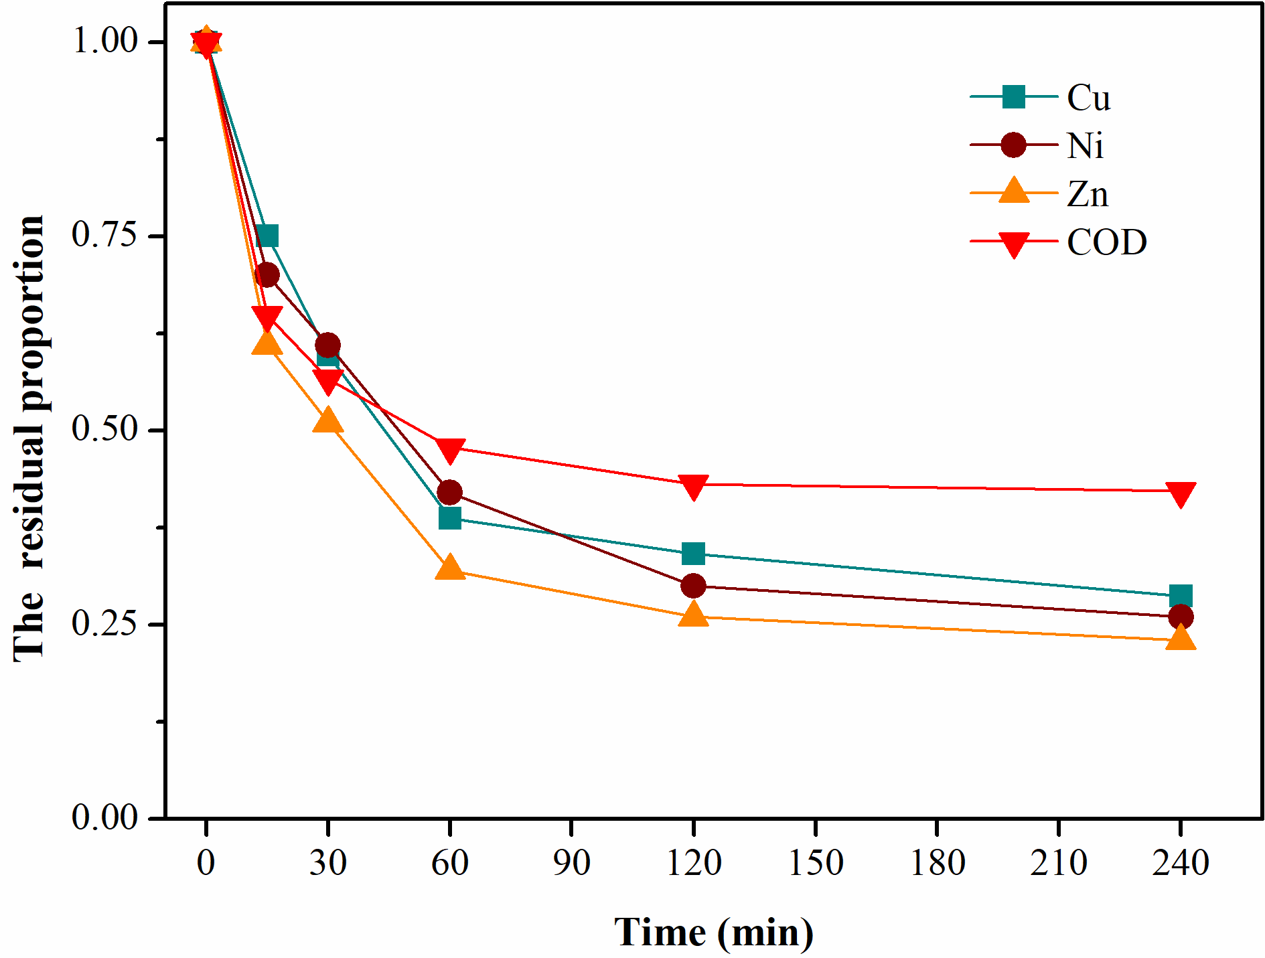
Figure S4. The removal of Cu，Ni , Zn and COD in soil washing wastewater by AOP and alkaline precipitation (pH was adjusted to 10.0±0.1).

