**Supplementary Information**

**BET surface area and pore size distribution**

N2-sorption isotherms and pore size distribution analysis results of HZSM-5 and Mo/HZSM-5 samples are presented in supplementary figure S1, S2 and Table 1 respectively. HZSM-5 with different Si to Al ratios showed greater BET surface area and pore volume over molybdenum deposited Mo/HZSM-5 samples. Further, calcination and carburization processes decreased the BET surface area of Mo/HZSM-5 samples (Table 1). It might be associated with the blockage of pores of HZSM-5 by molybdenum and or by coke (Tan et al., 2019). All of them exhibited IUPAC type-I isotherm with a *H4* type hysteresis loop at relative pressure between 0.45 and 1 (figure S1). The result suggests microporosity of the studied samples.

It is clear from the graph (S2) that HZSM-5= 23 and 30 samples exhibiting majority of micropores with minor portion of mesopores in the range of 1-2 nm and 3-5 nm respectively. However, a dramatic decrease in the micropore volume was observed for MoO3/HZSM-5= 23 and 30 samples, which suggests the deposition of molybdenum in to the micropores of HZSM-5 during its impregnation. Similar results were reported by Tan et al., (Tan et al., 2019) for Mo deposited HZSM-5=25 samples. Furthermore, micropores were totally disappeared in spent Mo2C/HZSM-5=23 and 30 samples. The results suggest that, coke deposition primarily occurred in the micropores of these samples during carburization and methane aromatization processes. On the other hand, molybdenum deposition was occurred in micro and mesopores of HZSM-5 with Si to Al ratio =50 and 80 samples. The difference in the deposition of the molybdenum in HZSM-5 supports with different Si to Al ratio might be associated with its surface acidity. The results are in consistent with Tessonnier et al., (Tessonnier et al., 2008) where the authors reported small polymolybdate or alumino-molybdate species that partially blocks micropores and mesopores of HZSM-5= 40 upon Mo loading. It is noteworthy that, mesopores observed at about 4nm pore size was slightly improved with increase in the Si to Al ratio of HZSM-5. Among the studied HZSM-5 supports, HZSM-5=80 showed the highest BET surface area (421 m2/g) and pore volume (0.250 cc/g) followed by HZSM-5=50 (395 m2/g, 0.249 cc/g), HZSM-5=30 (354 m2/g, 0.240 cc/g) and HZSM-5=23 (318 m2/g, 0.184 cc/g). It is clear from the results that, the BET surface area of Si to Al ratio= 30, 50 and 80 samples decreased upto 50% upon Mo loading and calcination. Whereas, this decrease was only about 10% for Si to Al ratio=23 sample. In conclusion, the zeolite structure was preserved upon Mo loading followed by calcination, carburization and methane aromatization processes in all the studied samples.





**S1:** N2-sorption isotherms of HZSM-5 and Mo/HZSM-5 samples.



**S2:** Pore size distribution of HZSM-5 and Mo/HZSM-5 samples.

**Table 1:** BET surface area, pore volume, weight loss and XPS data for studied samples

|  |  |  |  |  |
| --- | --- | --- | --- | --- |
| Sample | BET surface area m2g-1 | Pore volume cm3. g-1 | TGA wt. loss % | Atomic %  metallic Mo |
| **HZSM-5=23** | 318.0 | 0.184 | - | - |
| MoO3/HZSM-5=23 | 234.0 | 0.146 | - | - |
| Spent Mo2C/HZSM-5=23,700 oC | 218.0 | 0.141 | 20.0 | 0.20 |
| Spent Mo2C/HZSM-5=23,750 oC | 209.0 | 0.133 | 25.0 | 0.22 |
| **HZSM-5=30** | 354.0 | 0.240 | - | - |
| MoO3/HZSM-5=30 | 174.0 | 0.124 | - | - |
| Spent Mo2C/HZSM-5=30,700 oC | 168.0 | 0.114 | 23.0 | 0.33 |
| Spent Mo2C/HZSM-5=30,750 oC | 161.0 | 0.107 | 27.0 | 0.38 |
| **HZSM-5=50** | 395.0 | 0.249 | - | - |
| MoO3/HZSM-5=50 | 181.0 | 0.118 | - | - |
| Spent Mo2C/HZSM-5=50,700 oC | 169.0 | 0.115 | 28.0 | 0.54 |
| Spent Mo2C/HZSM-5=50,750 oC | 160.0 | 0.110 | 30.0 | 0.76 |
| **HZSM-5=80** | 421.0 | 0.250 | - | - |
| MoO3/HZSM-5=80 | 211.0 | 0.140 | - | - |
| Spent Mo2C/HZSM-5=80,700 oC | 160.0 | 0.111 | 31.0 | 0.71 |
| Spent Mo2C/HZSM-5=80,750 oC | 150.0 | 0.102 | 33.0 | 0.90 |

**SEM-EDX analysis**

SEM-EDX analysis results of spent Mo2C/HZSM-5 samples are presented as figure S3. Two types of particles with hexagonal and plate shape was observed respectively for all the studied samples. Bulk hexagonal particles might be associated with MoO3 and other small sized plate like particles might be associated with reduced MoO3 particles such as MoO2 or Mo2C (Alemán-Vázquez et al., 2005). EDX analysis of all the four samples showed in Fig.3e which revealed the presence of Mo, C, O, Si and Al elements.

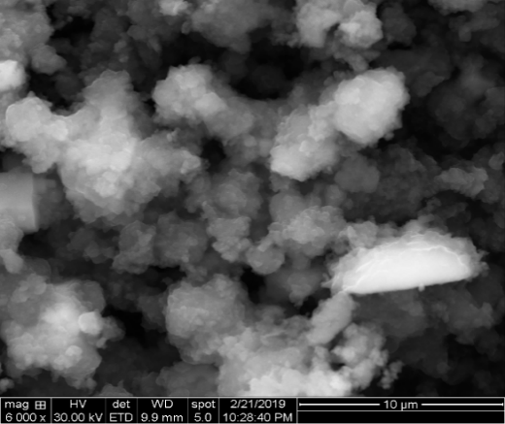

**(b)**

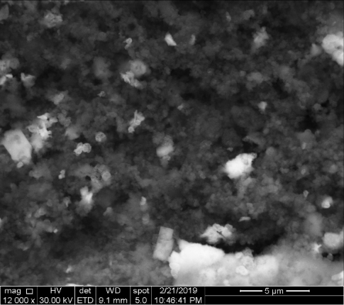

**(c)**

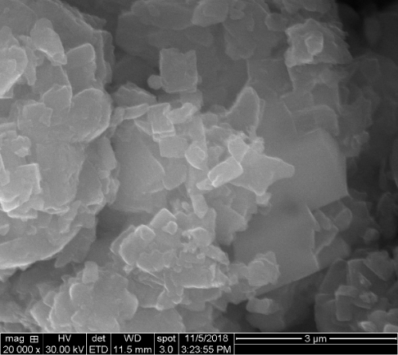

**(a)**



(e)

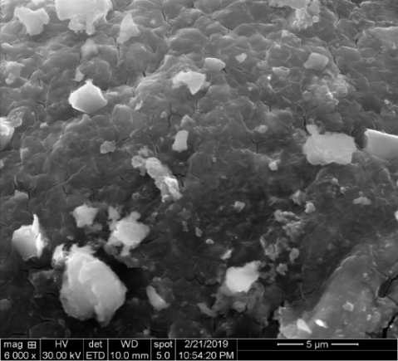

**(d)**

**S3:** SEM analysis of (a) spent Mo2C/HZSM-5=23, 700 oC (b) spent Mo2C/HZSM-5=30, 700 oC (c) spent Mo2C/HZSM-5=50, 700 oC (d) spent Mo2C/HZSM-5=80, 700 oC and (e) EDX analysis of spent Mo2C/HZSM-5 samples.

**References**

Tan, P., 2019. Ammonia-basified 10 wt% Mo/HZSM-5 material with enhanced dispersion of Mo and performance for catalytic aromatization of methane.Appl. Catal. A: Gen 580, 111-120.

Tessonnier, J. -P., Louis, B., Rigolet, S., Ledoux, M. J., Pham-Huu, C., 2008. Methane dehydro-aromatization on Mo/ZSM-5: About the hidden role of Brønsted acid sites.Appl. Catal. A: Gen. 336, 79-88.

Alemán-Vázquez, L. O., Torres-García, E., Villagómez-Ibarra, J. R., Cano-Domínguez, J. L., 2005. Effect of the particle size on the activity of MoO*x*C*y*catalysts for the isomerization of heptane. Catal. Lett. 100, 219–226.