*Supporting information for*

Highly efficient adsorption of Pb(II) by cubic nanocrystals in aqueous solution: behavior and mechanism

*Dan Ma[a], Xuegang Zou[a], Ruobai Li[a], Ping Chen[a,b], Yalan Wang[a], Tiansheng Chen[a], Qianxin Zhang[a], Haijin Liu[c],Yuping Chen[a], Wenying Lv [a]*, Yiping Feng[a], Guoguang Liu [a].*

[a]School of Environmental Science and Engineering, Guangdong University of Technology, Guangzhou 510006, China

[b] School of Environment, Tsinghua University, Beijing, 100084, China

[c] Key Laboratory for Yellow River & Huaihe River Water Environment and Pollution Control, School of Environment, Henan Normal University, Xinxiang, 453007, China

* **Corresponding author**: Wenying Lv,

 E-mail: lvwy612@163.com

Phone: +86-13538982812,

**Text S1.** **Adsorption experiments**

For the pH effect experiment, an 800 mgL-1 Pb(Ⅱ) solution was adsorbed with 10 mg of sample and the pH was adjusted to 2-6 with 5 % HNO3 and a 0.01 M NaOH solution at 298 K, which was followed by shaking for 12 h.

For the kinetic adsorption experiments, an 800 mgL-1 Pb(Ⅱ) solution was adsorbed with 10 mg of the sample at 298 K and the pH was adjusted to 5.0, which was followed by shaking for 26 h.

For the supplementary experiment, an 800 mgL-1 Pb(Ⅱ) solution was adsorbed with 10 mg of the sample at 298 K and the pH was adjusted to 5.0, which was followed by shaking for 4 h.

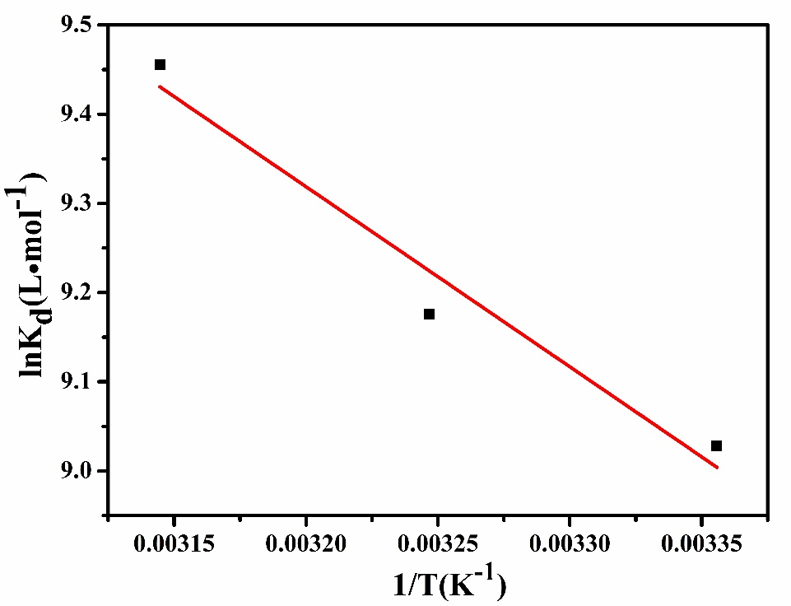**FIGURES**

Fig.S1 Plotting of ln(Kd) against 1/T on the KMFC.

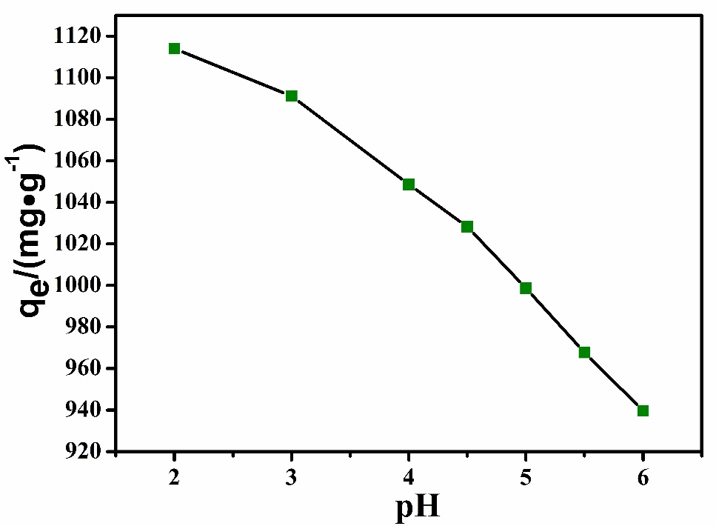Fig.S2 Effects of pH on the adsorption of Pb(Ⅱ) by the KMFC

Fig.S3 TEM images of the KMFC under strong acid and alkali.

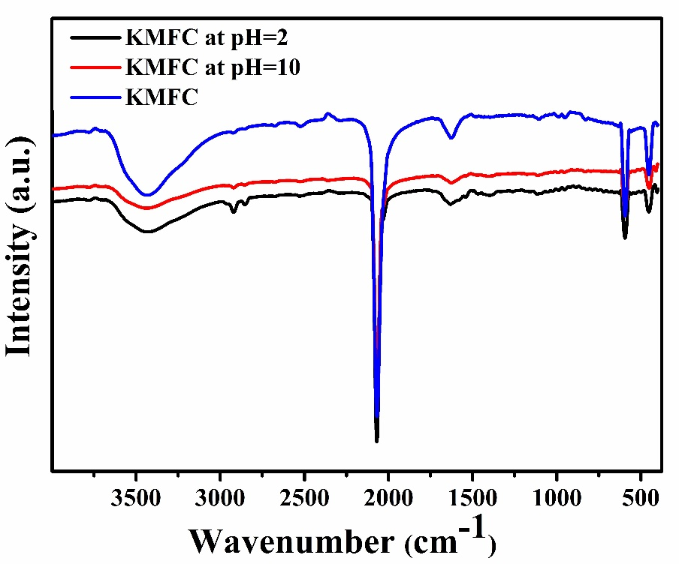Fig.S4 FT-IR spectra of the KMFC under strong acid and alkali.

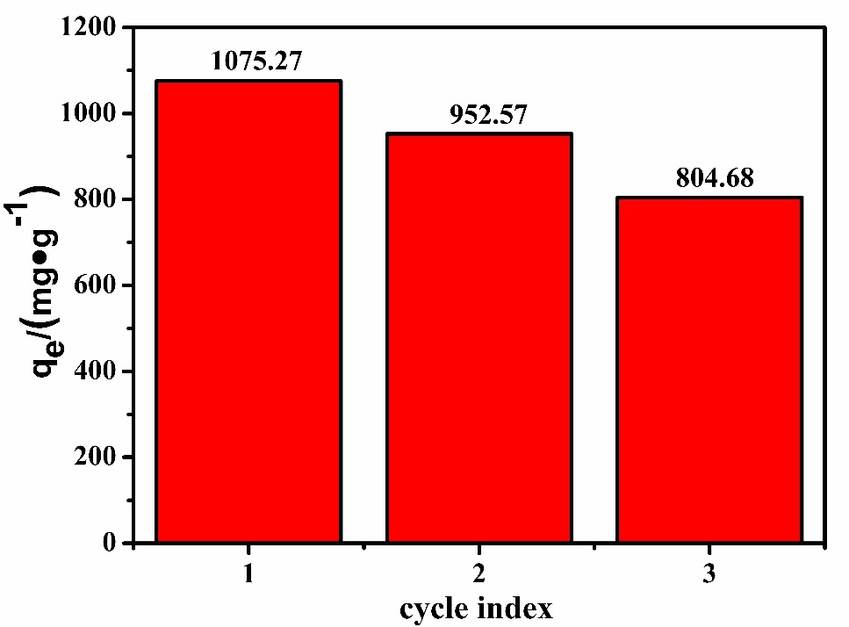

Fig.S5 The reusability of KMFC for the adsorption of Pb(II)

**TABLE**

**Table S1** FTIR spectral characteristics of KMFC prior to and following Pb(II) adsorption.

|  |  |  |  |
| --- | --- | --- | --- |
| KMFC | | |  |
| Prior to Adsorption | Following Adsorption | Difference | Assignment |
| 3433.03 | 3468.63 | -35.60 | O-H stretching |
| 2068.17 | 2040.43 | +27.74 | $C≡N$ stretching |
| 1629.30 | 1617.32 | +11.98 | O-H bending |
| 594.06 | 596.18 | 0 | Fe-CN stretching |
| 452.76 | 453.92 | 0 | Mn-CN stretching |