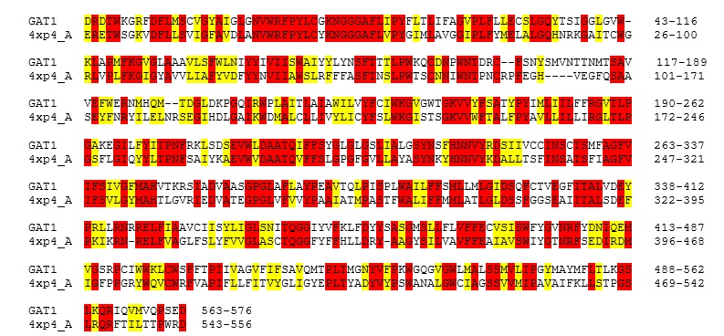

**Supplementary Figure 1.** Sequence alignment between GAT1 and drosophila melanogaster dopamine transporter (PDB ID: 4XP4_A).Identical residues are colored in red, while similar residues are colored in yellow (Reproduced with permission from RightsLink®; License number: 4781410075572).

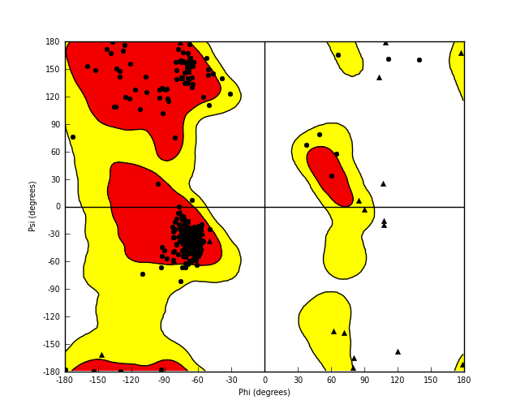**Supplementary Figure 2.** Ramachandran plot of the GAT1 3-dimensional model showing the dihedral angles of the amino acids(Reproduced with permission from RightsLink®; License number: 4781410075572).