SUPPORTING INFORMATION FOR

Tailoring of novel biologically active molecules based on N⁴-substituted sulfonamides bearing thiazole moiety exhibiting unique multi-addressable biological potentials
Essam M. Hussein^{a,b}*, Munirah M. Al-Rooqiª, Amal A. Elkhawaga^{c}, Saleh A. Ahmed^{a,b}*
ª Department of Chemistry, Faculty of Applied Science, Umm Al-Qura University, 21955 Makkah Saudi Arabia
^{b} Chemistry Department, Faculty of Science, Assiut University, 71516 Assiut, Egypt
^{c} Department of Medical Microbiology & Immunology, Faculty of Medicine Assiut University, 71516 Assiut, Egypt

*Correspondence may be addressed to: Saleh A. Ahmed and Essam M. Hussein: E-mail address: saahmed@uqu.edu.sa, saleh_63@hotmail.com, essam.hussein78@yahoo.com,

Tel./Fax: + 966 530435760

NMR spectra of the newly synthesized and investigated compounds (7a-l, 8b-l)

¹H NMR spectrum of N-[4-(piperidine-1-sulfonyl)phenyl]-2-(thiazol-2-ylamino)acetamide (7a)

¹³C NMR spectrum of N-[4-(piperidine-1-sulfonyl)phenyl]-2-(thiazol-2-ylamino)acetamide (7a)

Dept-135 NMR spectrum of N-[4-(piperidine-1-sulfonyl)phenyl]-2-(thiazol-2-ylamino)acetamide (7a)

¹H NMR spectrum of 2-(4-Phenylthiazol-2-ylamino)-N-[4-(piperidine-1-sulfonyl)phenyl]acetamide (7b)

¹³C NMR spectrum of 2-(4-Phenylthiazol-2-ylamino)-N-[4-(piperidine-1-sulfonyl)phenyl]acetamide (7b)

Dept-135 NMR spectrum of 2-(4-Phenylthiazol-2-ylamino)-N-[4-(piperidine-1-sulfonyl)phenyl]acetamide (7b)

¹H NMR spectrum of 2-[4-(4-Bromophenyl)-thiazol-2-ylamino]-N-[4-(piperidine-1-sulfonyl)phenyl]acetamide (7c)

¹³C NMR spectrum of 2-[4-(4-Bromophenyl)-thiazol-2-ylamino]-N-[4-(piperidine-1-sulfonyl)phenyl]acetamide (7c)

Dept-135 NMR spectrum of 2-[4-(4-Bromophenyl)-thiazol-2-ylamino]-N-[4-(piperidine-1-sulfonyl)phenyl]acetamide (7c)

¹H NMR spectrum of N-[4-(piperidine-1-sulfonyl)phenyl]-2-(4-(pyren-1-yl)thiazol-2-ylamino)acetamide (7d)

¹³C NMR spectrum of N-[4-(piperidine-1-sulfonyl)phenyl]-2-(4-(pyren-1-yl)thiazol-2-ylamino)acetamide (7d)

Dept-135 NMR spectrum of N-[4-(piperidine-1-sulfonyl)phenyl]-2-(4-(pyren-1-yl)thiazol-2-ylamino)acetamide (7d)

¹H NMR spectrum of 2-[4-(9H-fluoren-2-yl)thiazol-2-ylamino]-N-[4-(piperidine-1-sulfonyl)phenyl]acetamide (7e)

¹³C NMR spectrum of 2-[4-(9H-fluoren-2-yl)thiazol-2-ylamino]-N-[4-(piperidine-1-sulfonyl)phenyl]acetamide (7e)

Dept-135 NMR spectrum of 2-[4-(9H-fluoren-2-yl)thiazol-2-ylamino]-N-[4-(piperidine-1-sulfonyl)phenyl]acetamide (7e)

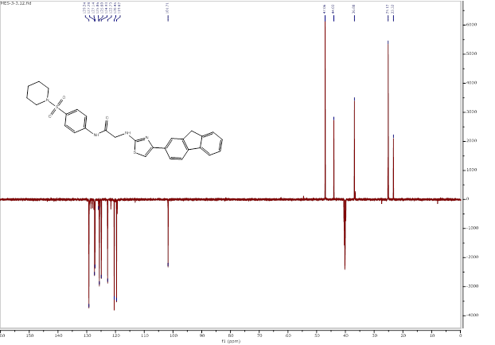

¹H NMR spectrum of 2-[4-(2,7-Dichloro-9H-fluoren-4-yl)thiazol-2-ylamino]-N-[4-(piperidine-1-sulfonyl)phenyl]acetamide (7f)

¹³C NMR spectrum of 2-[4-(2,7-Dichloro-9H-fluoren-4-yl)thiazol-2-ylamino]-N-[4-(piperidine-1-sulfonyl)phenyl]acetamide (7f)

Dept-135 NMR spectrum of 2-[4-(2,7-Dichloro-9H-fluoren-4-yl)thiazol-2-ylamino]-N-[4-(piperidine-1-sulfonyl)phenyl]acetamide (7f)

¹H NMR spectrum of N-[4-(morpholine-4-sulfonyl)phenyl]-2-(4-phenylthiazol-2-ylamino)acetamide (7h)

¹³C NMR spectrum of N-[4-(morpholine-4-sulfonyl)phenyl]-2-(4-phenylthiazol-2-ylamino)acetamide (7h)

Dept-135 NMR spectrum of N-[4-(morpholine-4-sulfonyl)phenyl]-2-(4-phenylthiazol-2-ylamino)acetamide (7h)

¹H NMR spectrum of N-[4-(4-bromophenyl)thiazol-2-yl]-2-[4-(morpholine-4-sulfonyl)phenylamino]acetamide (7i)

¹³C NMR spectrum of N-[4-(4-bromophenyl)thiazol-2-yl]-2-[4-(morpholine-4-sulfonyl)phenylamino]acetamide (7i)

Dept-135 NMR spectrum of N-[4-(4-bromophenyl)thiazol-2-yl]-2-[4-(morpholine-4-sulfonyl)phenylamino]acetamide (7i)

¹H NMR spectrum of N-(4-(morpholinosulfonyl)phenyl)-2-(4-(pyren-1-yl)thiazol-2-ylamino)acetamide (7j)

¹³C NMR spectrum of N-(4-(morpholinosulfonyl)phenyl)-2-(4-(pyren-1-yl)thiazol-2-ylamino)acetamide (7j)

Dept-135 NMR spectrum of N-(4-(morpholinosulfonyl)phenyl)-2-(4-(pyren-1-yl)thiazol-2-ylamino)acetamide (7j)

¹H NMR spectrum of 2-[4-(9H-fluoren-2-yl)thiazol-2-ylamino]-N-[4-(morpholine-4-sulfonyl)phenyl]acetamide (7k)

¹³C NMR spectrum of 2-[4-(9H-fluoren-2-yl)thiazol-2-ylamino]-N-[4-(morpholine-4-sulfonyl)phenyl]acetamide (7k)

Dept-135 NMR spectrum of 2-[4-(9H-fluoren-2-yl)thiazol-2-ylamino]-N-[4-(morpholine-4-sulfonyl)phenyl]acetamide (7k)

¹H NMR spectrum of 2-[4-(2,7-Dichloro-9H-fluoren-4-yl)thiazol-2-ylamino]-N-[4-(morpholine-4-sulfonyl)phenyl]acetamide (7l)

¹³C NMR spectrum of 2-[4-(2,7-Dichloro-9H-fluoren-4-yl)thiazol-2-ylamino]-N-[4-(morpholine-4-sulfonyl)phenyl]acetamide (7l)

Dept-135 NMR spectrum of 2-[4-(2,7-Dichloro-9H-fluoren-4-yl)thiazol-2-ylamino]-N-[4-(morpholine-4-sulfonyl)phenyl]acetamide (7l)

¹H NMR spectrum of N-(4-phenylthiazol-2-yl)-2-[4-(piperidine-1-sulfonyl)phenylamino]acetamide (8b)

¹³C NMR spectrum of N-(4-phenylthiazol-2-yl)-2-[4-(piperidine-1-sulfonyl)phenylamino]acetamide (8b)

Dept-135 NMR spectrum of N-(4-phenylthiazol-2-yl)-2-[4-(piperidine-1-sulfonyl)phenylamino]acetamide (8b)

¹H NMR spectrum of N-[4-(4-bromophenyl)thiazol-2-yl]-2-[4-(piperidine-1-sulfonyl)phenylamino]acetamide (8c)

¹³C NMR spectrum of N-[4-(4-bromophenyl)thiazol-2-yl]-2-[4-(piperidine-1-sulfonyl)phenylamino]acetamide (8c)

Dept-135 NMR spectrum of N-[4-(4-bromophenyl)thiazol-2-yl]-2-[4-(piperidine-1-sulfonyl)phenylamino]acetamide (8c)

¹H NMR spectrum of 2-(4-(Piperidin-1-ylsulfonyl)phenylamino)-N-(4-(pyren-1-yl)thiazol-2-yl)acetamide (8d)

¹³C NMR spectrum of 2-(4-(Piperidin-1-ylsulfonyl)phenylamino)-N-(4-(pyren-1-yl)thiazol-2-yl)acetamide (8d)

Dept-135 NMR spectrum of 2-(4-(Piperidin-1-ylsulfonyl)phenylamino)-N-(4-(pyren-1-yl)thiazol-2-yl)acetamide (8d)

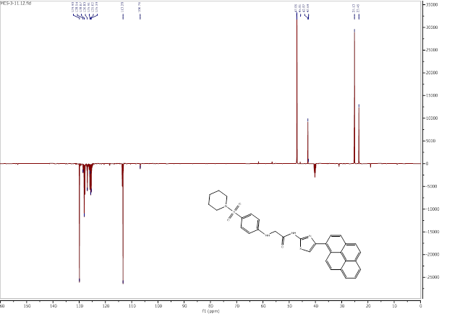

¹H NMR spectrum of N-[4-(9H-fluoren-2-yl)thiazol-2-yl]-2-[4-(piperidine-1-sulfonyl)phenylamino]acetamide (8e)

¹³C NMR spectrum of N-[4-(9H-fluoren-2-yl)thiazol-2-yl]-2-[4-(piperidine-1-sulfonyl)phenylamino]acetamide (8e)

Dept-135 NMR spectrum of N-[4-(9H-fluoren-2-yl)thiazol-2-yl]-2-[4-(piperidine-1-sulfonyl)phenylamino]acetamide (8e)

¹H NMR spectrum of N-[4-(2,7-dichloro-9H-fluoren-4-yl)thiazol-2-yl]-2-[4-(piperidine-1-sulfonyl)phenylamino]acetamide (8f)

¹³C NMR spectrum of N-[4-(2,7-dichloro-9H-fluoren-4-yl)thiazol-2-yl]-2-[4-(piperidine-1-sulfonyl)phenylamino]acetamide (8f)

Dept-135 NMR spectrum of N-[4-(2,7-dichloro-9H-fluoren-4-yl)thiazol-2-yl]-2-[4-(piperidine-1-sulfonyl)phenylamino]acetamide (8f)

¹H NMR spectrum of 2-[4-(Morpholine-4-sulfonyl)phenylamino]-N-(4-phenylthiazol-2-yl)acetamide (8h)

¹³C NMR spectrum of 2-[4-(Morpholine-4-sulfonyl)phenylamino]-N-(4-phenylthiazol-2-yl)acetamide (8h)

Dept-135 NMR spectrum of 2-[4-(Morpholine-4-sulfonyl)phenylamino]-N-(4-phenylthiazol-2-yl)acetamide (8h)

¹H NMR spectrum of N-[4-(4-bromophenyl)thiazol-2-yl]-2-[4-(morpholine-4-sulfonyl)-phenylamino]acetamide (8i)

¹³C NMR spectrum of N-[4-(4-bromophenyl)thiazol-2-yl]-2-[4-(morpholine-4-sulfonyl)-phenylamino]acetamide (8i)

Dept-135 NMR spectrum of N-[4-(4-bromophenyl)-thiazol-2-yl]-2-[4-(morpholine-4-sulfonyl)-phenylamino]acetamide (8i)

¹H NMR spectrum of 2-[4-(Morpholine-4-sulfonyl)phenylamino]-N-(4-pyren-1-yl-thiazol-2-yl)acetamide (8j)

¹³C NMR spectrum of 2-[4-(Morpholine-4-sulfonyl)phenylamino]-N-(4-pyren-1-yl-thiazol-2-yl)acetamide (8j)

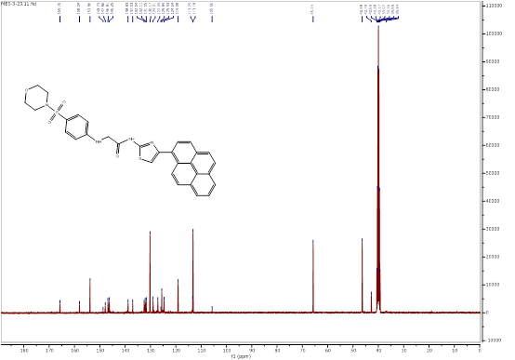

Dept-135 NMR spectrum of 2-[4-(Morpholine-4-sulfonyl)phenylamino]-N-(4-pyren-1-yl-thiazol-2-yl)acetamide (8j)

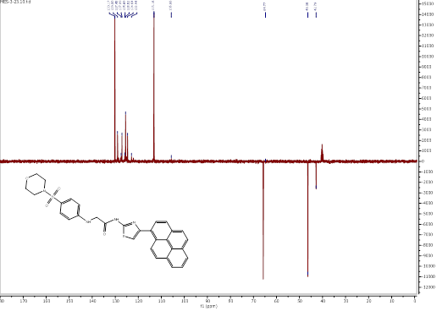

¹H NMR spectrum of N-[4-(9H-fluoren-2-yl)thiazol-2-yl]-2-[4-(morpholine-4-sulfonyl)phenylamino]acetamide (8k)

¹³C NMR spectrum of N-[4-(9H-fluoren-2-yl)thiazol-2-yl]-2-[4-(morpholine-4-sulfonyl)phenylamino]acetamide (8k)

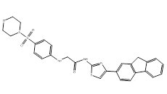
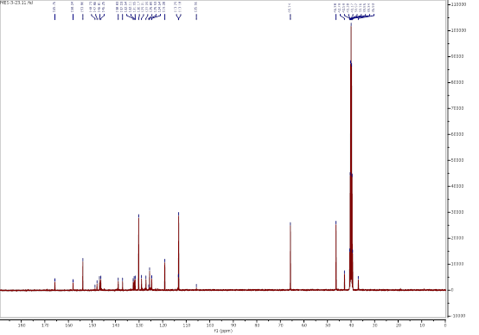

Dept-135 NMR spectrum of N-[4-(9H-fluoren-2-yl)thiazol-2-yl]-2-[4-(morpholine-4-sulfonyl)phenylamino]acetamide (8k)

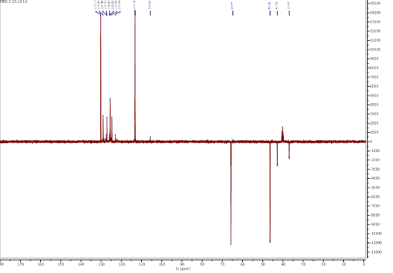

¹H NMR spectrum of N-[4-(2,7-dichloro-9H-fluoren-4-yl)thiazol-2-yl]-2-[4-(morpholine-4-sulfonyl)phenylamino]acetamide (8l)

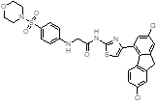

¹³C NMR spectrum of N-[4-(2,7-dichloro-9H-fluoren-4-yl)thiazol-2-yl]-2-[4-(morpholine-4-sulfonyl)phenylamino]acetamide (8l)

Dept-135 NMR spectrum of N-[4-(2,7-dichloro-9H-fluoren-4-yl)thiazol-2-yl]-2-[4-(morpholine-4-sulfonyl)phenylamino]acetamide (8l)

