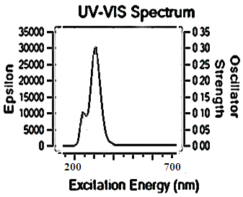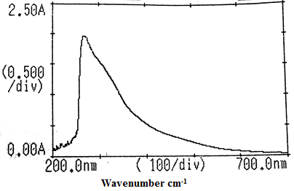

**(b)**

**(a)**

**Supplementary Fig. 3** UV-Visible spectra of Schiff base ligand (H2L) (a) theoretical spectrum and (b) experimental spectrum.