

Figure S1: Cibacron blue 3G-A dye calibration curve

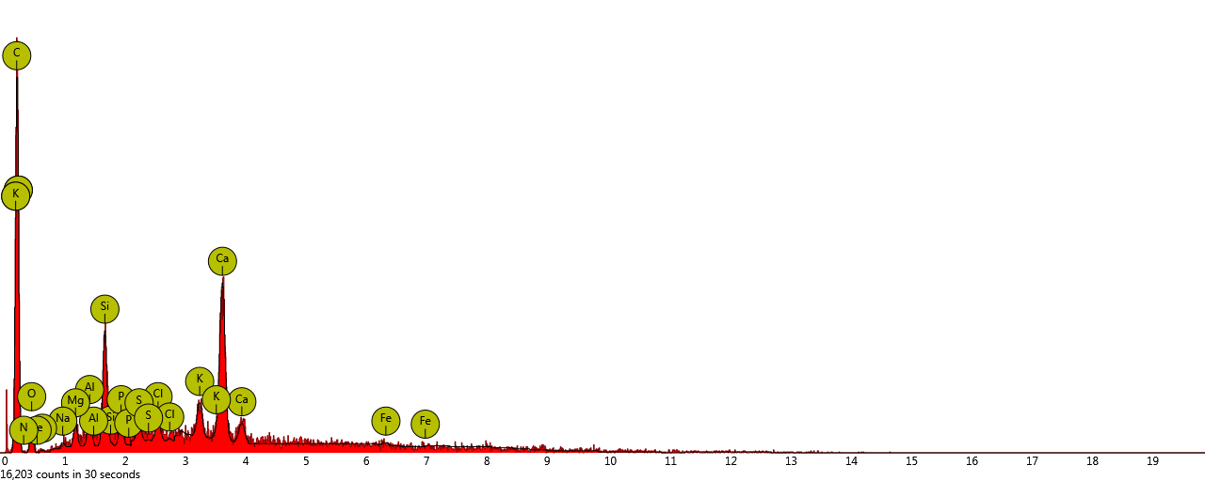

(a)

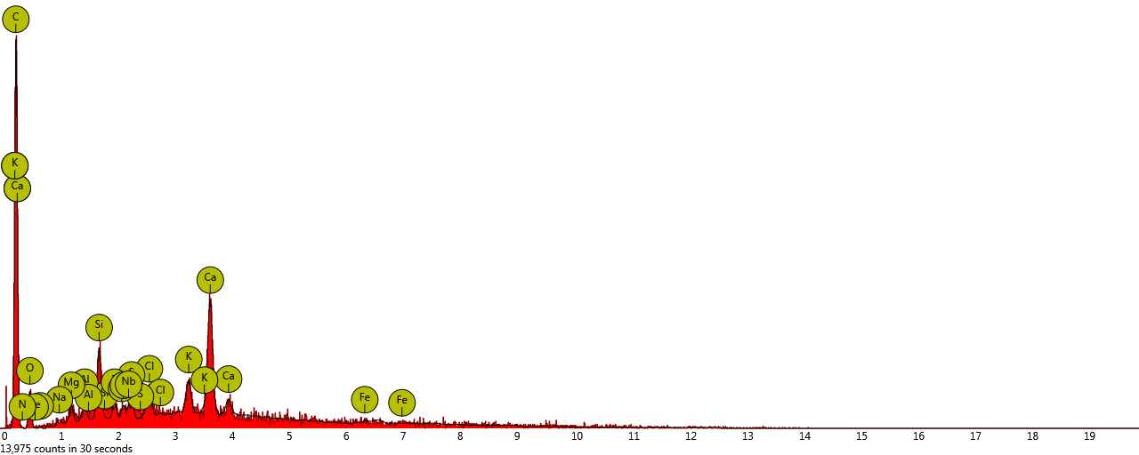

(b)

Figure S2: EDX spectral of PEF (a) and CB dye loaded PEF (b)



Figure S3: PEF N2 adsorption–desorption isotherms

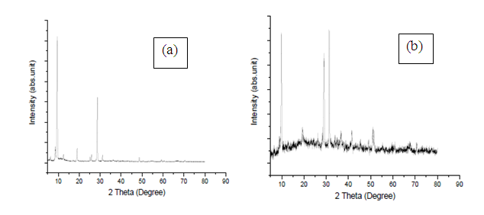

Fig. S4: XDR diffractograms of PEF (a) and CB dye loaded PEF (b)

Table S1 a: EDX elemental composition of PEF before adsorption

|  |  |  |  |  |
| --- | --- | --- | --- | --- |
| **Element Number** | **Element Symbol** | **Element Name** | **Atomic Conc.** | **Weight Conc.** |
| 6 | C | Carbon | 79.30 | 63.36 |
| 20 | Ca | Calcium | 5.21 | 13.85 |
| 8 | O | Oxygen | 7.44 | 7.95 |
| 14 | Si | Silicon | 2.33 | 4.31 |
| 19 | K | Potassium | 0.96 | 2.54 |
| 7 | N | Nitrogen | 1.58 | 1.47 |
| 13 | Al | Aluminium | 0.81 | 1.45 |
| 17 | Cl | Chlorine | 0.54 | 1.28 |
| 15 | P | Phosphorus | 0.52 | 1.08 |
| 12 | Mg | Magnesium | 0.58 | 1.10 |
| 16 | S | Sulfur | 0.36 | 0.80 |
| 26 | Fe | Iron | 0.22 | 0.77 |
| 11 | Na | Sodium | 0.16 | 0.23 |
|  |  |  |  |  |

Table S1 b: EDX elemental composition of CB dye loaded PEF

|  |  |  |  |  |
| --- | --- | --- | --- | --- |
| **Element Number** | **Element Symbol** | **Element Name** | **Atomic Conc.** | **Weight Conc.** |
| 6 | C | Carbon | 80.71 | 65.71 |
| 20 | Ca | Calcium | 3.95 | 10.69 |
| 8 | O | Oxygen | 8.31 | 9.06 |
| 14 | Si | Silicon | 1.49 | 2.83 |
| 19 | K | Potassium | 1.00 | 2.64 |
| 41 | Nb | Niobium | 0.33 | 2.09 |
| 17 | Cl | Chlorine | 0.66 | 1.55 |
| 7 | N | Nitrogen | 1.64 | 1.59 |
| 16 | S | Sulfur | 0.54 | 1.12 |
| 15 | P | Phosphorus | 0.35 | 0.78 |
| 13 | Al | Aluminium | 0.40 | 0.74 |
| 12 | Mg | Magnesium | 0.42 | 0.68 |
| 26 | Fe | Iron | 0.11 | 0.38 |
| 11 | Na | Sodium | 0.11 | 0.10 |
|  |  |  |  |  |