**Synthesis and characterization of CoFe2O4@SiO2-polyethyleneimine magnetic nanoparticle and its application for ultrasonic-assisted removal of disulfine blue dye from aqueous solution**

Maria Bektar, Hossein Ali Rasekh *, Mohammad Jaafar Soltanianfard

Department of Chemistry, Firoozabad Branch, Islamic Azad University, Firoozabad, Fars, Iran, P.O.Box, 74715-117.

* Corresponding author.  
E-mail address: Hossein.ali_Rasekh@yahoo.com (H. Ali Rasekh).

Figure S1. The effect of pH on extraction recovery. Condition (50.0 mL of 10.0 mg L-1 of DB, 10.0 mg of CoFe2O4@ PEI and ultrasonic time of 4.0 min).

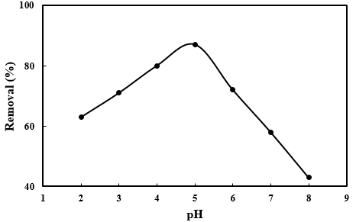

Figure S2. The effect of sorbent dosage on extraction recovery. Condition (50.0 mL of 10.0 mg L-1 of DB, pH of 5.0 and ultrasonic time of 4.0 min).

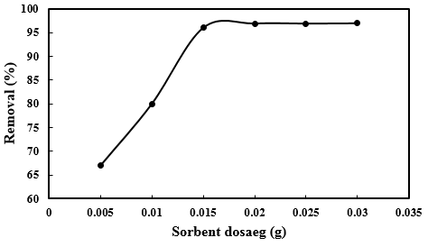

Figure S3. The effect of irradiation time on extraction recovery. Condition (50.0 mL of 10.0 mg L-1 of DB, pH of 5.0 and sorbent dosage of 0.015 g).

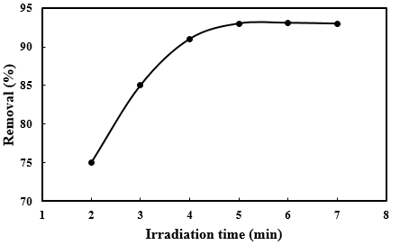

Figure S4. The effect of initial concentration on extraction recovery. Condition (50.0 mL of 10.0-35.0 mg L-1 of DB, pH of 5.0, sorbent dosage of 0.015 g and irradiation time of 5.0 min).

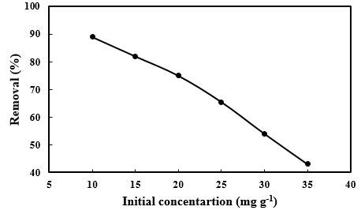

Figure S5. the UV-Vis spectra of disulfine blue before and after removal at optimum conditions.

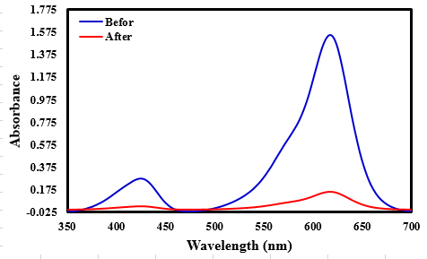

Figure S6. The maximum adsorption capacity of CoFe2O4@ PEI.

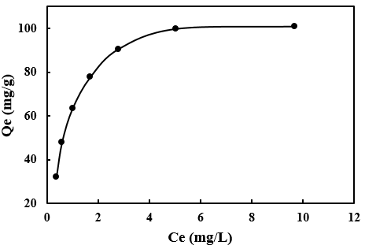

Figure S7. Reusability of CoFe2O4@ PEI.

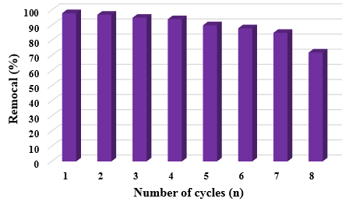

Table S1: Different isotherm models for removal of DB by CoFe2O4@ PEI. Conditions ((50.0 mL of 10.0 mg L-1 of DB, pH of 5.0, sorbent dosage of 0.015 g and irradiation time of 5.0 min).

|  |  |  |  |
| --- | --- | --- | --- |
|  | Parameters | Equations | Isotherms |
| 110 | qm (mg g-1) | Ce/qe = 1/(KaQm) +Ce/Qm | Langmuir |
| 1.38 | Ka (L mg-1) |
| 0.017-0.067 | RL |
| 0.9983 | R2 |
| 2.90 | n | Ln qe = ln KF + (1/n) ln Ce | Freundlich |
| 5.75 | KF (L mg-1) |
| 0.8739 | R2 |
| 22.17 | B1 | qe= B1 Ln KT + B1 Ln Ce | Temkin |
| 15.53 | KT (L mg-1) |
| 0.9421 | R2 |
| 95.70 | Qm (mg g-1) | Ln qe= Ln Qm – Kε2 | Dubinin and Radushkevich |
| -1.0 | K * 10-7 |
| 0.9788 | R2 |

Table S2: Different kinetic models for removal of DB by CoFe2O4@ PEI. Conditions ((50.0 mL of 10.0 mg L-1 of DB, pH of 5.0, sorbent dosage of 0.015 g and irradiation time of 1.0-7.0 min).

|  |  |  |  |
| --- | --- | --- | --- |
|  | Parameters | Equations | Kinetics |
| 0.0313 | K1 (min-1) | Log(qe-qt)=log qe –k1/2.303 t | First order kinetic model |
| 5.24 | qe (mg g-1) |
| 0.8086 | R2 |
| 0.0612 | K2 (min-1) | t/qt =1/k2 qe 2 + t/qt | Second order kinetic model |
| 33.22 | qe (mg g-1) |
| 0.09972 | R2 |
| 4.96 | Kdiff (mg g-1 min-1/2) | qt=Kdifft1/2+C | Intraparticle diffusion |
| 18.94 | C (mg g-1) |
| 0.8811 | R2 |
| 0.230 | β | qt= 1/β Ln(αβ) + 1/β Ln (t) | Elovich |
| 10000000 | α (mg g-1 min-1) |
| 0.9266 | R2 |
| 30.76 | qexp (mg g-1) |  | Experimental data |

Table S3: Comparison of the presented method.

|  |  |  |  |  |  |  |
| --- | --- | --- | --- | --- | --- | --- |
| Analyte | Sorbent | Adsorption  capacity (mg g-1) | Extraction  time (min) | pH | Sorbent  Mass (mg) | References |
| Disulfine blue | CuS–NP–AC a | 243.9 | 6.0 | 8.0 | 20.0 | Bagheri et al |
| Aniline blue | CoFe2O4@SiO2@NH-NH2-PCuW | 500.0 | 30.0 | 5.5 | 12.0 | Savari et al |
| Methylen blue | CoFe2O4–SiO2 | 3.76 | 30.0 | - | 30.0 | Li et al |
| Disulfine blue | CoFe2O4@SiO2-polyethyleneimine | 110.0 | 5.0 | 5.0 | 15.0 | Presented  work |

a Copper sulfide nanoparticles loaded on activated carbon