**Investigations on crystal structure of a novel 3-((4,6-dimethylpyrimidin-2-yl)amino)isobenzofuran-1(3*H*)-one, and related theoretical studies.**

Zeynep Tanrıkulu Yılmaza, H. Yasin Odabaşoğlub, Pelin Şenelc, Veselina Adımcılarc, Taner Erdoğand, Ayşe Daut Özdemirc, Ayşegül Gölcüc*, Mustafa Odabaşoğlue* and Orhan Buyukgungorf

*aPamukkale University, Faculty of Engineering, Chemical Engineering Department, Denizli, Turkey.*

*bHayat Kimya, R&D Department, Kocaeli, Turkey.*

*cIstanbul Technical University, Faculty of Sciences and Letters, Department of Chemistry, Istanbul 34469, Turkey.*

*d Kocaeli Univ, Kocaeli Vocat Sch, Dept Chem & Chem Proc Technol, Kocaeli, Turkey.*

*ePamukkale University, Chemistry Technology Programme, Kinikli 20070, Turkey.*

*fOndokuz Mayis University, Department of Physics, Samsun, Turkey.*

*\*Corresponding authors*

*E-mail:* [*aysegulgolcu@itu.edu.tr*](mailto:aysegulgolcu@itu.edu.tr)*,* [*mustafaodabasoglu@gmail.com*](mailto:mustafaodabasoglu@gmail.com)

**Contents**

**Fig. S1.** **1**H**-**NMR spectrum of 3-((4,6-dimethylpyrimidin-2-yl)amino)isobenzofuran-1(3*H*)-one (**1**)inDMSO-d*6* **……………………………………………………………………. 2**

**Fig. S2.** **13**C**-**NMR spectrum of 3-((4,6-dimethylpyrimidin-2-yl)amino)isobenzofuran-1(3*H*)-one (**1**)inDMSO-d*6* **…………………………………………………………………… 3**

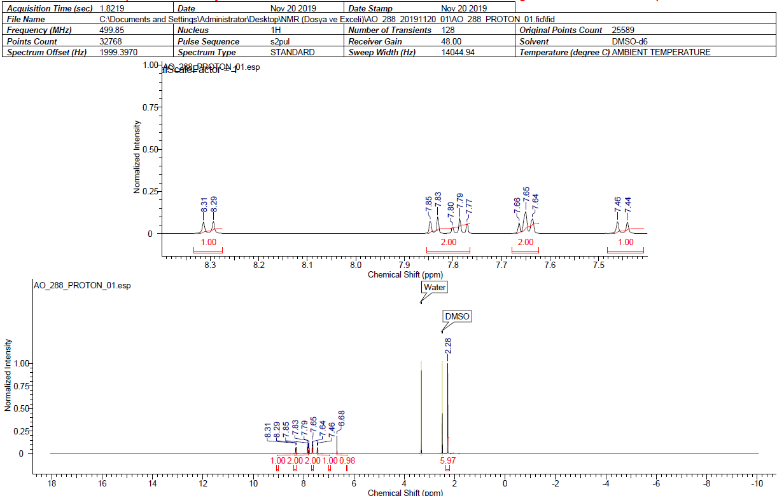

**Fig. S1. 1**H**-**NMR spectrum of 3-((4,6-dimethylpyrimidin-2-yl)amino)isobenzofuran-1(3*H*)-one (**1**)inDMSO-d6

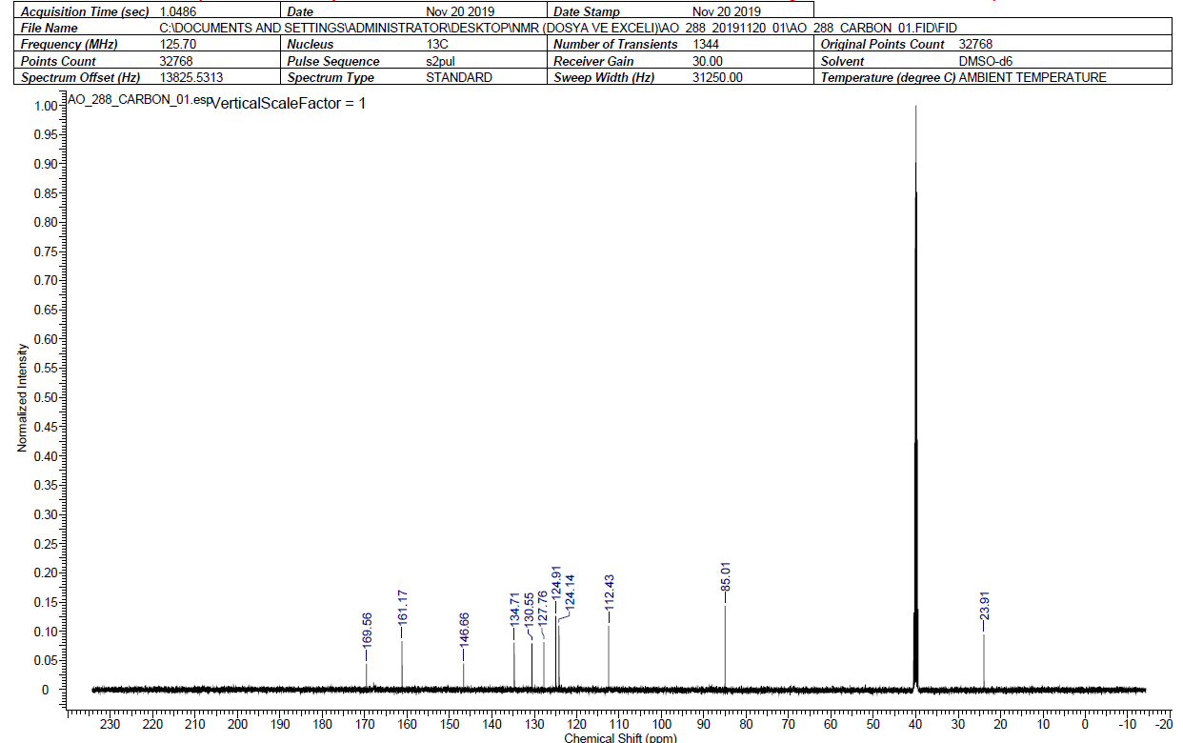

**Fig. S2.** **13**C**-**NMR spectrum of 3-((4,6-dimethylpyrimidin-2-yl)amino)isobenzofuran-1(3*H*)-one (**1**)inDMSO-d6