**Supporting Information**

**Ice-templated porous polymer/UiO-66 monolith for Congo Red adsorptive removal**

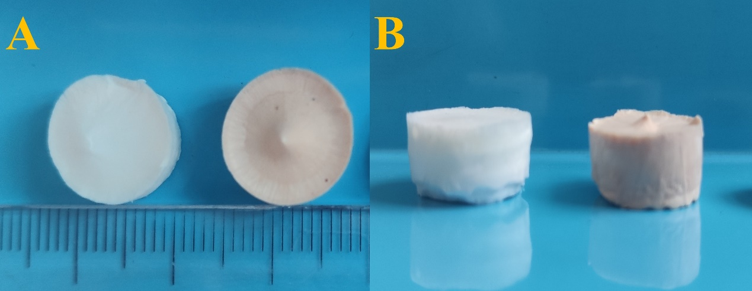

**Figure S1 Chitosan/UiO-66 three-dimensional block photo. From left to right: Chitosan/UiO-66, Chitosan/UiO-66-1.**

Preparation process of Chitosan/UiO-66: First, UiO-66 scatter 1%Chitosan solution.

Then, the mixture was directly freeze-dried to obtain.

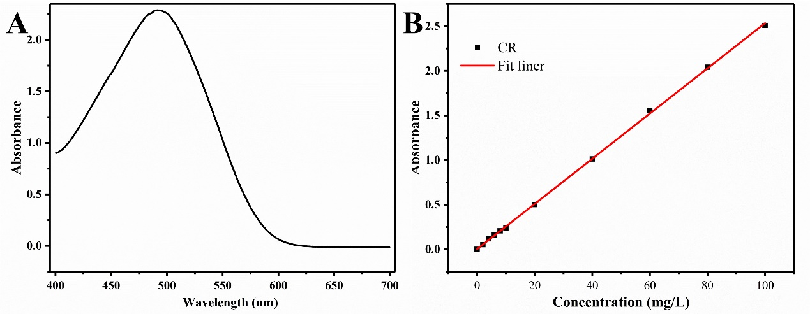

**Figure S2 (A) UV-Vis absorption spectra of Congo red solution. (B) Congo red calibration curve.**

Figure S2 A shows the UV-Vis absorption spectra of the aqueous solution of Congo red from 400 nm to 700 nm. From the spectra, as can be seen, the peak intensity of absorption corresponds to the Congo red molecules at 490 nm in Figure S2 B, a calibration curve was obtained based on the results of UV absorbance at 490 nm of the Congo red solutions (2-100 ppm). calibration curve follows equation A = 0.02529 C + 0.00387 (R2 = 0.99967).

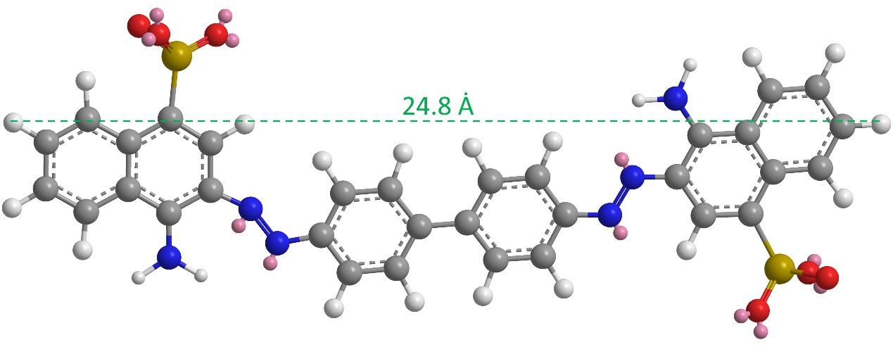

**Figure S3 Structural formula of Congo red.**