**Supplementary data**



**Figure S1**: HPLC of (a) NAP in plasma and (b) NAP from HPC-NAP conjugate in plasma after *in vivo* absorption/hydrolysis.

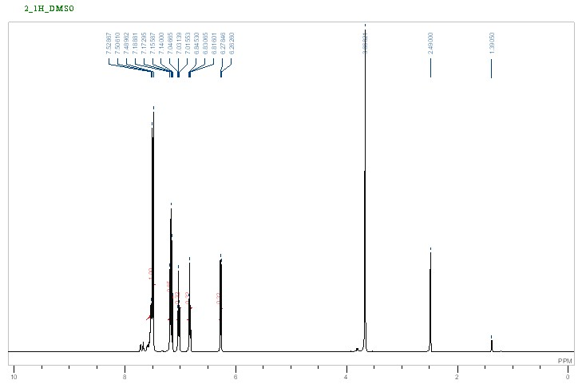

**Figure 2S:** 1HNMR spectrum of NAP.



**Figure 3S:** 1HNMR (400 MHz, 64 scans, ppm) spectrum of HPC.