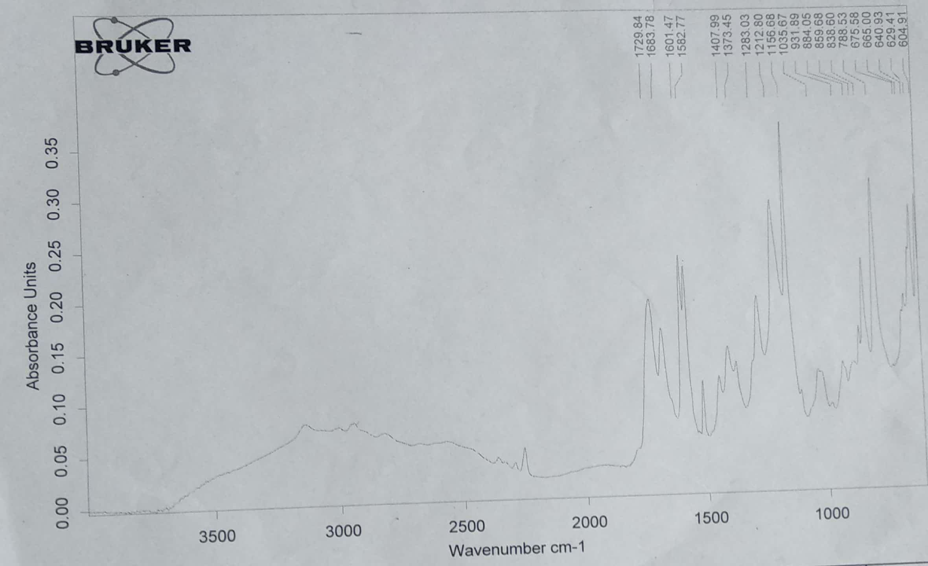

**FTIR spectrum of intermediate 1c**

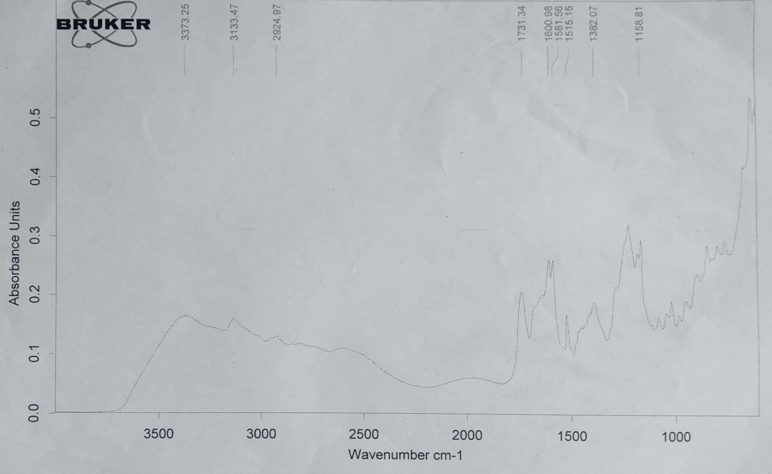

**FTIR spectrum of compound 1**

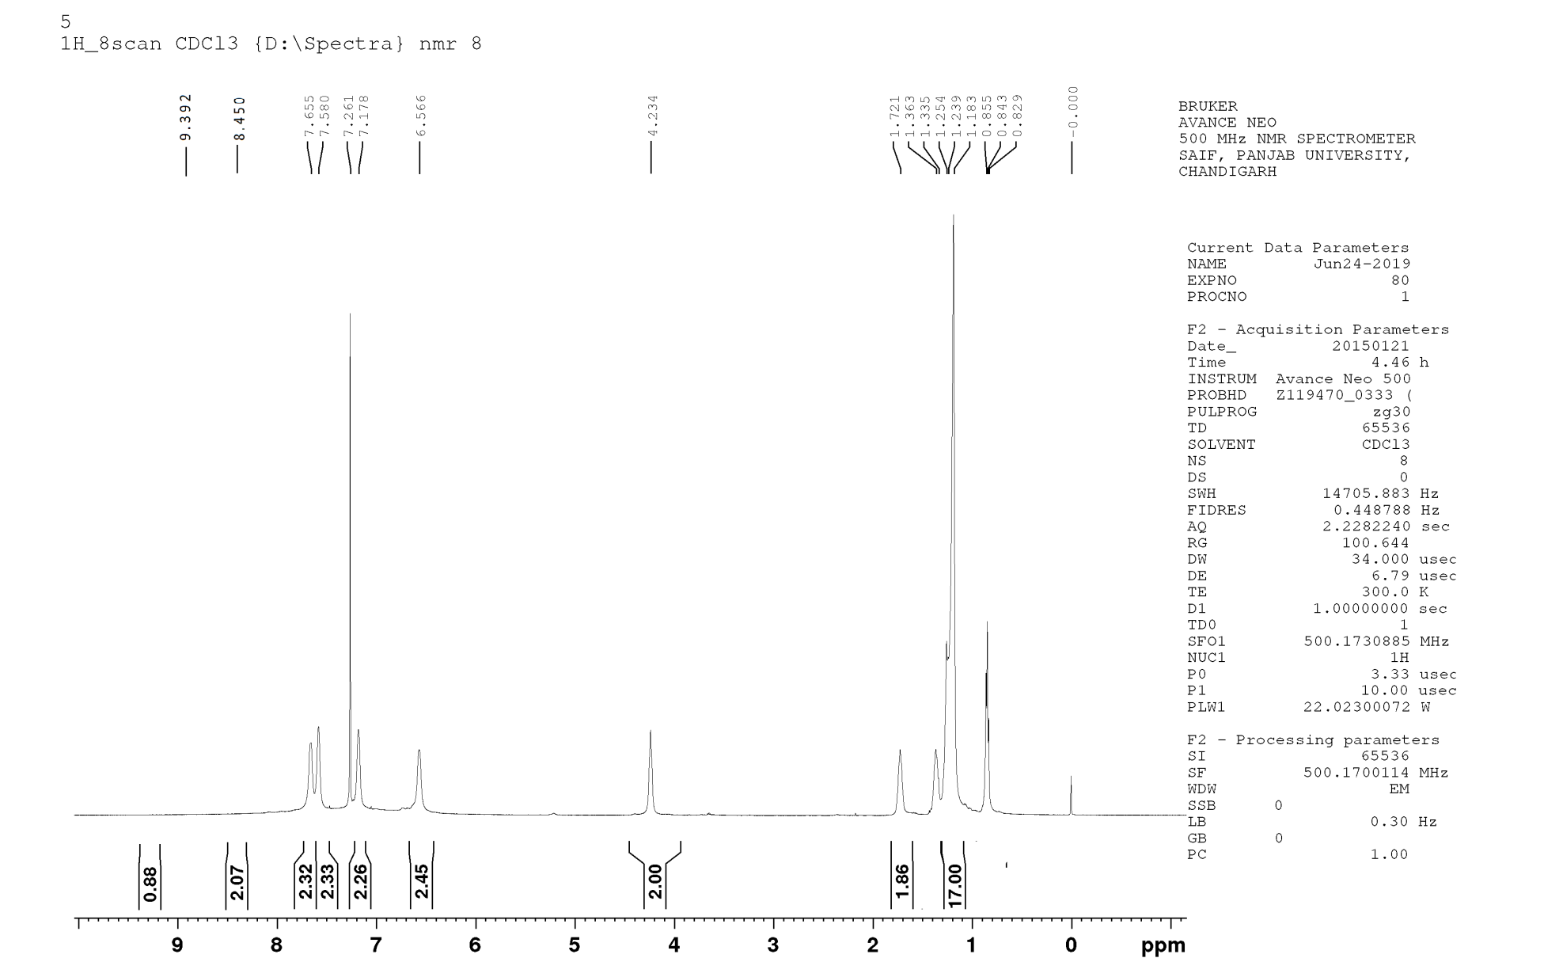

**1H NMR spectrum of compound 1**



**Mass spectrum of compound 1**

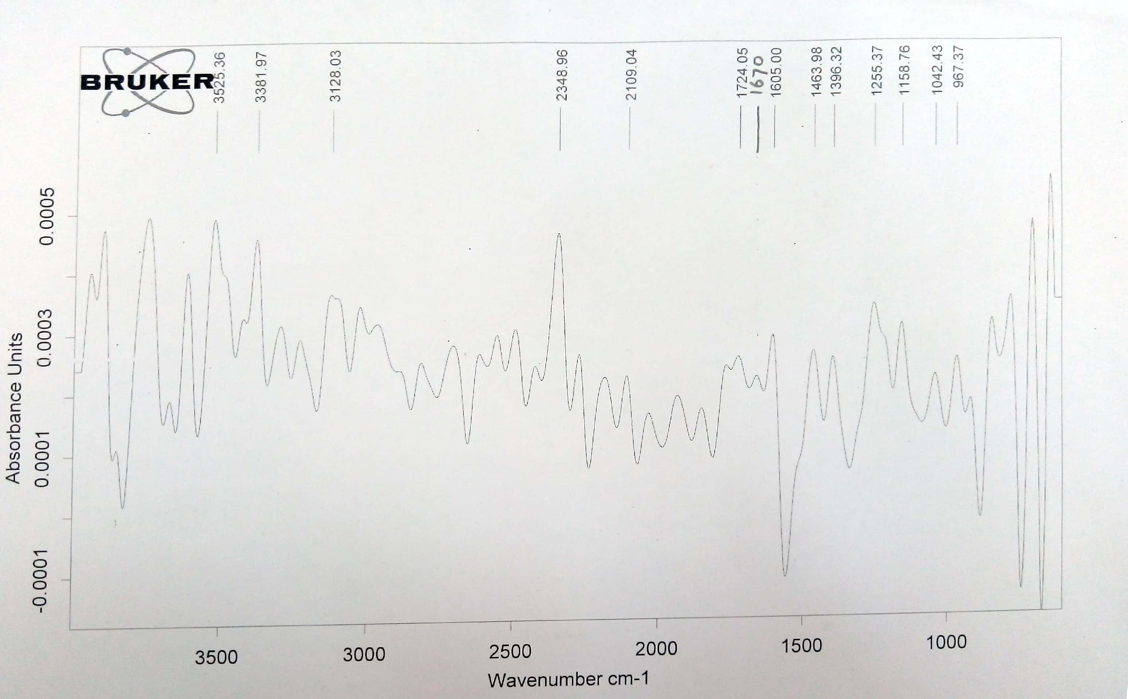

**FTIR spectrum of intermediate 1d**

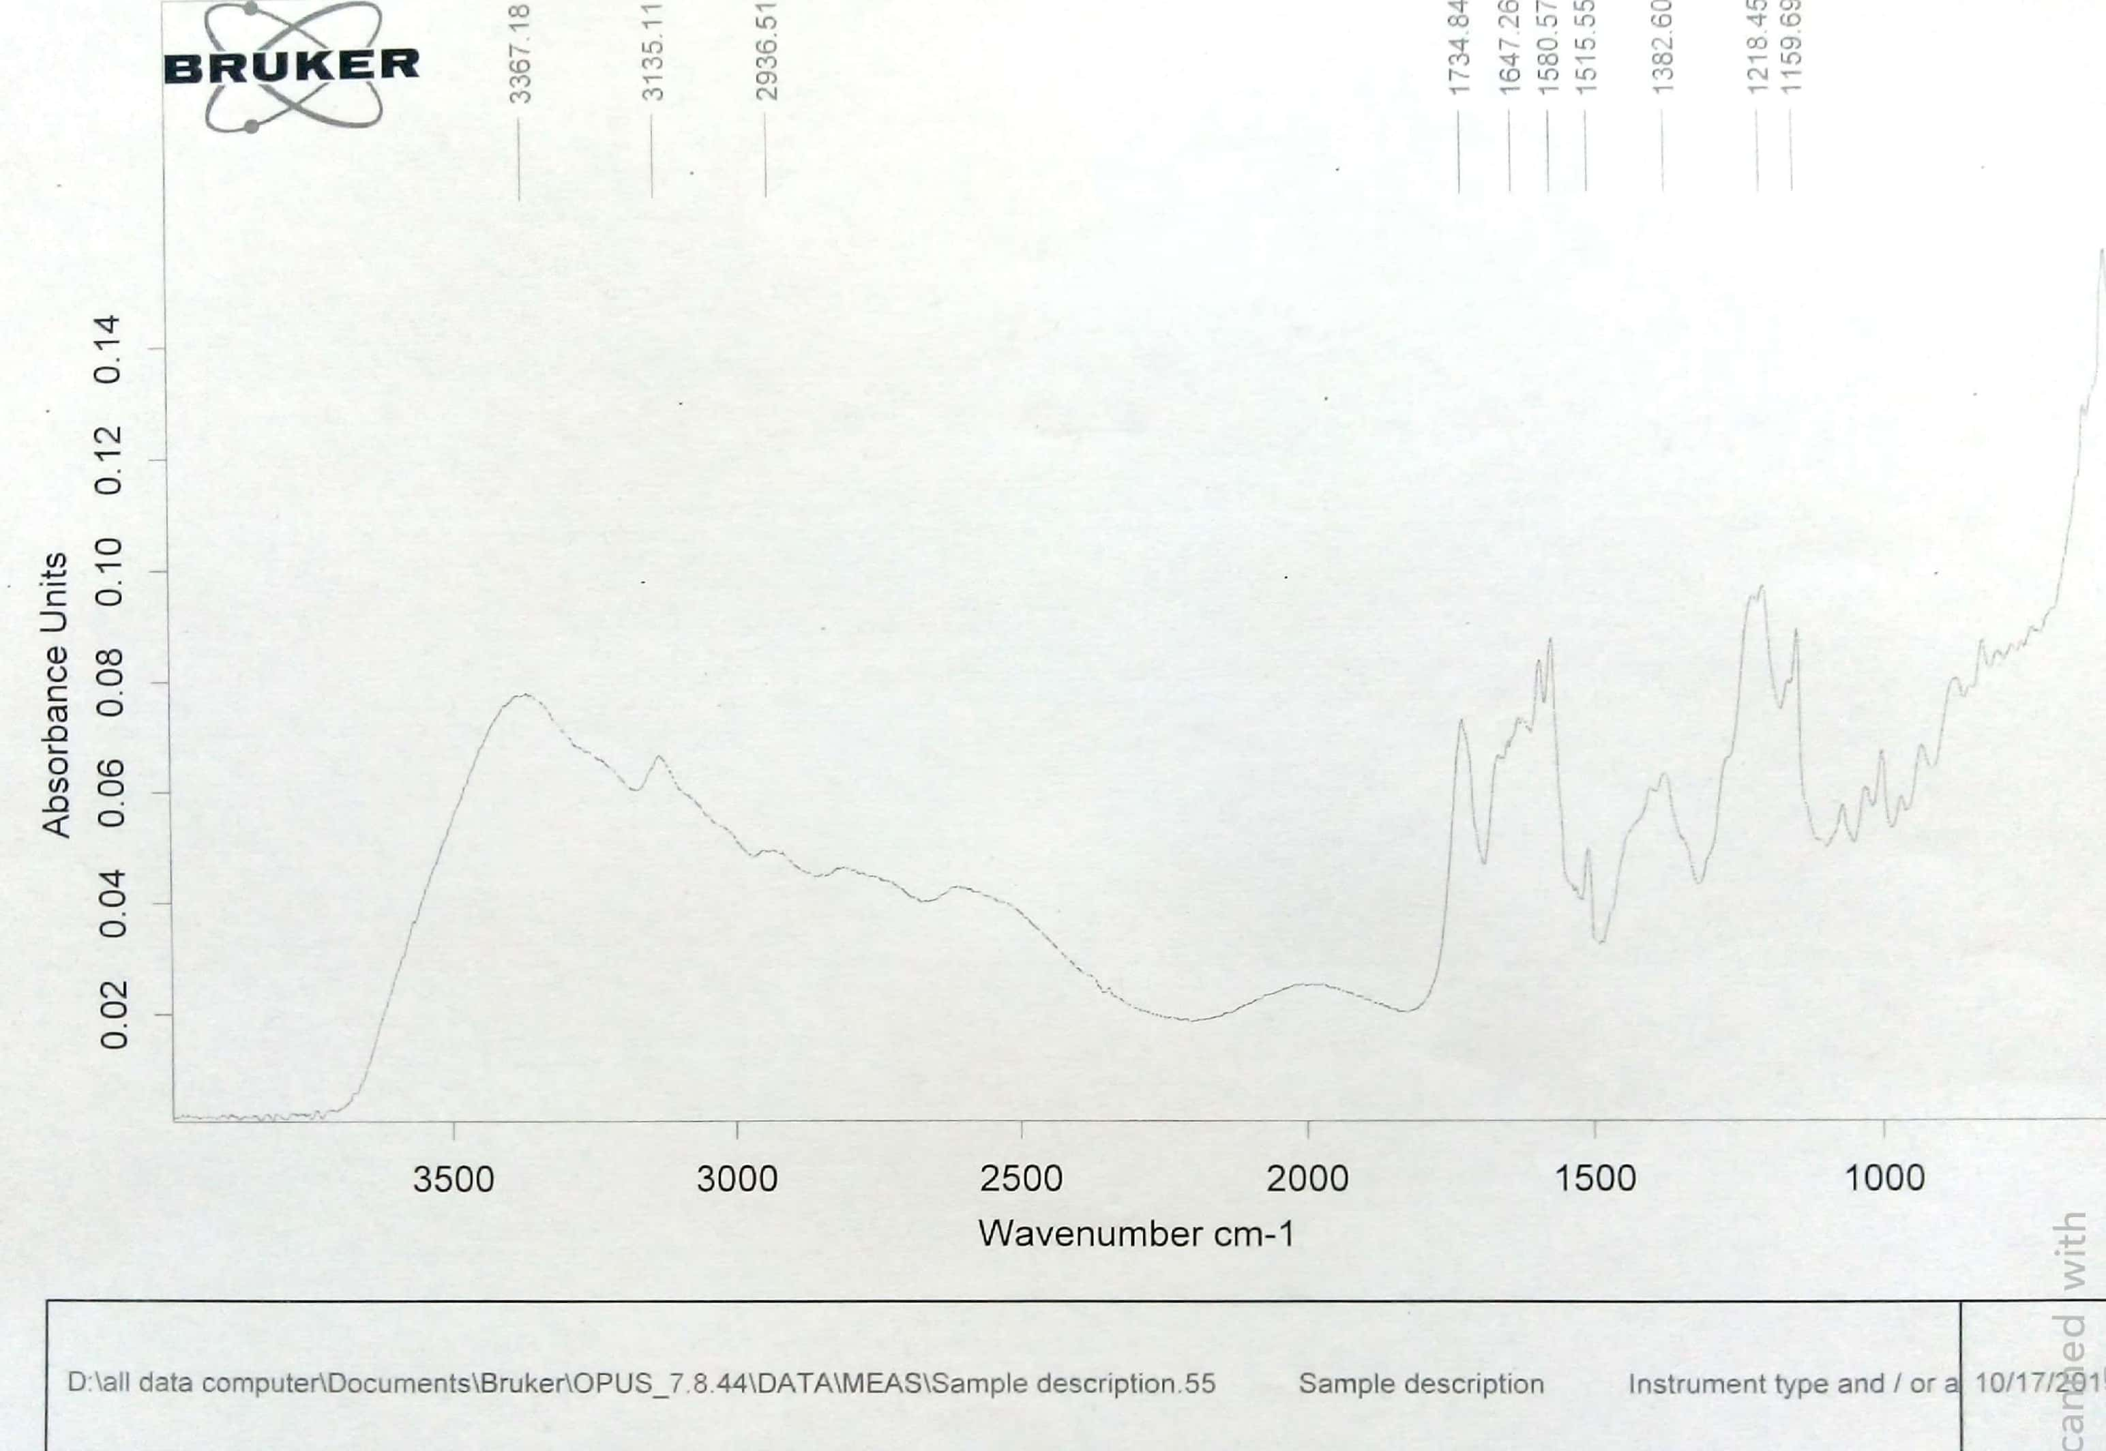

**FTIR spectrum of compound 4**



**1H NMR spectrum of compound 4**

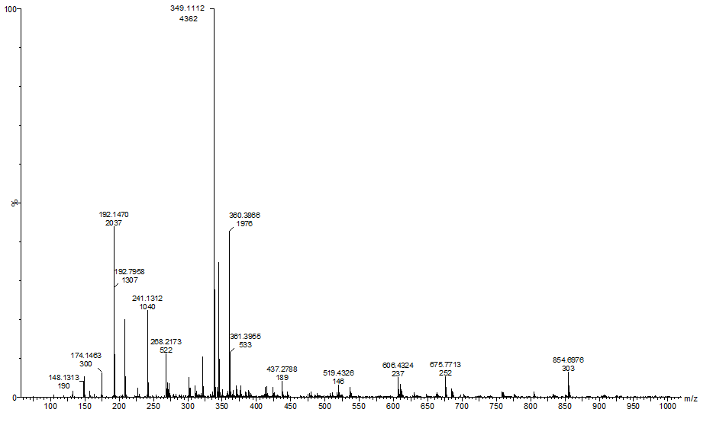

**Mass spectrum of compound 4**

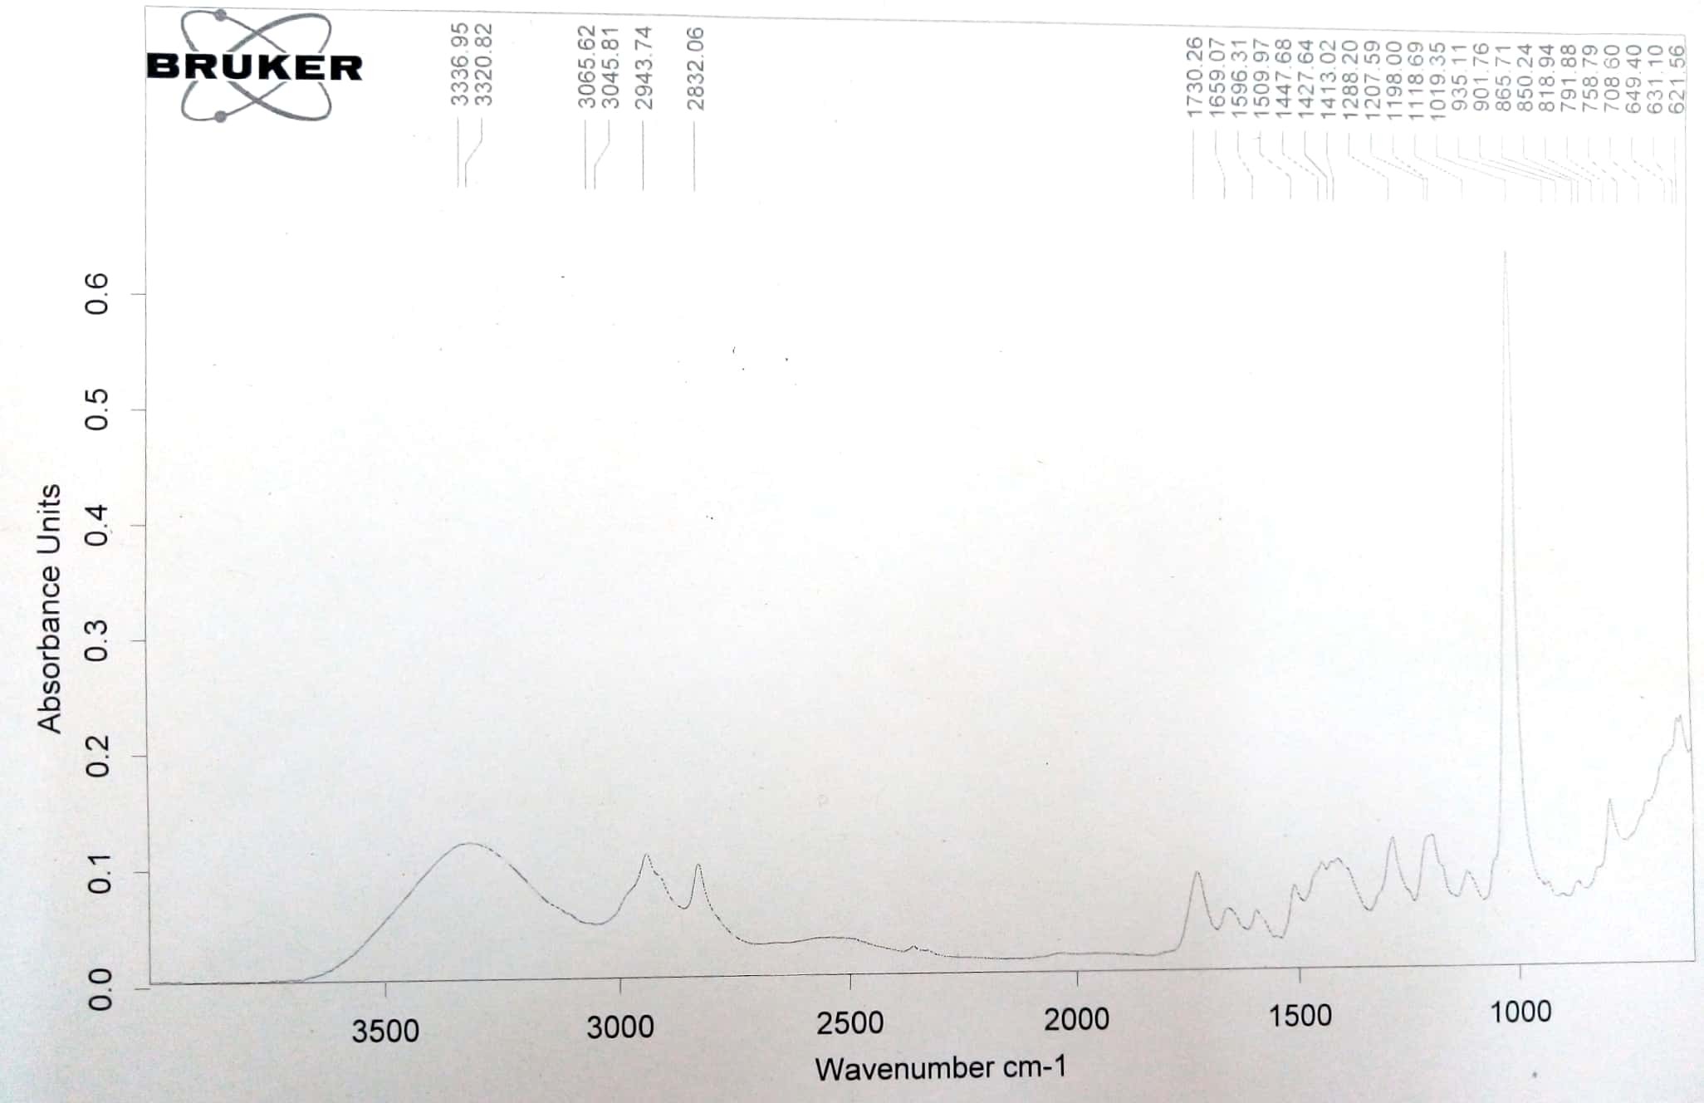

**FTIR spectrum of intermediate 1e**

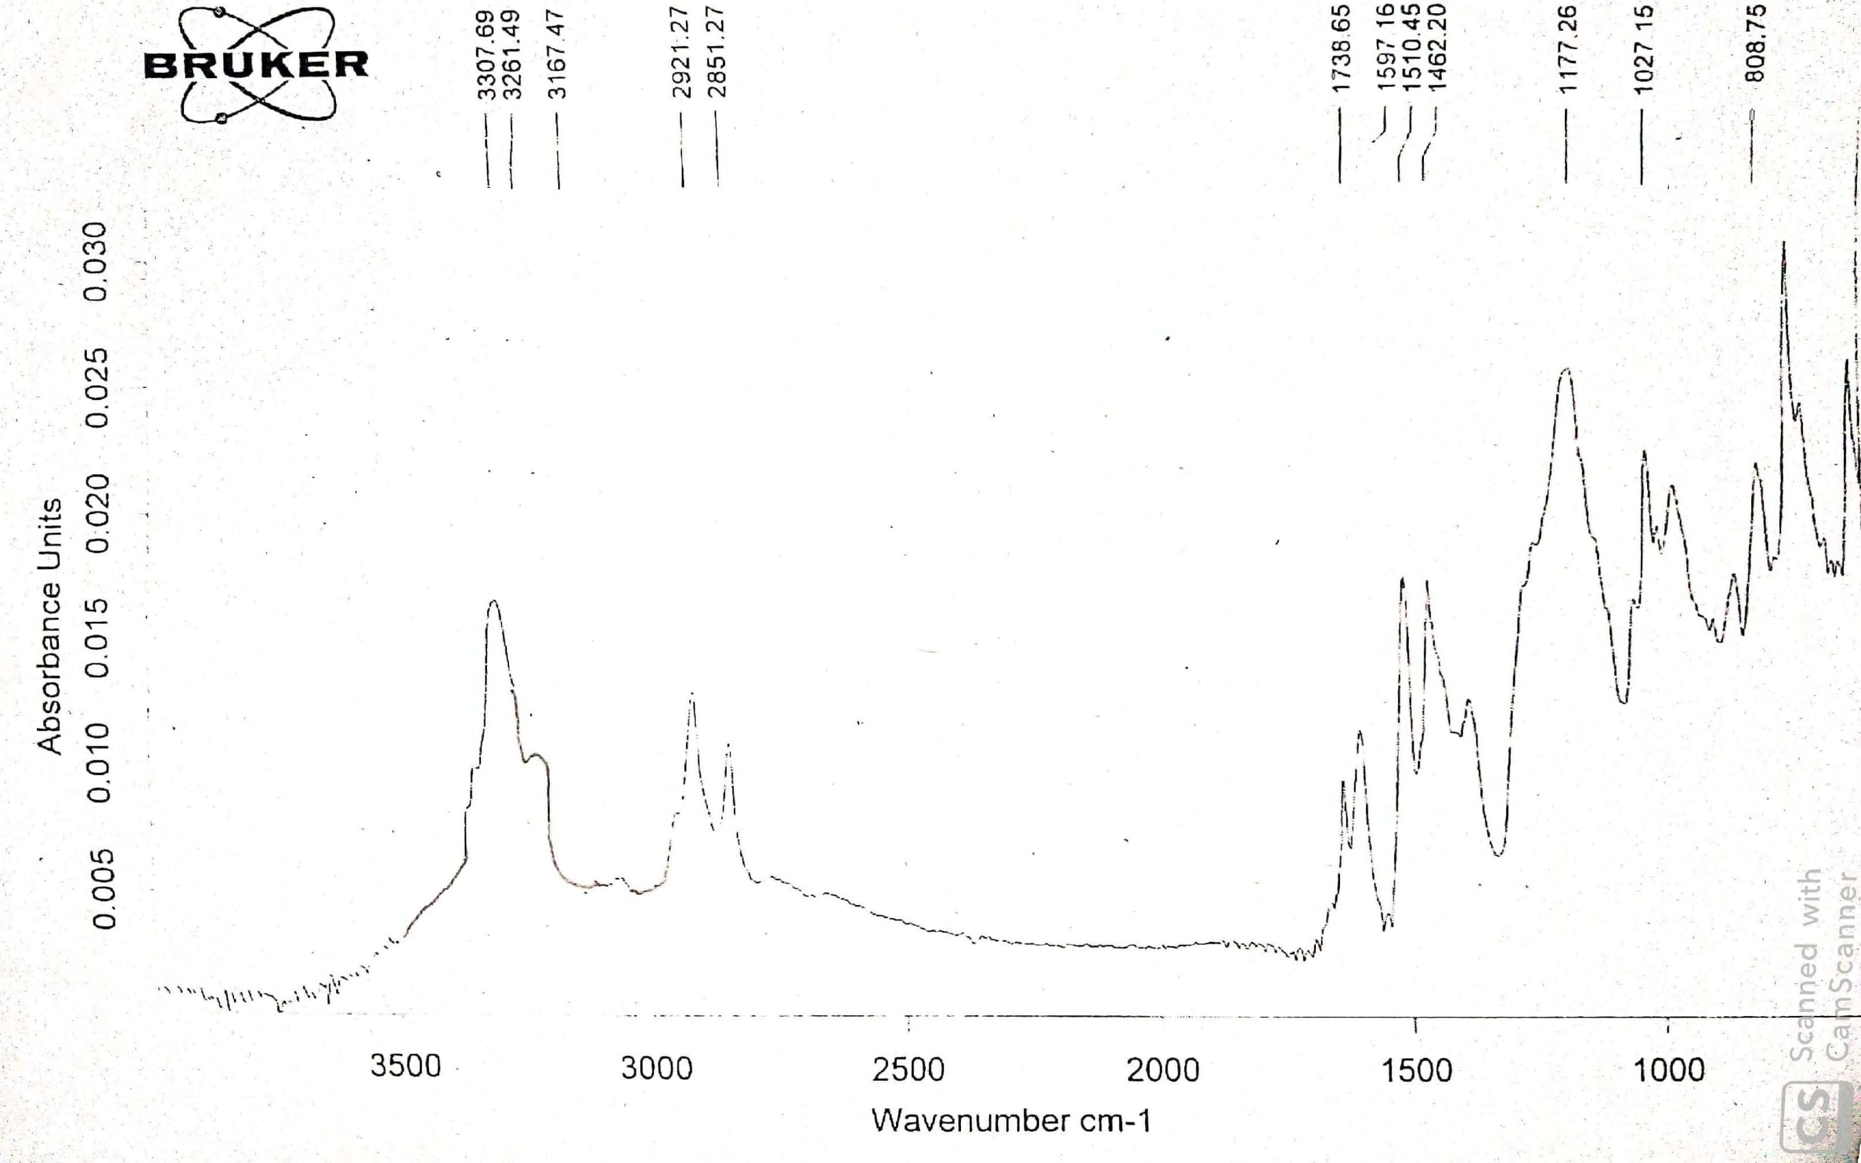

xii

**FTIR spectrum of compound 8**

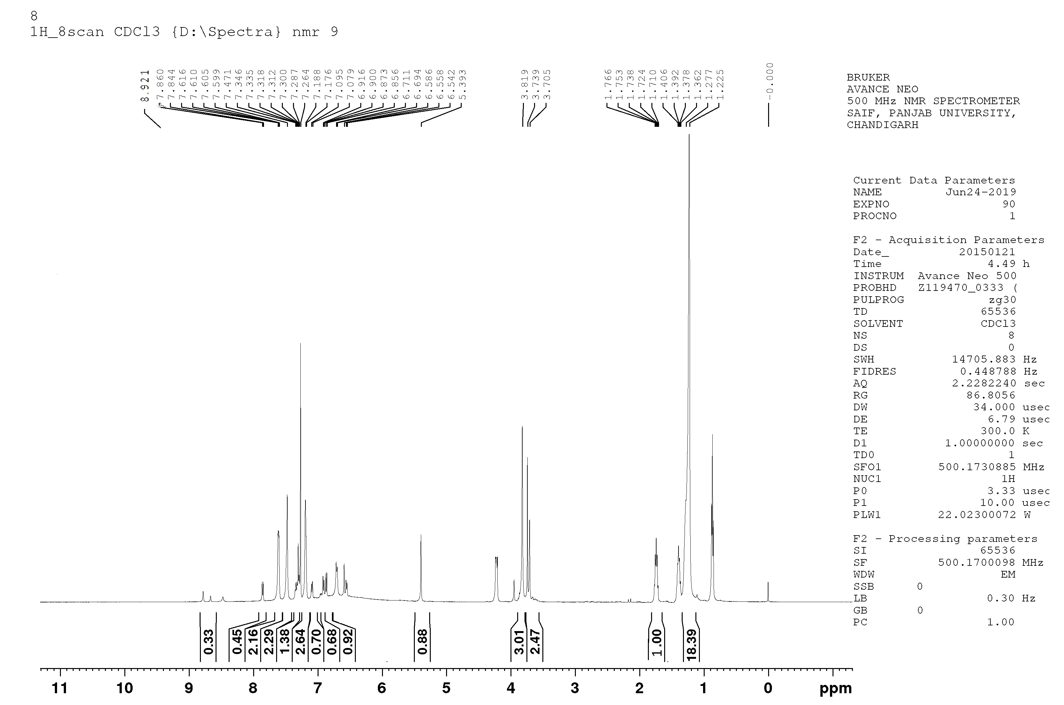

**1H NMR spectrum of compound 8**

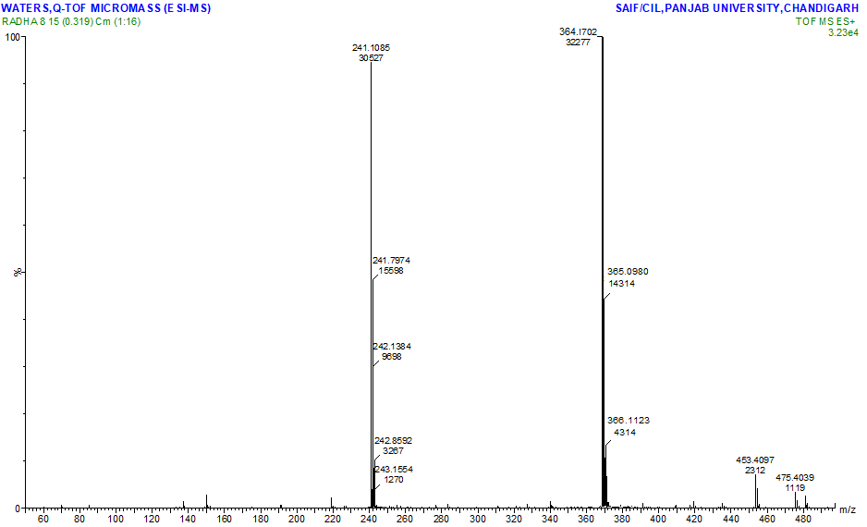

**1H Mass spectrum of compound 8**