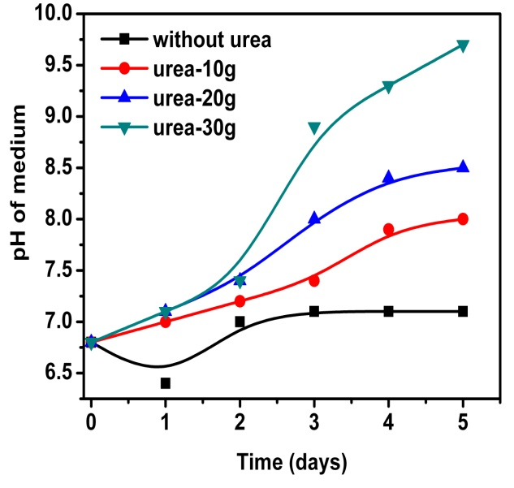

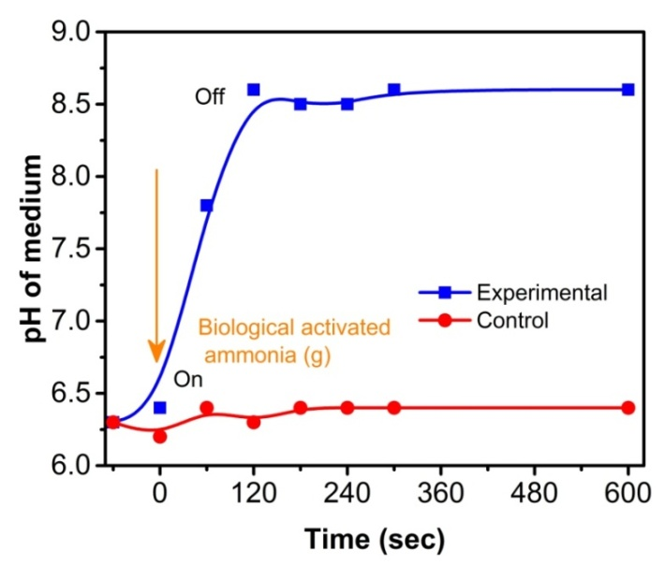Fig. S1. Ureolytic bacteria inoculated with synthetic urine at various concentration of urea

Fig. S2. Biologically activated ammonia(g)) purging into HAp precursors medium with respect to various time intervals

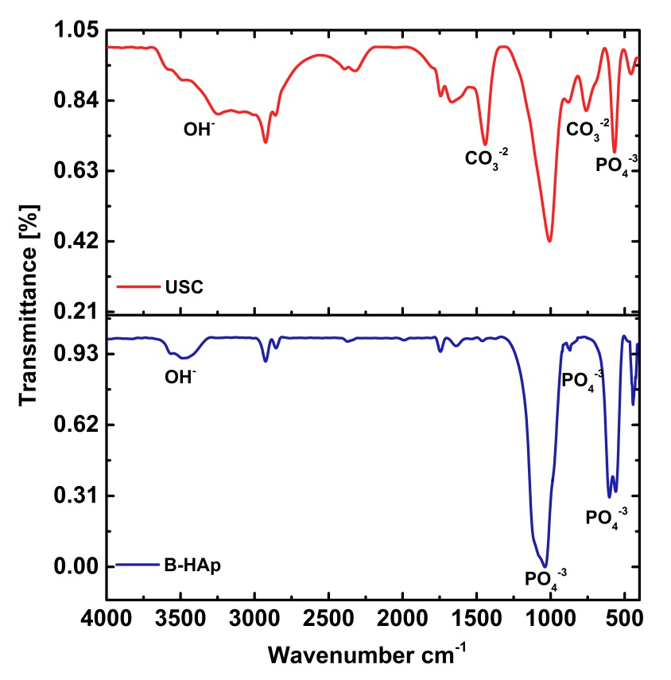

**b)**

**a)**

Fig. S3 . FT-IR spectra of (a) USC and (b) B-HAp sample.