Supplementary Information

Fluorescent pH indicators for alkaline pH range based on perylene tetra-(alkoxycarbonyl) derivatives

Fengxia Zhang a, Wenyao Dong c, Yongshan Ma a*, Tianyi Jiang a, Bing Liu a,b, Xuemei Li a, Yuanyuan Shao a and Junsen Wu a

a School of Municipal and Environmental Engineering, Shandong Jianzhu University, Jinan 250101，Shandong，China.

b Resources and Environment Innovation Research Institute，Jinan，250101，Shandong，China.

c the First Clinical Medical College of Shandong University of Chinese Medicine.* Corresponding author. E-mail: mlosh@sdjzu.edu.cn (Y. Ma). Tel.: +86 531 86361570.

**Table of contents**

**1. Synthesis protocols**

**2. Samples characteriaztions profiles**

1. **Synthesis protocols**

E:\0论文工厂\9 submited article\2019.10alkaline pH\ARABJC-D-20-00236\Scheme 1.tif

Scheme S1. The synthesis route of probes **1a-b**

**General procedure for the synthesis of 3a**

Fuming nitric acid (3.0mL) was added dropwise into a solution containing compound **2a** (2.0g, 3.0 mmol）and dichloromethane (200mL). The mixture was stirred at room temperature for 3h. Sodium bicarbonate solution (20%, 100 mL) was added in the resulting mixture. The organic phase was washed with water 3 times (100 ml×3) and dried with anhydrous MgSO4. Then the solvent was evaporated on a rotary evaporator until dry. The solid was purified on silica gel chromatographyeluted with dichloromethane/petroleum ether (2:1, v/v). After evaporated the eluent, it afford target red solid (0.9g, 86%). Characterization data: 1H-NMR(300 MHz, CDCl3, δ ppm): 8.40 (s, 1H), 8.37 (m, 2H), 8.26 (d, 1H), 8.14 (d, 1H, J=6 Hz), 7.97 (d, 1H, J=6 Hz), 7.93 (d, 1H, J=9 Hz), 4.37 (m, 8H), 1.82 (m, 8H), 1.55 (m, 8H), 1.03 (m, 12H). 13C NMR (75 MHz, CDCl3, δ ppm) : 168.06, 167.86, 167.79, 166.60, 146.32, 133.91, 132.53, 131.96, 131.61, 130.83, 130.51, 130.38, 130.00, 129.15, 128.73, 128.48, 127.92, 127.40, 126.63, 125.62, 123.13, 122.61, 66.02, 65.64, 65.58, 30.60, 19.23, 13.74. FT-IR (KBr, cm-1): *v =* 2959, 2871, 1711, 1589, 1529, 1460, 1394, 1353, 1274, 1249, 1163, 1108, 1062, 1021, 959, 899, 846, 801, 736, 702, 604, 506, 434. HRMS (APCI): m/z = 697.2913 (M + Na+).

**General procedure for the synthesis of 1a.**

A mixture of 3a (1.0 g, 1.5 mmol), ammonium chloride (0.8 g, 16.0 mmol) and zinc powder (0.5 g, 8.0 mmol) was stirred in tetrahydrofuran (80 mL) at room temperature for 3 h. The ammonium chloride and zinc powder were filtered. After evaporated the eluent, the crude product was purified on silica gel column chromatography with dichloromethane/ethyl acetate (20:1, V/V), affording dark brown solid (378.5 mg, 80%). Characterization data: 1HNMR (400 MHz, CDCl3, δ ppm): 8.08 (d, 1H, J=6 Hz), 8.06 (d, 1H, J=6 Hz), 7.94 (d, 1H, J=9 Hz), 7.80 (d, 1H, J=9 Hz), 7.70 (s, 1H), 7.33 (s, 1H), 4.57 (s, 1H), 4.32-4.34 (m, 8H), 3.83 (s, 2H), 1.72-1.84 (m, 8H), 1.46-1.53 (m, 8H), 0.96-1.04 (m,12H).13C-NMR (75 MHz, CDCl3,ppm): δ=169.03, 168.94, 167.96, 167.78, 155.68, 143.19, 133.47, 131.99, 131.80, 131.61, 129.97, 129.76, 128.87, 128.78, 127.42, 127.01, 126.20, 125.83, 125.57, 123.54, 122.18, 120.58, 90.57, 65.27, 65.19, 62.15, 31.06, 30.70, 30.60, 27.44, 19.28, 19.20, 13.79. FT-IR (KBr, cm-1): *v =* 3361, 3265, 3179, 2968, 2863, 1689, 1583, 1449, 1373, 1249, 1201, 1154, 1039, 857, 781, 752, 695. HRMS (APCI): m/z = 682.3004 [M-H]-.

**General procedure for the synthesis of 2b.**

Compound 3a (120 mg, 0.2 mmol) was dissolved in N-methylpyrrolidone (NMP, 10 ml). The resulting solution was stirred at 130℃ under O2 for 4 h until the starting material could not be detected by TLC, and then poured into 100 ml of 2 M HCl. The precipitate was collected by vacuum filtration and washed with water. After solvent was removed under vacuum, the crude product was purified by silica gel column chromatography with eluent dichloromethane/petroleum ether (5/2, V/V). After solvent was removed, a yellow solid of 34 mg (30%) 2b was obtained. 1H NMR (CDCl3, 400 MHz, ppm): 8.88 (d, 2H), 8.73 (s, 1H), 8.38 (d, 2H), 4.40-4.44 (m, 8), 1.82 (m, 8H), 1.50-1.55 (m, 8H), 0.89-1.04 (m, 12H). 13C NMR (100 MHz, CDCl3, δ ppm): 168.56, 168.50, 135.71, 132.40, 130.98, 130.13, 129.55, 129.33, 126.27, 125.96, 125.60, 121.80, 65.58, 65.47, 30.70, 19.29, 13.77. FT-IR (KBr, cm-1): *v =* 2921, 2846, 1692, 1652, 1612, 1416, 1344, 1308, 1258, 1178, 1000, 893, 852, 803, 736, 628, 578. MS (APCI-TOF) m/z = 666.2817 (M+)。

**General procedure for the synthesis of 3b.**

The compound **3b** was synthesized according to the procedure of **3a**, Briefly, Compound **2b** (280 mg, 0.4 mmol) and fuming nitric acid (2.5 mL) reacted for 3 h in dichloromethane at room temperature to yield **3a** (252mg, 87%). Characterization data: 1HNMR (400 MHz, CDCl3, δ ppm): 8.86 (s, 1H), 8.77 (s, 1H), 8.44 (d, 2H), 8.40 (s, 1H), 8.31 (d, 1H), 4.40-4.46 (m, 8), 1.81-1.89 (m, 8H), 1.52-1.57 (m, 8H), 1.00-1.04 (m, 12H). 13C NMR (100 MHz, CDCl3, δ ppm): 168.09, 167.91, 167.82, 166.55, 145.48, 136.24, 136.10, 132.05, 130.91, 130.50, 130.00, 129.27, 127.77, 127.36, 126.68, 126.52, 126.06, 125.82, 125.45, 123.81, 122.88, 66.16, 65.92, 65.80, 65.73, 30.65, 30.58, 19.25, 13.74. HRMS (APCI): m/z = 711.2732 (M + Na+).

**General procedure for the synthesis of 1b.**

Potassium carbonate (150 mg, 1.0 mmol) was added into a solution containing compound **3b** (150mg, 0.2mmol) and N-methylpyrrolidone (15ml). Under N2, the resulting solution was stirred at 60℃ for 5h. After cooling to room temperature, the mixture was poured into HCl (100ml, 2 M). The mixture is filtered, and the granular precipitate is washed thoroughly with water and dried under vacuum condition. The residue was purified by gel column chromatography with dichloromethane /ethyl acetate (20/1) as eluent to afford red solid **1b (**136mg, 86%). Characterization data: 1H-NMR (CDCl3, 300 MHz, δ ppm): 11.09 (s, 1H), 9.73 (d, J = 9.0 Hz, 1H), 8.71 (s, 1H), 8.55 (s, 1H), 8.33 (s, 1H), 8.11 (d, 1H), 4.34-4.43 (m, 8), 1.74 (m, 8H), 1.48 (m, 8H), 0.88-0.99 (m, 12H). 13C NMR (75 MHz, CDCl3, δ ppm): 169.59, 169.20, 168.81, 153.19, 129.87, 129.08, 128.16, 127.77, 126.94, 126.77, 125.43, 124.15, 123.01, 122.27, 119.10, 116.71, 65.71, 65.61, 65.42, 30.81, 29.67, 19.34, 13.84. FT-IR (KBr, cm−1): *v* = 3365, 3189, 2922, 2854, 1651, 1462, 1410, 1067, 873, 732, 661, 586, 528, 486, 437. HRMS (APCI): m/z = 682.2869(M+ -H).

1. **Sample characterizations profiles**

sizhixiaoh

**Figure S1.** 1H NMR spectrum of compound **3a**.

sizhixiaoc

**Figure S2.** 13 C NMR spectrum of compound **3a**.

sizhixiao

**Figure S3.** FT-IR profile of compound **3a**.

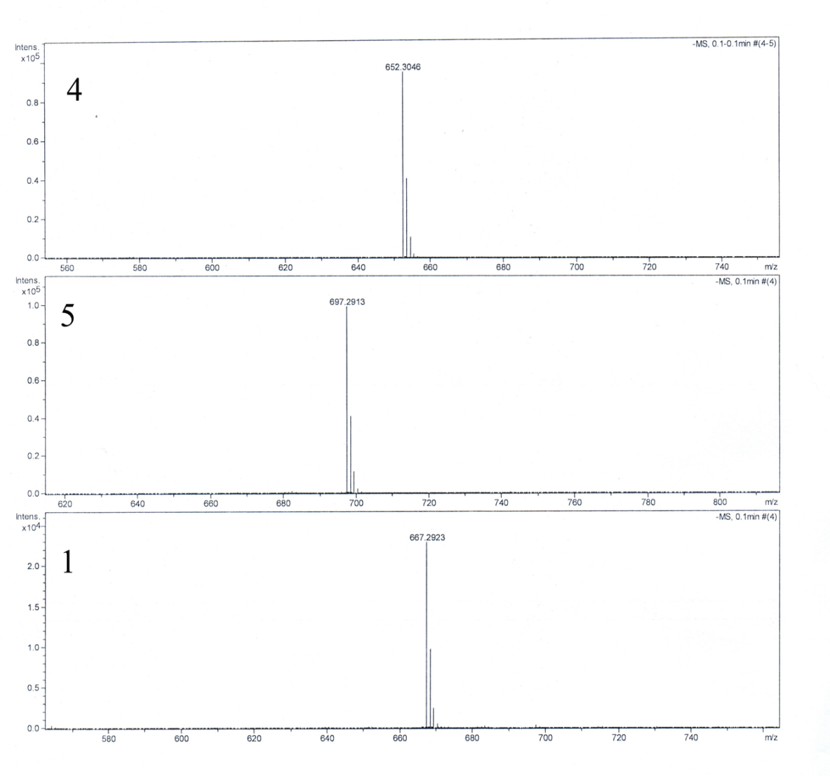

**Figure S4.** HRMS profile of compound **3a**.

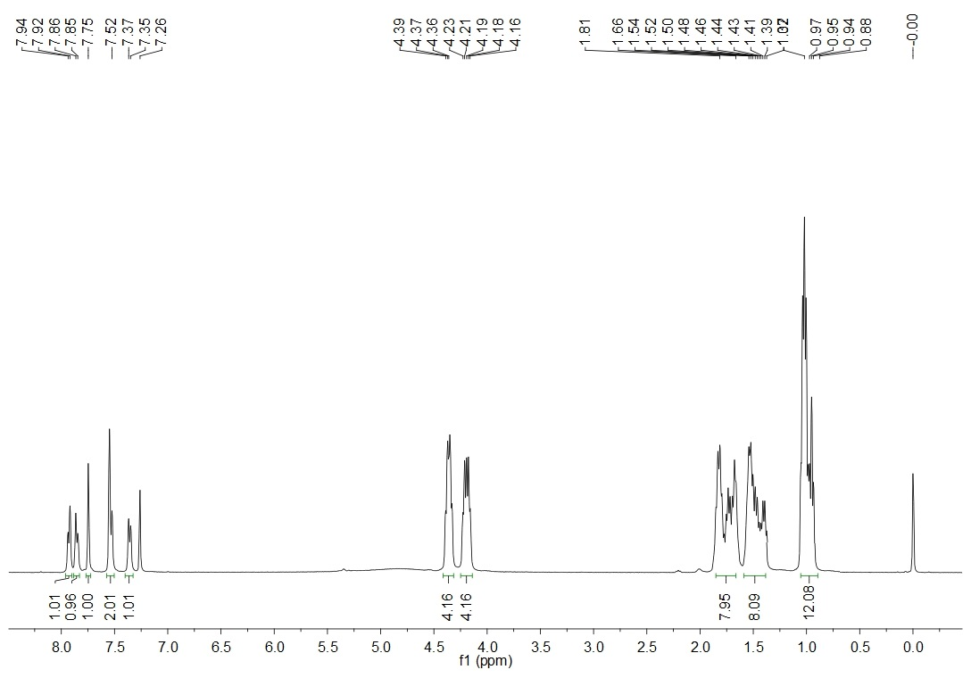

**Figure S5.** 1H NMR spectrum of compound **1a**.

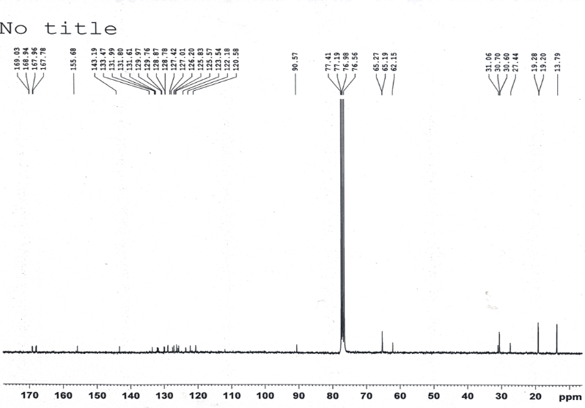

**Figure S6.** 13 C NMR spectrum of compound **1a**.

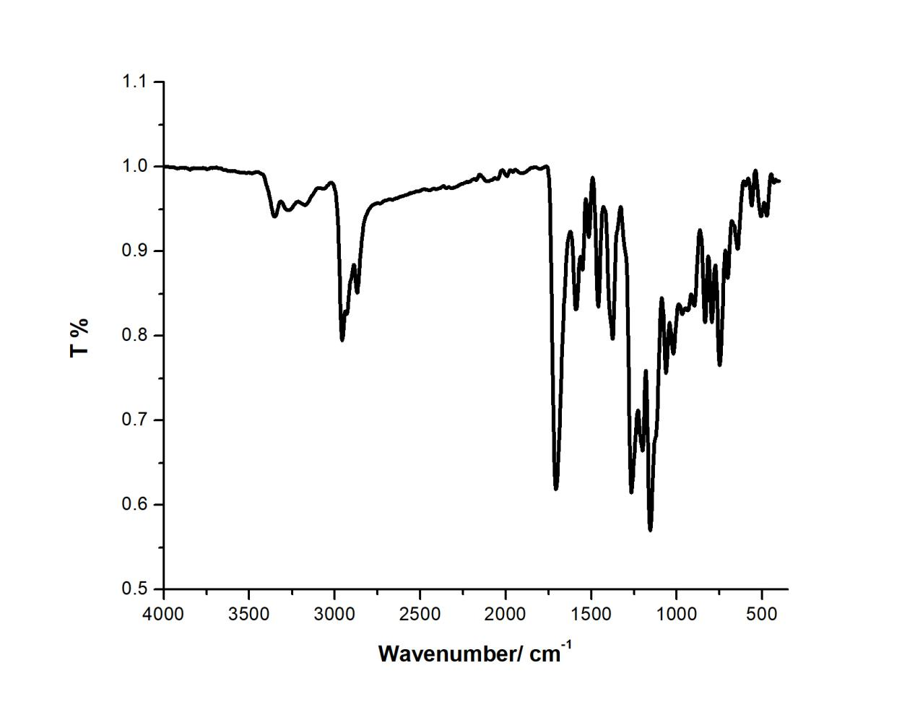



**Figure S7.** FT-IR profile of compound **1a**.



**Figure S8.** HRMS profile of compound **1a**.

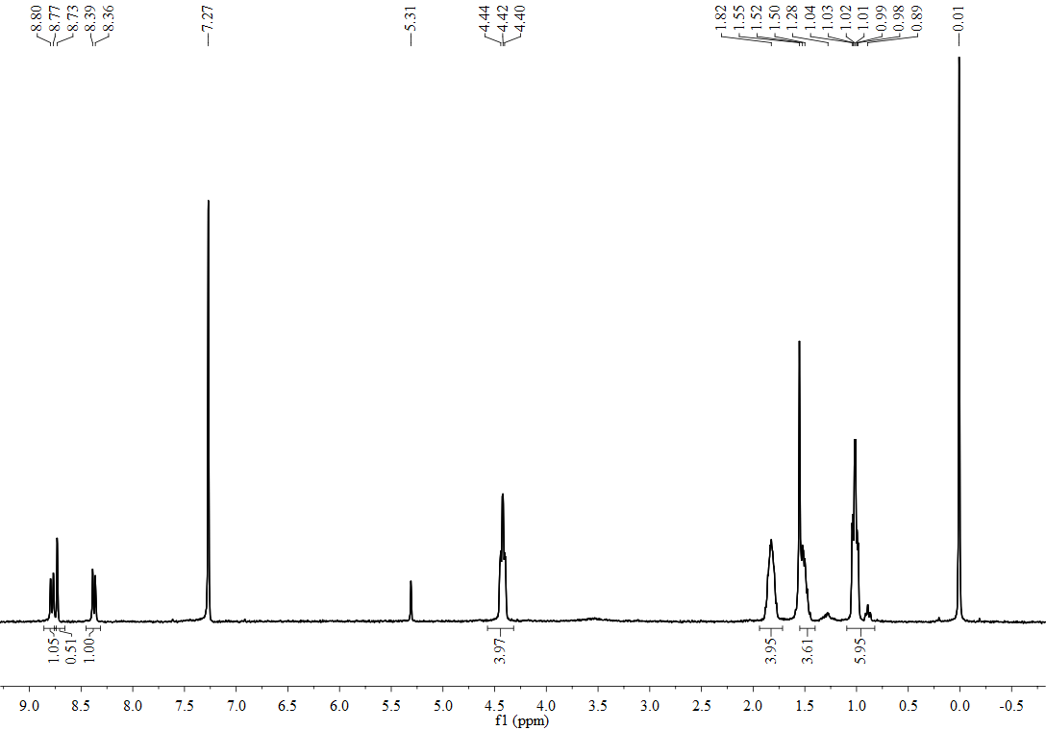

**Figure S9.** 1H NMR spectrum of compound **2b**.

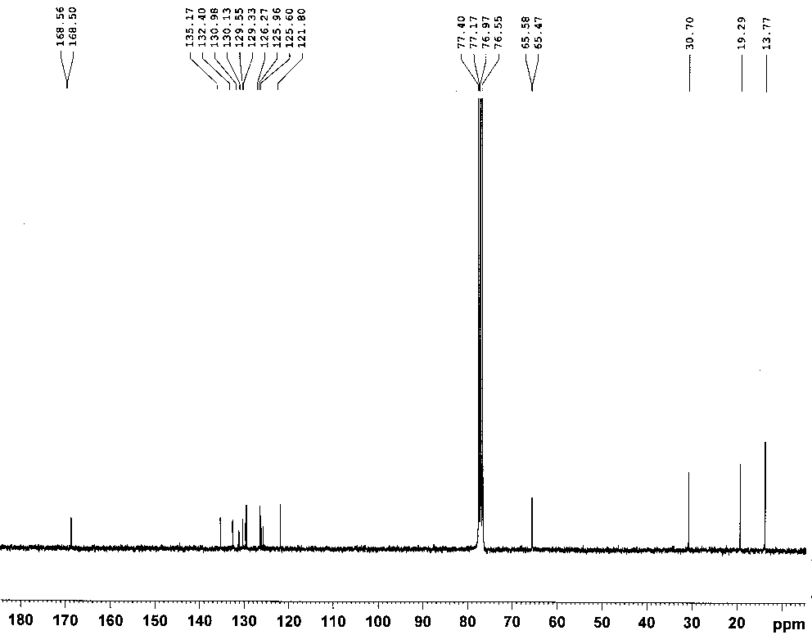

**Figure S10.** 13C NMR spectrum of compound **2b**.

C:\Users\Administrator\Desktop\Graph1.tif

**Figure S11.** FT-IR profile of compound **2b**.

C:\Users\Administrator\Desktop\MS of Smi.tif

**Figure S12.** HRMS profile of compound **2b**.

**C:\Users\Administrator\Desktop\未标题-1.tif**

**Figure S13.** 1H NMR spectrum of compound **3b**.

**C:\Users\Administrator\Desktop\未标题-2.tifFigure Figure S14.** 13 C NMR spectrum of compound **3b**.

C:\Users\Administrator\Desktop\未标题-3.tif

**Figure S15.** HRMS profile of compound **3b**.

**E:\0论文工厂\8 work on papers\羟基-单S羟基\单S羟基\谱图\H NMR.tif**

**Figure S16.** 1H NMR spectrum of compound **1b**.

E:\0论文工厂\8 work on papers\羟基-单S羟基\单S羟基\谱图\C NMR.tiff

**Figure S17.** 13 C NMR spectrum of compound **1b**.

E:\0论文工厂\8 work on papers\羟基-单S羟基\单S羟基\谱图\红外.tif

**Figure S18.** FT-IR profile of compound **1b**.

C:\Users\Administrator\Desktop\质谱.tif

**Figure S19.** HRMS profile of compound **1b**.