Supplementary information

Heteropoly-12-tungstophosphoric acid H₃[PW₁₂O₄₀] over natural bentonite as a heterogeneous catalyst for the synthesis of 3,4-dihydropyrimidin-2-(1H)-ones
Lakha V Chopdaª and Pragnesh N Dave*^{b}
ª Chemical Engineering Depaertment , Government Engineering College Bhuj, India
^{b} Department Of Chemistry, Sardar Patel University , Vallabh Vidyanagar, India
Email id: pragneshdave@gmail.com

(d)
(c)
(b)
(a)
Figure 1 : EDS (a) Raw bentonite (b) 10 % PTA /bent (c) 20 % PTA /bent (d) 30 % PTA /bent.

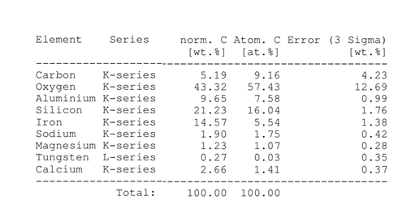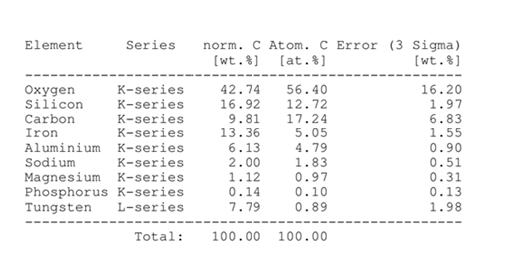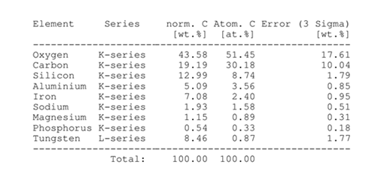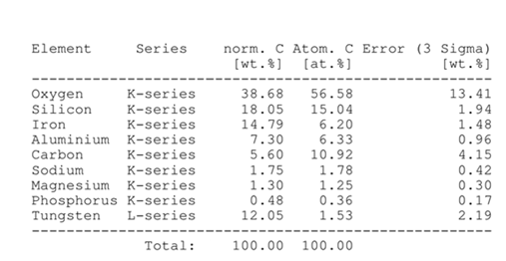
Table S1: Element analysis by EDS (a) Raw bentonite (b) 10%TPA/bent (c) 20% TPA /bent (d) 30% TPA /bent.
(a)
(b)
(c)
(d )

NMR Spectra
5-(Ethoxycarbonyl)--6-methyl-3,4-dihydropyrimidin-2(1H)-one(Table no.1, Entry no. 3).
¹H-NMR (500 MHz, DMSO-d₆)
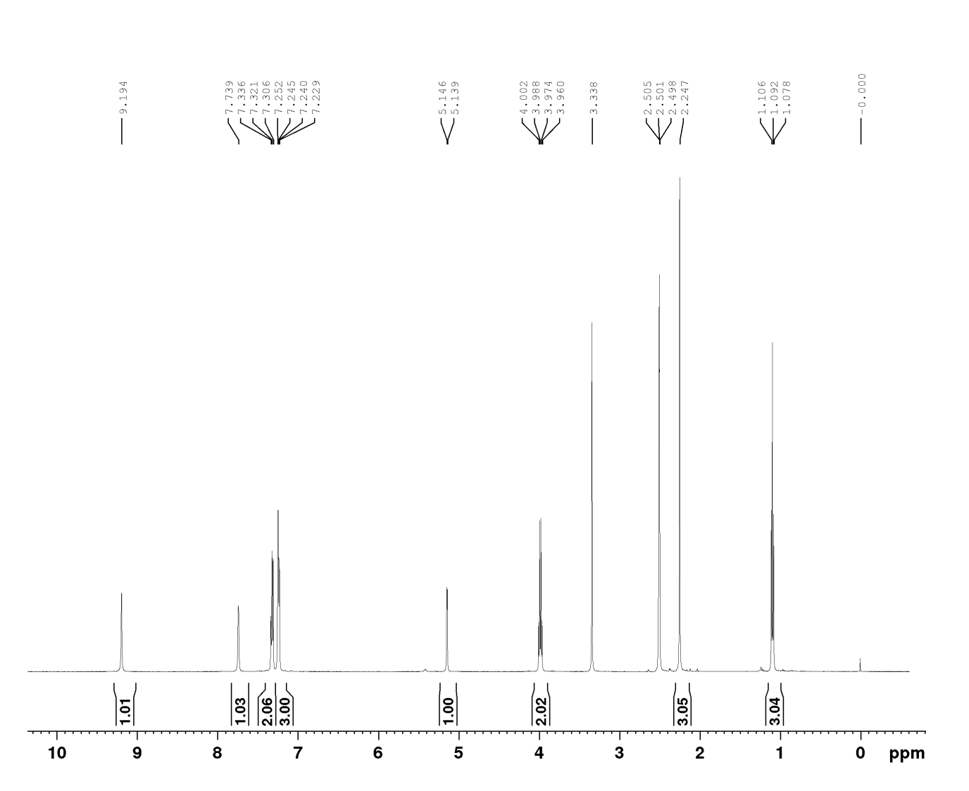
¹³C-NMR (400 MHz, DMSO-d₆)
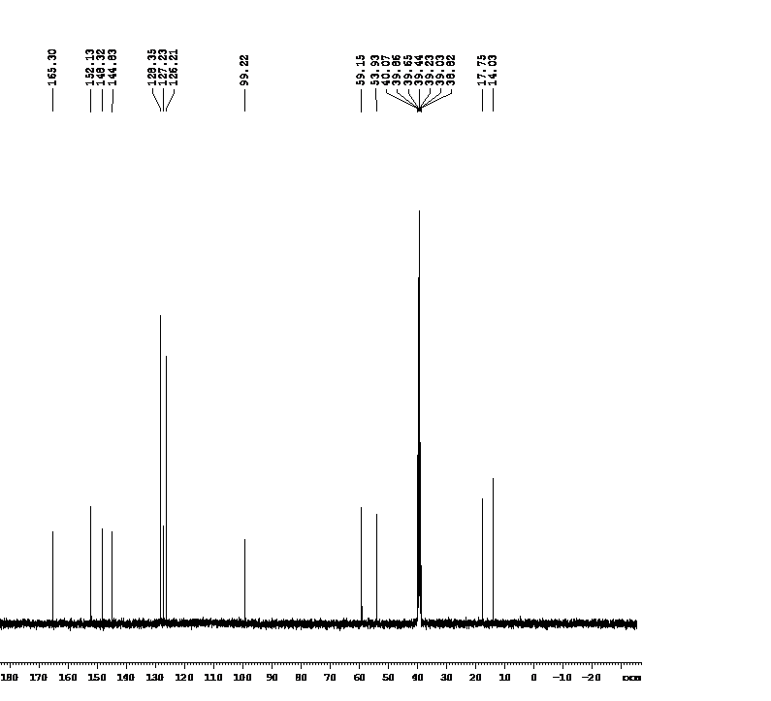
5-(Ethoxycarbonyl)-4-(4-methoxyphenyl)-6-methyl-3, 4-dihydropyrimidin-2(1H) -one (Table no.2, entry no.1).
¹H-NMR (500 MHz, DMSO-d₆)
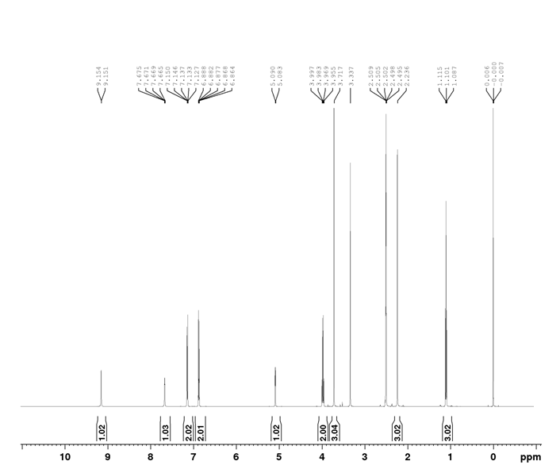
¹³C-NMR (400 MHz, DMSO-d₆)
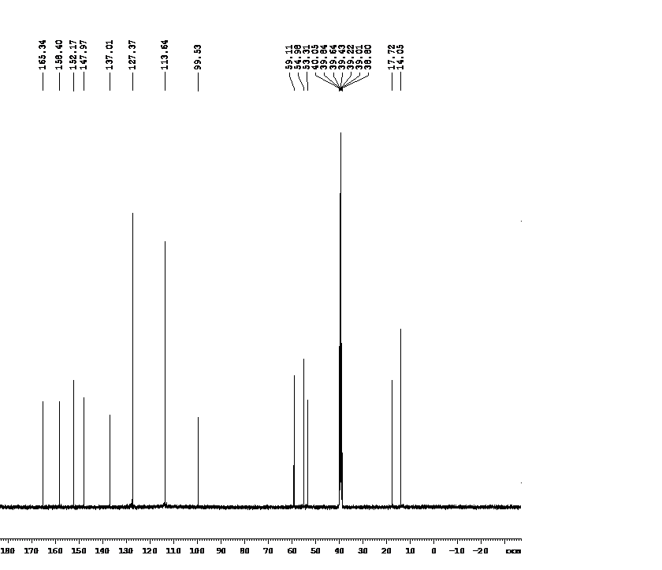
5-(Ethoxycarbonyl)-4-(3-methoxyphenyl)-6-methyl-3, 4-dihydropyrimidin-2(1H)-one (Table no.2, entry no.2).
¹H-NMR (500 MHz, DMSO-d₆)
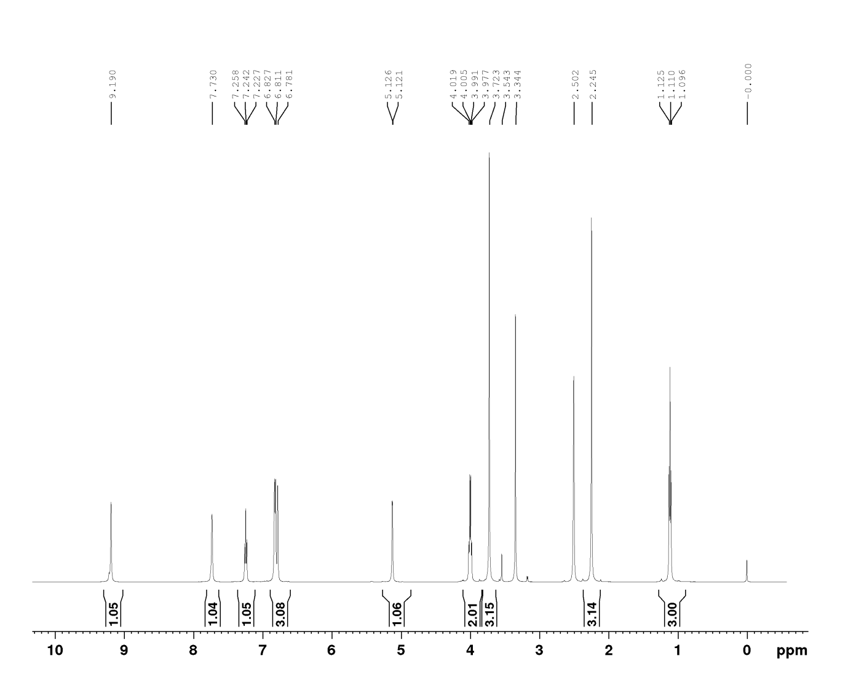
¹³C-NMR (500 MHz, DMSO-d₆)
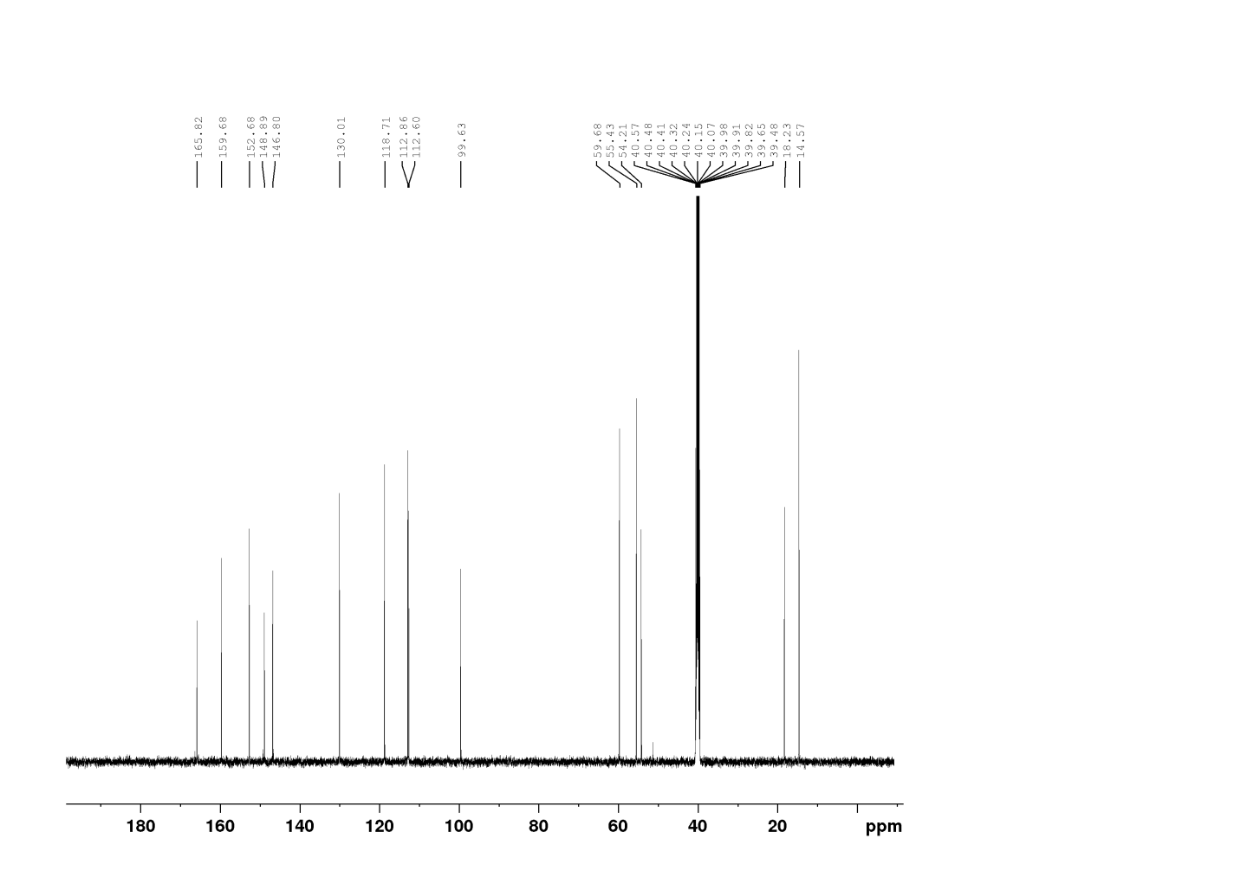
5-(Ethoxycarbonyl)-4-(4-chlorophenyl)-6-methyl-3,4-dihydropyrimidin-2(1H)-one(Table no.2, entry no.3).
¹H-NMR (500 MHz, DMSO-d₆)
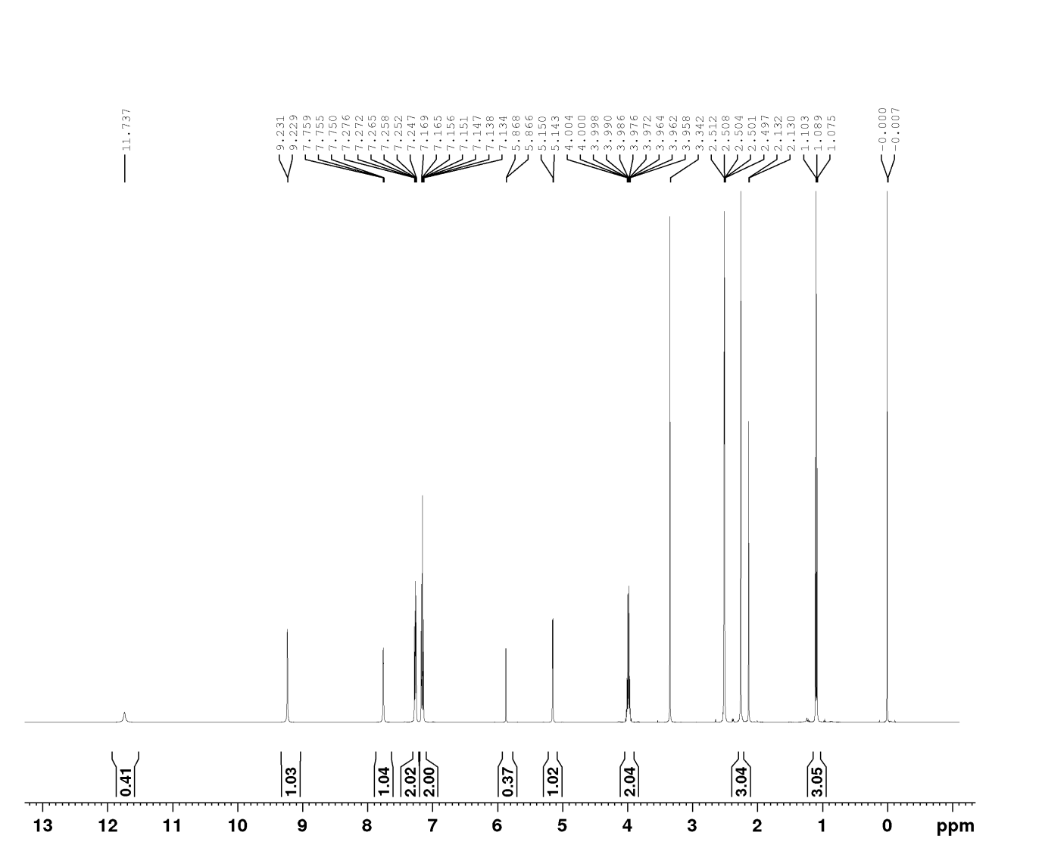
¹³C-NMR (400 MHz, DMSO-d₆)

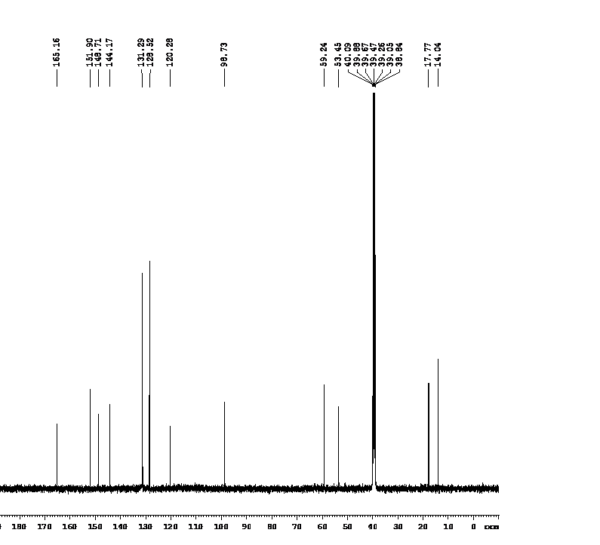

5-(Ethoxycarbonyl)-4-(3,4-dimethoxyphenyl)-6-methyl-3,4-dihydropyrimidin-2(1H)-one(Table no.2, Entry no. 4).
¹H-NMR (500 MHz, DMSO-d₆)
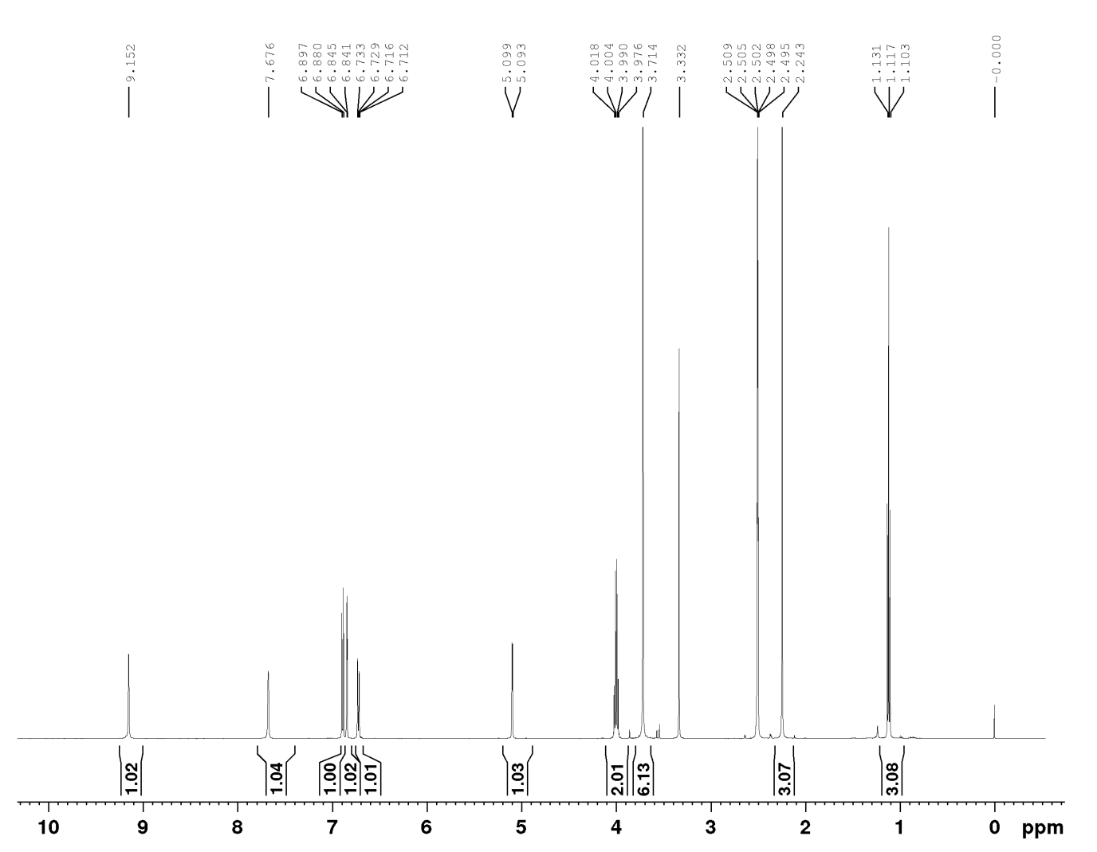
¹³C-NMR (400 MHz, DMSO-d₆)
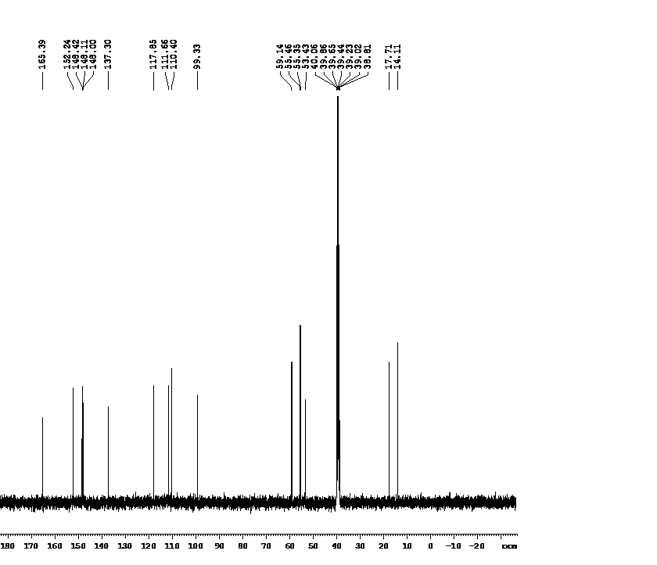
5-(Ethoxycarbonyl)-4-(N,N-dimethylaminephenyl)-6-methyl-3,4-dihydropyrimidin-2(1H)-one (Table no.2, Entry no.5).
¹H-NMR (500 MHz, DMSO-d₆)
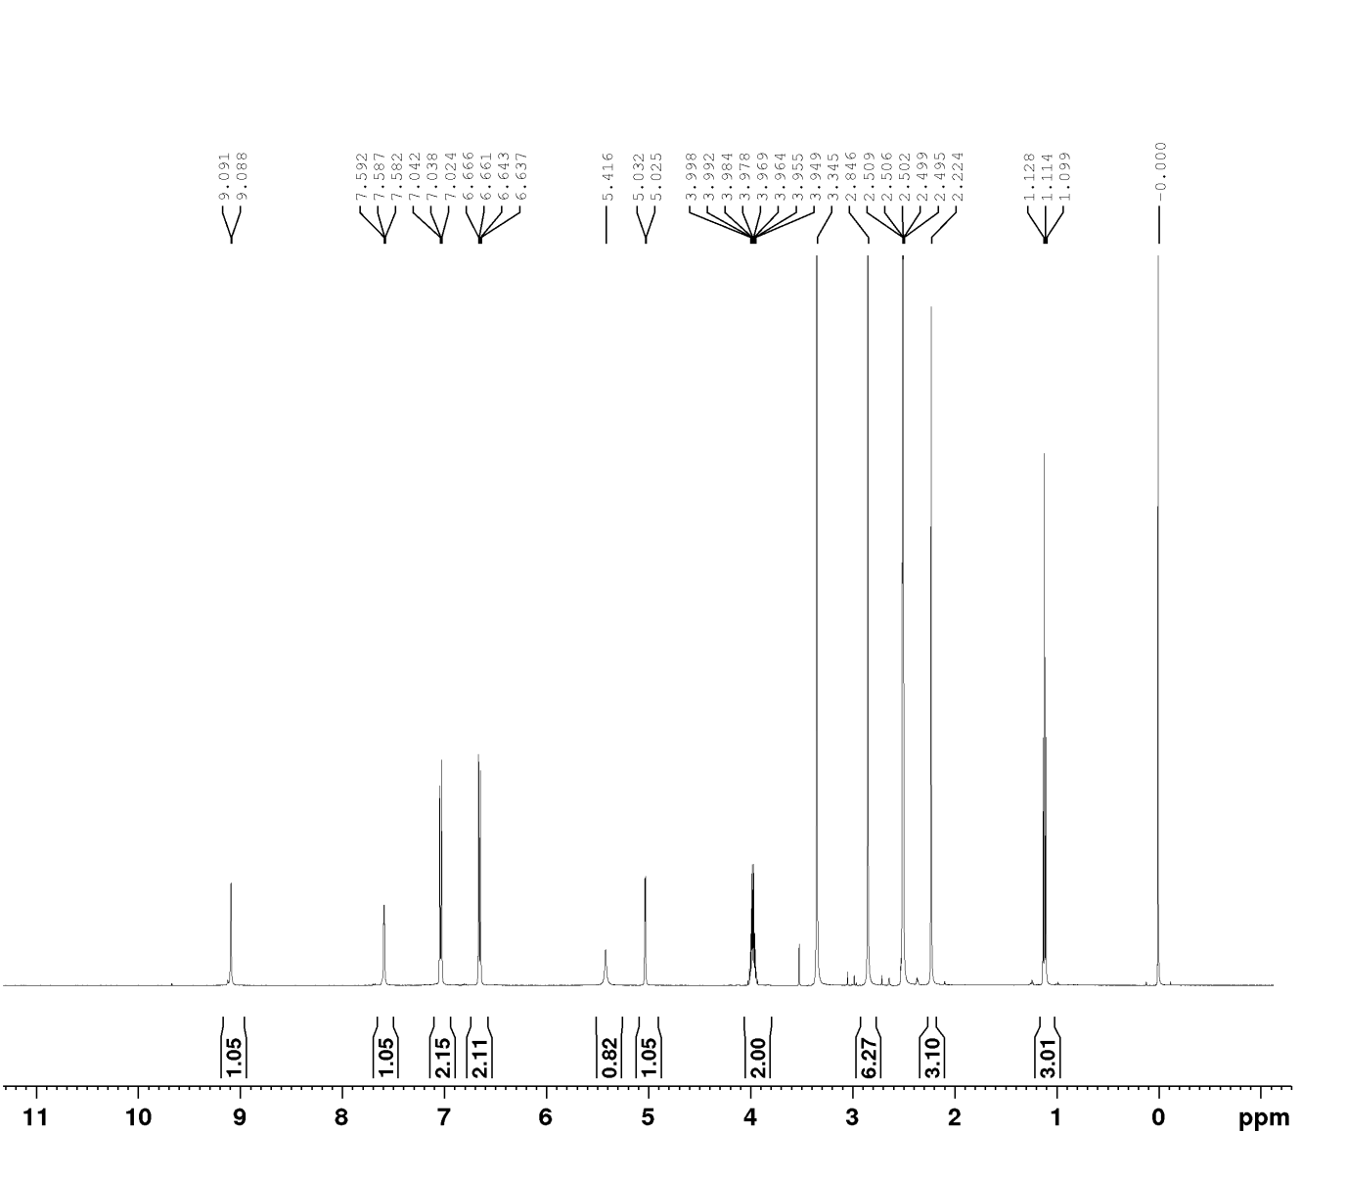
¹³C-NMR (500 MHz, DMSO-d₆)
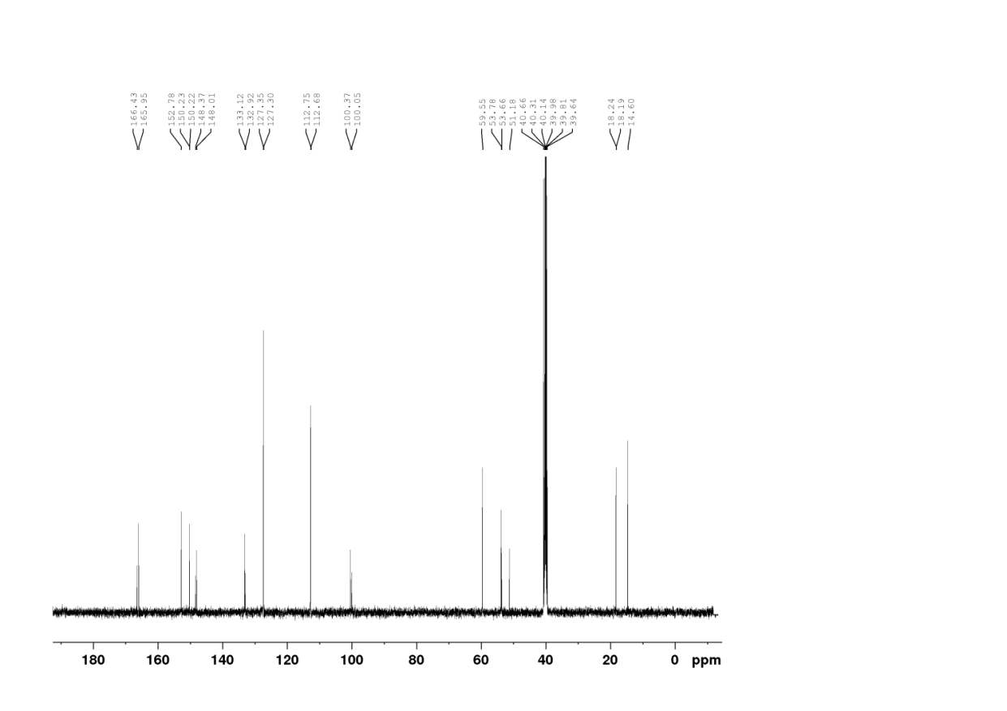
5-(Ethoxycarbonyl)-4-(4-hydroxyphenyl)-6-methyl-3,4-dihydropyrimidin-2(1H)-one (Table no.2, Entry no. 6).
¹H-NMR (500 MHz, DMSO-d₆)
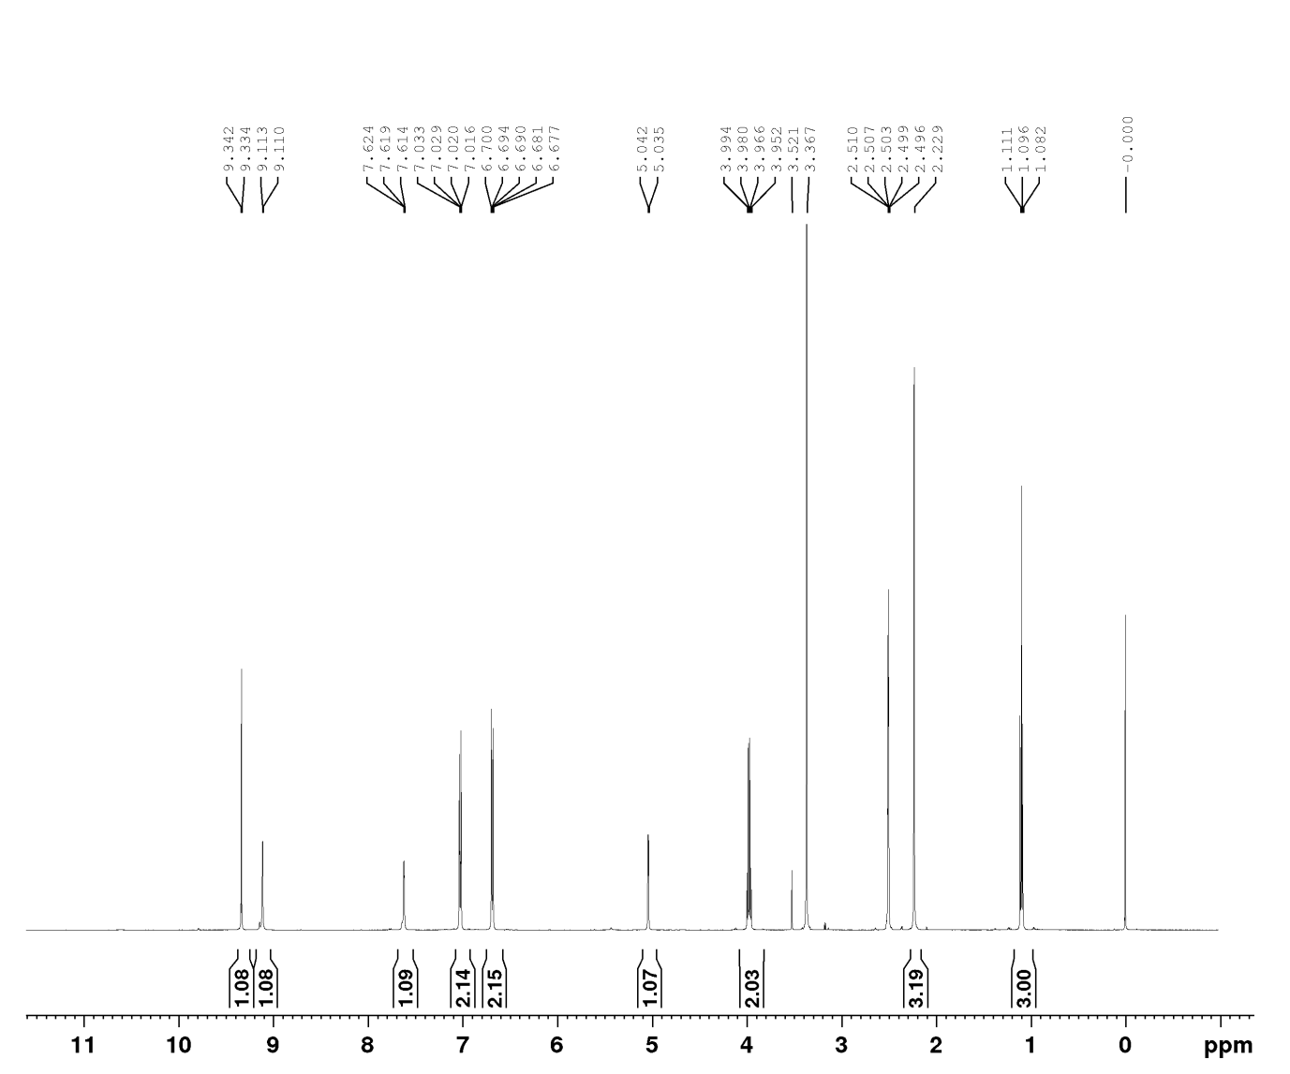
¹³C-NMR (400 MHz, DMSO-d₆)

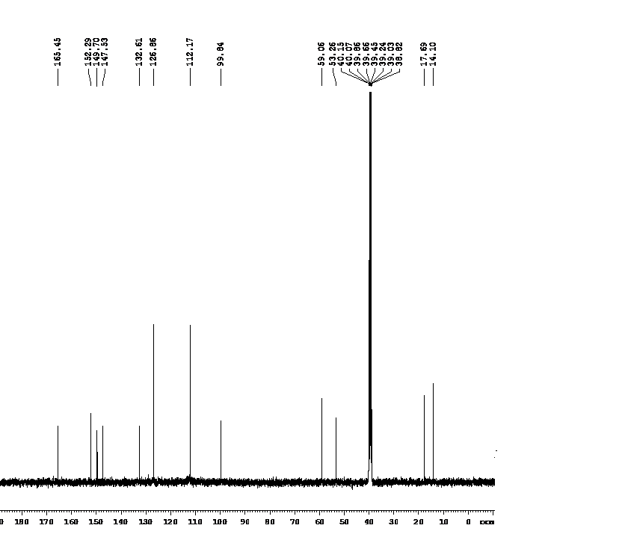

5-(Ethoxycarbonyl)-4-(4-fluorophenyl)-6-methyl-3,4-dihydropyrimidin-2(1H)-one (Table no.2, Entry no. 7).
¹H-NMR (500 MHz, DMSO-d₆)
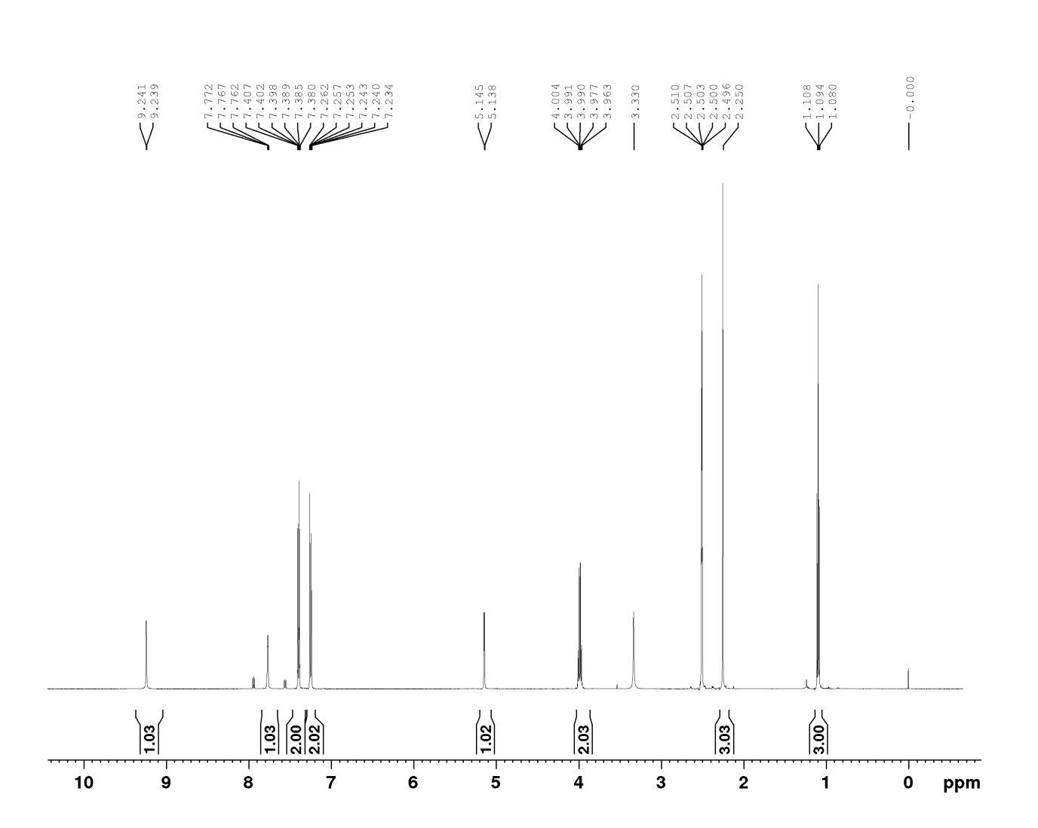
¹³C-NMR (500 MHz, DMSO-d₆)
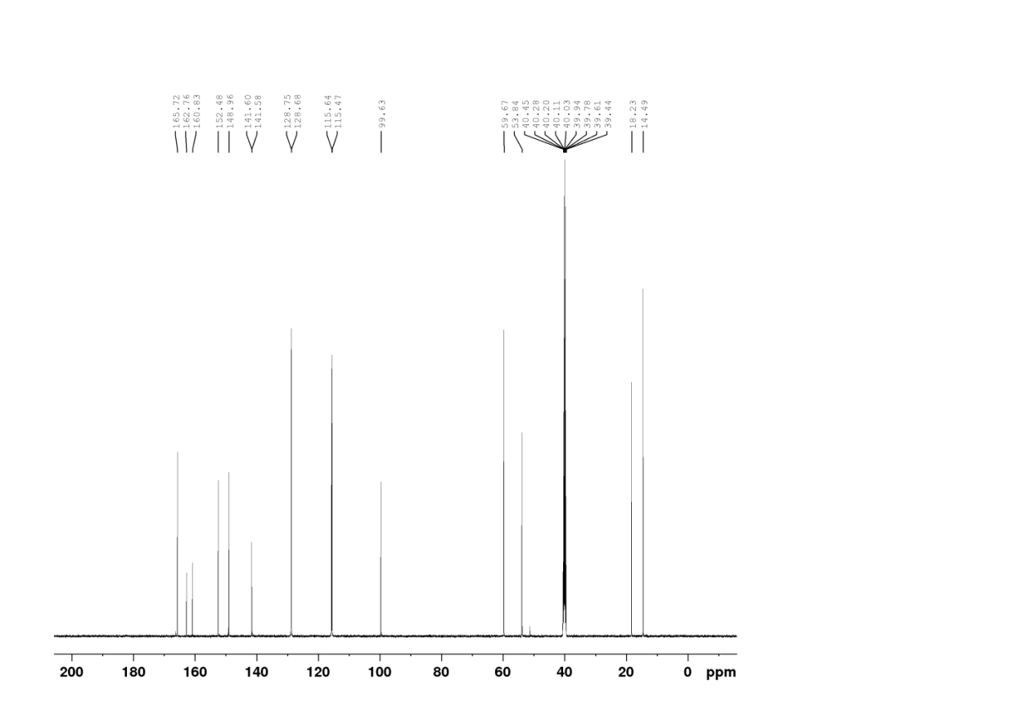

5-(Ethoxycarbonyl)-4-(4-Nitrohenyl)-6-methyl-3, 4-dihydropyrimidin-2(1H)-one (Table no.2, Entry no. 8).
¹H-NMR (500 MHz, DMSO-d₆)

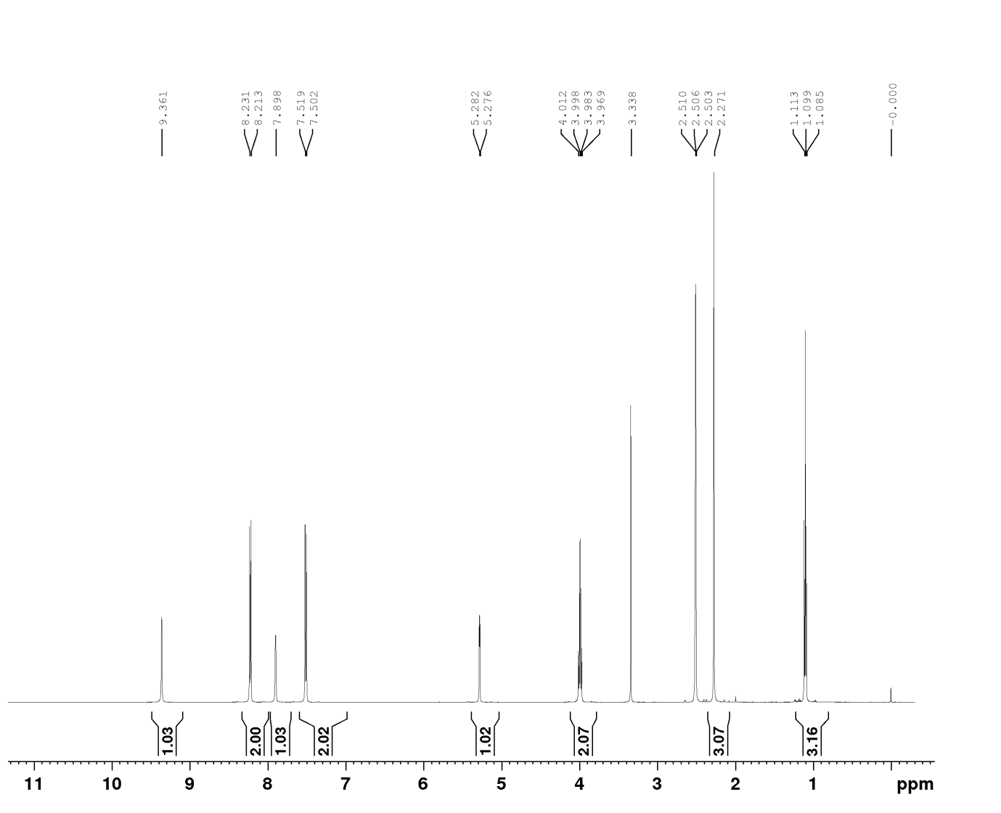
¹³C-NMR (400 MHz, DMSO-d₆)
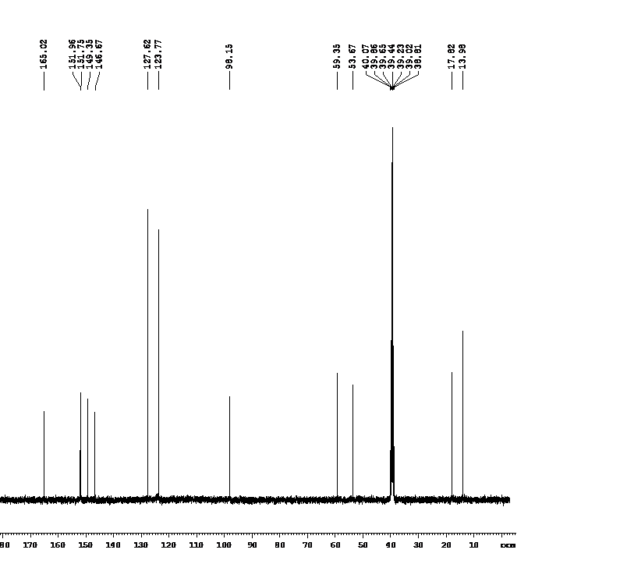

5-(Ethoxycarbonyl)-4-(4-bromophenyl)-6-methyl-3, 4-dihydropyrimidin-2(1H)-one (Table no.2, Entry no. 9).
¹H-NMR (500 MHz, DMSO-d₆)
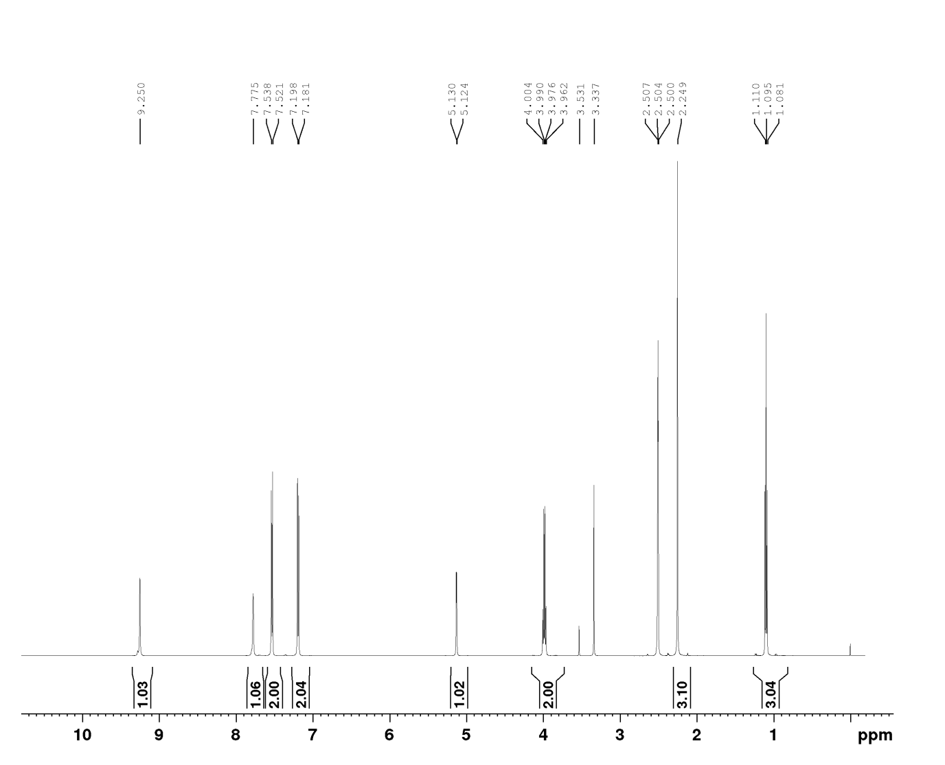
¹³C-NMR (400 MHz, DMSO-d₆)
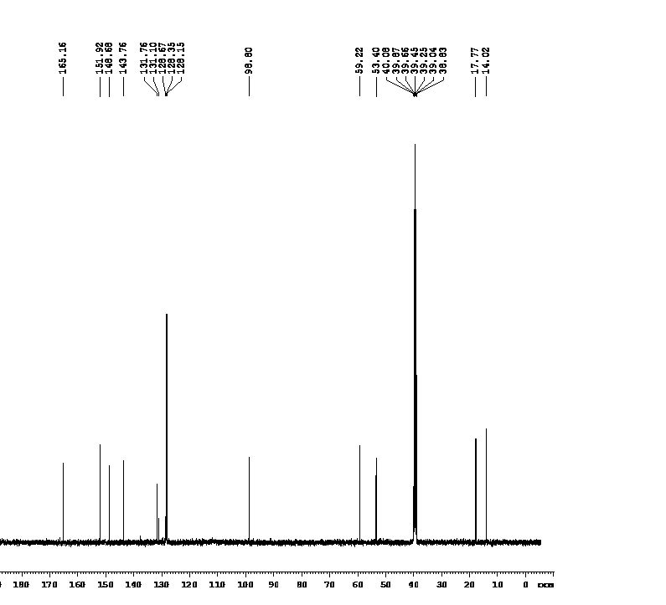
5-(Ethoxycarbonyl)-4-(2-chlorophenyl)-6-methyl-3,4-dihydropyrimidin-2(1H)-one(Table no 2, Entry no. 10).
¹H-NMR (500 MHz, DMSO-d₆)
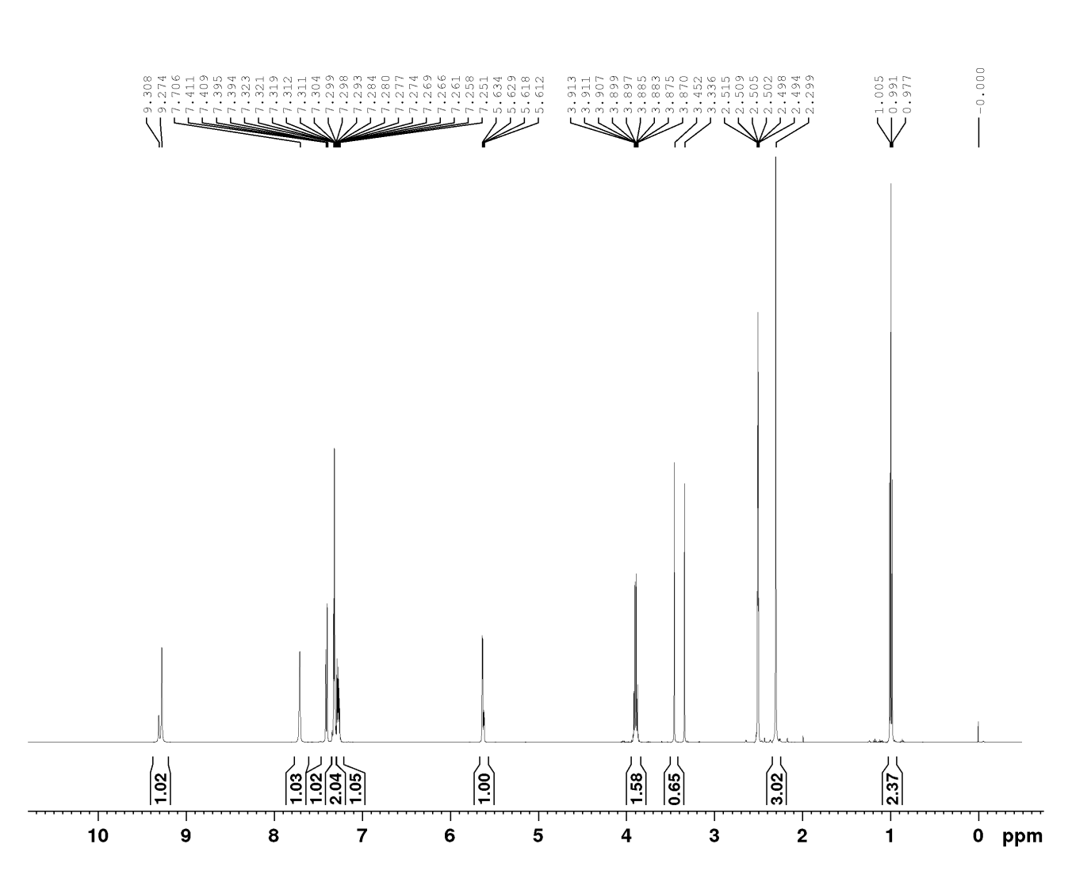
¹³C-NMR (500 MHz, DMSO-d₆)
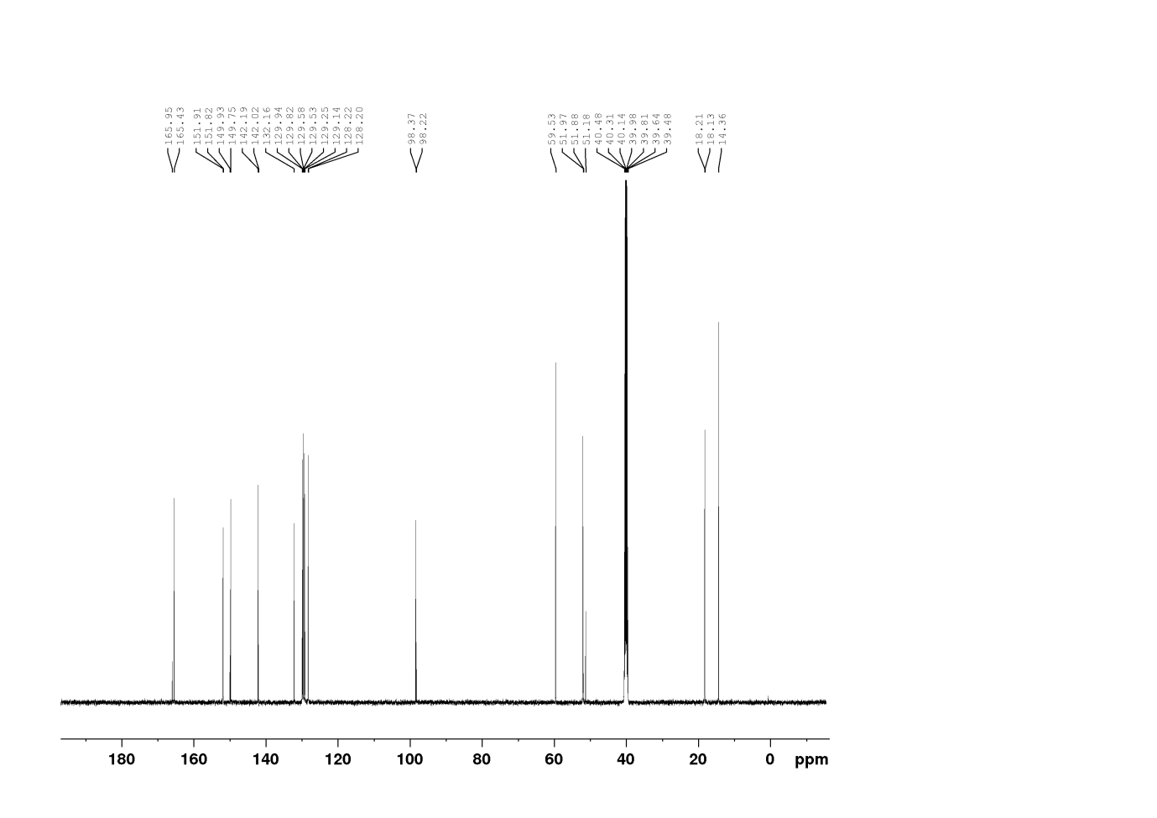
5-(Ethoxycarbonyl)-4-(3-Nitrohenyl)-6-methyl-3,4-dihydropyrimidin-2(1H)-one (Table no.2, Entry no. 11).
¹H-NMR (500 MHz, DMSO-d₆)
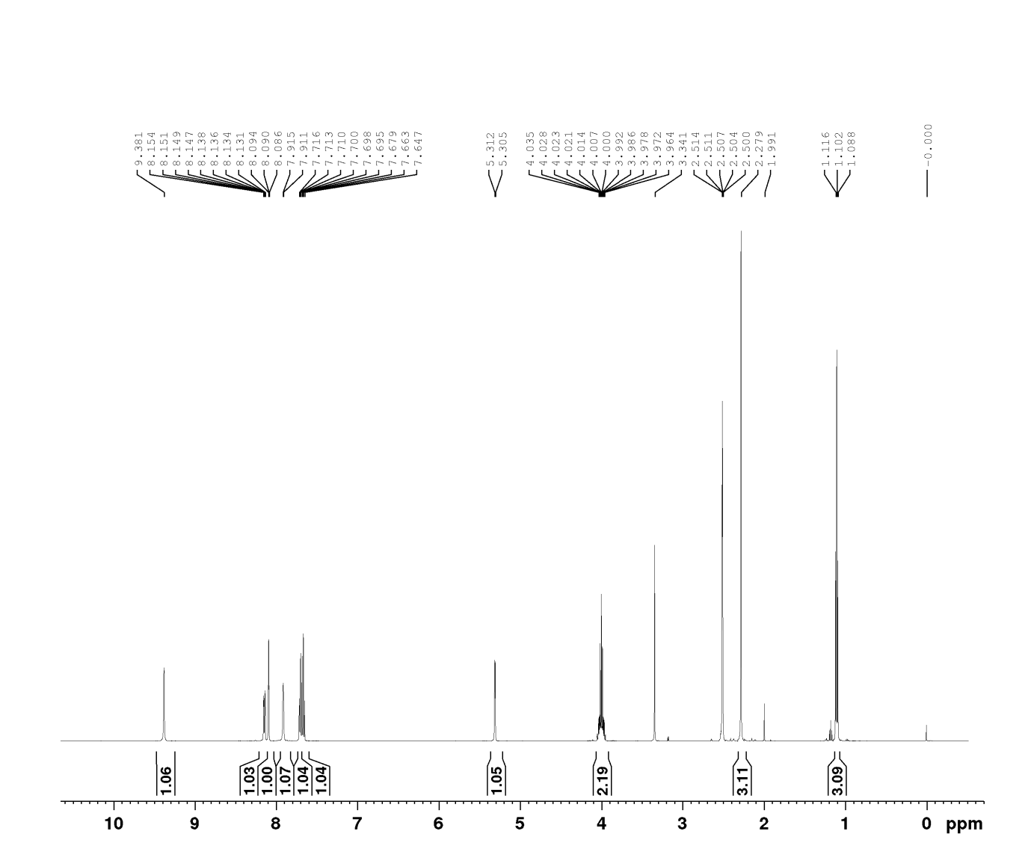
¹³C-NMR (500 MHz, DMSO-d₆)
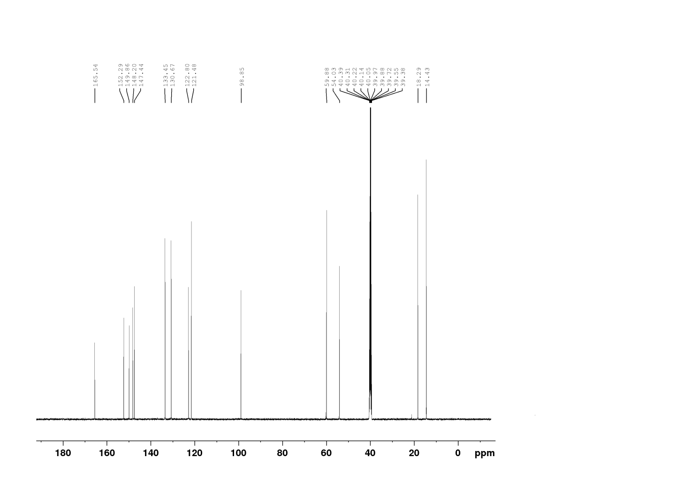
5-(Ethoxycarbonyl)-4-(3-methylphenyl)-6-methyl-3,4-dihydropyrimidin-2(1H)-one (Table no.2, Entry no. 12).
¹H-NMR (500 MHz, DMSO-d₆)
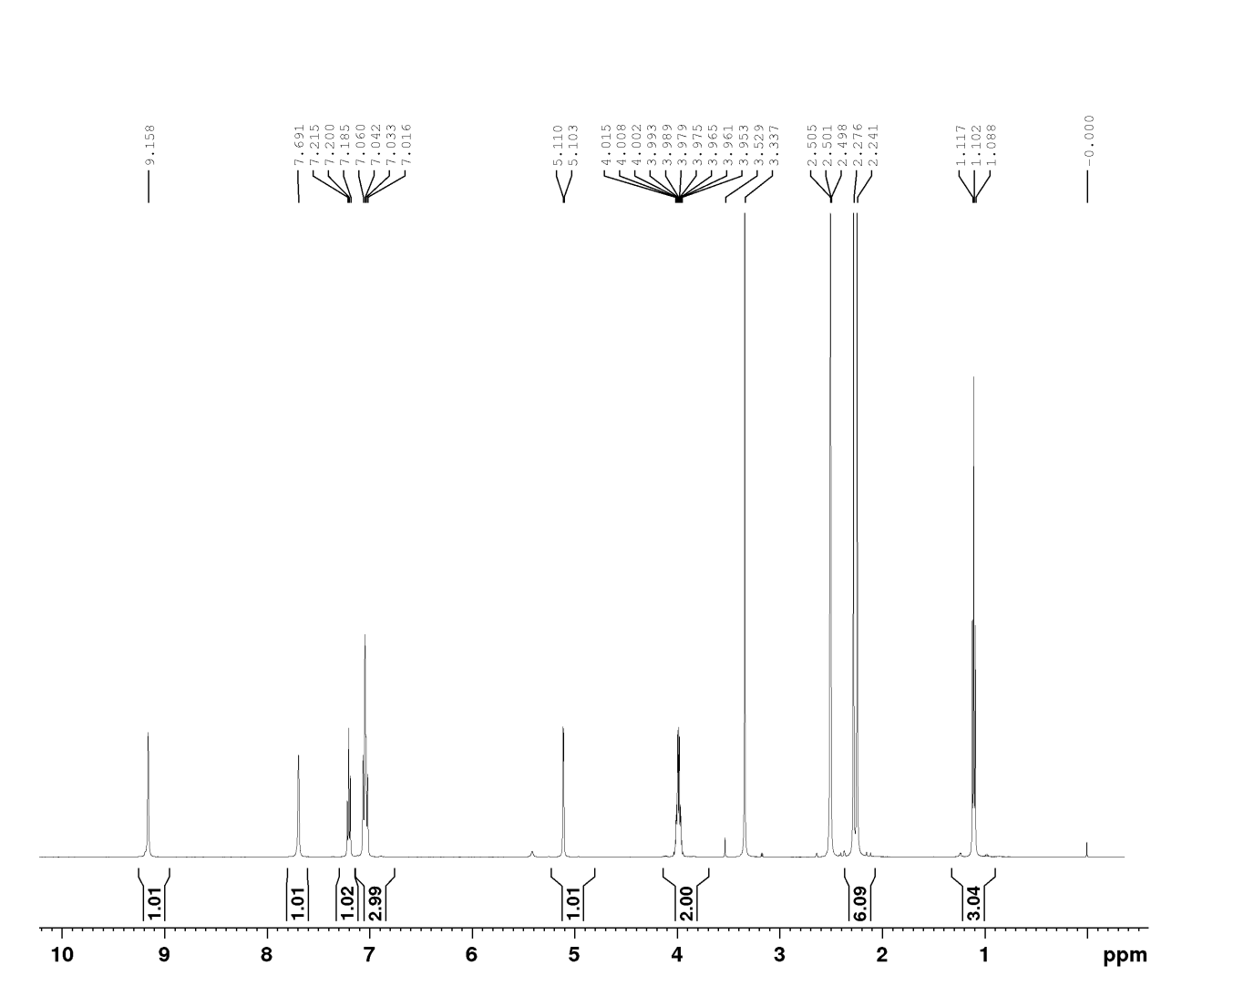
¹³C-NMR (500 MHz, DMSO-d₆)

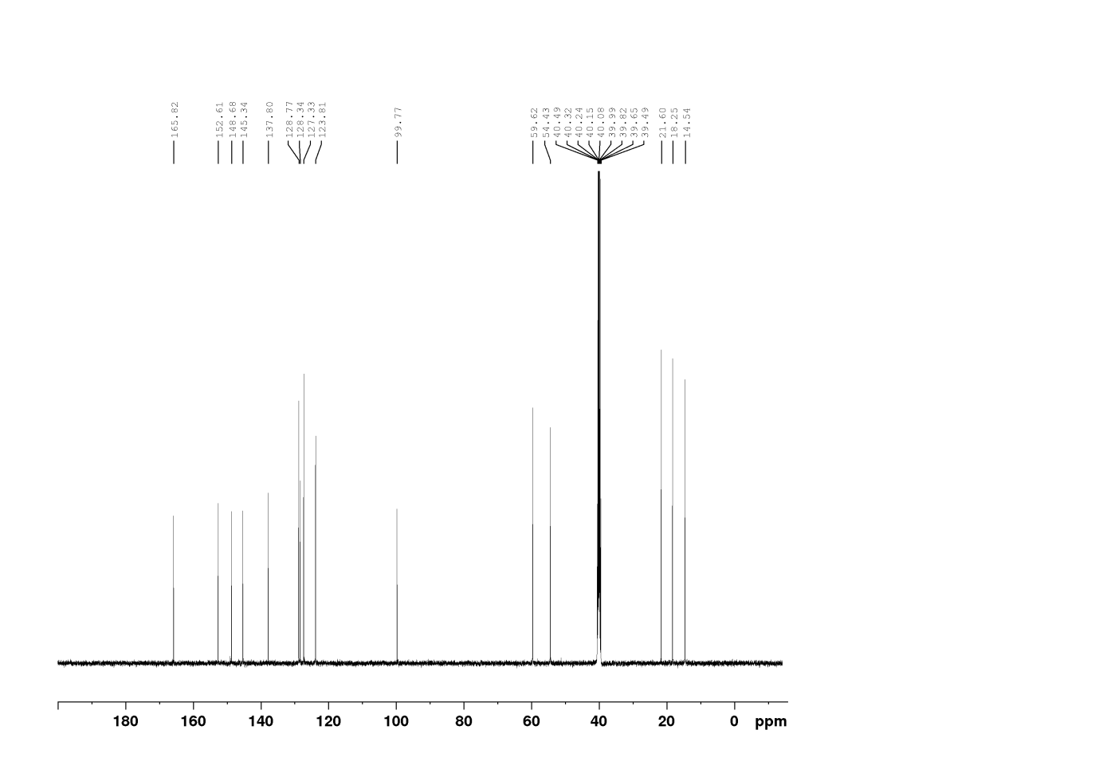
5-(Ethoxycarbonyl)-4-(furan-2-yl)-6-methyl-3,4-dihydropyrimidin-2(1H)-one(Table no.2, Entry no. 13).
¹H-NMR (500 MHz, DMSO-d₆)
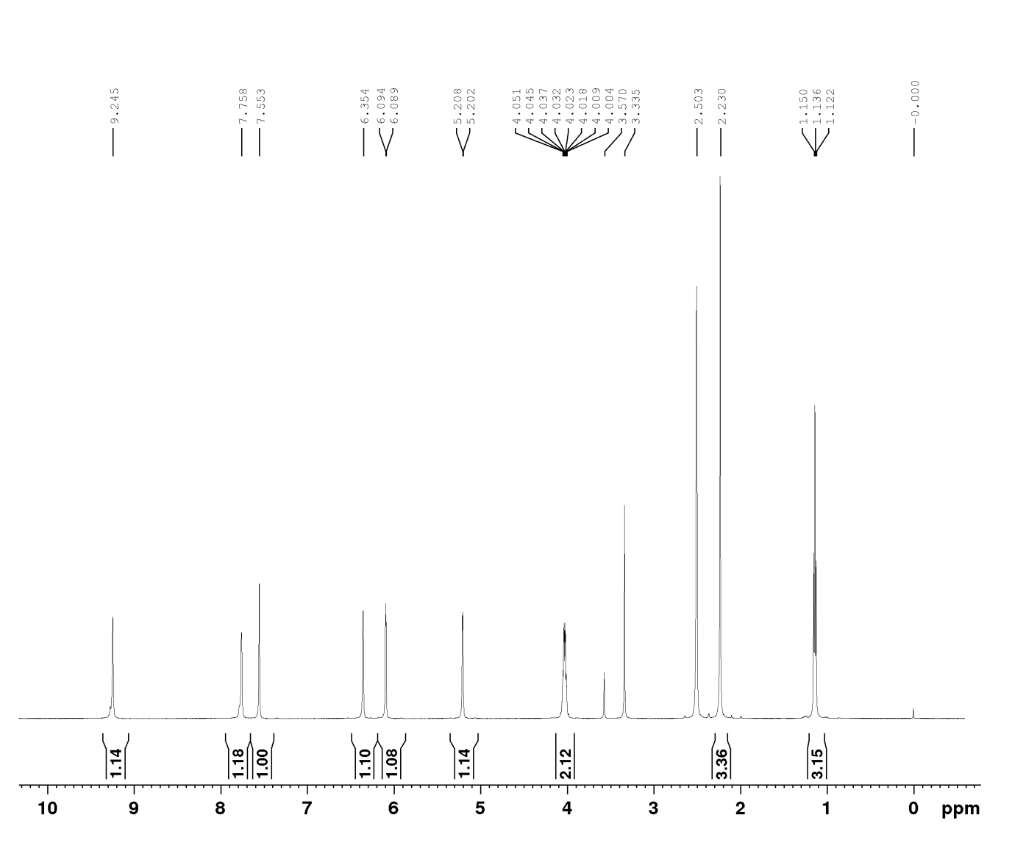
¹³C-NMR (500 MHz, DMSO-d₆)
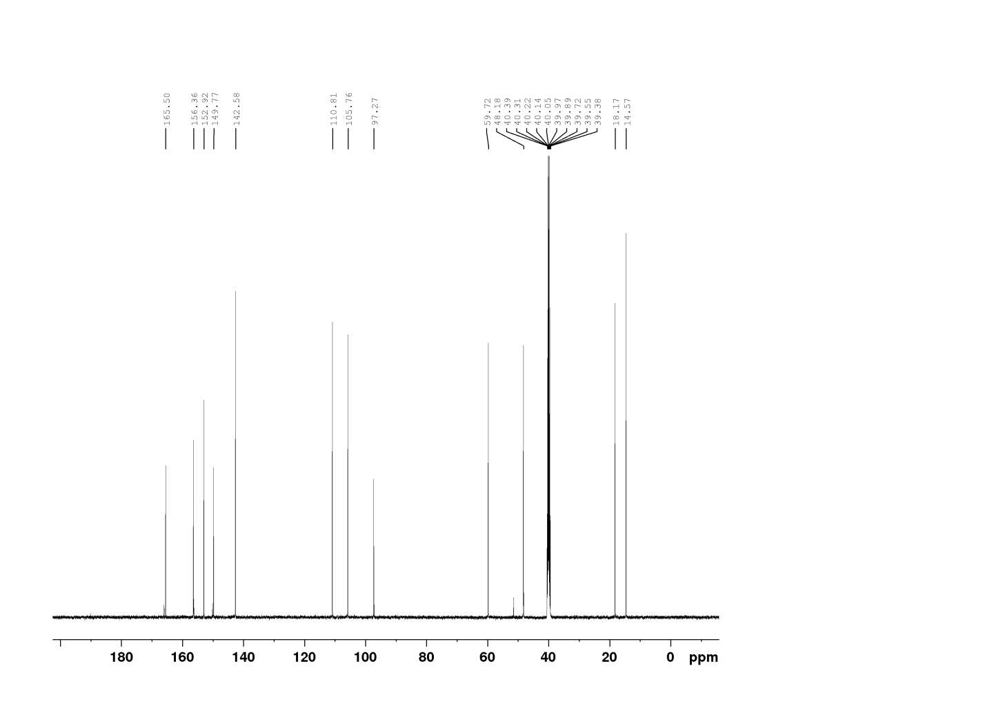
5-(Ethoxycarbonyl)-4-(thiophene-2-yl)-6-methyl-3,4-dihydropyrimidin-2(1H)-one (Table no.2, Entry no. 14).
¹H-NMR (500 MHz, DMSO-d₆)
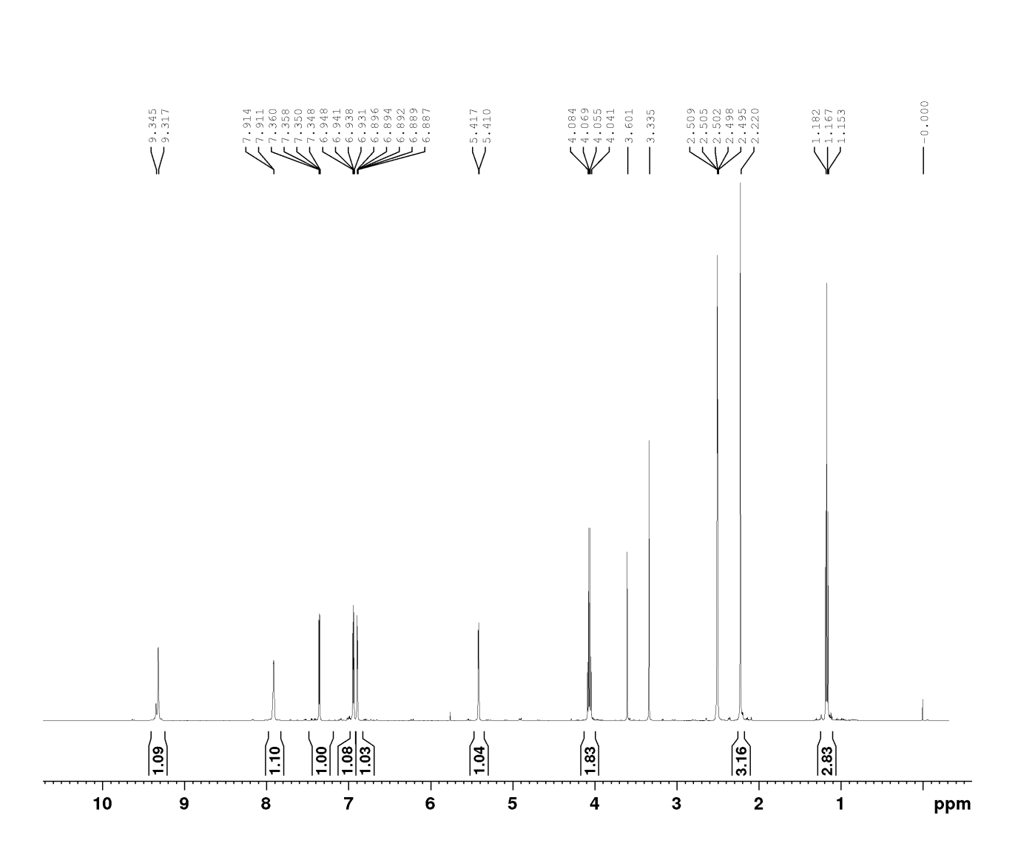
¹³C-NMR (500 MHz, DMSO-d₆)
