**Supplementary material**

*Materials*

Chitosan (Mv 87,000 g/mol and 85% deacetylated) was purchased from Golden-Shell Biochemical (China). Poly(vinyl alcohol) (PVA) (Mw 124,000 g/mol and 99% hydrolyzed) was purchased from Sigma-Aldrich (USA). Glutaraldehyde (25 wt/v-% aqueous solution) was purchased from Vetec (Brazil). Hydrogen peroxide (H2O2, 35 v/v-%) was purchased from Synth (Brazil). Methyl red (acid red 2 pure, MR) and methyl orange (MO) were purchased from Acros-Organics (USA). Water-soluble pentacationic 5,10,15,20-tetrakis(*N*-methyl-4-pyridyl)porphyrin-Fe(III) tetrachloride (FeTMPyP; Mw 909.92 g/mol) was purchased from Frontier Scientific (Logan, Utah, USA). All chemicals of analytical grade were used as received without further purification.

*Characterization*

The chemical nature of the prepared films was investigated by Fourier Transform Infrared (FTIR) spectroscopy. FTIR spectra were recorded in an Affinity-1 Shimadzu spectrometer (Japan) operating in the spectral region of 4000–600 cm-1 with a resolution of 4 cm-1, 64 scans. Powder samples were ground with spectroscopic grade KBr and pressed into disks prior analysis. Ultraviolet-visible (UV-Vis) absorption spectra were taken by using a Perkin Elmer Lambda 35 spectrometer (USA). Thermal stability was assessed by thermogravimetric analysis (TGA), which were performed in a DTG60 Analyzer Shimadzu (Japan) operating in a scanning rate of 10 ºC/min under N2(g) atmosphere with a flow of 20 mL/minin a range of temperature of 25–700 ◦C. Different microscopy techniques were used to investigate the morphology of the prepared films and the distribution of the FeTMPyP through the polymeric matrix. Scanning electron microscopy (SEM) images were recorded on a JEOL JSM-6610LV microscope (USA) coupled with an energy-dispersive X-ray (EDX) analyzer. The samples were gold-coated by sputtering before the image acquisition.

Atomic force microscopy (AFM) and electric force microscopy (EFM) were performed simultaneously in a Park NX10 (Park Systems, Korea) instrument equipped with a SmartScan® software version 1.0. RTM 11a. Samples were cut into small pieces (~5.0 mm side) and imaged in non-contact mode. The measurements were conducted using a PPP-EFM (Nanosensors, Switzerland) Si probe PtIr coated, with a nominal resonance frequency of 75 kHz and 2.8 N m-1 force constant. All measurements were made under ambient conditions at room temperature of 20 ± 5 °C and relative humidity of 50 ± 10% with a scanning rate of 0.25 Hz. Images were treated offline using XEI software version 4.3.4 Build 22. RTM 1. Also, XEI software was used to calculate average roughness (*Ra*) and fractal dimension (*D*).

Swelling experiments were performed to investigate the liquid uptake capacity of the prepared samples under different pH conditions. Briefly, dry samples (60 mg) were put into vials filled with distilled water (50 mL, 25 ºC) under static conditions. The pH of the swelling medium was ranged from 2 to 12 using HCl or NaOH solutions (1.0 mol/L) before the sample immersion. At desired time intervals, the samples were withdrawn, and the excess of liquid on their surfaces was blotted. Then, the swollen samples were weighed. Eq. (S1) was used to calculate the swelling rate after each time interval:

$swelling \left(\%\right)= \frac{w_{s}- w_{d}}{w_{d}} x 100$ (S1)

where *ws* (mg) is the sample weight in the swollen state at different time intervals, and *wd* (mg) is the sample weight in the dry state. The experiment was performed in triplicate for each sample.

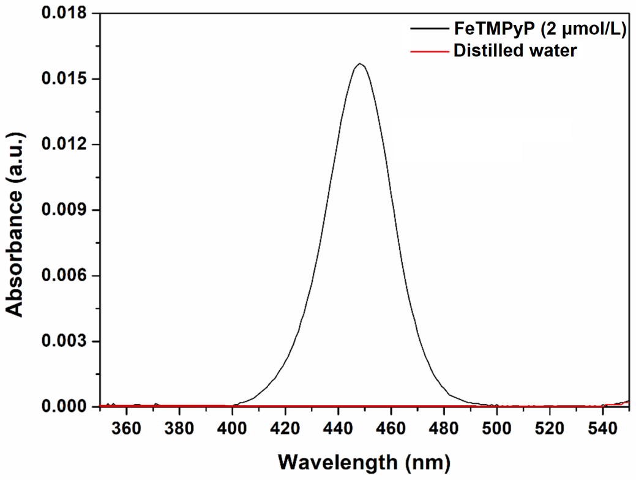

**Fig. S1.** UV-Vis spectra of FeTMPyP and the distilled water used to wash the as-synthesized Cht/PVA-Fe(III)Pr film.

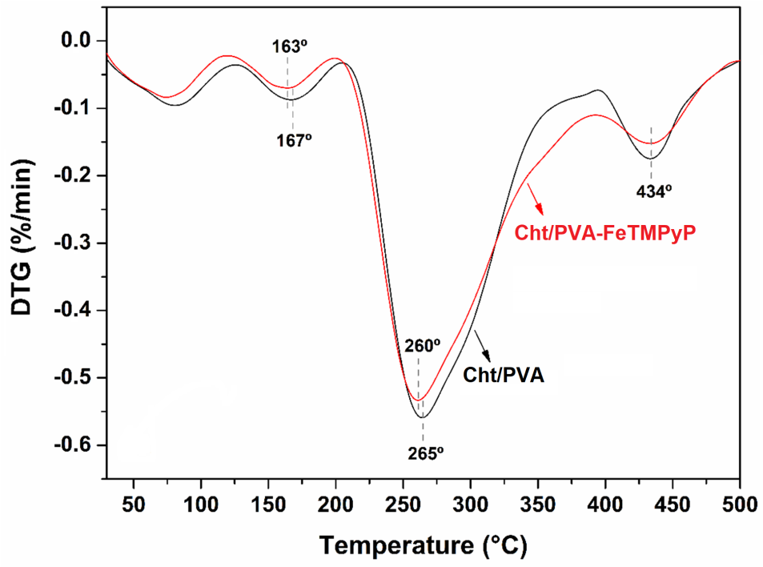

**Fig. S2.** DTG curves obtained for the Cht/PVA and Cht/PVA-FeTMPyP films.

*Thermal degradation kinetic*

The thermal degradation kinetics of the hybrid film was investigated using the Arrhenius´ equation. According to the Arrhenius correlation, the conversion rate (i.e., thermal degradation rate) can be expressed as:

|  |  |  |
| --- | --- | --- |
|  | $$\frac{dα}{dt}=Ae^{-\frac{E_{a}}{RT} }f\left(α\right)$$ | (S1) |

where α is the conversion ratio obtained from the TGA data by the Eq. (S2), while the *f*(*α*) represents the function assigned to the conversion ratio, which can be simplified to Eq. (S3):

|  |  |  |
| --- | --- | --- |
|  | $$α=\frac{m_{0}-m_{T}}{m_{0}-m_{f}}$$ | (S2) |
|  |  |  |
|  | $$f\left(α\right)={\left(1-α\right)}^{n}$$ | (S3) |

where *m0* is the initial mass of the sample, *mT* is the mass of the sample at the temperature *T,* and *mf* is the final mass of the sample. Besides that, *n* is a constant associated with the reaction order of the thermal degradation process (Bu et al., 2016). Thus, the conversion rate can be rewritten as:

|  |  |  |
| --- | --- | --- |
|  | $$\frac{dα}{dt}=Ae^{-\frac{E_{a}}{RT} } {\left(1-α\right)}^{n}$$ | (S4) |

In parallel, isoconversional kinetic models have been widely used for describing the kinetics of thermal degradation of polymeric materials (Bu et al., 2016). These models assumed that the reaction mechanism is independent of the change in temperature and heating rate. So, the kinetic constants are a function of the temperature at a determined conversion (*f*(α,*T*)). The Coats-Redfern model was used to investigate the kinetics of the thermal degradation of the Cht/PVA and Cht/PVA-FeTMPyP films. This model is commonly utilized in the non-isothermal kinetic analysis and enables the use of a single heating rate (Bu et al., 2016). For a constant heating rate (*β*), the Coats-Redfern model predicts that the conversion rate should be written as:

|  |  |  |
| --- | --- | --- |
|  | $$\frac{dα}{dt}=\frac{A}{β}e^{-\frac{E_{a}}{RT}}{\left(1-α\right)}^{n}$$ | (S5) |

The Eq. (S5) can be expressed, after re-arranging and integrating both sides of the equation, as follows:

|  |  |  |
| --- | --- | --- |
|  | $$\int_{0}^{α}{\frac{dα}{{(1-α)}^{n}}=\frac{A}{β}\int_{0}^{T}{e^{-\frac{E_{a}}{RT}}}}dT$$ | (S6) |

After the appropriate integration and using the logarithmic properties, the Eq. (S6) can be expressed as follows:

|  |  |  |  |
| --- | --- | --- | --- |
|  | $$ln\left(\frac{-ln {(1-α)}^{1-n}}{T^{2}\left(1-n\right)}\right)=\ln\left(\frac{AR}{βE_{a}}\right)-\frac{E_{a}}{RT}$$ | | (S7) |
|  | |  |  |
|  | | $$\ln\left(f\left(α,T\right)\right)= \ln\left(\frac{AR}{βE_{a}}\right)-\frac{E_{a}}{RT}$$ | (S8) |

Then, Eq. (S8) was used to evaluate the thermal degradation process of the prepared hybrid film.

**Table S1.** Kinetic parameters calculated for the thermal degradation of Cht/PVA and Cht/PVA-FeTMPyP films.

|  |  |  |  |  |
| --- | --- | --- | --- | --- |
| **Degradation stages** | **Cht/PVA** | | **Cht/PVA-FeTMPyP** | |
| ***Ea* (kJ/mol K)** | **R2** | ***Ea* (kJ/molK)** | **R2** |
| 1º | 35.30 | 0.981 | 34.00 | 0.980 |
| 2º | 7.54 | 0.971 | 6.92 | 0.970 |
| 3º | 38.31 | 0.973 | 35.40 | 0.985 |
| 4º | 24.30 | 0.990 | 21.46 | 0.992 |

Figure 2a.tifFigure 2b.tif

**Fig. S3.** SurfaceSEM images of (a) Cht/PVA film and (b) Cht/PVA-FeTMPyP film.





**Fig. S4.** EDX analysis of (a) Cht/PVA and (b) Cht/PVA-FeTMPyP films.

*Swelling experiments*

As assessed, both films showed a remarkable swelling ability with a pH-dependent profile. Also, the presence of FeTMPyP into the Cht/PVA seems to not affect the swelling ability of the hybrid film when compared to the pristine one. As shown in Fig. S4a, the Cht/PVA film exhibited a high swelling rate up to 20 min after the beginning of the experiment under all tested pH conditions. This behavior can be ascribed to the hydrophilic nature of both polymers, Cht and PVA. After this while, the swelling process slows down and the liquid uptake tends to leave off, which means that the swelling equilibrium was achieved. The maximum swelling (~295%) was achieved at pH 2, likely due to the protonation of the amino groups of Cht and hydroxyl groups of PVA. The protonation of these functional groups increases the positive charge density inside the polymeric matrix causing the appearing of cation-cation repulsive forces. As a result, these repulsive forces promote the expansion of the polymeric matrix favoring the liquid sorption. At pH 4 and 6, this effect is attenuated, which reduces the film swelling. Under neutral and alkaline conditions (pH ≥ 6), the amine and hydroxyl groups are not protonated longer. Thus, the cation-cation repulsive forces do not affect the stability of the polymeric matrix, and the liquid uptake process is only driven by the hydrophilic nature of the crosslinked polymers (Fajardo et al., 2012). At pH 12, a strong alkaline condition, the maximum swelling was half of the value calculated at pH 2, for instance.

The swelling profile of the Cht/PVA-FeTMPyP film is similar to that presented by the Cht/PVA film (Fig. S4b). Again, the maximum swelling values were achieved under acidic conditions (pH ≤ 6) while an increase of pH decreased the liquid uptake by the hybrid film. Yet, it is noticeable some discrepancies regarding the swelling kinetics and the maximum swelling of the Cht/PVA-FeTMPyP film with respect to the pristine film. In general lines, the swelling ability of the Cht/PVA matrix is slightly reduced likely due to the H-bonds formed between the FeTMPyP and the hydrophilic groups of Cht and PVA (amino and hydroxyl groups). Such interaction, which was confirmed by FTIR and TGA analyses, promotes the stabilization of the polymer matrix and restricts the number of hydrophilic groups available to interact with the water molecules (Fajardo et al., 2012).

**Figure 4a.tifFigure 4b.tif**

**Fig. S5.** Swelling curves of (a) Cht/PVA film and (b) Cht/PVA-FeTMPyP film in aqueous medium with different pHs.

 

**Fig. S6.** UV-Vis spectra in solid-state of Cht/PVA-FeTMPyP film before and after the MO degradation reactions performed at (a) pH 3, (b) pH 5, and (c) pH 7.

 

**Fig. S7.** UV-Vis spectra in solid-state of Cht/PVA-FeTMPyP film before and after the MR degradation reactions performed at (a) pH 3, (b) pH 5, and (c) pH 7.

 

**Fig. S8.** UV-Vis spectra in solid-state of Cht/PVA-FeTMPyP film before and after the MO degradation reaction in the presence of (a) 1 mmol/L, (b) 5 mmol/L and (c) 10 mmol/L of H2O2.

 

**Fig. S9.** UV-Vis spectra in solid-state of Cht/PVA-FeTMPyP film before and after the MO degradation reaction in the presence of (a) 1 mmol/L, (b) 5 mmol/L and (c) 10 mmol/L of H2O2.



**Fig. S10.** Effect of the initial dye concentration on the decolorization of (a) MO and (b) MR solutions by Fenton-like reactions using the Cht/PVA-FeTMPyP film as catalyst.



**Fig. S11.** Effect of H2O2 concentration on the decolorization of (a) MO and (b) MR solutions by Fenton-like reactions using the Cht/PVA-FeTMPyP film as catalyst.



**Fig. S12.** Effect of the catalyst dosage on the decolorization of (a) MO and (b) MR solutions by Fenton-like reactions.

**Table S2.** Kinetic constants and half-times for the decolorization of MO and MR using the Cht/PVA-FeTMPyP film under different experimental conditions.

|  |  |  |  |  |  |
| --- | --- | --- | --- | --- | --- |
| **Variable** | **Dye** | **Value** | ***kapp* x 10-2 (1/min)** | ***t1/2* (min)** | **R2** |
| Initial dye concentration | MO | 1 ppm | 4.42 ± 0.09 | 15.68 | 0.992 |
| 10 ppm | 4.36 ± 0.20 | 15.90 | 0.994 |
| 20 ppm | 1.21 ± 0.08 | 57.28 | 0.983 |
| MR | 1 ppm | 2.21 ± 0.15 | 31.36 | 0.990 |
| 10 ppm | 2.16 ± 0.11 | 32.09 | 0.992 |
| 20 ppm | 1.13 ± 0.09 | 61.34 | 0.982 |
| H2O2 concentration | MO | 1 mmol/L | 4.62 ± 0.09 | 15.00 | 0.996 |
| 5 mmol/L | 4.23 ± 0.05 | 14.81 | 0.997 |
| 10 mmol/L | 3.87 ± 0.11 | 17.91 | 0.980 |
| MR | 1 mmol/L | 2.61 ± 0.07 | 26.56 | 0.992 |
| 5 mmol/L | 2.54 ± 0.05 | 27.29 | 0.995 |
| 10 mmol/L | 2.13 ± 0.10 | 32.54 | 0.990 |
| Catalyst dosage | MO | 60 mg | 4.52 ± 0.28 | 15.33 | 0.988 |
| 80 mg | 5.18 ± 0.40 | 13.38 | 0.985 |
| 100 mg | 7.41 ± 0.32 | 9.35 | 0.995 |
| MR | 60 mg | 2.40 ± 0.06 | 28.88 | 0.990 |
| 80 mg | 2.18 ± 0.14 | 31.80 | 0.970 |
| 100 mg | 2.11 ± 0.19 | 32.85 | 0.978 |

*FTIR and GC/MS analyses of the by-products*

Firstly, for the isolation of the by-products, the reaction medium (after the end of the dye decolorization experiment) was mixed with an equal quantity of ethyl acetate and, then, anhydrous sodium sulfate was added in order to dry the extracted products further in the rotary vacuum evaporator (Akansha et al., 2019). The FTIR spectra obtained from the by-products were compared with the spectra of the raw azo dyes (Fig. S13).

*Figure 11.tif*

**Fig. S13**. FTIR spectra of raw dyes and their by-products generated after the decolorization reaction.

The FTIR spectra of raw MO and MR showed their characteristic bands assigned to the ‒N=N‒ bond stretching vibration at 1531 cm-1 and 1540 cm-1, respectively. Moreover, both FTIR spectra also exhibited strong bands at 3444 cm-1 due to the O-H stretching arising from water molecules adsorbed on their structures and bands at 824 cm-1 assigned to their benzene di-substituted groups. In addition, the MO spectrum showed bands at 2917 cm-1 and 2819 cm-1 related to C-H stretching, and a band at 1380 cm-1 due to the S=O stretching of its sulfate groups (Khan et al., 2019). The MR spectrum showed a band at 1715 cm-1 due to the C=O stretching of its free carboxylic groups.

After the MO decolorization, the FTIR spectrum of its by-products did not exhibit the characteristic azo bond band or the typical band of di-substituted benzene. Despite this, low intensity and shifted bands proceeding from the MO structure, as well as, new bands were noticed in the MO by-products spectrum. For instance, the band at 1461 cm-1 can be associated with the N-H bond deformation of amine groups (‒NH2) likely due to the formation of simple molecules (Khan et al., 2019; Yang et al., 2018).

The FTIR spectrum of the by-products isolated from the MR decolorization also follows the same trend of MO by-products with the absence of the azo bond band and the band from the di-substituted benzene groups. However, the FTIR spectrum of MR by-products presented a broadening in the O-H stretching band (3444 cm-1) and a new band at 1457 cm-1. These observations suggest the presence of free ‒NH2 groups in the structure of the MR by-products (Khan et al., 2019; Q. X. Yang et al., 2017). Further, the intensity of the C-H stretching bands was increased, suggesting the presence of simple molecules in the by-product.

The isolated by-products were also analyzed by GC/MS (Figs. S14 and S15). In general, the degradation pathway of MO and MR by Fenton-based catalysts is well-known, and their specificities can be found in the literature (Devi et al., 2009; Xie et al., 2016). Based on the GC/MS analysis, a general degradation pathway for the degradation of the azo dyes was proposed in Fig. S16, where the main identified degradation products are showed. As aforementioned, the •OH radicals are the main oxidant species responsible for the degradation of the MO and MR using the Cht/PVA-FeTMPyP film. The •OH radicals are electrophilic species and can abstract electrons from electron-rich functional groups, such as the N=N bond presented in MO and MR structures (Devi et al., 2009). Therefore, it is reasonable to consider that this bond is firstly attacked by these radicals, being oxidized. As result, the oxidation of this functional group increases the instability of the dye molecules, and as the •OH radicals continue to attack, several organic compounds, such as aniline (*m/z* 93), anthranilic acid (m/z 137), amino benzenesulphonic acid (*m/z* 172), dimethyl-4-phenylenediamine (*m/z* 136), phenol (*m/z* 94) and sulfurous acid (*m/z* 82) are produced (Devi et al., 2009; Xie et al., 2016). Further degradation occurred by an additional •OH radical attack and ring cleavage, which results in small mass molecules (Boxi and Paria, 2015). Finally, MO and MR are mineralized to CO2, H2O, and inorganic salts, which are harmless (Boxi and Paria, 2015). Moreover, the peaks of small molecules (*m/z* > 100) strongly suggest the degradation of MO and MR to simple molecules. In general, all these considerations agree with the FTIR data described above.







**Fig. S14**. Mass spectra of MO decolorization by-products at the retention times of (a) 6.900, (b) 12.970 and (c) 15.025.



**Fig. S15.** Mass spectra of MR decolorization by-products at the retention times of (a) 9.092, (b) 10.120 and (c) 15.858.



**Fig. S16.** Probable decolorization pathways for MO and MR catalyzed by the Cht/PVA-FeTMPyP film in the presence of H2O2.

 

**Fig. S17.** SEM images taken of the Cht/PVA-FeTMPyP films after five consecutive decolorization cycles of (a) MO and (b) MR solutions.





**Fig. S18.** EDX analysis of the Cht/PVA-FeTMPyP films after five consecutive decolorization cycles of (a) MO and (b) MR solutions.

 

**Fig. S19.** UV-Vis spectra in solid-state of Cht/PVA-FeTMPyP film before and after five consecutive decolorization cycles of (a) MO and (b) MR solutions.

**References**

Akansha, K., Chakraborty, D., Sachan, S. G., 2019. Decolorization and degradation of methyl orange by Bacillus stratosphericus SCA1007. Biocatal. Agricult. Biotechnology, 18, 1-6

Boxi, S.S., Paria, S., 2015. Visible light induced enhanced photocatalytic degradation of organic pollutants in aqueous media using Ag doped hollow TiO2 nanospheres. RSC Adv. 5, 37647–37668.

Bu, Q., Lei, H. W., Qian, M.,Yadavalli, G., 2016. A thermal behavior and kinetics study of the catalytic pyrolysis of lignin. RSC Adv. 6(103), 100700-100707.

Devi, L.G., Raju, K.S.A., Kumar, S.G., 2009. Photodegradation of methyl red by advanced and homogeneous photo-Fenton’s processes: A comparative study and kinetic approach. J. Environ. Monit. 11, 1397–1404.

Fajardo, A. R., Lopes, L. C., Rubira, A. F., Muniz, E. C., 2012. Development and application of chitosan/poly(vinyl alcohol) films for removal and recovery of Pb(II). Chem. Eng. J., 183, 253-260.

Khan, S. A., Shahid, S., Nazir, M., Kanwal, S., Zaman, S., Sarwar, M. N., Haroon, S. M., 2019. Efficient template based synthesis of Ni nanorods by etching porous alumina for their enhanced photocatalytic activities against Methyl Red and Methyl Orange dyes. J. Mol. Struct., 1184, 316-323.

Xie, S., Huang, P., Kruzic, J.J., Zeng, X., Qian, H., 2016. A highly efficient degradation mechanism of methyl orange using Fe-based metallic glass powders. Sci. Rep. 6, 1–10.

Yang, H. M., Li, J. S., Zeng, X. Q., 2018. Correlation between molecular structure and interfacial properties of edge or basal plane modified graphene oxide. ACS Appl, Nano Mater. 1(6), 2763-2773.

Yang, Q. X., Song, H. M., Li, Y. P., Pan, Z. H., Dong, M. G., Chen, F. H., Chen, Z. J. (2017). Flower-like core-shell Fe3O4@MnO2 microspheres: Synthesis and selective removal of Congo red dye from aqueous solution. J. Mol. Liq. 234, 18-23.